**Feedback 1 – Create a Sales PowerPoint Template**

We need to create a branded PowerPoint template that we can use for sale presentations. The PowerPoint templates should follow the design colors, elements, etc. of the stationaries - letterhead, business cards, envelope so things flow and everything is branded with Cyzerg. Sometime ago we did a branded PowerPoint presentation for the foundation and this is how it came up – click [here](https://www.dropbox.com/s/reeh4o0bzflqi7b/Foundation%20Overview%20V2.pptx).

**Feedback 2 – Update/Adjust Business Cards**

We need to make the content area of the business cards a little bit bigger – now is too small and hard to read – and update all the information as per below. We also need you to generate ready to print PDF files so we can send it over to the printing company to print. Once you have made the changes if you could print it in regular paper that will be good so you can see if the new size of the content area is acceptable and easy to read. Please send us back the updated vector.

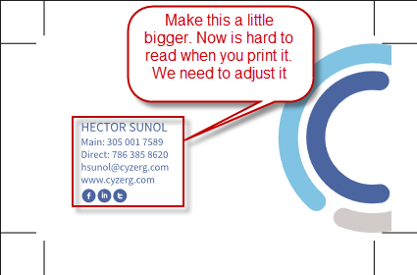

**Business Card 1 Info:**

Hector E. Sunol

Main: 954.505.8925

Direct: 954.505.8919

[hsunol@cyzerg.com](mailto:hsunol@cyzerg.com)

[www.cyzerg.com](http://www.cyzerg.com)

**Business Card 2 Info:**

Manuel Cassola

Main: 954.505.8925

Direct: 954.505.8923

[mcassola@cyzerg.com](mailto:mcassola@cyzerg.com)

[www.cyzerg.com](http://www.cyzerg.com)