**Develop Collaboration Systems Page**

This page is linked to the **Benefits** of Email Systems and Collaboration Tools section of the Cloud Applications page. Get design from [Here](https://www.dropbox.com/s/i5q3nu079oynlmm/Collaboration%20Systems.png).

**Develop Financial Systems Page**

This page is linked to the **Benefits** of Accounting and Financial Systems section of the Cloud Applications page. Get design from [Here](https://www.dropbox.com/s/f0jhulk86vv0jks/Financial%20Systems.png).

**Develop Document Management Systems Page**

This page is linked to the Benefits of Document Management and Processing section of the Cloud Applications page. Design is going to be provided by designer after some minor changes.

**Develop CRM Systems Page**

This page is linked to the Benefits of the Customer and Relationship Management section of the Cloud Applications page. Design is going to be provided by designer after some minor changes.

**Development Comments**

We are in the last face of the web development and from now on we are going to be making very final details. This is all now about details so it is very important that we pay attention to details and all the requests/notes. Nothing can be overlooked.

**Feedback 1 - Search Box**

The search box is not in line with the grey bar. All the other menus are aligned well but no the search box.

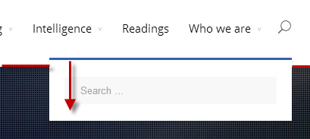

**MORE NEXT PAGE**

**Feedback 2 - Homepage**

Here we are missing the word: Home

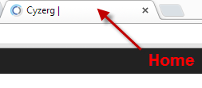

**Feedback 3 - Cloud Infrastructures**

Missing an **S** at the end of Infrastructures



**Feedback 4 – Blogs**

Here we are missing the word Blogs.



**MORE NEXT PAGE**

**Feedback 5 – Careers**

The top image banner gets cutoff when is displayed in a large monitor. The same happens with the 3 banners that have the icons. See examples below.

Online

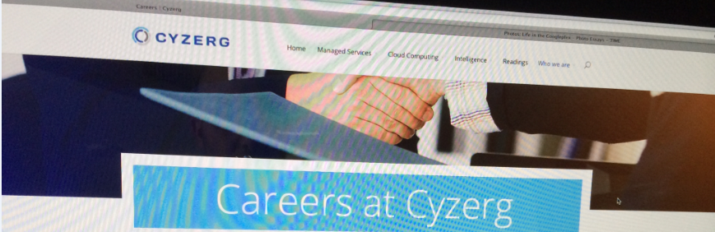

Design



Online

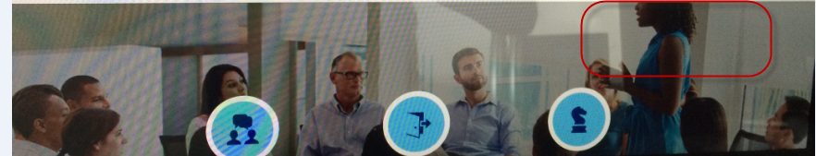

Design



**Feedback 6 – Careers**

The above banners/slider with the icons are no longer changing. We need to make the image and the icons change – rotate through the 3 images with their corresponding icons.

**Feedback 7 - Vision and History**

This banner is not right yet. Look at the difference between online and design.

Online



Design

