**Feedback 1 – Job Description**

The form to submit job applications is not working. The problem seems to be happpening because we we are missing the Captcha box to enter the code – see below. If so, please make the following adjustments

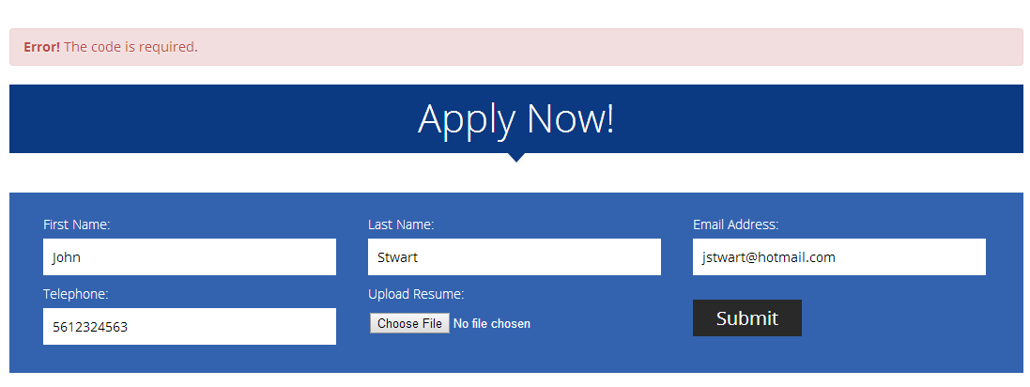

Adjustments for Captcha code. On top of the Captcha text box it needs to say: Enter the code

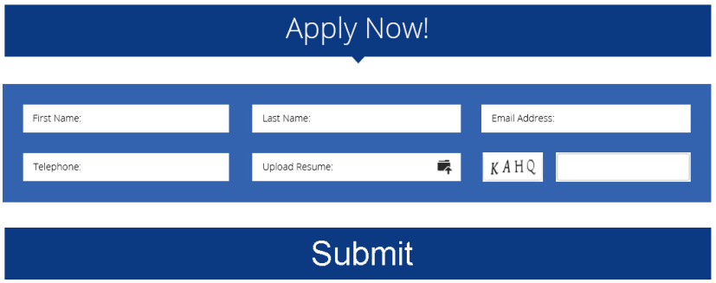

**Feedback 2 – Job Description**

We are missing the blue banner at the bottom of the page as per the design



**MORE NEXT PAGE**

**Feedback 3 – Contact Us**

Move spinning Logo next to submit like in the following image.

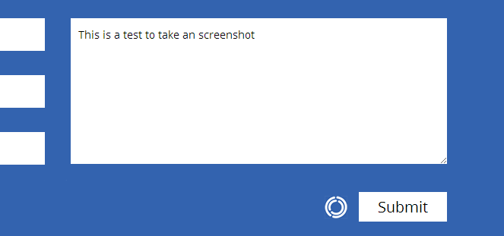

**Feedback 4 – Search**

We need to develop the Search page. Now when you search on the site the results are not organized. Designer will provide you with the updated design. He is just making an small change.