**Desktop Manage Service page**

Capital **L**evel 1 **D**esktop **M**anagement. The same for the other levels.

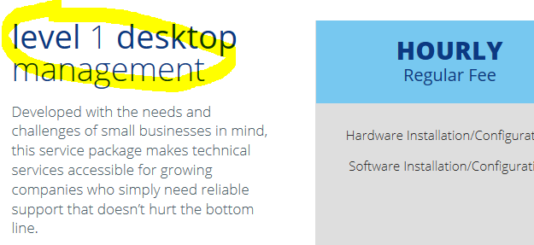

Capital **L**evel 1 **S**erver **M**anagement. The same for the other levels.

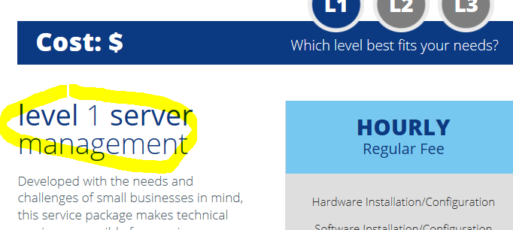

Network Manage and Mobile Manage have the same problem.

**Cloud Computing**

These two links goes nowhere.

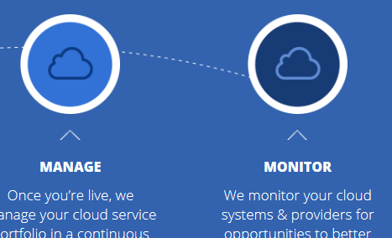

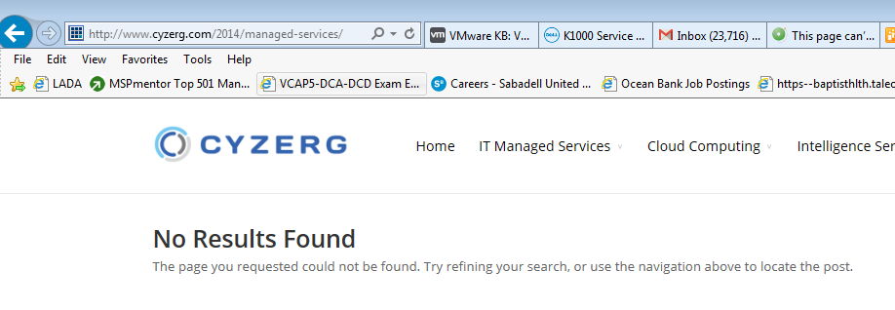

**Technology consulting page**

[**http://www.cyzerg.com/2014/intelligence-services/technology-consulting/**](http://www.cyzerg.com/2014/intelligence-services/technology-consulting/)

We should make the content shorter so when we select Testing and Exercise TAB the size of the page do not change.

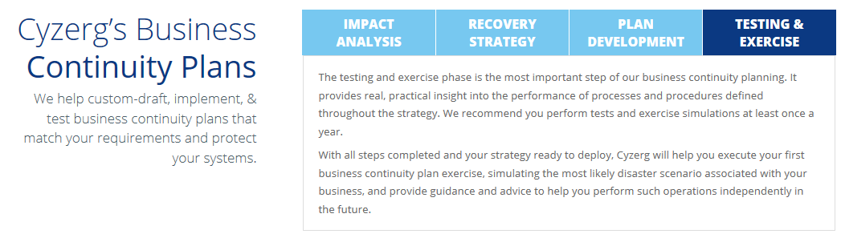

**Blog**

**http://www.cyzerg.com/2014/blogs/**

G+ page not ready yet

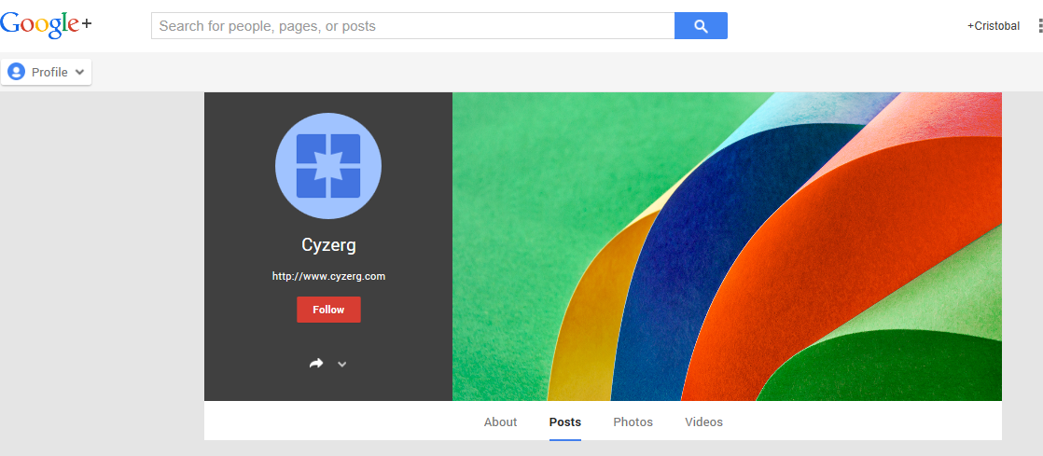



This link just opens the blog in another Window.