**Design of an Elevator system**

I'm aware of intelligent elevators (AI or learning based) that understand and adapt to traffic flows so that when you have multiple elevators in a building, wait in the floors where they'd be closest to the floor where more request is predicted to come, meanwhile minimizing wait time, as well as minimizing movement and power consumption

Occupants would need to be willing to share their identity via Bluetooth, have a Bluetooth capable device, and visit the building often enough to make the investment of their time worthwhile. If the population includes a significant transient component (training, entertainment, consulting, etc.) it could reduce the data needed for optimization.

To make the efficient design with limited time and resources, certain things need to be kept in mind, what kind of users we are going to deal with

1. Suppose a 500 floor building is potentially a whole city living inside a mega structure, from companies to families, so it is feasible there is everything a city needs( like schools, malls, hospitals) within the building. It means everyone is a user (Kids,adults, people with vision/auditory).
2. To make it more efficient we need to be aware of the speed, let’s assume the speed to be around 20 mph , this means it would take around 4 minutes to get to the 500th floor while travelling at top speed.
3. It’s likely that a you’ll spend a good amount of time searching for the right floor button to press, a small pro although, is that you only need to press one button and you’re done.

Points need to be keep in consideration while designing an elevator

1. Adding and removing floors should be easy, feedback should be seen visually
2. Time and details for the next floor
3. Quick link for popular floors (like ground floor)
4. Emergency call and alarm button
5. Open and close button with less closing and opening time so that users don’t have to wait long.

Let’s break down the components here

1. Simple 12 button numeric keypad with a lcd screen above it, type in the floor number you want to go to and press add.
2. A lcd screen to the right which shows a clear visualization of the floors the elevator is going to travel to, press add on the keypad adds your floor to this visualization, giving you instant feedback on your action, current floor is highlighted in a different color.
3. The open and buttons are intentionally bigger, it’s one of the buttons I’m assuming a lot of people need to look for in a short amount of time.
4. Keycard slot for private floors.
5. Alarm, help button and a slot to insert the maintenance key.

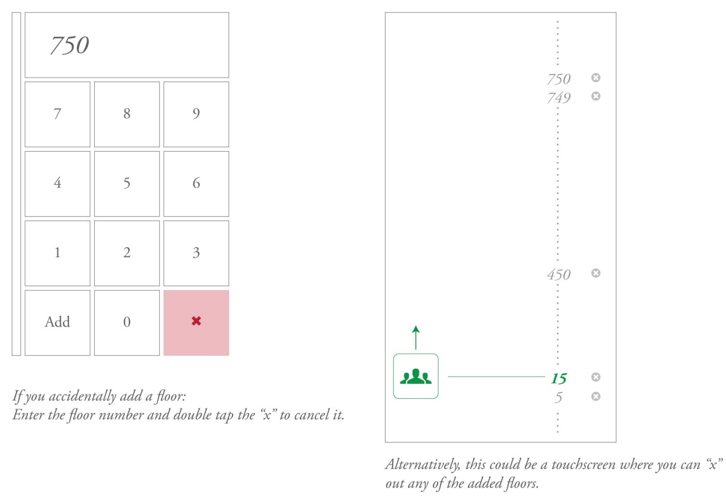

For this design I have chosen to go with physical buttons for the keypad and separate lcd screens instead of stuffing an ipad as the do it all screen, low maintenance interfaces might be preferred in a building where you have 500 floors and 1 elevator being used by tens of thousand of people daily

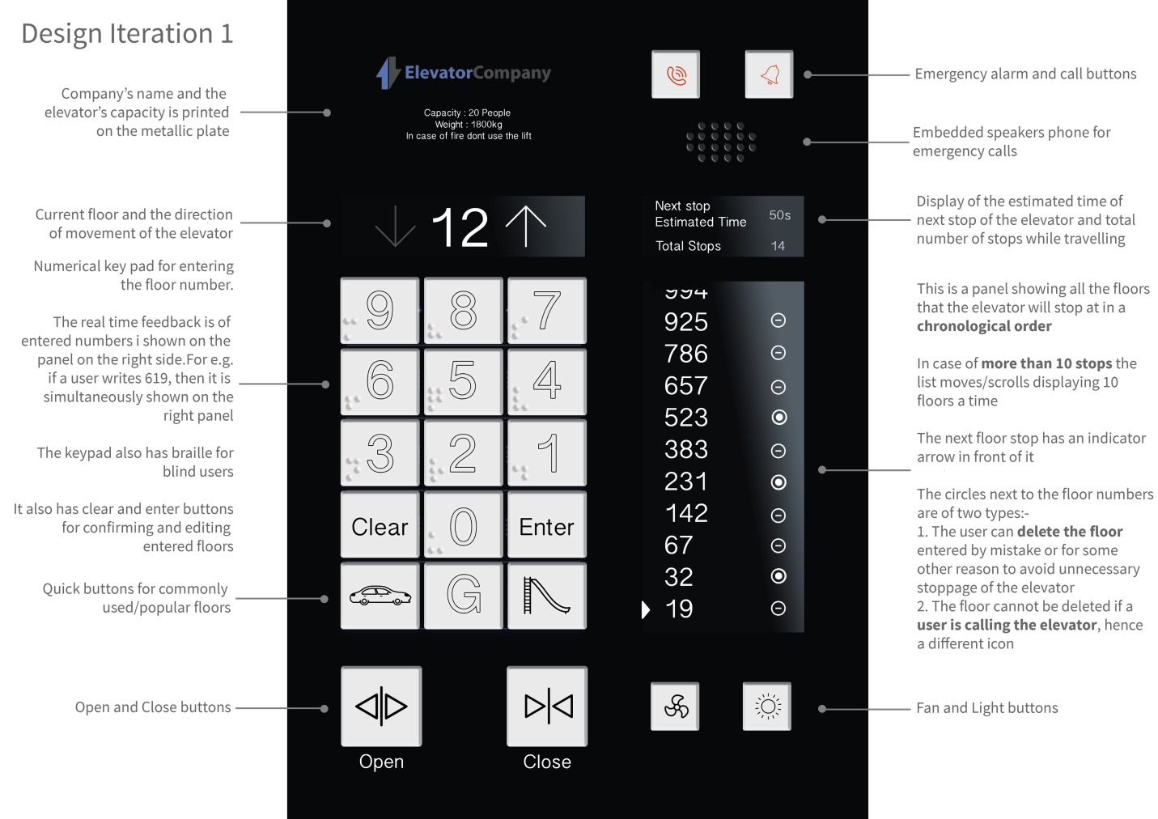

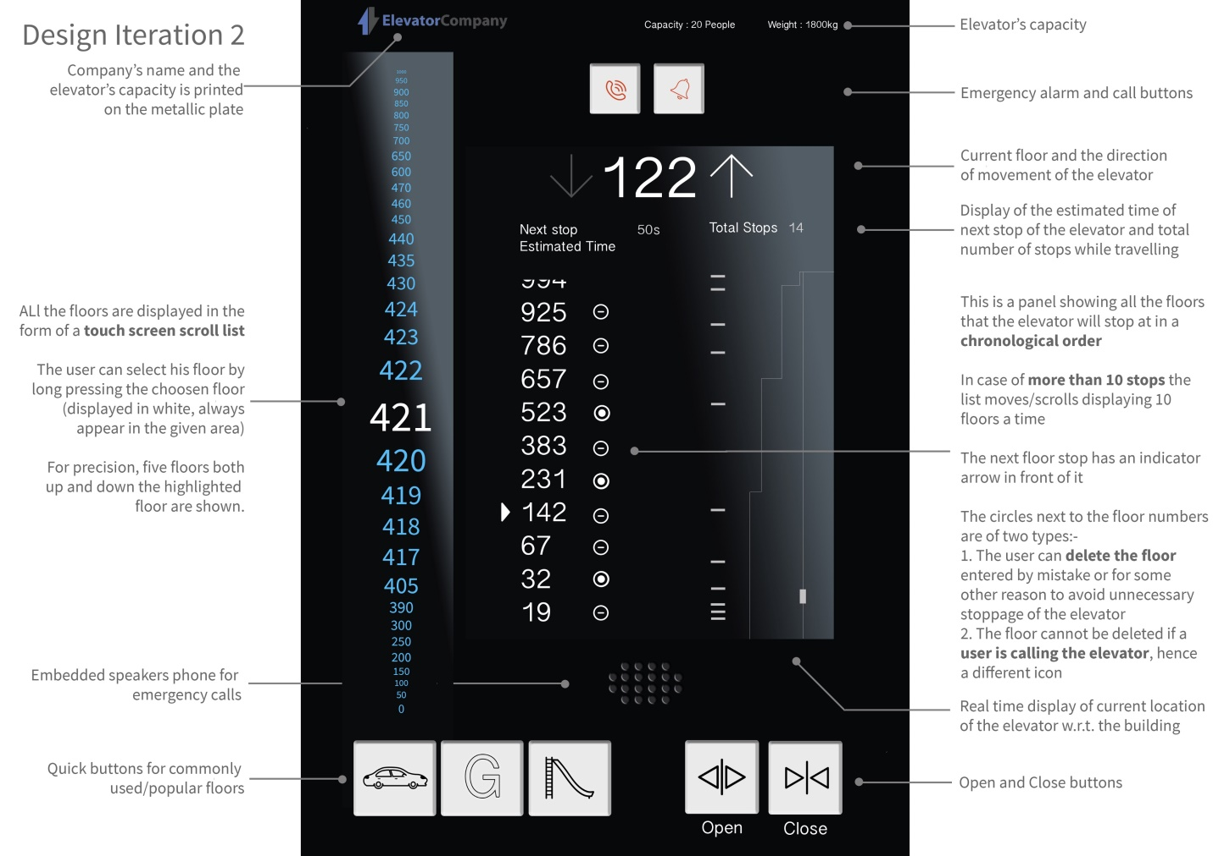

Overall, this solutions works well for what it is, a quick way for multiple people to navigate between a large number of floors, of course if I was looking to implement this in real life, I would go with the multi elevator, double check car route efficiency pruposes, although it might not make a significant difference when I it comes to design I purpose, so I think this solution will work absolutely fine with limited resources and time.