# Case Study Of Iaas.

**Aim:-** case study of iaas….

**Theory:-** [Infrastructure as a service (IaaS)](https://www.ibm.com/cloud/infrastructure)  is a cloud computing offering in which a vendor provides users access to computing resources such as servers, storage and networking. Organizations use their own platforms and applications within a service provider’s infrastructure.

**Key features:-**

* Instead of purchasing hardware outright, users pay for IaaS on demand.
* Infrastructure is scalable depending on processing and storage needs.
* Saves enterprises the costs of buying and maintaining their own hardware.
* Because data is on the cloud, there can be no single point of failure.
* Enables the virtualization of administrative tasks, freeing up time for other **.**

**IaaS**

Infrastructure as a service offers a standardized way of acquiring computing capabilities on demand and over the web. Such resources

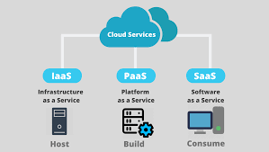

include storage facilities, networks, processing power, and virtual private servers. These are charged under a “pay as you go” model where you are billed by factors such as how much storage you use or the amount of processing power you consume over a certain timespan. In this service model, customers do not need to manage infrastructure, it is up to the provider to guarantee the contracted amount of resources and availability. According to Gartner, this service model is forecasted to grow by 35.9% in 2018[2]. IaaS services offered today, include Google Cloud Platform and Amazon EC2.

***Conclusion :-***

**Conclusion**. **IaaS** provides cost-cutting on IT infrastructure for mid-level to large scale industries. **IaaS** is also known as Cloud storage, where clients store their data on the cloud and can access the data from anyplace.