*Input device &* ***output device….***

DEEPAK BHARDWAJ

007

B.VOC3rdyear (sd)

submitted to:- Sudipti mam

INPUT DEVICES

**Aim:-**Input , output devices &Storage devices.

**Theory:-**Input device enables the user to send data, information, or control signals to a computer. The Central Processing Unit (CPU) of a computer receives the input and processes it to produce the output.

Following are some of the important input devices which are used in a computer −

* Keyboard
* Mouse
* Scanner
* Microphone

1. Keyboard

The [keyboard](https://www.javatpoint.com/computer-shortcut-keys) is a basic input device that is used to enter data into a computer or any other electronic device by pressing keys. It has different sets of keys for letters, numbers, characters, and functions. Keyboards are connected to a computer through [USB](https://www.javatpoint.com/usb-full-form) or a Bluetooth device for wireless communication.



2.Mouse

Mouse is the most popular pointing device. It is a very famous cursor-control device having a small palm size box with a round ball at its base, which senses the movement of the mouse and sends corresponding signals to the CPU when the mouse buttons are pressed.

Generally, it has two buttons called the left and the right button and a wheel is present between the buttons. A mouse can be used to control the position of the cursor on the screen, but it cannot be used to enter text into the computer.

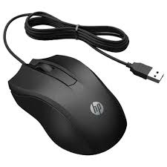

3.Scanner

Scanner is an input device, which works more like a photocopy machine. It is used when some information is available on paper and it is to be transferred to the hard disk of the computer for further manipulation.

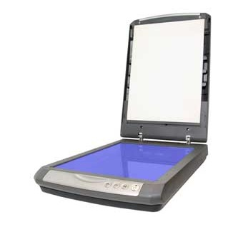

4.Microphone

Microphone is an input device to input sound that is then stored in a digital form.

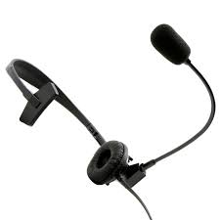

The **microphone** is a device that converts sound waves into electrical signals. **Microphones** use the generator effect to induce a changing current from the pressure variations of sound waves.

OUTPUT DEVICE

An **output device** is any piece of computer hardware equipment which converts information into human-readable form. It can be text, graphics, tactile, audio, and video. Some of the **output devices** are Visual Display Units (VDU) i.e. a Monitor, Printer, Graphic **Output devices**, Plotters, Speakers etc.

## Monitors

Monitors, commonly called as **Visual Display Unit** (VDU), are the main output device of a computer. It forms images from tiny dots, called pixels that are arranged in a rectangular form. The sharpness of the image depends upon the number of pixels.

There are two kinds of viewing screen used for monitors.

* Cathode-Ray Tube (CRT)
* Flat-Panel Display

### Cathode-Ray Tube (CRT) Monitor

The CRT display is made up of small picture elements called pixels. The smaller the pixels, the better the image clarity or resolution. It takes more than one illuminated pixel to form a whole character, such as the letter ‘e’ in the word help.

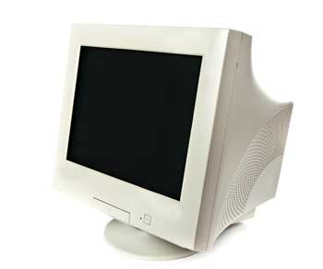

### Flat-Panel Display Monitor

The flat-panel display refers to a class of video devices that have reduced volume, weight and power requirement in comparison to the CRT. You can hang them on walls or wear them on your wrists. Current uses of flat-panel displays include calculators, video games, monitors, laptop computer, and graphics display.

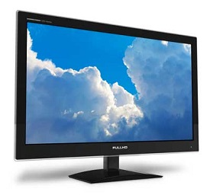

## Printers

Printer is an output device, which is used to print information on paper.

There are two types of printers −

* Impact Printers
* Non-Impact Printers

### Impact Printers

Impact printers print the characters by striking them on the ribbon, which is then pressed on the paper.

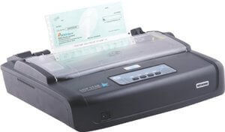

## Non-Impact Printer:

Non-impact printers don't print characters or images by striking a print head or hammer on the ink ribbon placed against the paper.

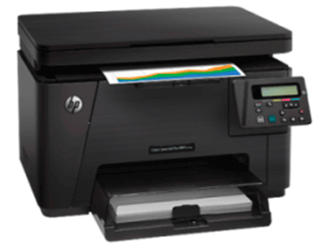

3) Projector

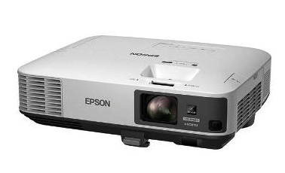

A projector is an output device that enables the user to project the output onto a large surface such as a big screen or wall. It can be connected to a computer and similar devices to project their output onto a screen. It uses light and lenses to produce

STORAGE DEVICE

Computer Storage contains many computer components that are used to store data. It is traditionally divided into primary storage, secondary storage and tertiary storage. Details about these storage types and devices used in them are as follows −

## Primary Storage

Primary storage is also known as the main memory and is the memory directly accessible by the CPU. Some primary storage devices are −

### ROM

ROM is read only memory. This memory cannot be changed, it can only be read as required. Since ROM is unchangeable memory, it is used by data and programs that are frequently required and seldom changed, like the system boot program.

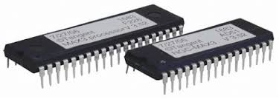

### RAM

RAM is random access memory. It is volatile i.e. the data in RAM is lost when the power is switched off. RAM is the major form of primary memory as it is quite fast. However, it is also quite expensive.

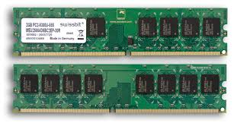

### Cache Memory

Cache is used to store data and instructions that are frequently required by the CPU so it doesn't have to search them in the main memory. This is a small memory that is also very fast.

## Secondary Storage

Secondary or external storage is not directly accessible by the CPU. The data from secondary storage needs to be brought into the primary storage before the CPU can use it. Secondary storage contains a large amount of data permanently .The different types of secondary storage devices are −

### Hard Disk

Hard disks are the most famously used secondary storage devices. They are round, flat pieces of metal covered with magnetic oxide. They are available in many sizes ranging from 1 to 14 inch diameter.

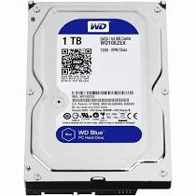

### Flash Drive

This is also known as a pen drive. It helps in easy transportation of data from one system to another. A pen drive is quite compact and comes with various features and designs.

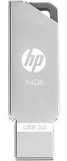

### CD-ROM

This is short for compact disk - read only memory. A CD is a shiny metal disk of silver colour. It is already pre recorded and the data on it cannot be altered. It usually has a storage capacity of 700 MB.

. 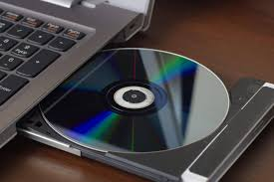

***Conclusion :***-After describing and explaining **input**, **output, and storage devices**, we can see that the utilisation of computer in operations, functions, and processes are based within these **devices**, without just one of them work can't be done.