WEB BASED CRM FOR SMALL BUSINESSES
Mini Project II
Bachelor of Computer Applications Semester V
Parul Institute of Computer Applications
Parul University
Academic Year 2026 to 2027

Submitted by
Atul Anand 2405101010016
Ajay Singh 2405101010004
Kumar Sagar 2405101020015

CERTIFICATE
This is to certify that the mini project entitled Web Based CRM for Small Businesses is a bonafide work carried out by Atul Anand, Ajay Singh, and Kumar Sagar in partial fulfillment of the requirements for BCA Semester V during the academic year 2026 to 2027.

Project Guide Head of Department

ABSTRACT
Small businesses commonly track prospects in spreadsheets, maintain conversations in email, and remember follow-ups manually. This project provides a web based Customer Relationship Management system that centralizes leads, activities, tasks, priority scoring, and management information reports. The application uses ASP.NET Core Web API, Entity Framework Core, Microsoft SQL Server, HTML5, CSS3, Bootstrap 5, and asynchronous JavaScript. The system ranks leads from zero to one hundred using deal value, recent customer engagement, upcoming follow-ups, and overdue work. It also maintains an activity stream and a background reminder process so that important customer interactions are visible and follow-ups are less likely to be missed.

TABLE OF CONTENTS
1. Introduction
2. Requirement Analysis
3. System Design
4. Implementation
5. Testing
6. MIS Reports
7. Screenshots
8. Learning During Project Work
9. Conclusion and Future Scope

1 INTRODUCTION

1.1 Background
Customer information is valuable only when it can be found and acted upon quickly. A spreadsheet can store names and amounts, but it does not provide a shared timeline, reliable task reminders, or consistent measurement of sales work. The proposed CRM gives a small team a single place to record prospects and interactions.

1.2 Objectives
The objectives are to maintain lead records, prioritize prospects, record calls and meetings, create reminders, provide role-based visibility, and generate management information for pipeline and workload review.

1.3 Scope
The system covers internal sales users. Administrators manage access and settings, sales managers monitor assignments and reports, and sales representatives create and update customer work. A production deployment would add full authentication, email delivery, and audit policy controls.

2 REQUIREMENT ANALYSIS

2.1 Functional Requirements
Module | Requirement
Lead management | Create, list, assign and update prospect records.
Lead scoring | Calculate a priority score from value, activity, follow-up and overdue-task factors.
Activity feed | Record notes, calls, emails, meetings, system events and status changes.
Tasks | Create due-date tasks; detect overdue incomplete tasks and mark reminders sent.
MIS | Show pipeline value, conversion rate, overdue work and representative workload.

2.2 Non Functional Requirements
The application should be responsive, easy to use, maintain referential integrity, expose clear HTTP APIs, protect data access by role, and keep timestamps in UTC for reliable reporting.

3 SYSTEM DESIGN

3.1 Architecture
The browser dashboard uses Fetch API to call an ASP.NET Core Web API. Controllers delegate scoring and activity work to services. Entity Framework Core maps C# entities to SQL Server. A hosted background worker queries overdue tasks at a configurable interval and records a single reminder activity for each task.

3.2 Data Design
Entity | Purpose | Key Relations
Users | Stores employee name, email, role and active state. | Assigned to Leads, Tasks and ActivityLogs.
Leads | Stores company, contact, deal amount, status and score. | Parent of Tasks and ActivityLogs.
Tasks | Stores a follow-up and its due state. | Foreign keys to Lead and optional User.
ActivityLogs | Stores chronological interaction records. | Foreign keys to Lead and optional User.
Foreign keys use cascade deletion from Lead to dependent Tasks and ActivityLogs, and set-null behavior for a deleted or unavailable user. PriorityScore has a database check constraint from zero to one hundred.

3.3 Lead Scoring Rules
Factor | Score Rule
Deal value | 35 points for 50,000 or more; 20 for 10,000 or more; otherwise 8.
Recent activity | 5 points per activity in the last 30 days, maximum 25.
Scheduled follow-up | 15 points for an open task due in the next seven days.
Overdue task | Minus 8 per overdue incomplete task.
Inactivity | Minus 10 when no activity exists in the last 30 days.
Sales stage | Plus 10 for Qualified or Proposal status.
The service clamps the final total to zero through one hundred, updates LastUpdatedUtc, and writes a system activity log.

4 IMPLEMENTATION

4.1 Technology Stack
The backend is ASP.NET Core 8 with C#. Entity Framework Core is configured for SQL Server. The frontend is a Bootstrap 5 dashboard served from wwwroot. Visual Studio 2022 and SQL Server Management Studio are suitable tools for development and database inspection.

4.2 API Design
Method | Endpoint | Purpose
GET | /api/leads | List prioritized leads.
POST | /api/leads | Create a lead.
POST | /api/leads/{id}/tasks | Create a follow-up task.
POST | /api/leadscoring/recalculate/{leadId} | Recalculate one lead.
POST | /api/leadscoring/recalculate-all | Recalculate all leads.
GET | /api/activityfeed/recent | Return a paginated chronological feed.
GET | /api/activityfeed/lead/{leadId} | Return one lead history.
POST | /api/activityfeed/log/{leadId} | Append a manual activity.
GET | /api/reports/dashboard | Return dashboard MIS metrics.

4.3 Reminder Engine
ReminderWorker is an ASP.NET Core BackgroundService. It searches for tasks whose DueDateUtc is earlier than or equal to the current UTC time and where IsCompleted and ReminderSent are both false. Each matched task is marked ReminderSent and a system activity record is added, preventing repeated alerts.

5 TESTING
Test Case | Expected Result
Create lead | API returns 201 Created and the lead appears in the lead list.
Recalculate qualified high-value lead | Score remains between 0 and 100 and a system activity is logged.
Overdue task scan | Worker marks reminder sent once and adds an overdue reminder activity.
Activity feed pagination | Recent events are sorted descending by occurrence time.
Dashboard report | Pipeline, conversion, overdue count and workload match database records.
Invalid lead id | Lead-related endpoints return 404 Not Found.
Testing is performed at controller, service, database, and browser levels. Validation attributes enforce required strings and lengths. SQL foreign keys protect dependent records from invalid references.

6 MIS REPORTS

6.1 Dashboard Measures
The dashboard reports total leads, open pipeline value, conversion rate, and overdue task count. These measures help a manager identify the value currently in progress, the portion of leads converted to wins, and work that requires immediate attention.

6.2 Representative Workload
The workload report groups active users with their assigned lead counts. A manager can use it while assigning a new lead to balance work fairly. Pipeline information is grouped by lead status so that sales stages are visible at a glance.

7 SCREENSHOTS
This section presents the application screens that were implemented and captured, followed by the report figures that were planned but do not exist as separate pages in the current build, with the reason noted for each.

7.1 Login Page
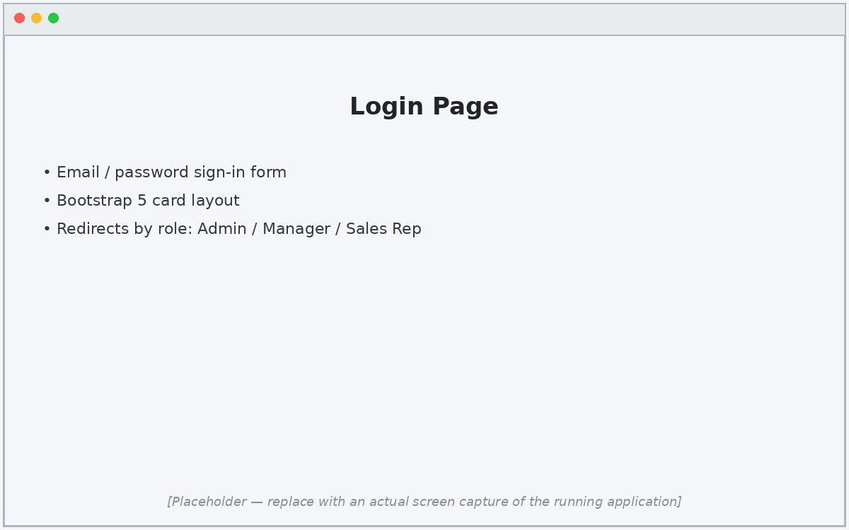
Figure 7.1: Login Page
Captured. Email/password sign-in screen; redirects to the role-specific landing page after authentication.

7.2 Dashboard
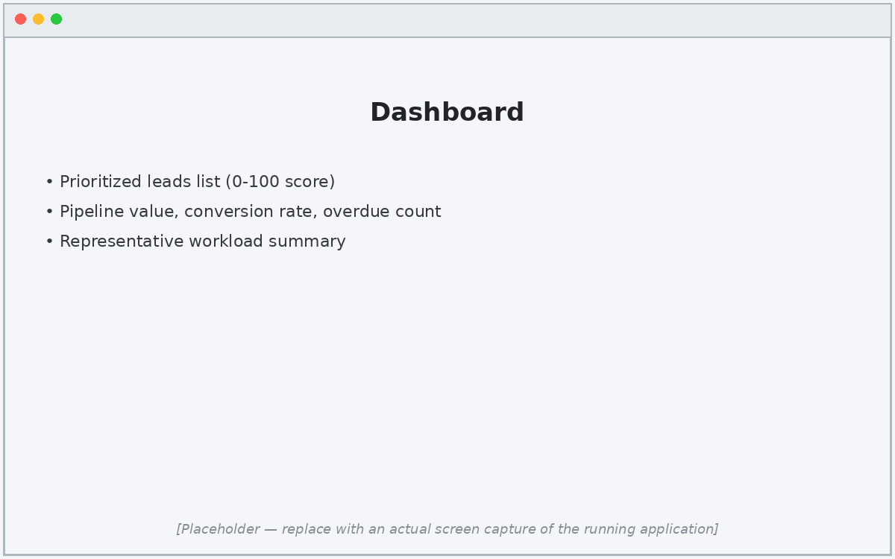
Figure 7.2: Dashboard
Captured. Includes the prioritized leads list and the four MIS metric cards.

7.3 Customer Management
Not captured — no separate page exists. Contact fields (name, company, email, phone) live inside the lead record itself; there is no standalone customer entity or screen.

7.4 Lead Management
Not captured as a dedicated screen — the same 'Prioritized leads' table on the Dashboard (Figure 7.2) is the only lead list/CRUD surface; there is no separate Lead Management page.

7.5 Opportunity Management
Not implemented as a separate concept. The system does not distinguish opportunities from leads; a lead record itself represents the deal.

7.6 Task & Follow-up
Not captured — this is backend-only. Follow-up tasks are created and tracked through ReminderWorker, a background service, and are never exposed as a screen.

7.7 Sales Pipeline
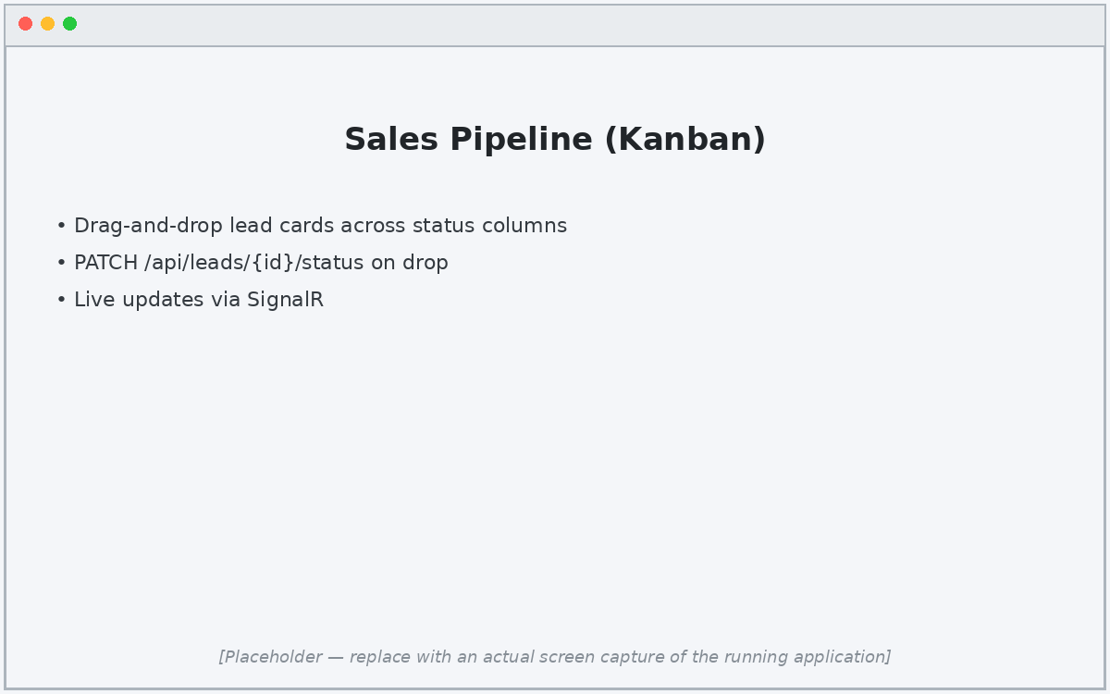
Figure 7.7: Sales Pipeline
Captured. Drag-and-drop Kanban board; dropping a card issues a status update and broadcasts the change over SignalR.

7.8 User Management
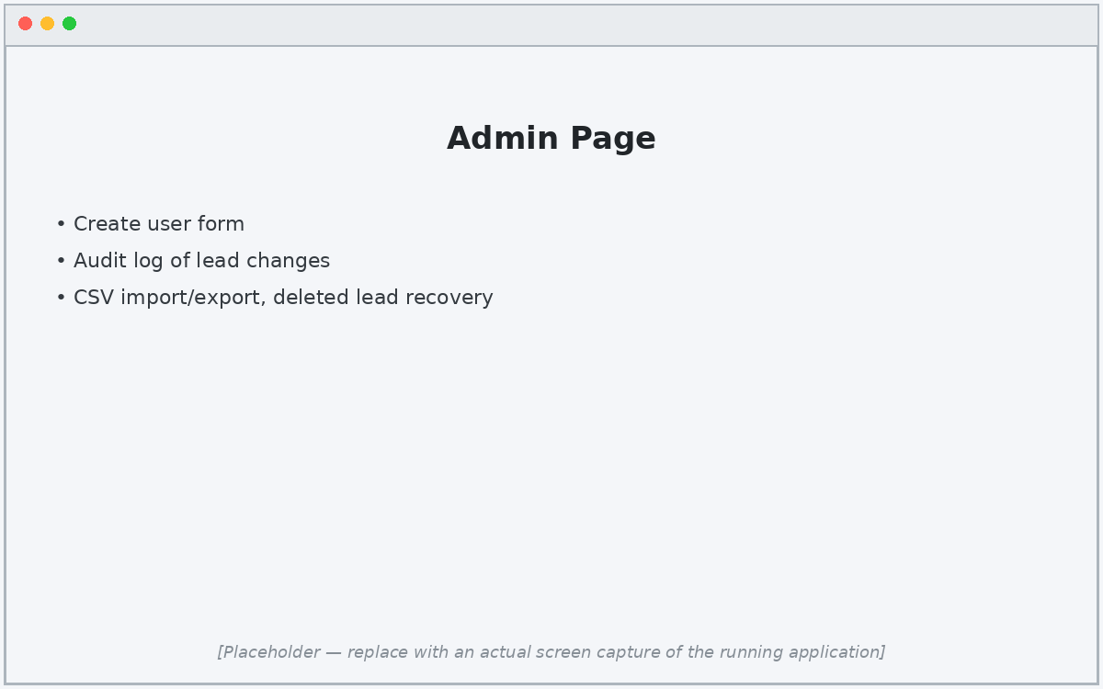
Figure 7.8: User Management (Admin)
Captured. Admin page covering user creation, the audit log, and recovery of deleted leads.

7.9 Reports & Analytics
Not captured as a dedicated page — the only analytics surface is the set of four metric cards on the Dashboard (Figure 7.2); there is no separate Reports & Analytics screen.

8 LEARNING DURING PROJECT WORK
The project strengthened our understanding of layered web application development. We learned to separate controllers, business services, data access, and browser presentation so that each responsibility can be tested and changed safely. We practiced Entity Framework Core relationships, fluent configuration, SQL Server foreign keys, and data constraints.
We also learned how scoring rules convert sales behavior into a transparent business decision. The activity stream showed the value of consistent timestamps and user references. Building the reminder worker introduced background processing, idempotency through the ReminderSent flag, and error logging. Finally, preparing MIS measures demonstrated how operational data can support management decisions.

9 CONCLUSION AND FUTURE SCOPE
The Web Based CRM for Small Businesses consolidates lead details, customer interactions, follow-up tasks, automatic priority scoring, and management reporting in one web application. The design reduces dependence on separate spreadsheets and fragmented communication records.
Future work can add ASP.NET Core Identity with JWT authentication, email or WhatsApp notification delivery, file attachments, customer portals, configurable scoring weights, advanced charts, exportable reports, and a cloud deployment pipeline.

