Bank WebApp

Need of system
Conventional method of bank transactions can be a tedious work for the bank empoyee. This system eases the work of bank employees to do transactions and maintain data.

Requirement Specification
- Node JS
- Express
- MongoDB
- React JS

Literature Survey

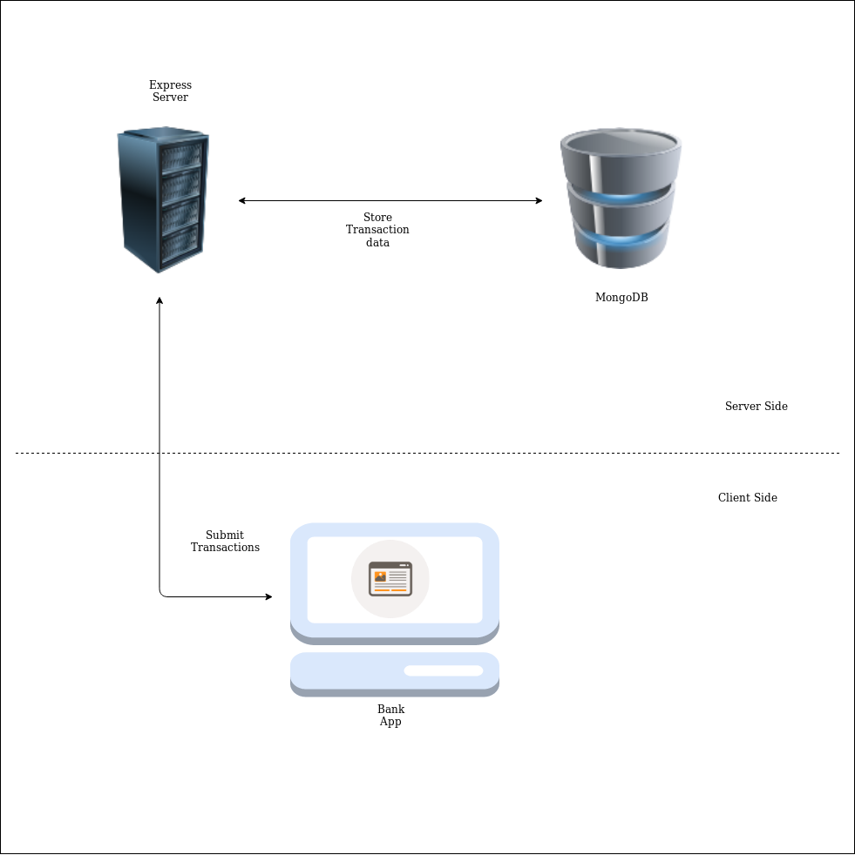
Architecture Diagram

Implementation Details

MongoDB Schema
const BankSchema = new Schema({
AccNo: {
type: Number,
required: true,
unique: true
},
Name: {
type: String,
required: true
},
Balance: {
type: Number,
// default: 0.0
required: true
},
date: {
type: Date,
default: Date.now
}
});

Create new Bank Account holder

router.post('/', (req, res) => {
const newUser = new users({
Name: req.body.Name,
AccNo: req.body.AccNo,
Balance: req.body.Balance
});
newUser.save().then(users => res.json(users));
});

Credit Amount
router.post('/update', (req, res) => {
const filter = { AccNo : req.body.AccNo };
const update = {$inc: {Balance: req.body.Balance }};

users.countDocuments(filter);

users.findOneAndUpdate(filter, update, {
new: true,
upsert: false,
useFindAndModify: false
})
.then(users => res.json(users));
})

Debit Amount
router.post('/debit', (req, res) => {
const filter = { AccNo : req.body.AccNo,Balance: {$gte: req.body.Balance} };
const update = {$inc: {Balance: -req.body.Balance }};

users.countDocuments(filter);

users.findOneAndUpdate(filter, update, {
new: true,
upsert: false,
useFindAndModify: false
})
.then(users => res.json(users));
})

