

WebApp for Bank Employees

Project submitted by,

Ajay S

(2018202003)

MCA II year

1.Objective
To ease the work of bank employees to do transactions and maintain data online.

2.Need for the system
The conventional method of bank transactions using paperwork can be a tedious task for the bank employees. This system helps to maintain data online and aids in data maintainability and also speeds up the transaction process, thus reducing the time and work for the bank employees. This system will lead to faster work and better customer satisfaction.

3.Requirement Specification
- Node JS
- Express
- MongoDB
- React JS
- Material UI

4.WebApp System Architecture
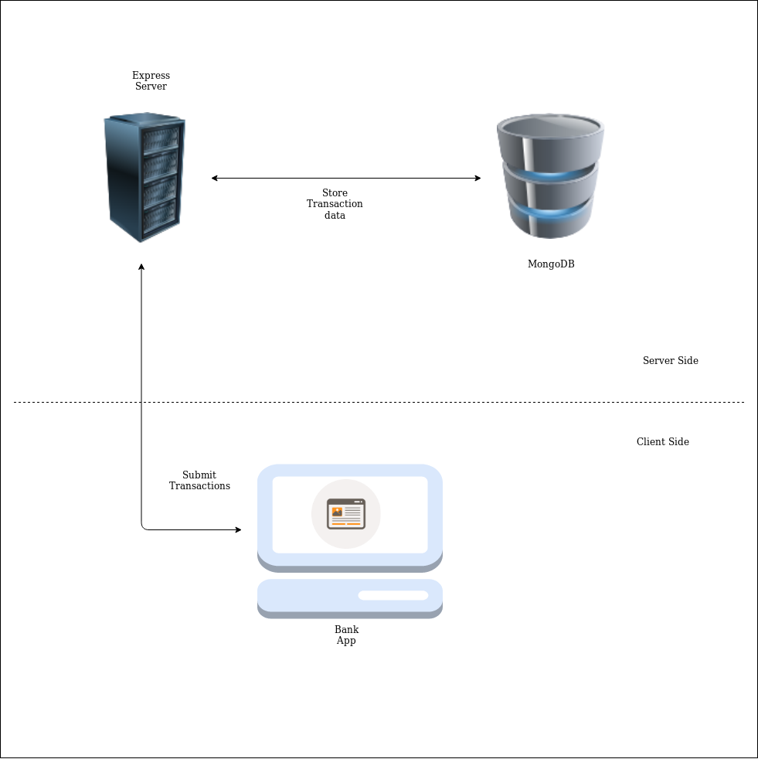
Figure 1
The client-side app will provide the interface to submit transactions like add new account, debit amount and credit amount. The transactions will be posted to the Express REST API¹ server created with Express(JS) and the Express REST API¹ will post the successful transaction data into the MongoDB along with that success message will be passed to the client and in case of erroneous transaction, the error message will be sent back to the client.

5.Implementation Details

MongoDB Schema⁴
const BankSchema = new Schema({
AccNo: {
type: Number,
required: true,
unique: true
},
Name: {
type: String,
required: true
},
Balance: {
type: Number,
// default: 0.0
required: true
},
date: {
type: Date,
default: Date.now
}
});

This represents the schema of the database. It contains the account number, name of account holder, account balance along with the timestamp of account creation

Create new Bank Account holder³

router.post('/', (req, res) => {
const newUser = new users({
Name: req.body.Name,
AccNo: req.body.AccNo,
Balance: req.body.Balance
});
newUser.save().then(users => res.json(users));
});

This is the route of REST API through which a new user can be created. The client app will post the data as request to this API endpoint which will create a new instance of account in database

Credit Amount³
router.post('/update', (req, res) => {
const filter = { AccNo : req.body.AccNo };
const update = {$inc: {Balance: req.body.Balance }};

users.countDocuments(filter);

users.findOneAndUpdate(filter, update, {
new: true,
upsert: false,
useFindAndModify: false
})
.then(users => res.json(users));
})

This is the route of REST API through which the amount can be credited to an existing account. The client app will post the data as a request to this API endpoint which will update the balance amount of the specified account number.

Debit Amount³
router.post('/debit', (req, res) => {
const filter = { AccNo : req.body.AccNo,Balance: {$gte: req.body.Balance} };
const update = {$inc: {Balance: -req.body.Balance }};

users.countDocuments(filter);

users.findOneAndUpdate(filter, update, {
new: true,
upsert: false,
useFindAndModify: false
})
.then(users => res.json(users));
})

This is the route of REST API through which the amount can be debited from an existing account. The client app will post the data as a request to this API endpoint which will deduct the amount from the current balance if sufficient balance is available in the specified account or else an error message will be returned to the client.

6.Results

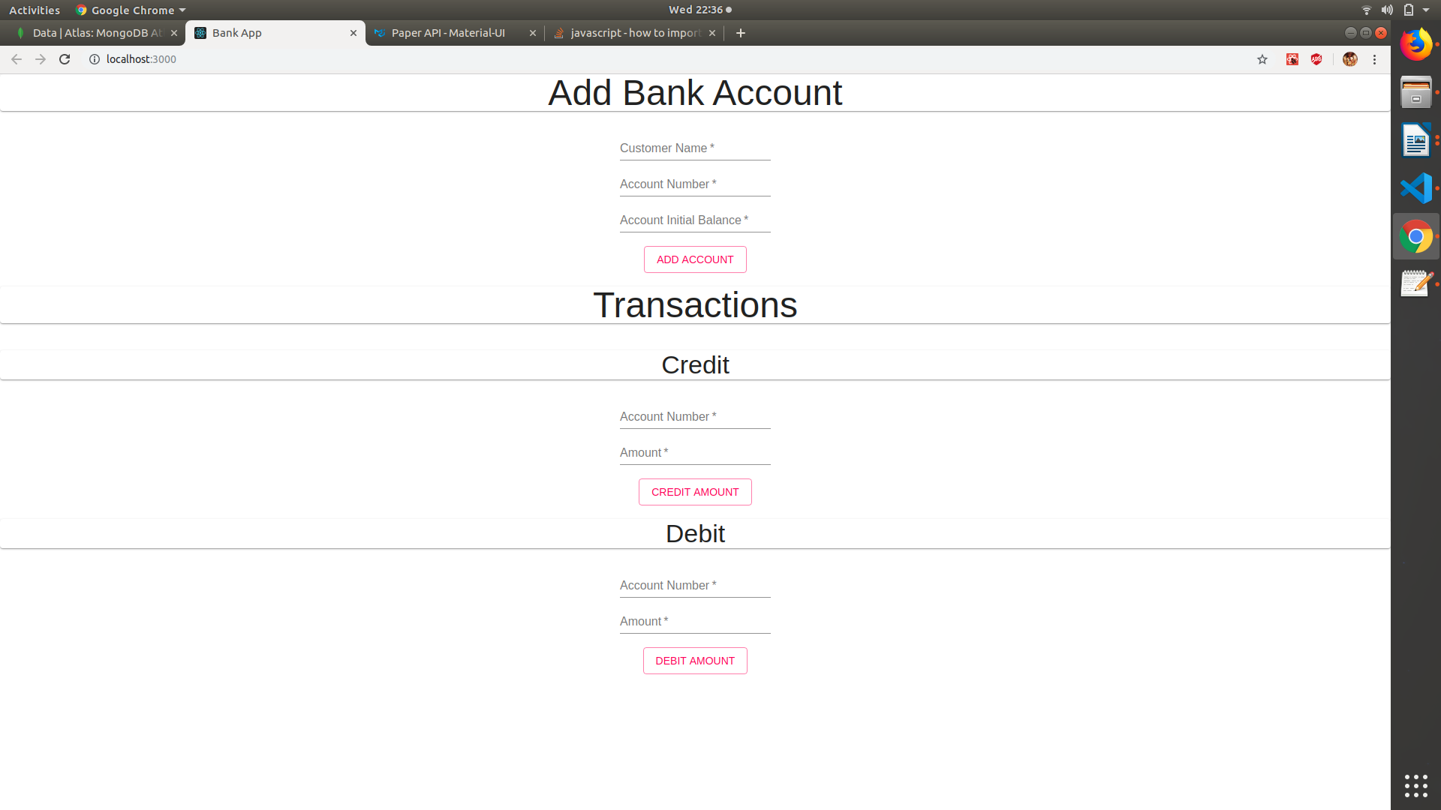
Add Account

Transactions

Material-UI components are used for design. Typography⁵ is used for headings, TextField⁵ is used to get user input, Button⁵ of type “outlined” and “secondary” as color is used to submit transactions.

7.References
- https://www.youtube.com/channel/UC29ju8bIPH5as8OGnQzwJyA
- https://www.traversymedia.com/
- https://expressjs.com/en/api.html
- https://docs.atlas.mongodb.com/getting-started/
- https://material-ui.com/

