




























Government Raja Mirasudhar Hospital,

Human Institute Ethical Committee,

Respected Sir,

I Dr.G.Venikaviya ,working as a Post graduate in the department of Obstetrics

.Self declaration






















Government Raja Mirasudhar Hospital, Thanjavur


INTRODUCTION
Fetal growth restriction is, despite advances in neonatal care and uptake of antenatal ultrasound scanning, still a major cause of perinatal morbidity. Neonates with birth weight> 10th percentile are assumed to be appropriate-for-gestational-age (AGA), although many are at increased risk of perinatal morbidity, because of undetected mild restriction of growth potential.
One of the most important risk factors for stillbirth is fetal growth restriction. In many cases, Fetal growth restriction reflects placental insufficiency, where the placenta is functioning sub-optimally in its role to supply oxygen and nutrients , the fetus fails to maintain adequate growth in utero, and is unable to reach its biological growth potential. While being small-for-gestational-age due to placental insufficiency is a major risk factor for stillbirth, stillbirths also occur in appropriate-for-gestational-age (AGA, > 10th centile) fetuses. AGA fetuses are plausibly also at risk of stillbirth if placental insufficiency is present. Such fetuses may be expected to demonstrate declining growth trajectory across pregnancy, although they do not fall below the 10th centile before birth.

AIM AND OBJECTIVES
- To determine if reduced growth velocity in AGA fetuses is linked to placental insufficiency indicators and whether these fetuses might be at an increased risk of adverse outcomes, similar to SGA fetuses.
- To analyse Fetal outcome of AGA fetuses with reduced growth velocity

JUSTIFICATION FOR THE CONDUCT OF STUDY:
- By intensely monitoring the growth velocity of the AGA fetuses antenatally , the effects and risks of placental insufficiency like still birth could be reduced and can be managed with planned delivery at term.
- This research emphasizes the need to consider growth velocity as acrucial parameter in prenatal care especially for fetuses not traditionally categorized as at risk due to their birth weight percentile

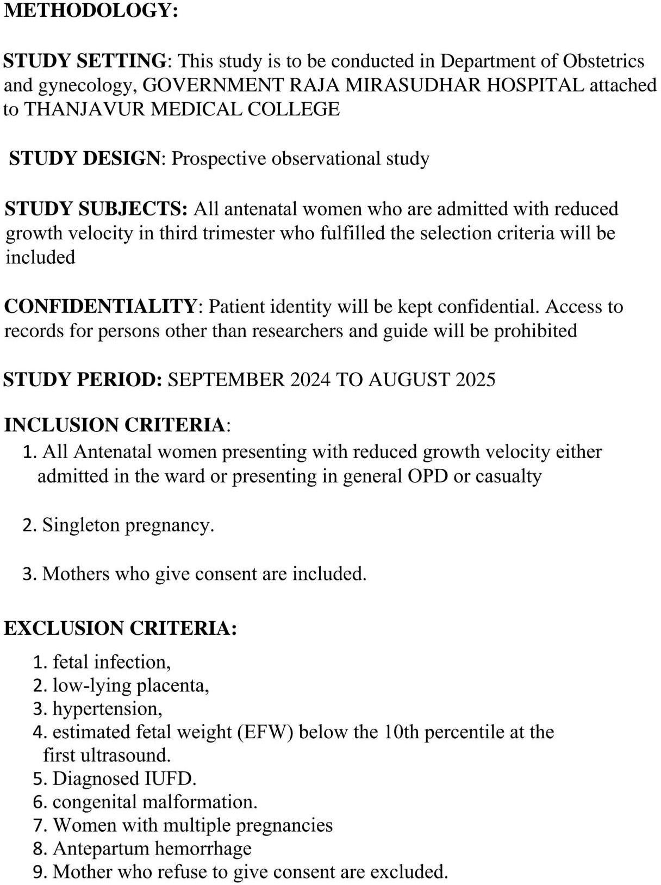

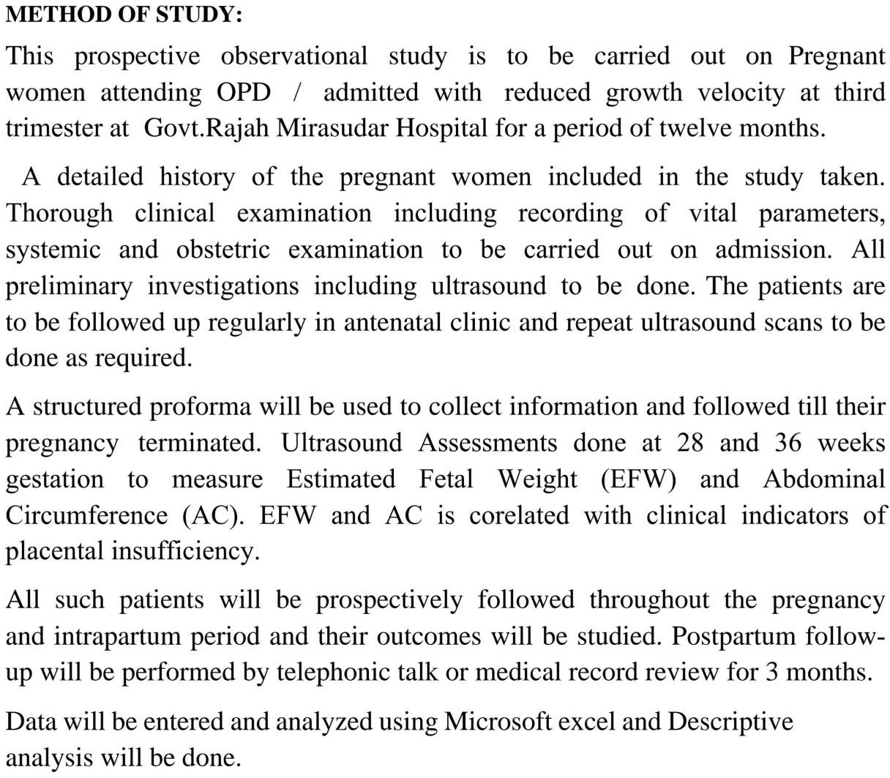

Gestational Age:
Previous type of deliveries:

Regular/Irregular cycles:

Tobacco chewing: H/0 Antenatal steroids:
Obesity



















Preterm labour o

Height:

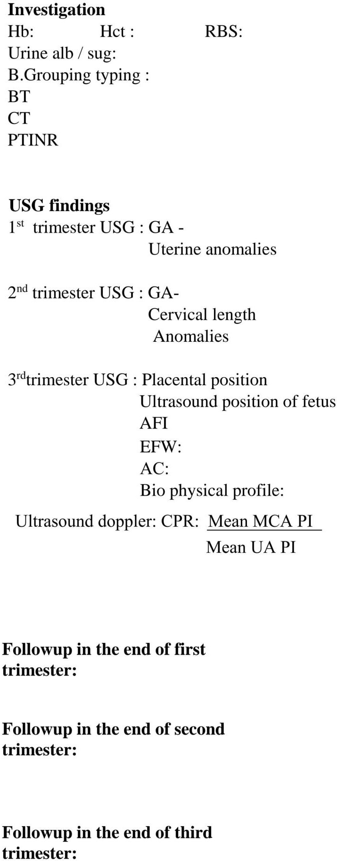









Doppler study

Induction details
Mode of delivery(vaginal,cesarean,instrumental)







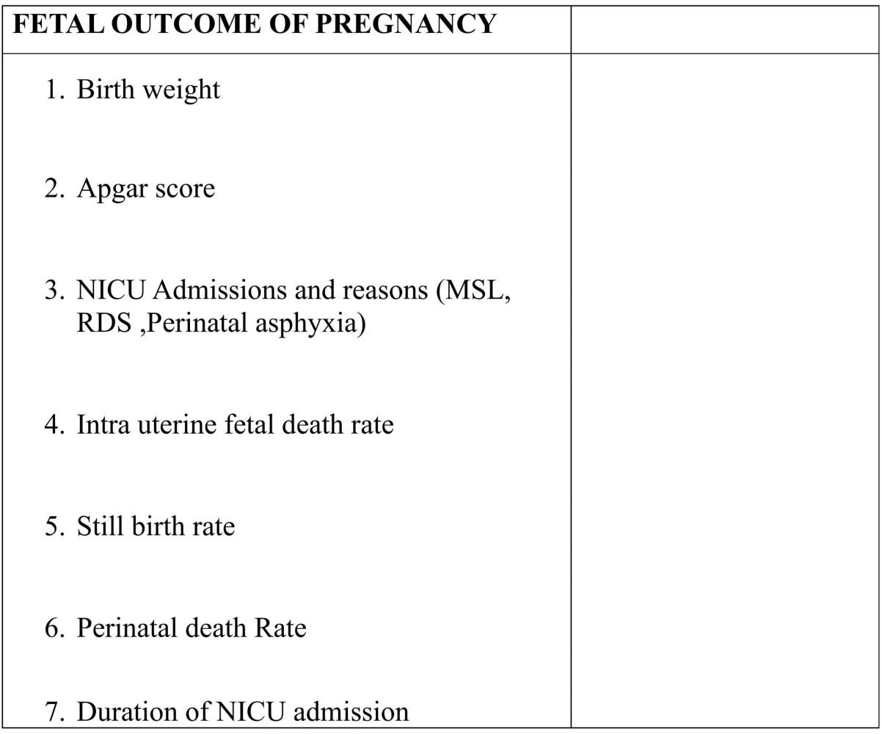





























Prospective







