

DISTRIBUTED SYSTEMS (CSE -3261) MINI PROJECT REPORT ON

Distributed Implementation of
Clock Synchronization Algorithms

SUBMITTED TO
Department of Computer Science & Engineering

by

Name | Registration  Number | Roll Number | Semester | Section
Shyam Sundar Bharathi S | 200905302 | 53 | VI | B
Parv Jain | 200905316 | 56 | VI | B
Ajay Rajendra Kumar | 200905390 | 61 | VI | B
Ryan Sojan | 200905396 | 64 | VI | B

Name & Signature of Evaluator 1 Name & Signature of Evaluator 2

(Jan 2023 – May 2023)
Table of Contents
 |  |  |  | Page No
Chapter 1 |  |  | INTRODUCTION
 | 1.1 | Introduction |  | 3
 | 1.2 | Motivation |  | 4
Chapter 2 |  |  | BACKGROUND THEORY | 5
Chapter 3 |  |  | METHODOLOGY | 6
Chapter 4 |  |  | RESULTS AND DISCUSSION
 | 4.1 | Results |  | 8
 | 4.2 | Discussions |  | 10
Chapter 5 |  |  | CONCLUSIONS AND FUTURE ENHANCEMENTS
 | 5.1 | Conclusions |  | 11
 | 5.2 | Future Enhancements |  | 11
 |  |  |  | 12
  Chapter 6 | REFERENCES

CHAPTER 1: INTRODUCTION
  - Introduction
Clock synchronization algorithms are used to synchronize the clocks of multiple devices or systems to a common time reference. In distributed systems, different devices may have slightly different clock speeds or may experience varying network latencies, which can cause inconsistencies in timestamping events and data. This can lead to incorrect sequencing of events, which can cause errors in the system. Therefore, clock synchronization is essential to ensure the correctness of distributed systems.

The Berkeley algorithm is a centralized algorithm that relies on a central time server to distribute time to other machines in the network. Each machine periodically sends its own clock time to the time server, and the time server calculates the average time among all machines and sends it back to each machine to adjust its clock accordingly. This algorithm is relatively simple and easy to implement, but it relies on a centralized time server and can be vulnerable to network outages or server failures.
The Lamport algorithm is a logical clock synchronization algorithm developed by computer scientist Leslie Lamport. In this algorithm, each device has its own logical clock that is incremented for every event that occurs on that device. When two devices communicate, the device with the lower clock value adjusts its clock to the higher value. This algorithm does not require a centralized time server and can handle network delays, but it assumes that events are completely ordered and may not work well in cases where there are causal relationships between events.
The Christian algorithm is a clock synchronization algorithm based on the Network Time Protocol (NTP), which uses a hierarchical system of time servers to synchronize clocks. The algorithm works by measuring the round-trip time between a client and a server and adjusting the client's clock based on the time difference. This algorithm is highly accurate and can handle network delays and disruptions, but it requires a reliable network connection and may not be suitable for systems with strict security requirements.

  - Motivation
The motivation behind developing clock synchronization algorithms is to ensure that different devices or systems have a common time reference for accurate timestamping of events and coordination of tasks. In many real-world applications, such as distributed systems, financial transactions, and industrial automation, accurate time synchronization is critical for maintaining consistency and integrity of data, avoiding conflicts and errors, and ensuring the proper functioning of the system. Clock synchronization algorithms aim to reduce clock drift and offset caused by various factors, such as hardware imprecision, network delays, and clock skew, and to maintain a common time base for all devices in the system. By achieving accurate clock synchronization, these algorithms enable efficient and reliable communication and coordination among different components, leading to improved performance, productivity, and user experience.

Chapter 2: BACKGROUND THEORY
Clock synchronization algorithms aim to ensure that different devices or systems have a common time reference, despite variations and drifts in their local clocks. The basic principle of clock synchronization is to exchange clock information between devices and adjust their clocks, accordingly, using various techniques and protocols.

One of the earliest clock synchronization algorithms is the Network Time Protocol (NTP), developed in the 1980s, which uses a hierarchical system of time servers to synchronize clocks over the internet. NTP employs a combination of polling and filtering techniques to estimate the offset and delay between clocks and adjust them to the most accurate source.

Another well-known algorithm is the Berkeley algorithm, proposed by Mills in 1989, which uses a central time server to distribute time to other machines in the network. Each machine periodically sends its own clock time to the time server, and the time server calculates the average time among all machines and sends it back to each machine to adjust its clock accordingly.

The Lamport algorithm, developed by Leslie Lamport in 1978, is a logical clock synchronization algorithm that assigns a unique logical timestamp to each event in the system, based on the causality relationship between events. This algorithm does not rely on a central server and can handle network delays and disruptions, but it assumes that events are completely ordered and may not work well in cases where there are causal relationships between events.

Other clock synchronization algorithms include the Precision Time Protocol (PTP), which is designed for high-precision synchronization in industrial and measurement applications, and the Global Positioning System (GPS) synchronization, which uses satellite signals to synchronize clocks in a geographic area.

Chapter 3: METHODOLOGY
Berkeley Algorithm: -
The Berkeley algorithm is a centralized clock synchronization algorithm that uses a central time server to distribute time to other machines in the network. Each machine periodically sends its own clock time to the time server, and the time server calculates the average time among all machines and sends it back to each machine to adjust its clock accordingly. This algorithm requires a reliable network connection to the time server and assumes that the time server is highly accurate. The method involves sending messages from each machine to the time server, calculating the average time, and distributing the adjusted time back to the machines. The method is relatively simple and easy to implement but is vulnerable to network outages or server failures.

Christian Algorithm: -
The Christian clock synchronization algorithm is a method for synchronizing the clocks of computers on a network. To implement this algorithm, the first step is to select a server that will act as the time reference for the network. Next, the Christian clock synchronization software should be installed on each computer that needs to be synchronized, and then configured to use the chosen server as the time reference. The software will periodically synchronize the clock on each computer with the server, ensuring that all clocks are kept accurate. It is important to monitor the synchronization process to ensure that all computers on the network are synchronized and that there are no errors or discrepancies. By following this methodology, the Christian clock synchronization algorithm can help ensure that all computers on a network are synchronized, allowing for accurate timekeeping and improved network performance.

Lamport Algorithm: -
Lamport clock synchronization algorithm is a technique used to order events in a distributed system. The algorithm was proposed by Leslie Lamport in 1978. In this algorithm, each process maintains a logical clock, which is updated whenever an event occurs. An event can be a process receiving a message, sending a message, or performing a local computation.

To synchronize the clocks, whenever a process sends a message, it includes its current logical clock value in the message. When a process receives a message, it updates its logical clock to be the maximum of its current value and the value in the received message plus one. This ensures that the logical clocks of different processes always move forward, and events are ordered correctly.

By using this algorithm, we can order events in a distributed system even if the events occur concurrently at different processes. The algorithm is simple and efficient, but it does not guarantee that the clocks will be perfectly synchronized, as clock drift can still occur.

Chapter 4: RESULTS & DISCUSSIONS
4.1 Results
Lamport Algorithm
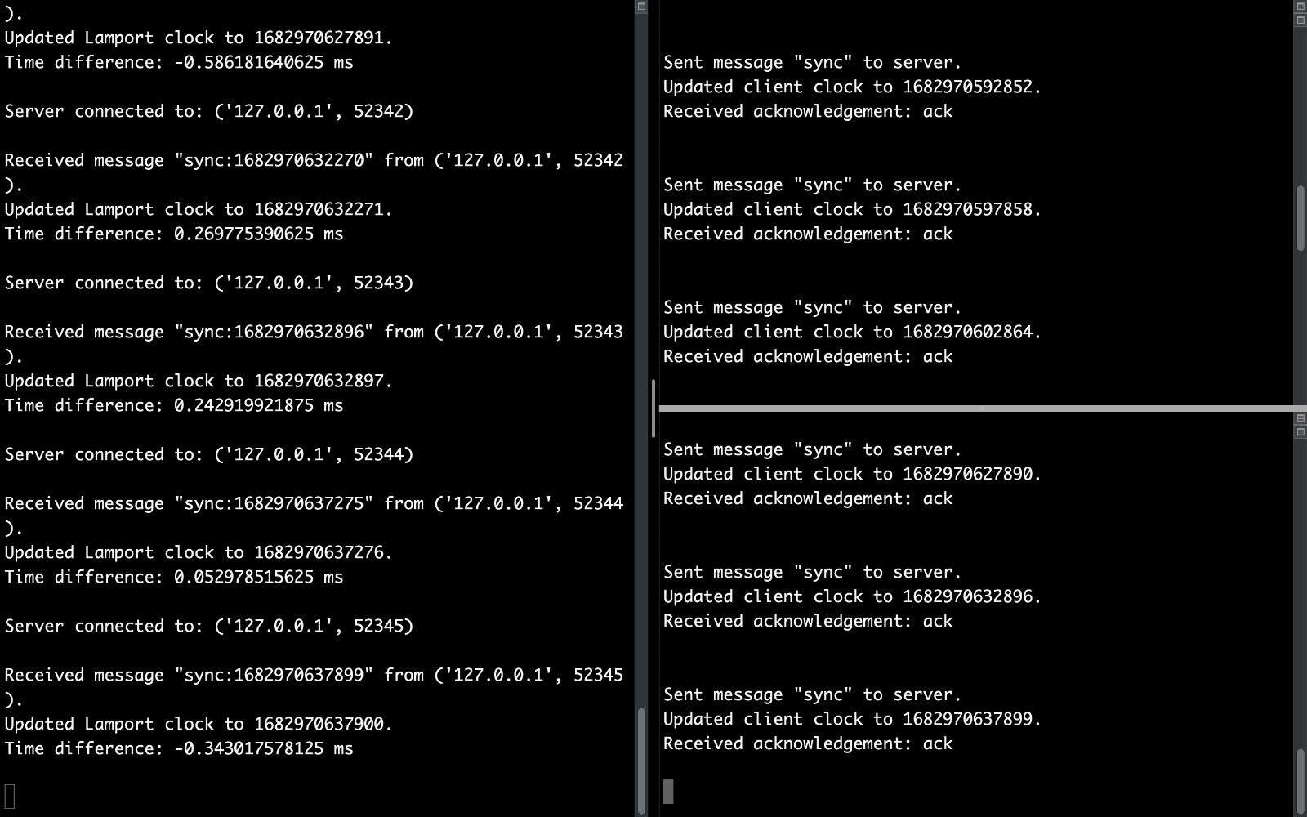

Berkeley Algorithm
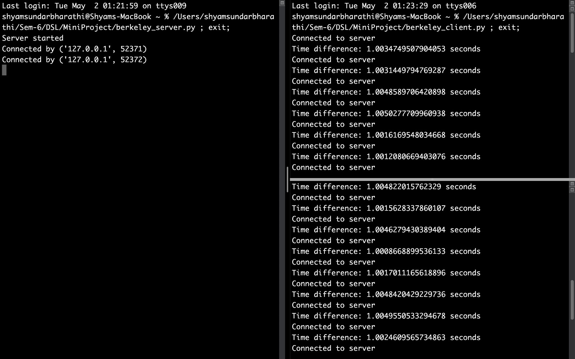

Christian Algorithm
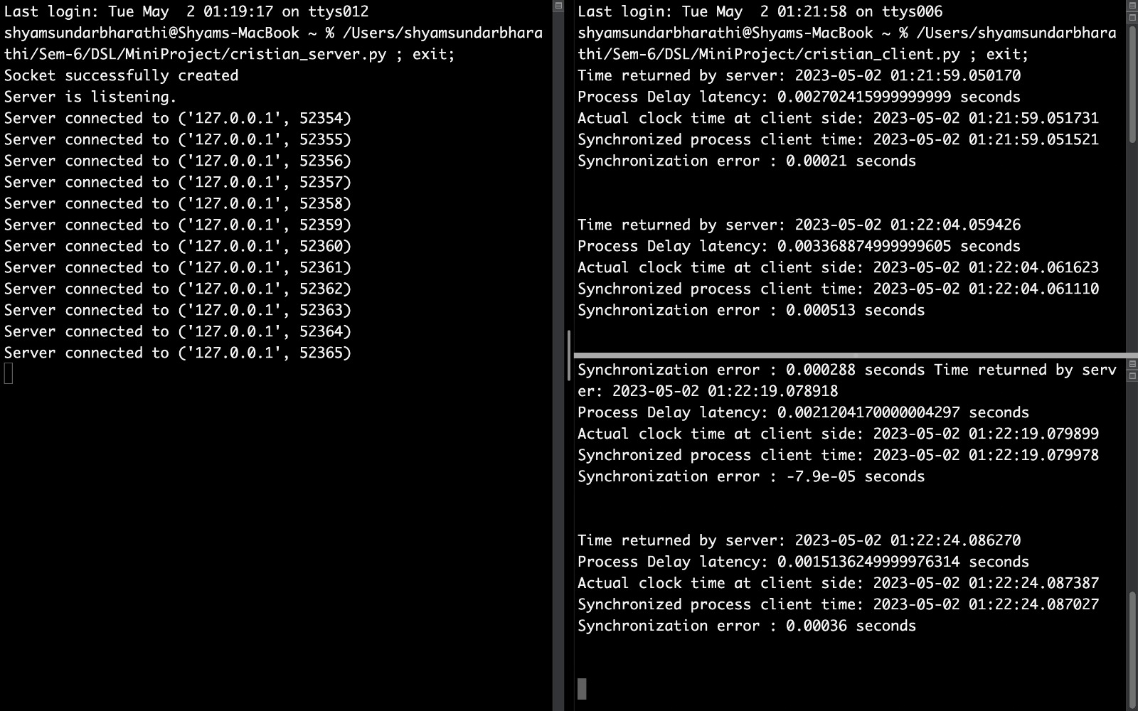
4.2 Discussions
Discussions on clock synchronization algorithms often focus on the trade-offs between accuracy, reliability, and complexity, as well as the specific requirements and constraints of the system in question. Some common topics of discussion include the choice between centralized and distributed algorithms, the impact of network delays and disruptions, the use of logical clocks versus physical clocks, and the integration of security mechanisms.
Another important topic of discussion is the evaluation and comparison of different clock synchronization algorithms, which may involve benchmarking, simulation, or empirical testing. Metrics such as clock accuracy, convergence time, overhead, and scalability are often used to evaluate the performance of different algorithms under various conditions.
Finally, discussions on clock synchronization algorithms may also involve the development of new algorithms or improvements to existing ones.

Chapter 5: CONCLUSIONS & FUTURE ENHANCEMENTS
5.1 Conclusions
In conclusion, clock synchronization algorithms play a crucial role in distributed systems, where multiple processes communicate and execute tasks concurrently. These algorithms enable us to order events correctly, ensuring consistency and coherence of the system. The Lamport clock synchronization algorithm, proposed by Leslie Lamport in 1978, is a fundamental technique used in many modern systems. This algorithm uses logical clocks to synchronize the clocks of different processes, ensuring that events are ordered correctly. While this algorithm is efficient and simple to implement, it does not guarantee perfect synchronization, as clock drift can still occur. Overall, clock synchronization algorithms are essential for the efficient and reliable functioning of distributed systems.

5.2 Future Enhancements
Clock synchronization algorithms are crucial for ensuring consistency and coherence in distributed systems where multiple processes communicate and execute tasks concurrently. The Lamport clock synchronization algorithm, proposed by Leslie Lamport in 1978, uses logical clocks to synchronize the clocks of different processes, ensuring that events are ordered correctly. While the Lamport algorithm is simple and efficient, there are several future enhancements that can improve its accuracy, reliability, and security. These enhancements include hybrid clock synchronization algorithms, adaptive clock synchronization, fault-tolerant clock synchronization, blockchain-based clock synchronization, and quantum clock synchronization. These enhancements can make clock synchronization algorithms more suitable for modern distributed systems, providing better accuracy, reliability, and security.

Chapter 6: References
- https://www.geeksforgeeks.org/synchronization-in-distributed-systems/
- https://www.tutorialspoint.com/index.html
- https://en.wikipedia.org/wiki/Clock_synchronization
- https://www.thecode11.com/2022/06/clock-synchronization-in-distributed-system.html

