 | COURIER TRACKING SYSTEM  Technical Design Document
 | Prepared By / Last Updated By | Reviewed By | Approved By
Name
Role
Signature
Date

Table of Contents

1.0 Introduction 3
1.1 Purpose of this document 3
1.2 Project overview 3
2.0 Solution Summary 3
2.1 Scope 3
2.2 Assumptions 3
2.3 Dependencies 3
2.4 Risks 3
3.0 Schematic Diagram 3
4.0 System Design 4
4.1 Proposed design 4
4.2 Component inventory 4
5.0 Database Design 4
5.1 Data Model 4
5.2 Tables Structure 4
6.0 Appendices 4
6.1 Glossary 4
6.2 Other 5
7.0 Terms & Conditions 5
8.0 Change Log 5

Introduction

Purpose of this document
The purpose of this document is to document the technical design, component details and Database design. This will also capture the scope, assumptions, risk, dependencies of this project.

Project overview
To create a courier tracking web application using spring – a java framework.

Solution Summary

Scope
The system is being used in day to day activities such as booking a courier, tracking a courier etc. It is a computerized approach for better and clear view about the parcel we are sending through courier service.

Assumptions
The basic assumption of the project is to track the courier.

Dependencies
Courier tracking system depends upon factors such as weight of the parcel, distance from sender address to deliver address for calculating cost.

Risks
This project limits users to register parcel which is above 25 kg.

Schematic Diagram
A schematic, or schematic diagram, is a representation of the elements of a system using abstract, graphic symbols rather than realistic pictures. It gives an overview of overall system
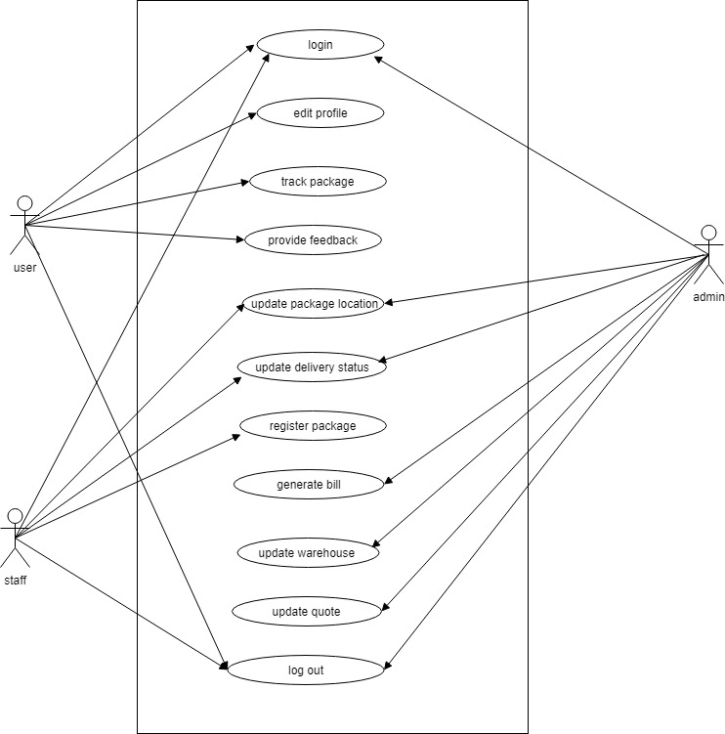

System Design

Proposed design
This web application has three types of users. Admin, Staff, Customer. Admin is responsible for accepting registrations enrolled by staffs and users. The parcel given by the user is registered by the admin/staff and the cost of the parcel is calculated by the system automatically.After registering the parcel, user can track where his parcel is using this application. For this, he needs to provide his parcel’s id which is unique. The location of the parcel and the date when it arrived there will be updated by the staff as well as the admin. Once the parcel is delivered, the staff/admin will update the status as delivered and after delivery, when user tries to track his parcel it will show as delivered.

Component inventory
The components used in this project are STS (spring tool suite), MYSQL.

Database Design

Data Model
Database name: courier
Tables used:
Register,
User roles,
Package,
Quote,
Warehouse
Offers.

Tables Structure
Register
Column Name | Data Type | Length | Nulls
id | Integer | 11 | No
Firstname | Varchar | 20 | no
Lastname | Varchar | 20 | no
Gender | Varchar | 10 | no
Username | Varchar | 20 | No
Email id | Varchar | 50 | No
Phoneno | Varchar | 10 | No
Password | Varchar | 8 | No
Secretquestion | Varchar | 50 | No
Secretanswer | Varchar | 50 | no

Userroles
Column Name | Data Type | Length | Nulls
id | Integer | 11 | No
Role | Varchar | 10 | no

Package
Column Name | Data Type | Length | Nulls
pid | Integer | 11 | No
Acceptdate | Date |  | no
Weight | Double |  | No
Cost | Double |  | No
Senderaddress | Varchar | 100 | No
Receiveraddress | Varchar | 100 | No
Customerid | Integer | 11 | No
Employeeid | Integer | 11 | No
Status | Varchar | 10 | no

Quote
Column Name | Data Type | Length | Nulls
Weight | varchar | 11 | No
distance | double |  | No
Cost of transport | Double |  | No
Parcel type | Varchar | 30 | no

Warehouse
Column Name | Data Type | Length | Nulls
Branch id | Integer | 3 | No
Branch name | Varchar | 20 | No
Branch location | varchar | 20 | No
Contact number | Varchar | 10 | no

Offers
Column Name | Data Type | Length | Nulls
Offer price | Varchar | 20 | No
Offer discount | Varchar | 20 | no

Appendices

Glossary
Acronyms | Definitions

Other

Terms & Conditions
Disclaimer: Please do not circulate or distribute this document outside of Cognizant Network, We have a Zero Tolerance Policy. Kindly adhere to 100% Compliance at all times.

Change Log
Please note that this table needs to be maintained even if a Configuration Management tool is used.
Version Number | Changes made
V<n.n> | <If the change details are not explicitly documented in the table below, reference should be provided here>
V<n.n> | Page no | Changed by | Effective date | Changes effected

