Scenario:
Imagine you're working for a museum with numerous exhibits connected by hallways. You need to
create a program to help visitors plan the most efficient tour based on their interests.
Problem Statement 1: Building the Museum Layout (Graph)
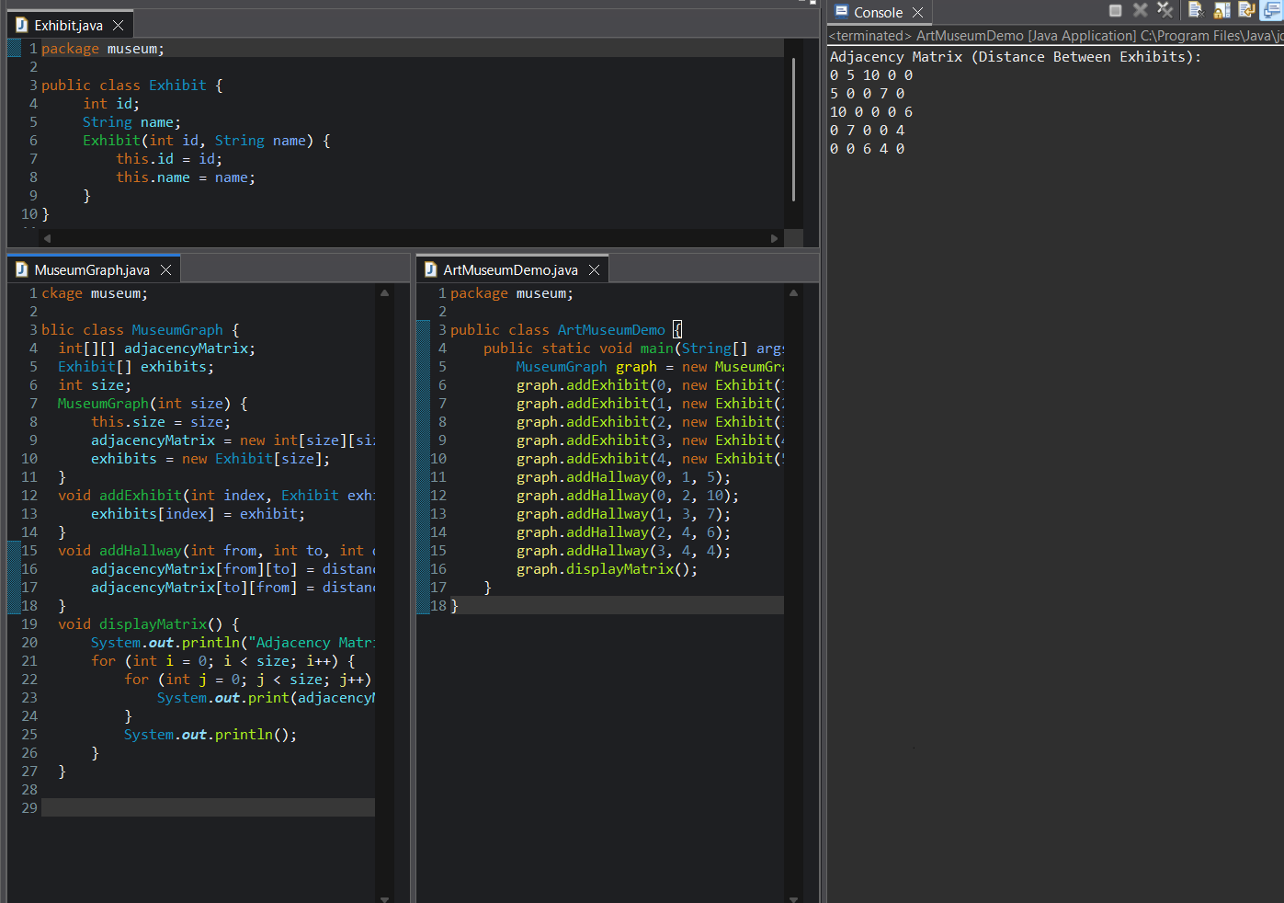
Problem Statement 2: Mapping Connections
Exhibit Index Mapping
Index | Exhibit
0 | Monet’s Water Lilies
1 | Michelangelo’s Pieta
2 | Egyptian Sarcophagi
3 | Picasso’s Guernica
4 | Van Gogh’s Sunflowers

0 1 2 3 4
---------------------
0 | 0 4 9 0 0
1 | 4 0 6 7 0
2 | 9 6 0 0 5
3 | 0 7 0 0 3
4 | 0 0 5 3 0
Adjacency Matrix (Time in Minutes)

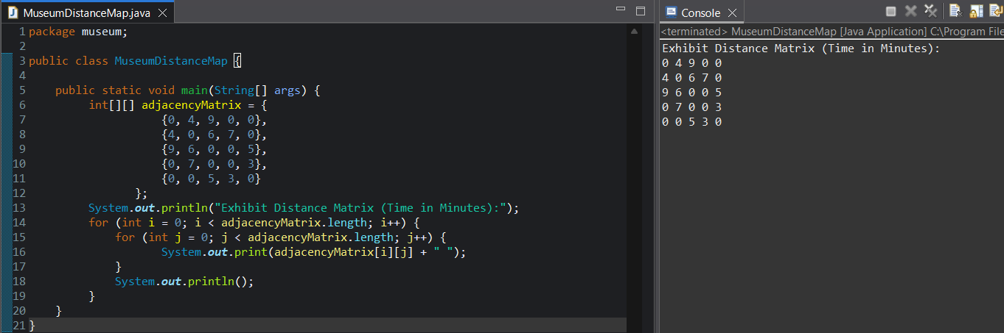
Problem Statement 3: Planning the Tour (Dijkstra's Algorithm)
Output: Display the most efficient tour sequence (exhibit names) along with the total tour time.
