Assignment 1 : Inheritance (Person → Student)
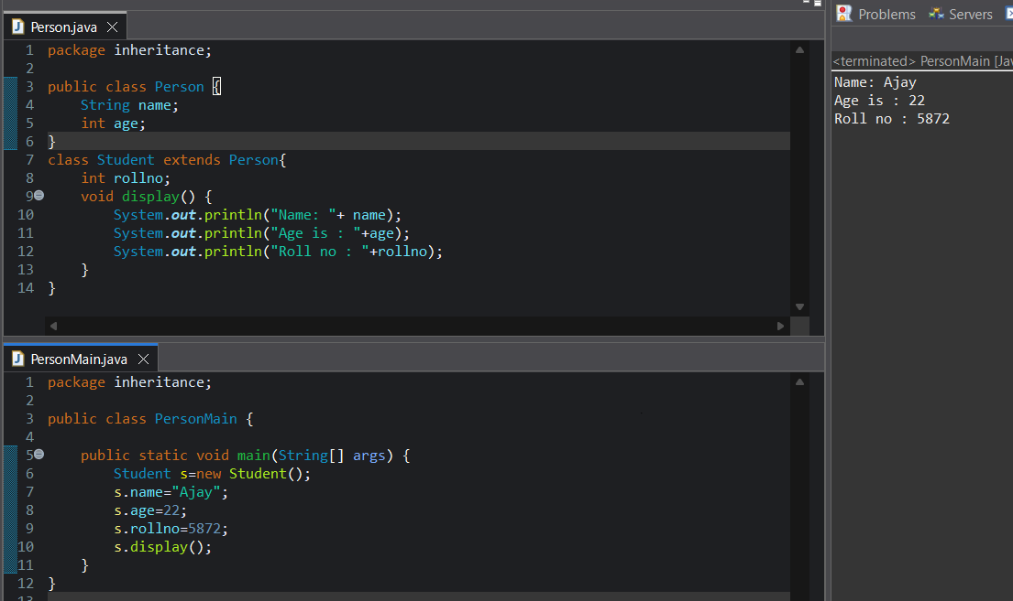
Assignment 2: Inheritance(Vehicle Car)
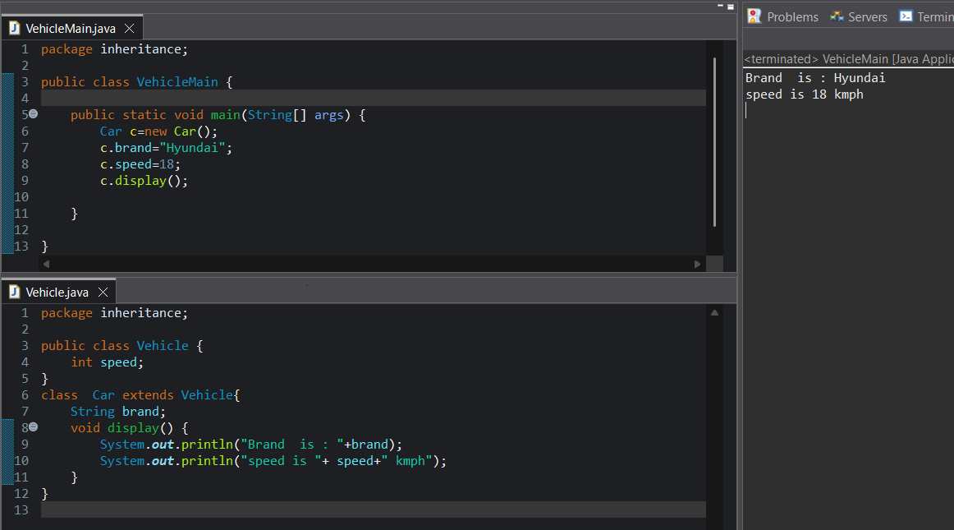

Assignment 3: Inheritance(Animal Dog)
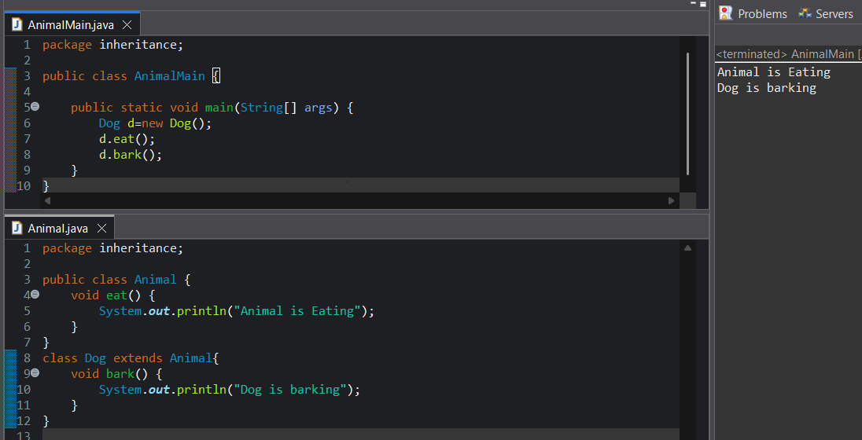
Assignment 4: Inheritance( Employee Manager)
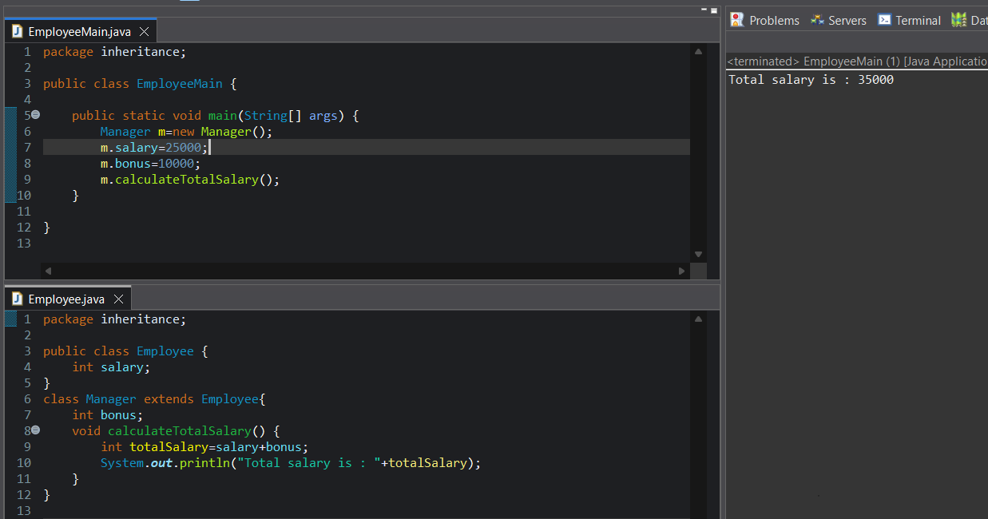

Assignment 5: Inheritance (Bank SavingsAccount)
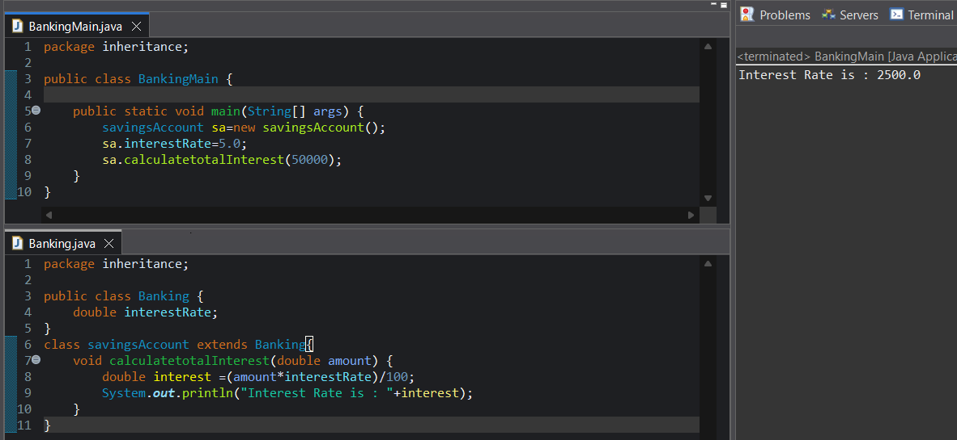
Assignment 6: Inheritance (Constructor Inheritance)
