Assignment 1: Calculator Overloading
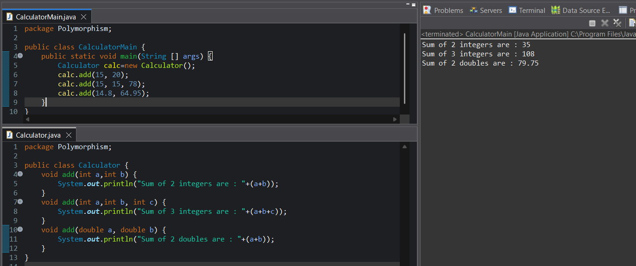
Assignment 2: Area Calculator
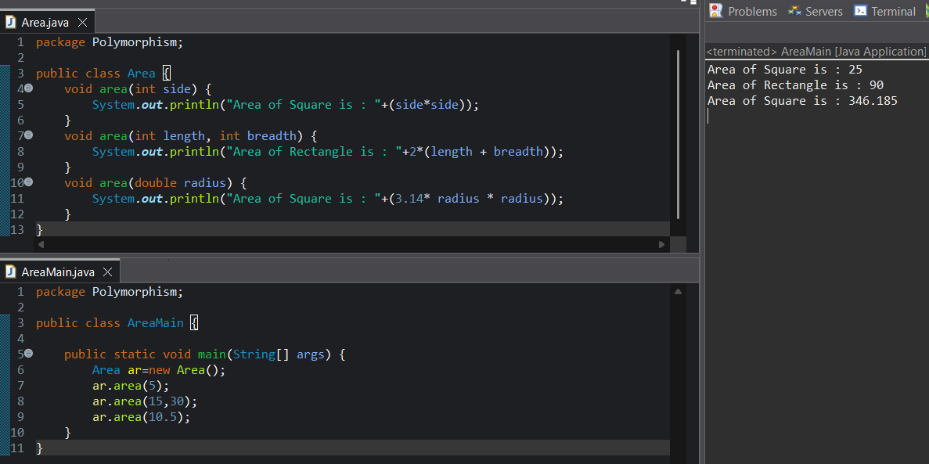

Assignment 3: Print Data
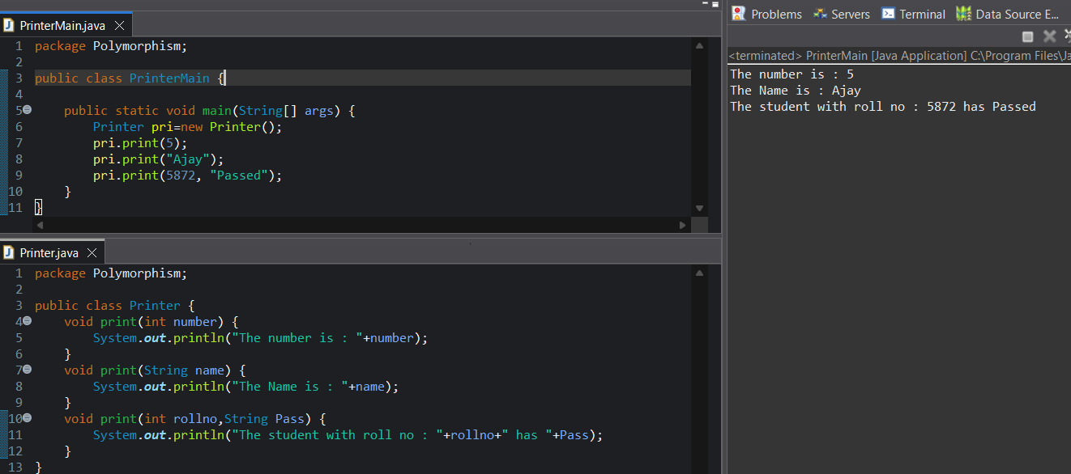
Assignment 4: Login System
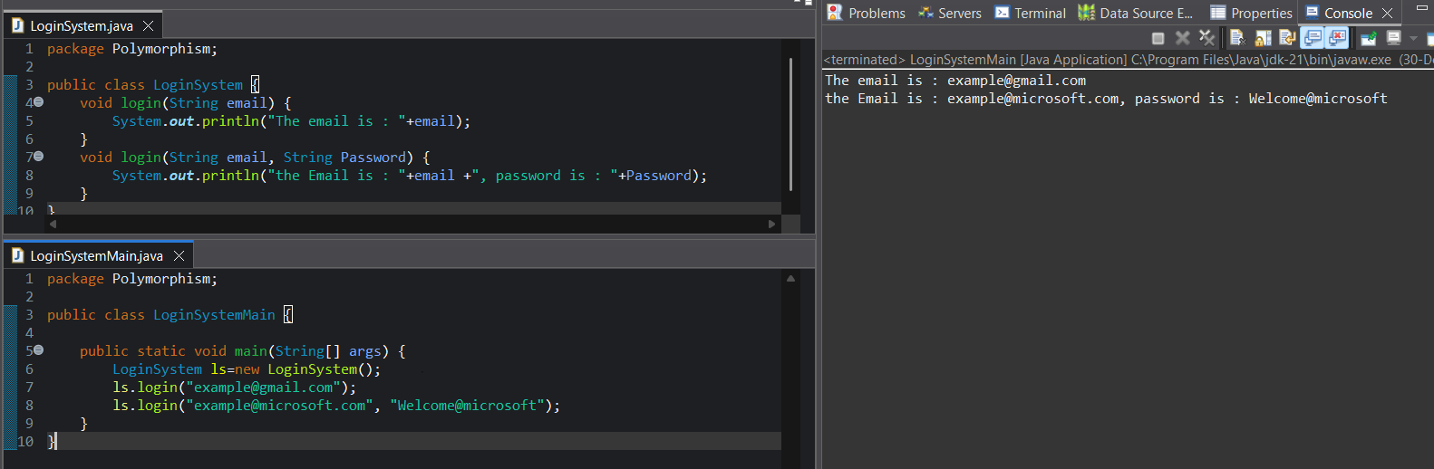
Assignment 5: Payment Calculation
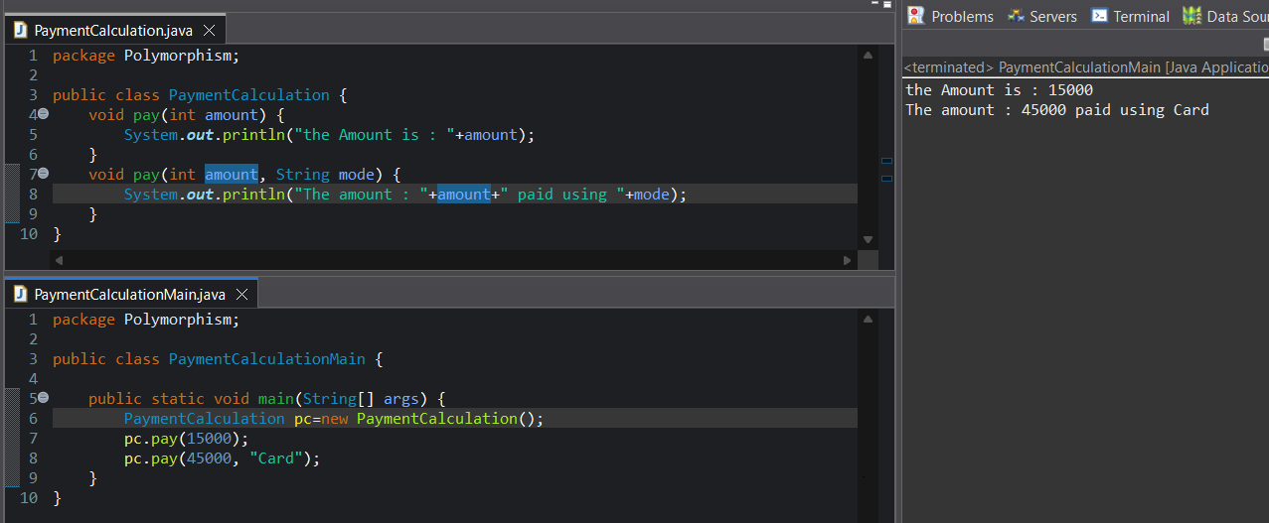

Assignment 6: Shape Drawing
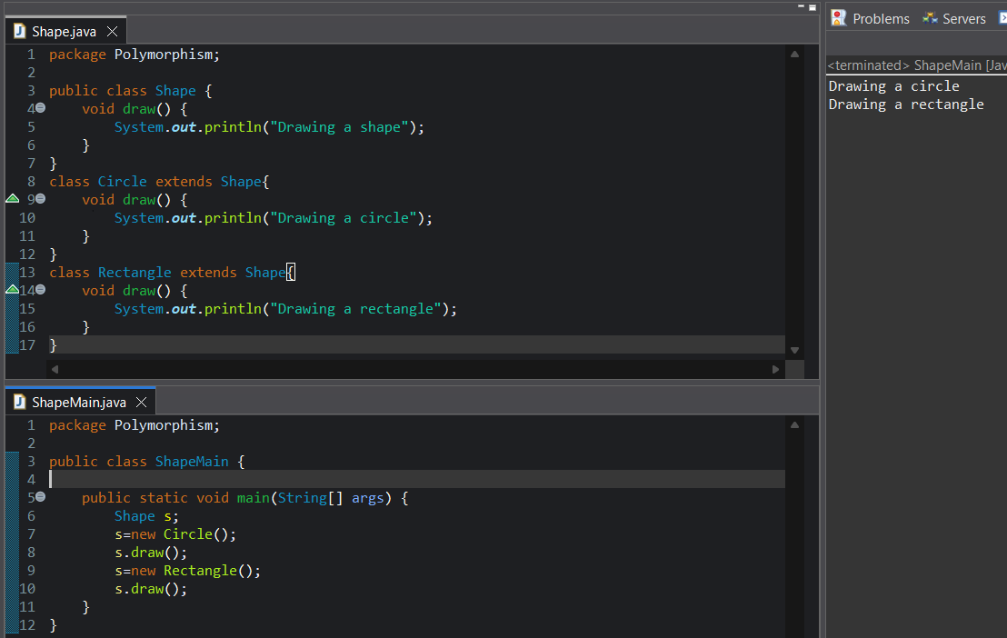
Assignment 7: Bank Interest
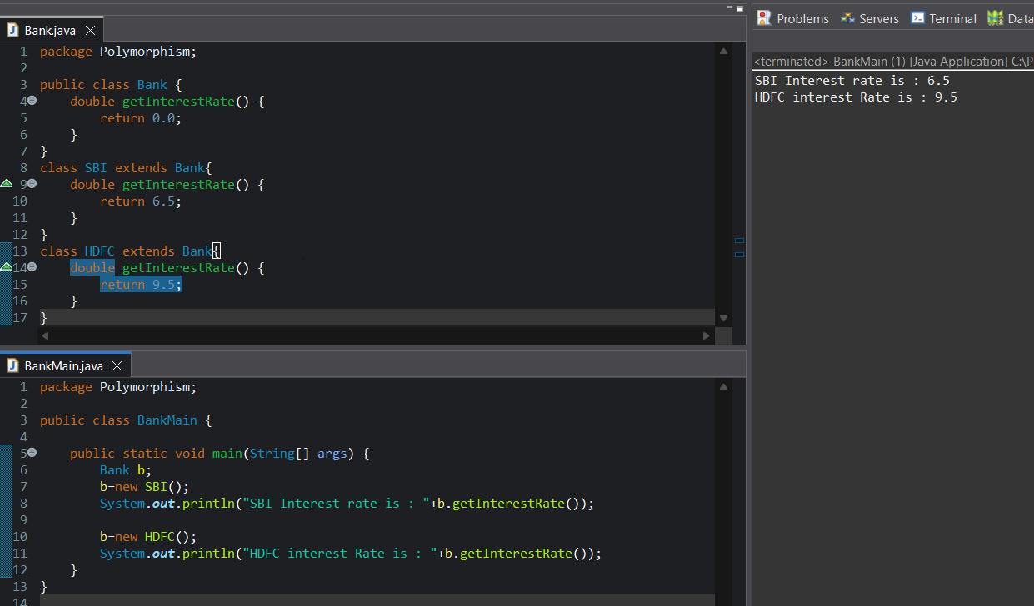

Assignment 8: Notification System
