SQL-ASSIGNMENT-3

1. write a SQL query to find Employees who have the biggest salary in their Department

SELECT e.emp_name,e.salary,d.dept_name
FROM employee as e
INNER JOIN department as d
ON e.dept_id=d.dept_id
WHERE (e.dept_id) in (
SELECT d.dept_id
FROM Department as d
INNER JOIN employee e
ON d.dept_id=e.dept_id
GROUP BY d.dept_id
)
AND(e.salary) in (
SELECT MAX(e.salary)
FROM Department as d
INNER JOIN employee e
ON d.dept_id=e.dept_id
GROUP BY d.dept_id
);

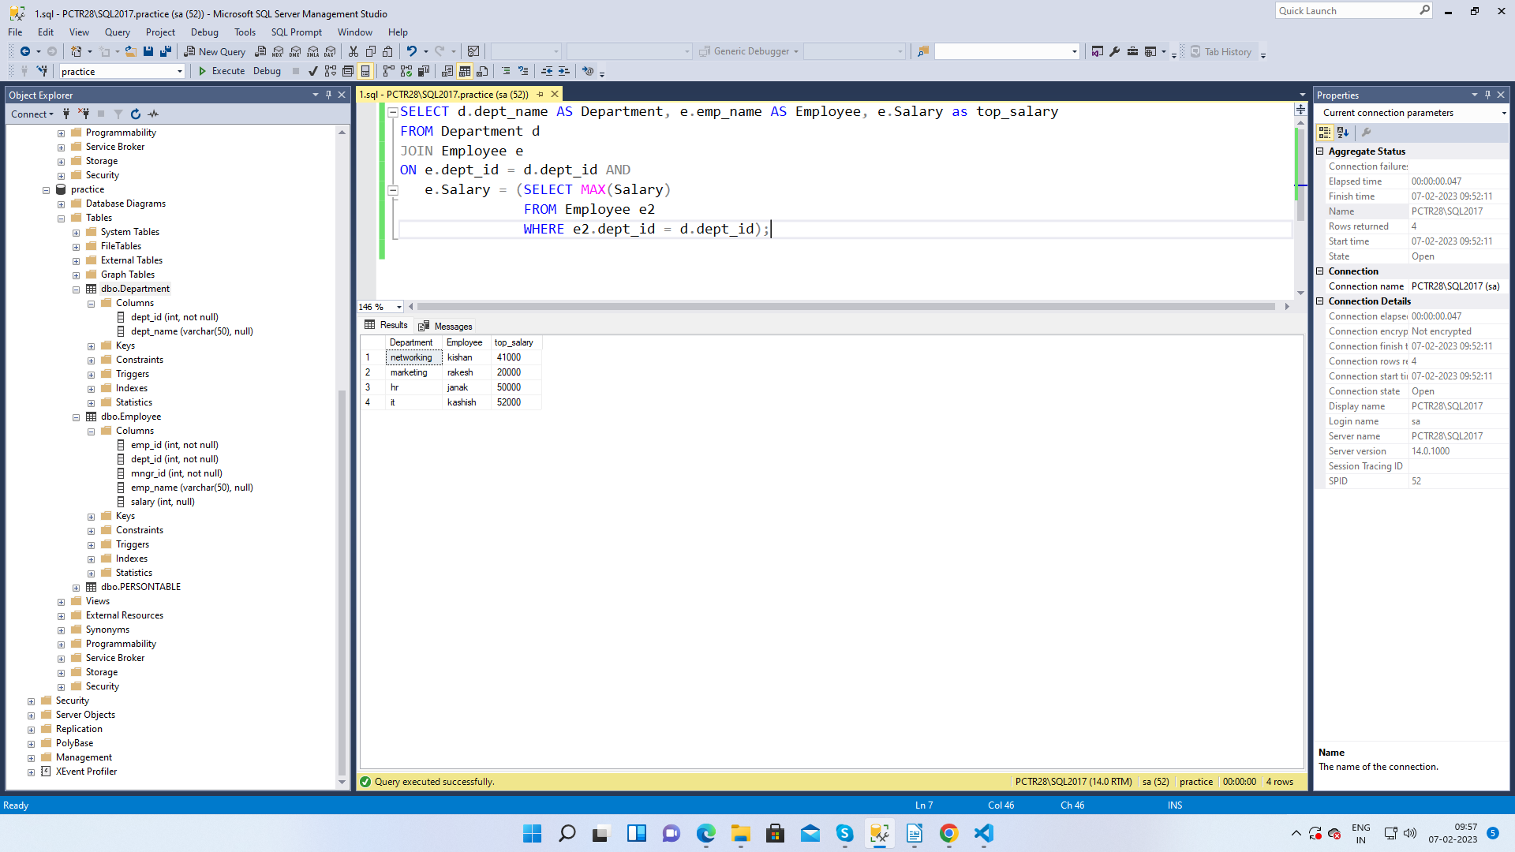

2. write a SQL query to find Departments that have less than 3 people in it
select d.dept_name from Department d left join Employee e
on d.dept_id=e.dept_id
group by d.dept_name
having count(e.emp_id)<3;

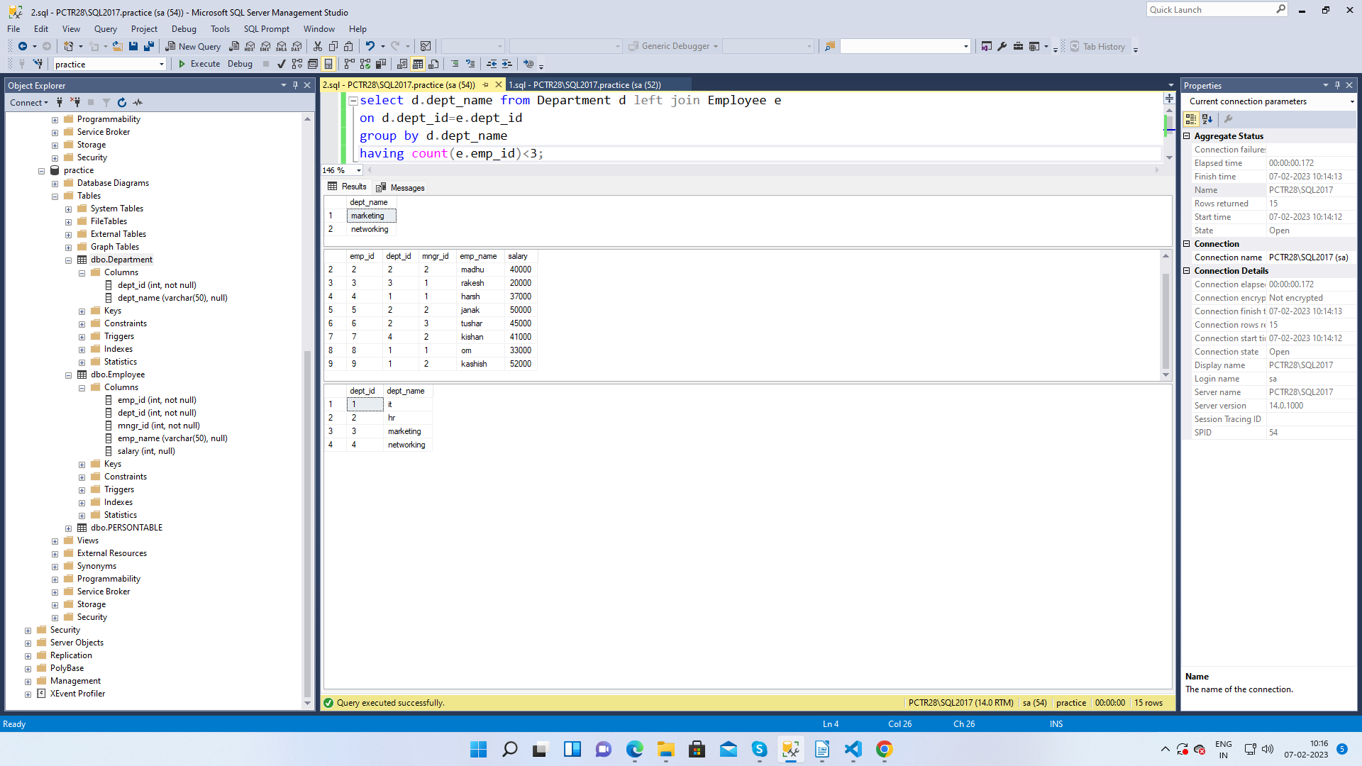

3. write a SQL query to find All Department along with the number of people there

SELECT d.dept_name AS 'Department Name',
COUNT(*) AS 'No of Employees'
FROM Department d
INNER JOIN Employee e
ON e.dept_id = d.dept_id
GROUP BY d.dept_id, d.dept_name;
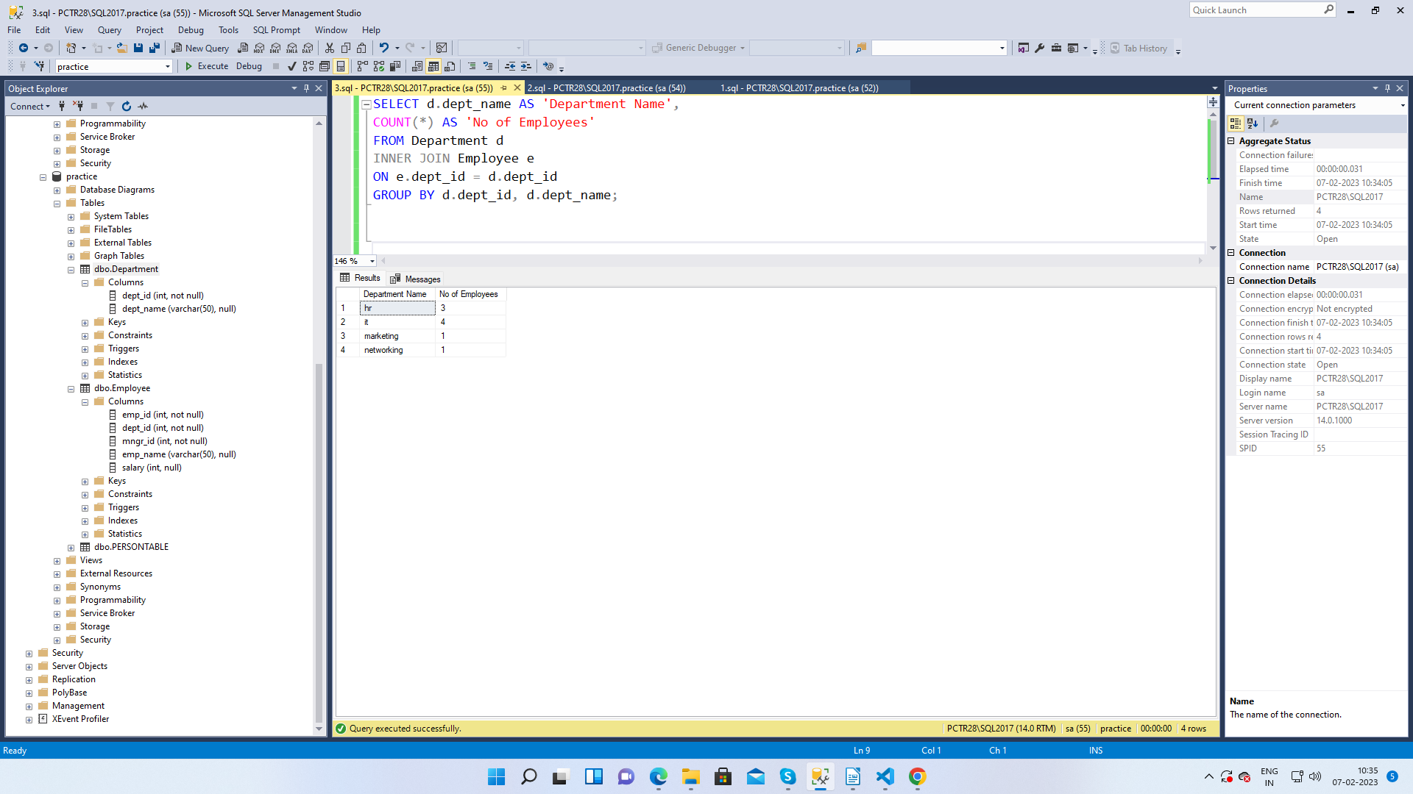

4. write a SQL query to find All Department along with the total salary there

SELECT dept.dept_name, sum(emp.salary) as 'Total Salaries'
FROM Employee emp, Department dept
WHERE emp.dept_id = dept.dept_id
GROUP by dept.dept_name;
