SQL-ASSIGNMENT-4

1. Create a stored procedure in the Northwind database that will calculate the average value of Freight for a specified customer.Then, a business rule will be added that will be triggered before every Update and Insert command in the Orders controller,and will use the stored procedure to verify that the Freight does not exceed the average freight. If it does, a message will be displayed and the command will be cancelled.

CREATE PROCEDURE spGetAvgFreight
@id nchar(5),
@AvgFreight float out
AS
BEGIN
SELECT @AvgFreight=AVG(Freight) FROM ORDERS WHERE customerId=@id;
END

/*execution*/
DECLARE @AvgFreight float;
DECLARE @id nchar(5);
SET @id='ALFKI';
EXECUTE spGetAvgFreight @id,@AvgFreight out;
print @AvgFreight;
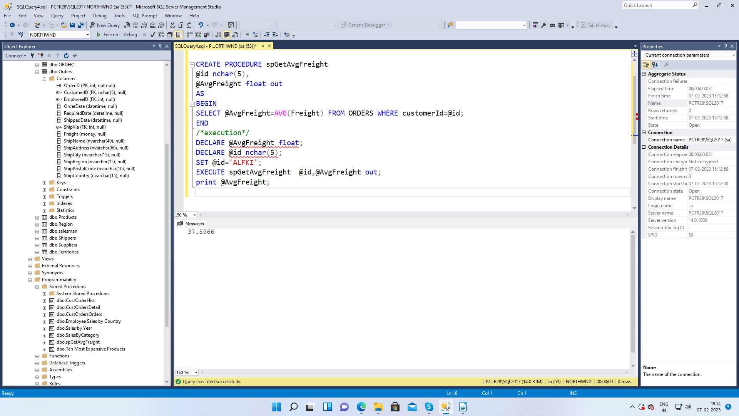

2. write a SQL query to Create Stored procedure in the Northwind database to retrieve Employee Sales by Country .

CREATE PROCEDURE spGetEmployeeSalesByCountry
@country nvarchar(15)
as
begin
select * from Orders where ShipCountry=@country;
end

/*EXECUTION*/
declare @country nvarchar(15);
set @country='USA';
execute spGetEmployeeSalesByCountry @country;

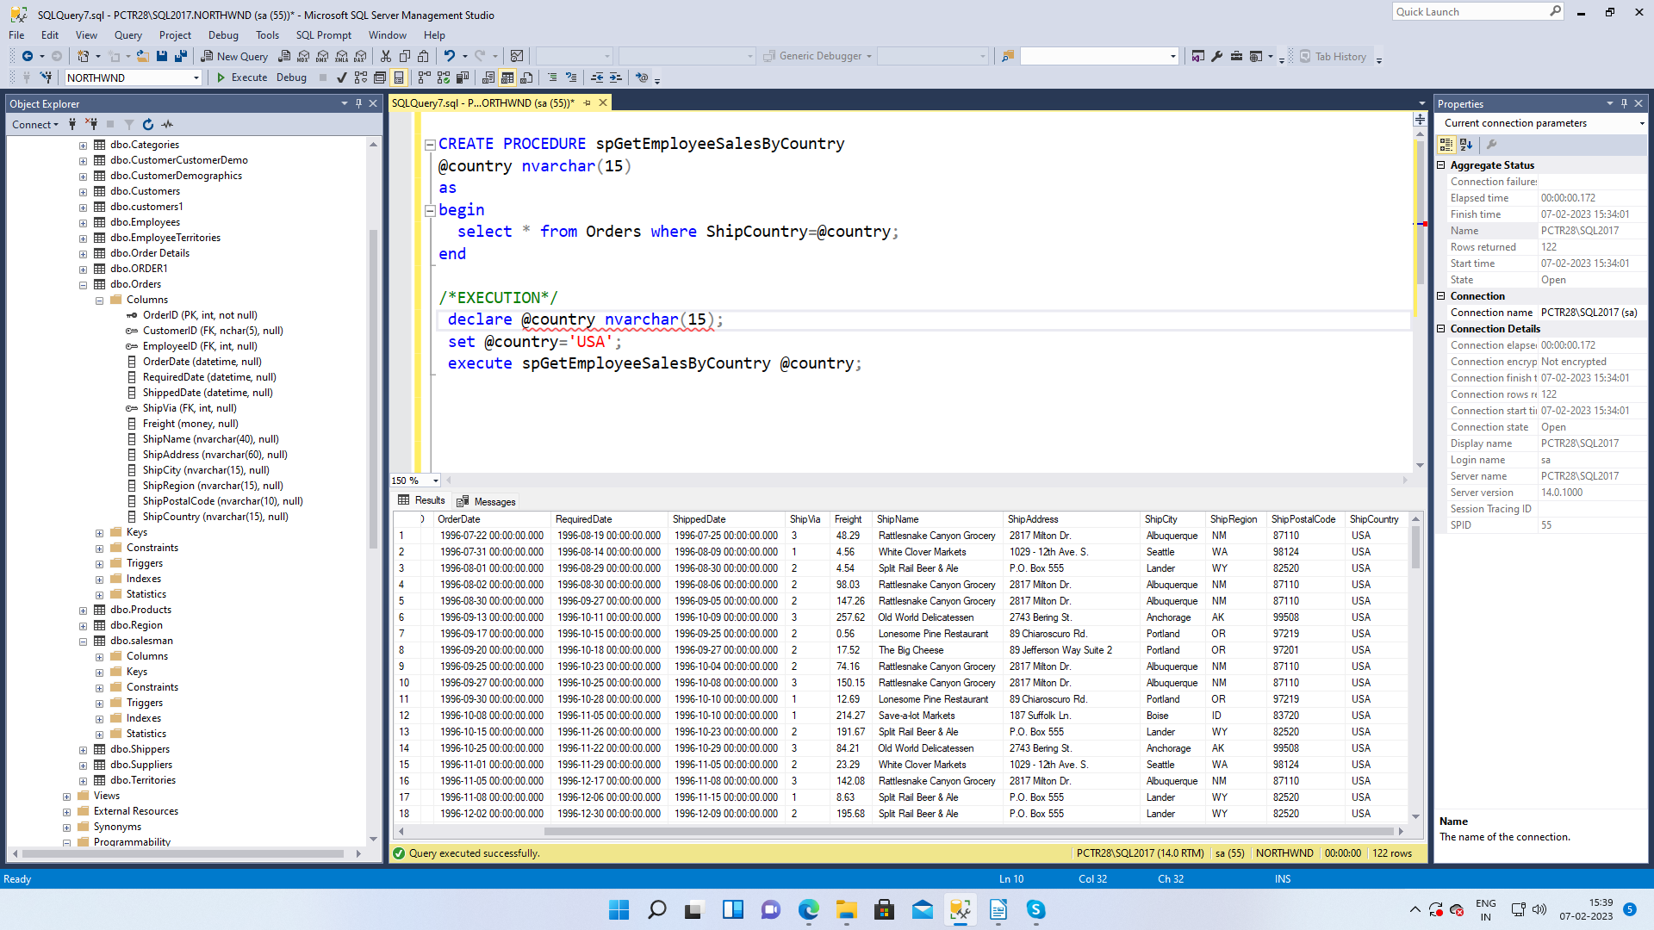

3. write a SQL query to Create Stored procedure in the Northwind database to retrieve Sales by Year.

CREATE PROCEDURE spGetSalesByYear
@year int
as
begin
select * from Orders where Year(OrderDate)=@year;
end

/*execution*/
DECLARE @year int;
set @year=1996;
execute spGetSalesByYear @year;

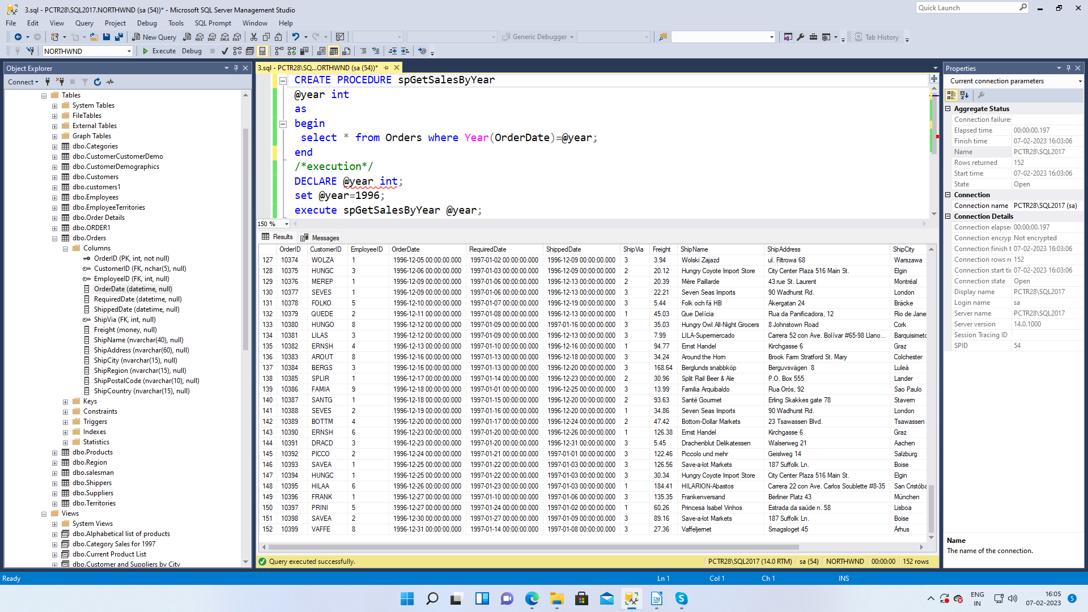

4. write a SQL query to Create Stored procedure in the Northwind database to retrieve Sales By Category .

create procedure spGetSalesByCategory
@Category nvarchar(20)
as
begin
select * from Orders where OrderID in
(select OrderID from [Order Details]where ProductID in
(select ProductID from Products where CategoryID in
(select CategoryID from Categories where CategoryName=@Category )));
end
/*execution*/
declare @Category nvarchar(20);
set @Category = 'Beverages';
execute spGetSalesByCategory @Category;

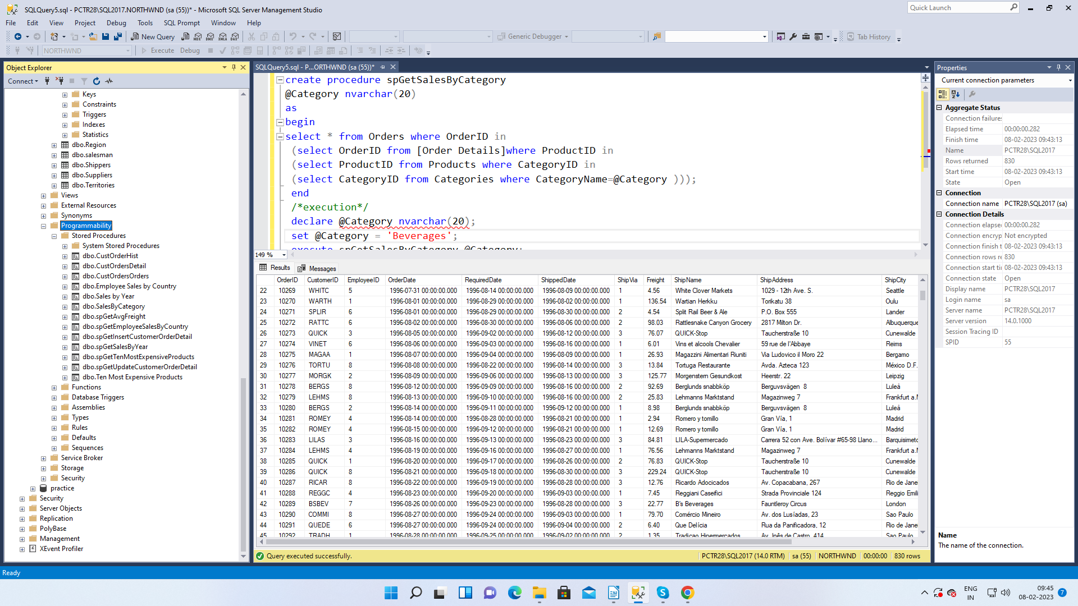

5. write a SQL query to Create Stored procedure in the Northwind database to retrieve Ten Most Expensive Products

create procedure spGetTenMostExpensiveProducts
as
begin
SELECT top(10) Products.ProductName AS TenMostExpensiveProducts, Products.UnitPrice
FROM Products
ORDER BY Products.UnitPrice DESC
end
/*execution*/
execute spGetTenMostExpensiveProducts;

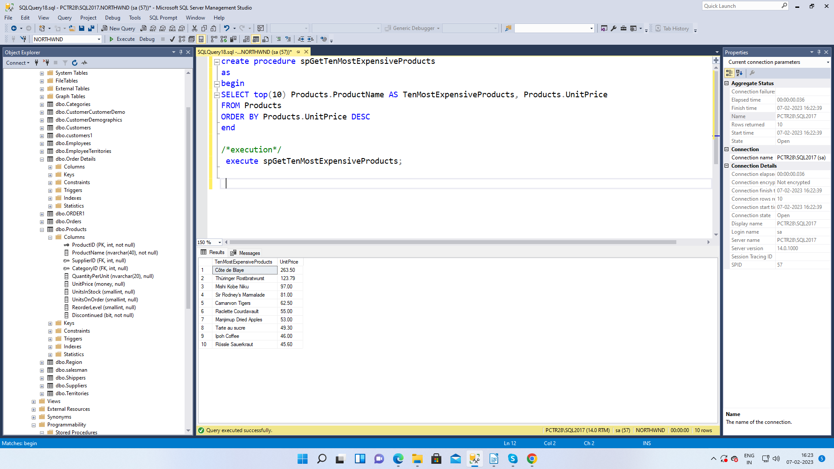

6. write a SQL query to Create Stored procedure in the Northwind database to insert Customer Order Details .
create procedure spGetInsertCustomerOrderDetail
@orderid int,
@productid int,
@unitprice money,
@quantity smallint,
@discount real
as
begin
insert into [Order Details]
(
OrderID,ProductID,UnitPrice,Quantity,Discount
)
values
(
@orderid ,
@productid ,
@unitprice ,
@quantity ,
@discount
)
end
/*execution*/
declare @orderid int;
declare @productid int;
declare @unitprice money;
declare @quantity smallint;
declare @discount real;

set @orderid = 10248;
set @productid = 14;
set @unitprice=50;
set @quantity =50;
set @discount =0.5;

execute spGetInsertCustomerOrderDetail @orderid ,
@productid ,
@unitprice ,
@quantity ,
@discount ;
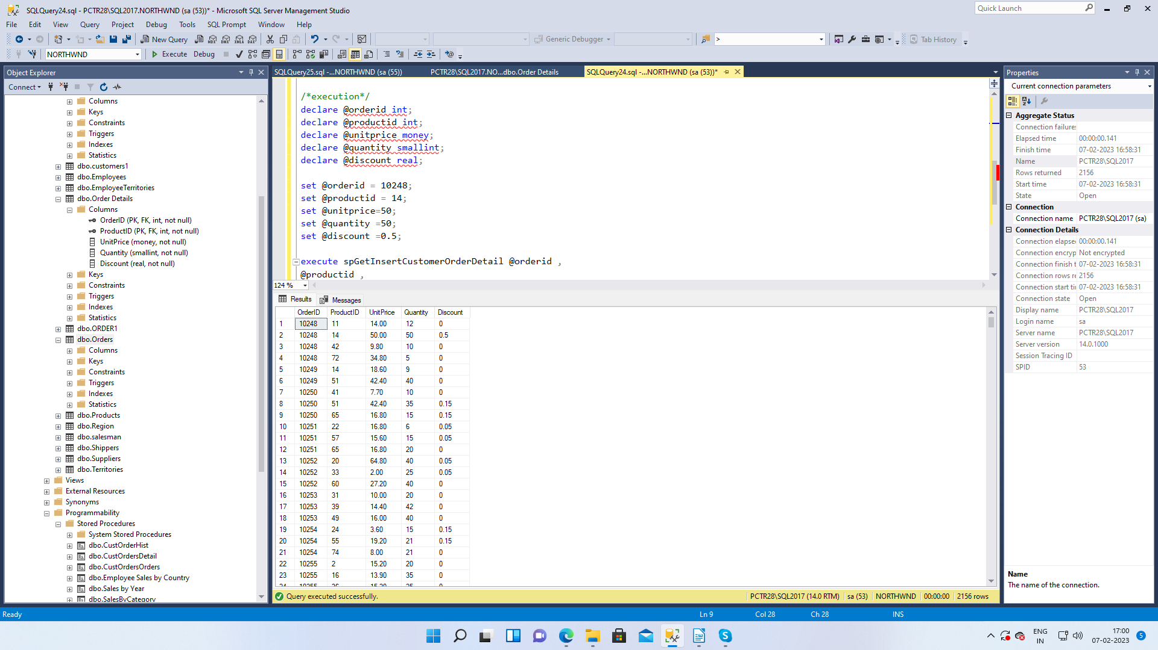

7. write a SQL query to Create Stored procedure in the Northwind database to update Customer Order Details

create procedure spGetUpdateCustomerOrderDetail
@orderid varchar(6),
@unitprice money,
@quantity smallint,
@discount real
as
begin
update [Order Details]
set
UnitPrice=@unitprice,Quantity=@quantity,Discount=@discount
WHERE
OrderID=@orderid
end

/*execution*/

declare @orderid varchar(6);
declare @unitprice money;
declare @quantity smallint;
declare @discount real;

set @orderid ='10253';
set @unitprice ='50';
set @quantity ='44';
set @discount ='0.5';
execute spGetUpdateCustomerOrderDetail @orderid,
@unitprice,@quantity,@discount;
