SQL Assignment -1
1.Write a query to get a Product list (id, name, unit price) where current products cost less than $20.

->SELECT ProductID,ProductName,UnitPrice from Products where UnitPrice<20

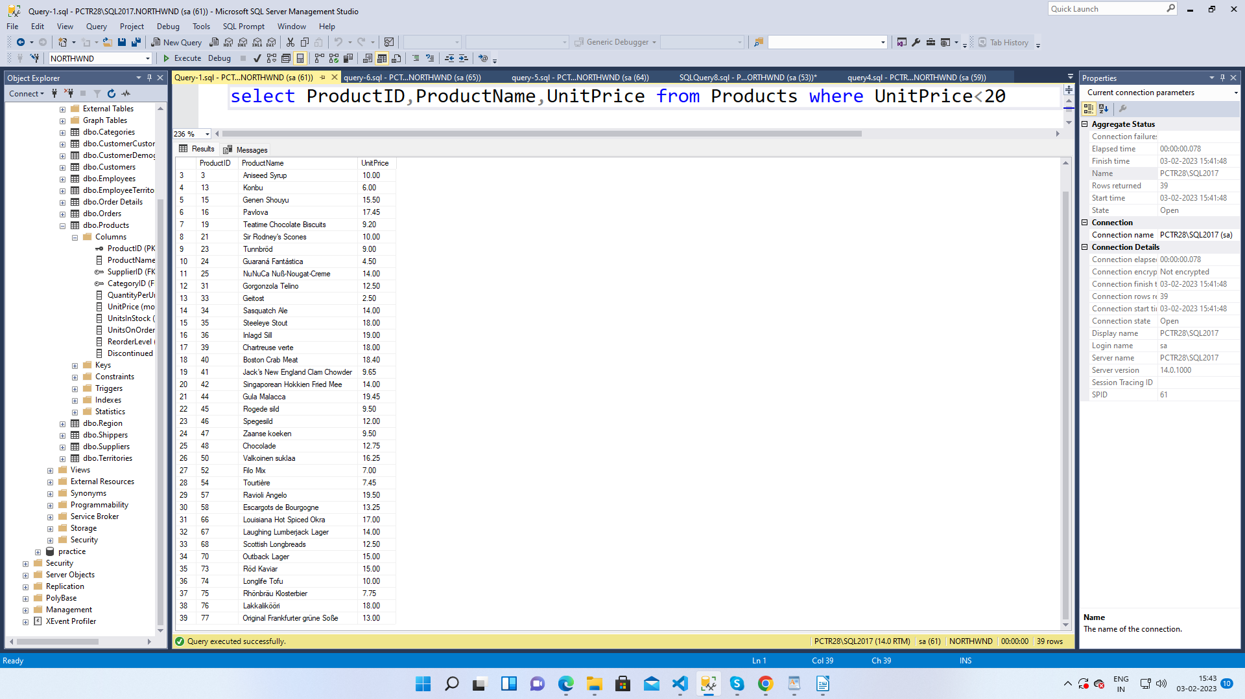

2.Write a query to get Product list (id, name, unit price) where products cost between $15 and $25

-> SELECT ProductID,ProductName,UnitPrice from Products where UnitPrice BETWEEN 15 AND 25

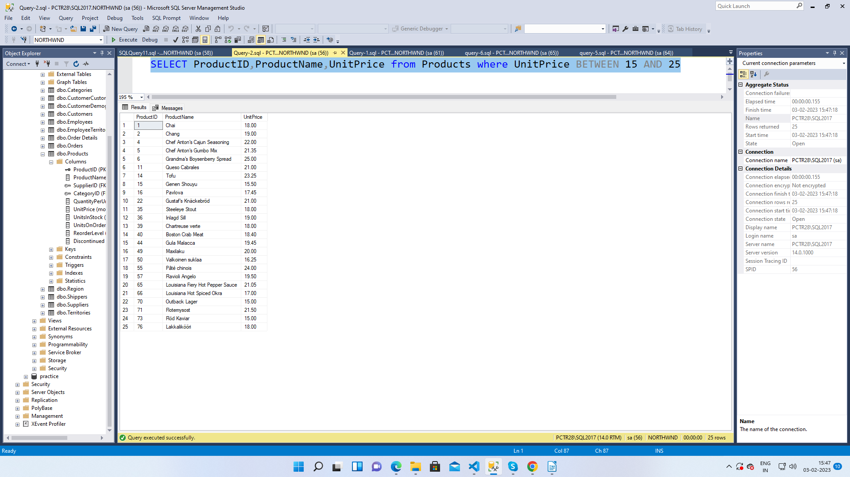

3. Write a query to get Product list (name, unit price) of above average price.

->SELECT ProductName,UnitPrice from Products where UnitPrice > (select AVG(UnitPrice)from Products)

4. Write a query to get Product list (name, unit price) of ten most expensive products

->select top(10)ProductName,UnitPrice from Products order by UnitPrice desc

5. Write a query to count current and discontinued products

->SELECT Count(ProductName)FROM Products
GROUP BY Discontinued;

6. Write a query to get Product list (name, units on order , units in stock) of stock is lessthan the quantity on order.

->SELECT ProductName, UnitsOnOrder , UnitsInStock FROM Products WHERE UnitsInStock<UnitsOnOrder;

