Project Documentation

**Project Title:** Airline Booking Data Preparation and Cleaning

**Name: AJAY**

**Batch: 1st_May**

**Project GitHub Link:** [Add your project link here]

**Project Explanation Video Link:** [Add your video link here]

# Task 1: Data Preparation and Cleaning

## Objective:

The objective of this task was to perform data preparation and cleaning on an airline booking dataset using Power BI's Power Query Editor.

## Steps Completed:

**Extract and Transform Data in Power Query:** Imported raw booking data from the source ECSV file into Power BI and loaded the data into Power Query Editor for transformation.

**Removed Duplicates:** Identified and removed duplicate rows to ensure data uniqueness.

**Handled Missing Values:** Checked all columns for null or missing values and handled them appropriately:

**Formatted Columns:** - Converted date columns to proper Date format.  
- Converted numeric columns like Ticket Price and Passenger Count to Number format.  
- Applied proper text casing for categorical columns like Destination and Airline Name.

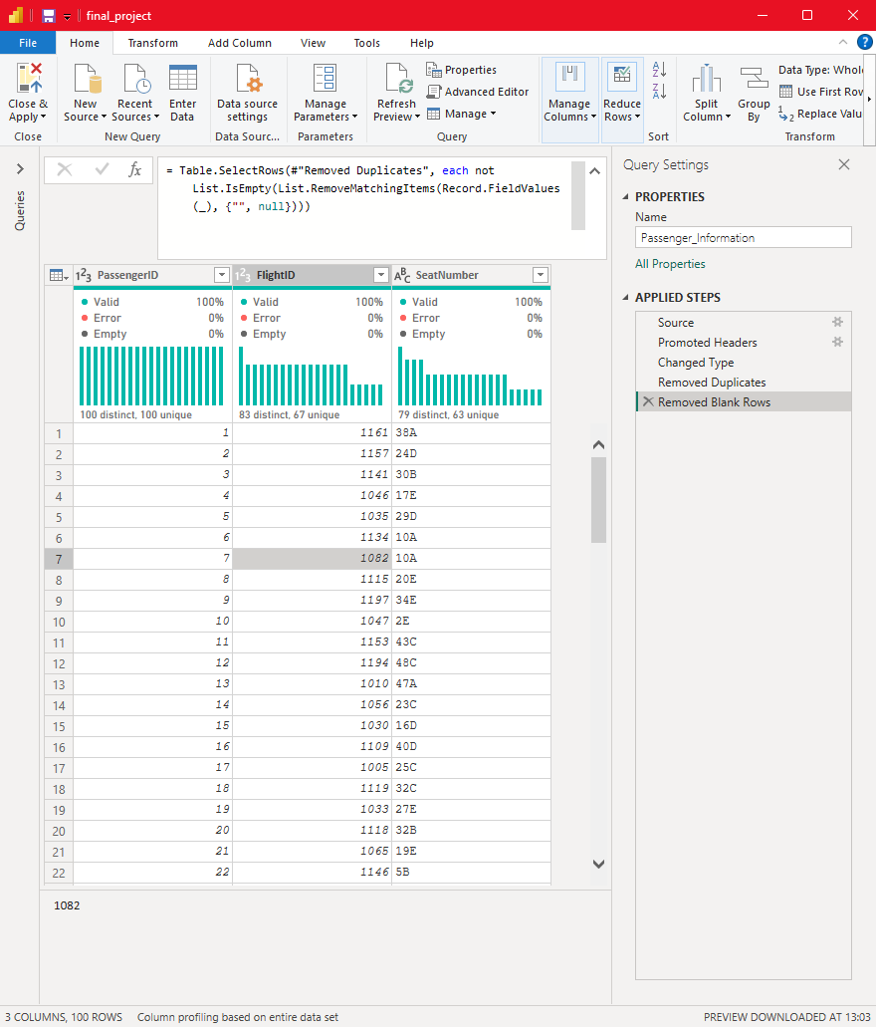

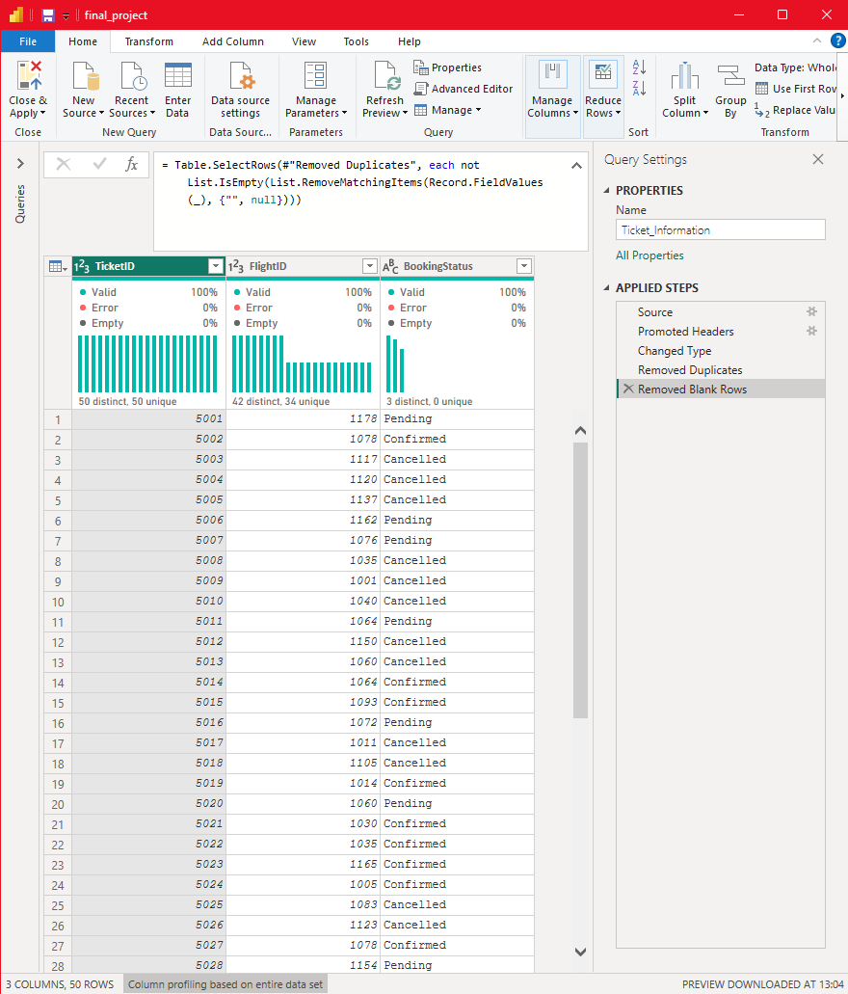

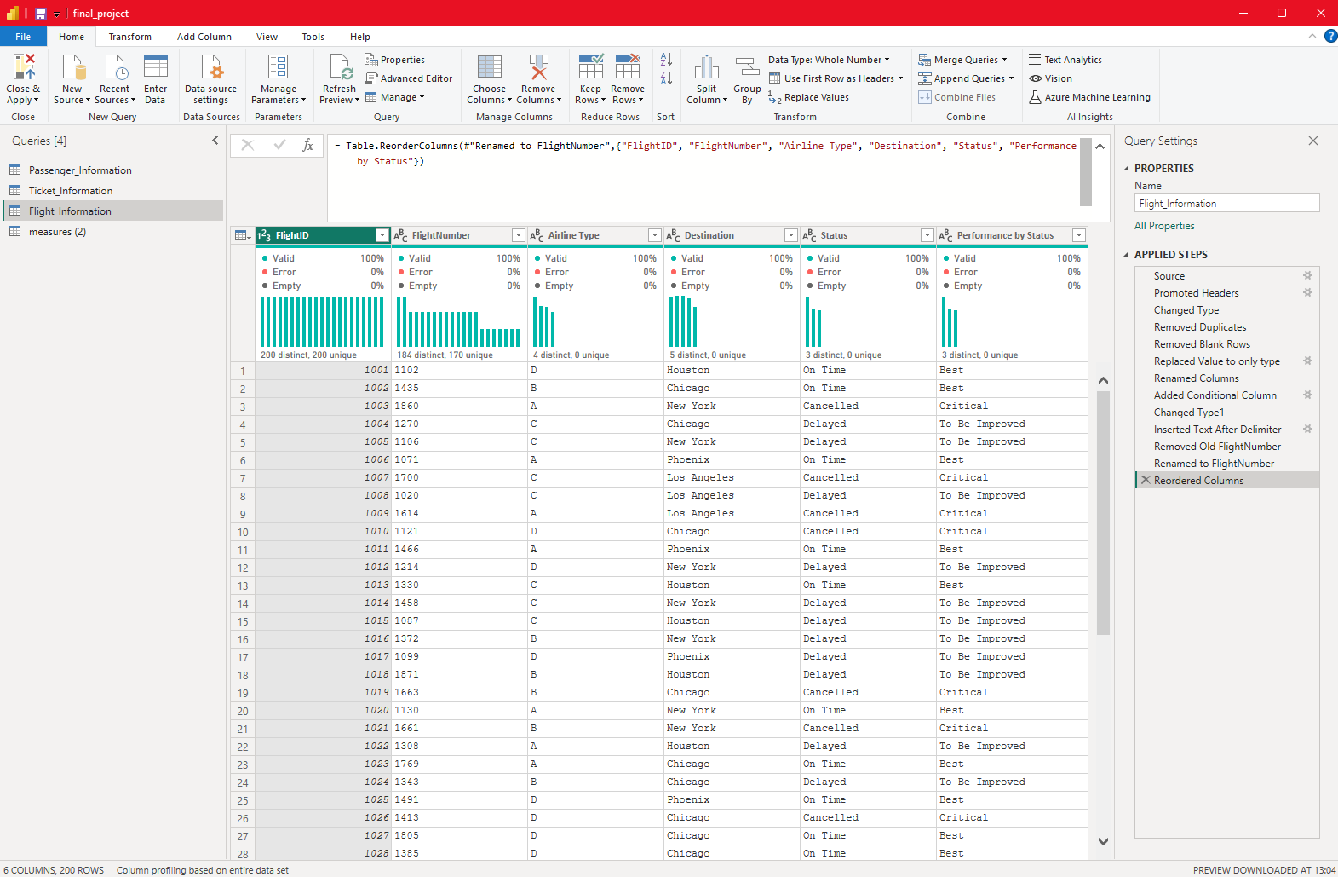

# Task 2: Data Modeling

## Objective:

The objective of this task was to create relationships between different datasets using **FlightID as the key** and create the model appropriately.

## Steps Completed:

* Created relationships between tables using **FlightID as the key.**
* Established correct relationship (**One-to-Many**) between related tables**.**

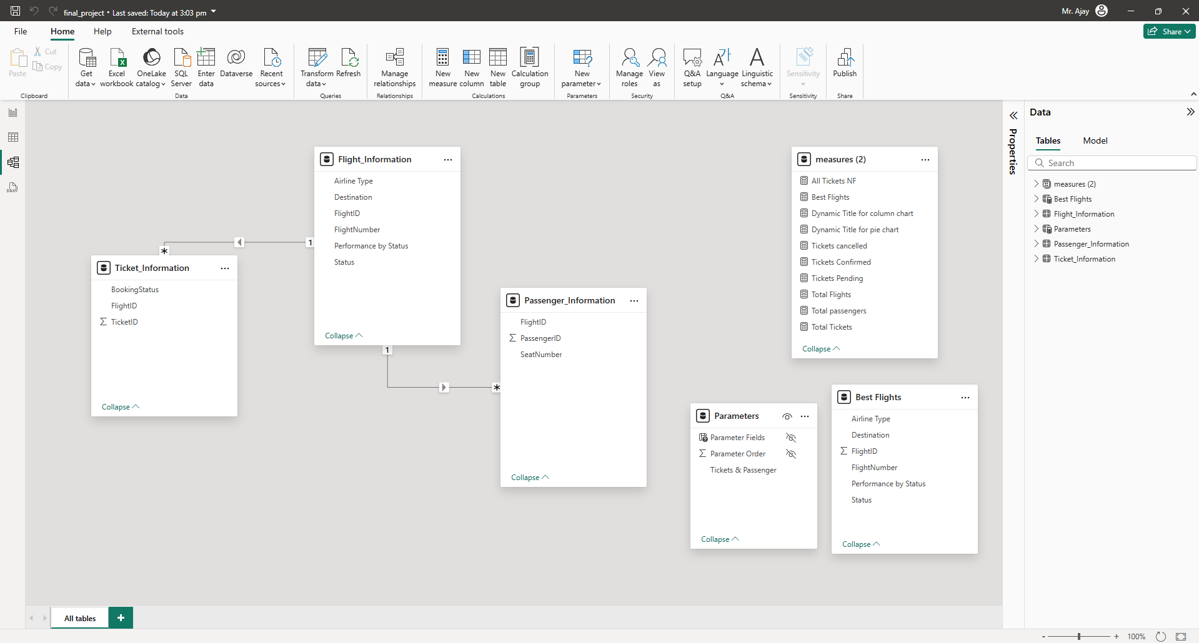

# Task 3: Enhanced Data Insights

## Objective:

## The objective of this task was to create new insights by adding a Conditional Column and extracting data using Column from Examples.

## Steps Completed:

* Added a **Conditional Column** to classify flights as **"Best"** or **"To Be Improved"** based on flight status.
* Used **'Column from Examples'** to extract the flight number from the **FlightNumber** column.

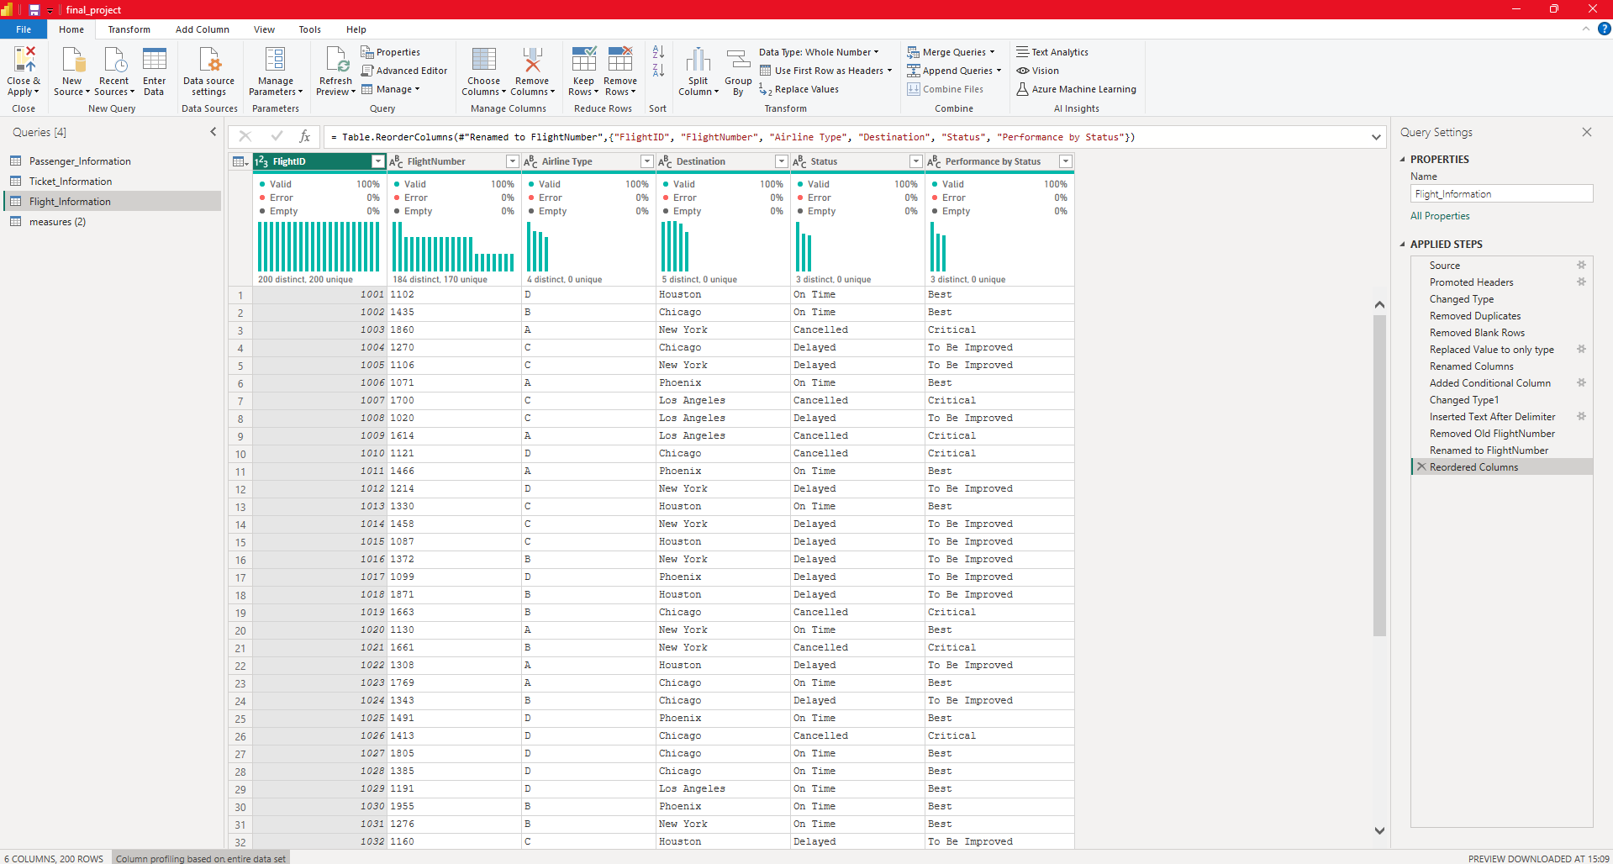

# Task 4: Enhanced Data Insights

## Objective:

## The objective was to create DAX measures to calculate key metrics from the dataset.

## Steps Completed:

* Calculated **Total Passengers** for a specific flight with **CountRows Function**

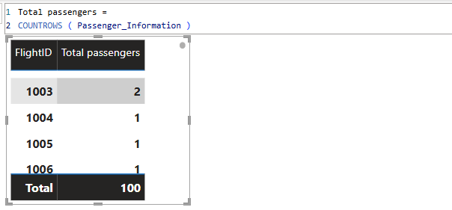

* Calculated **Total Tickets Booked** with **COUNT Functions** because all TicketID id were in numeric format

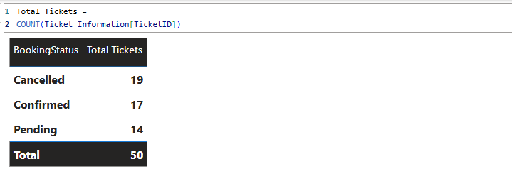

* Created a **Filtered Table** to show only **"Best"** flights using **DAX** shows below in ScreenShot.  
  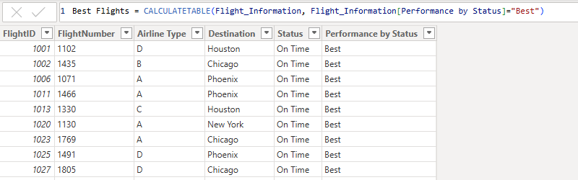

# Task 5: Enhanced Data Insights

## Objective:

## The objective of this task was to visualize the data and add interactive features for better analysis in Power BI.

## Steps Completed:

* **Created visuals for:**

1. Used **Pie Chart** for **Passengers by airline**
2. Used **Column Chart** for **Ticket booking statuses**
3. Used **Stacked Column Chart** for **Flights by airline and destination**

* **Added interactive features:**

1. **Slicer** for **Destination** and **Airline** to filters the visuals
2. **Drill through** and **Bookmarks** for **Quick views** that matters.  
   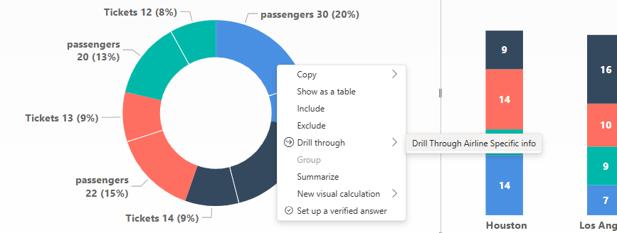

After **DrillTrough** leads to Airline specific Pages containing **Bookmarks** and **slicer** with **Dynamic Page Title** and **Key insights** in card visual

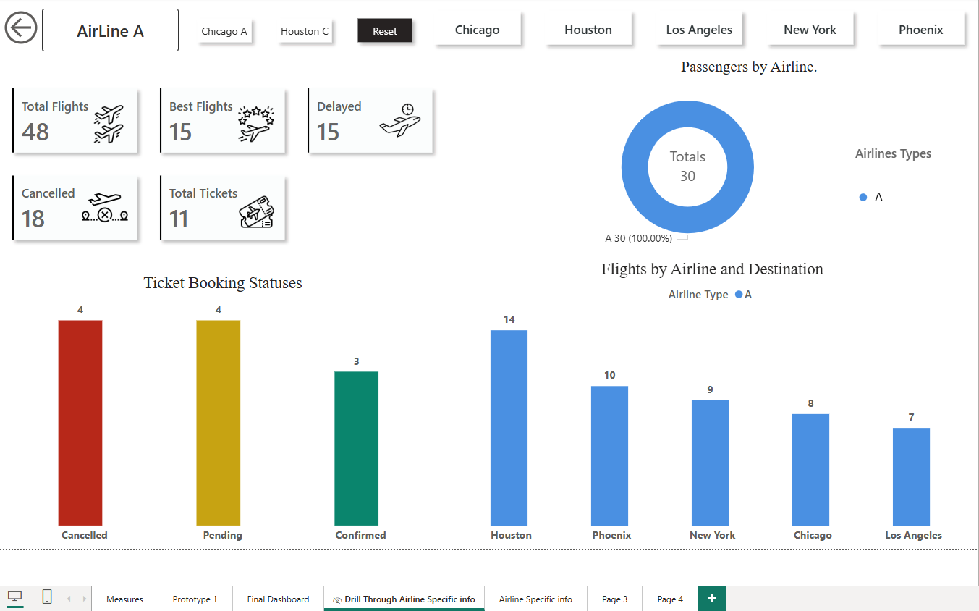

1. Created Airline specific page focused on **Airline**-**specific** **All** **Info** with **interactive Slicers** for **Airline** and **Destinations**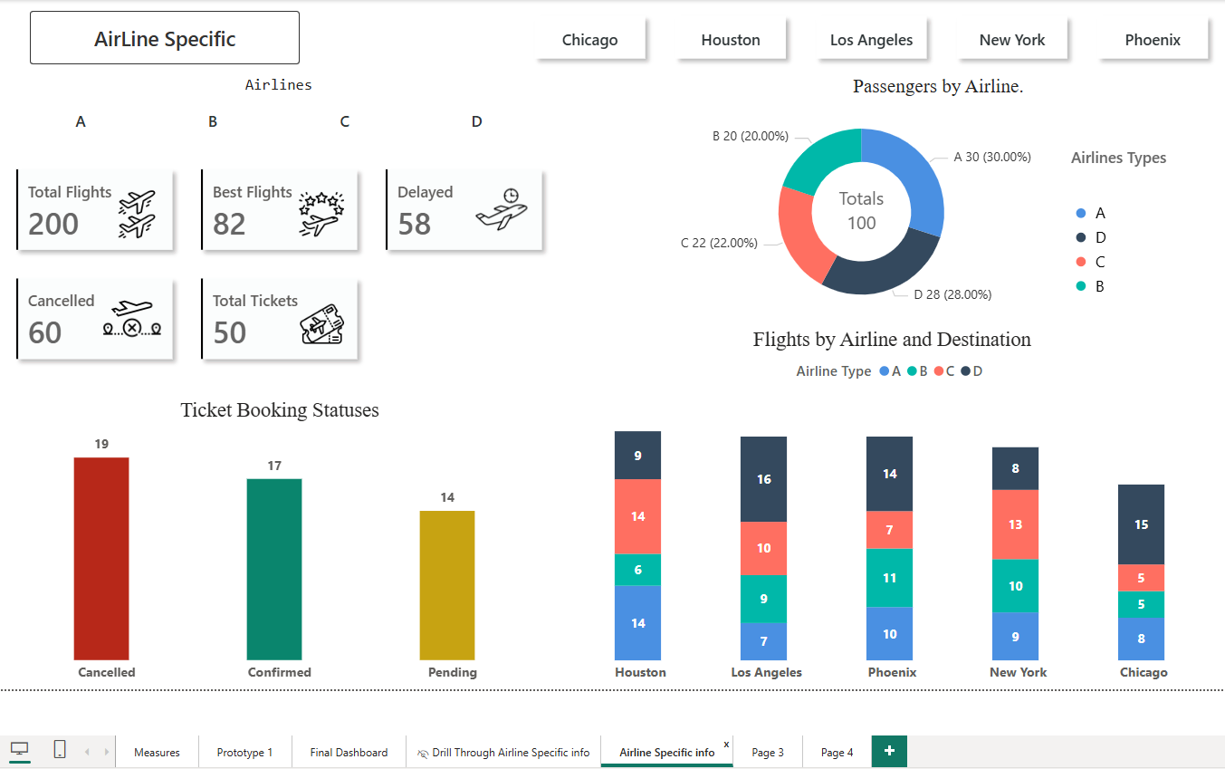

# Task 5: Final Dashboard and Power BI Service

# Objective:

## The objective was to design a comprehensive dashboard and publish it to the Power BI Service with scheduled refresh and Row-Level Security (RLS).

## Steps Completed:

* Designed a final **dashboard** with key visuals and insights over power Bi Service  
  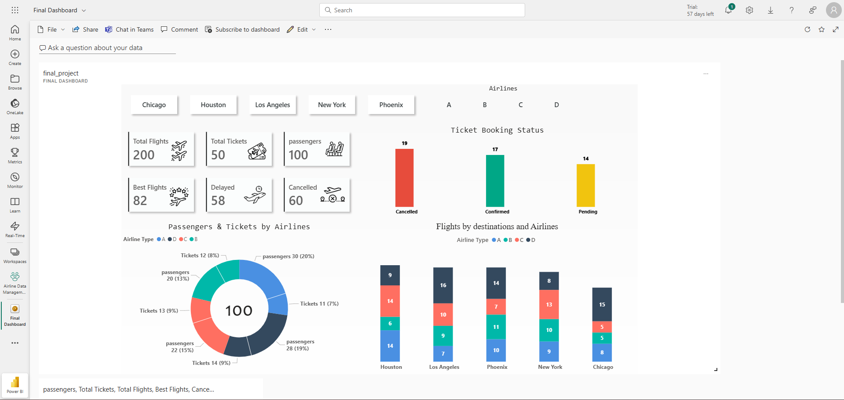
* Configured **Row-Level Security (RLS)** in Power Bi Desktop for **Airline A**  
  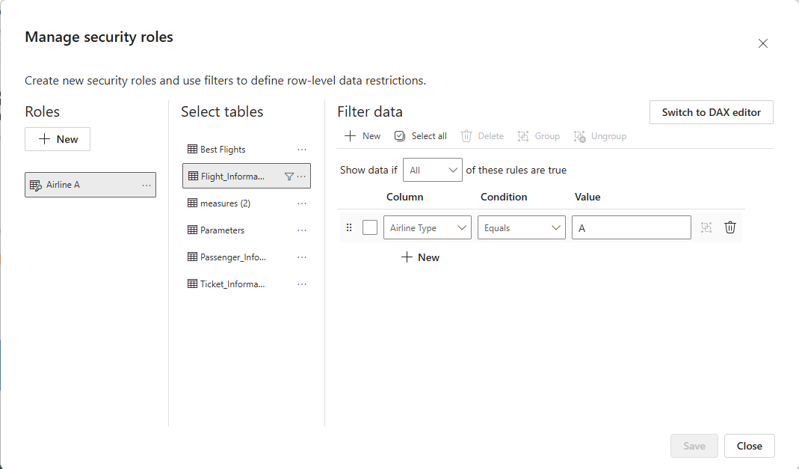  
  **Assigned it to a specific user** using **Power Bi Service**.  
  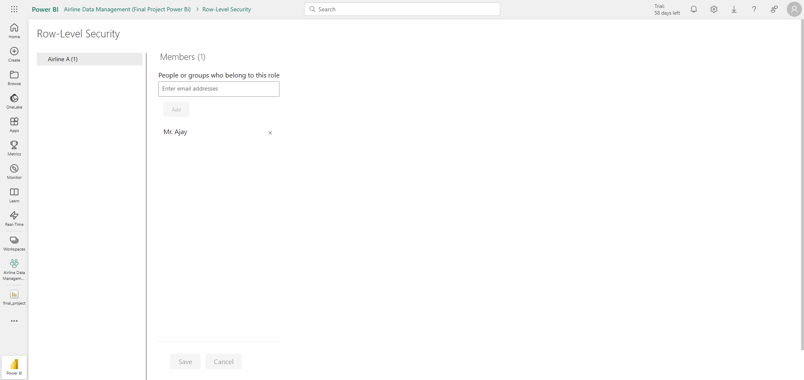
* Scheduled data **refresh** to run daily at **5 PM** for India Time Zone.  
  