**Name: Ajay**

**Project: KPMG Data Analysis using Excel**

**Video Link:** <https://www.loom.com/share/c92e210607064eb0af3517af6c069649?sid=adccb1c7-eef1-4f17-bb28-30e409c2a8f7>

**Summary of Key Insights:**

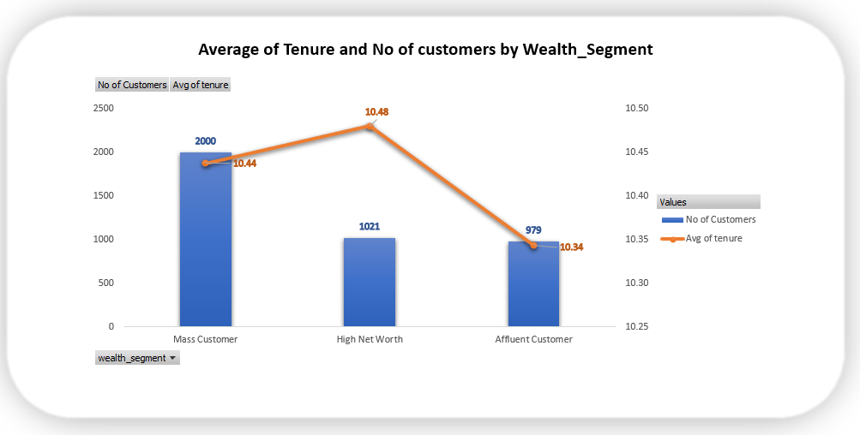

1. Out of Total Customers half 50% of them are **Mass Customers** belongs to lower income and asset level as compared to other wealth Category and their **Average tenure is slightly lower** than the **High Net Worth** Customers.
2. **High Net Worth** Customers with the **highest** **Average** **tenure** suggest **good retention** while being fewer in numbers
3. **Affluent Customers** slightly below than the other two in terms of Average **tenure**.

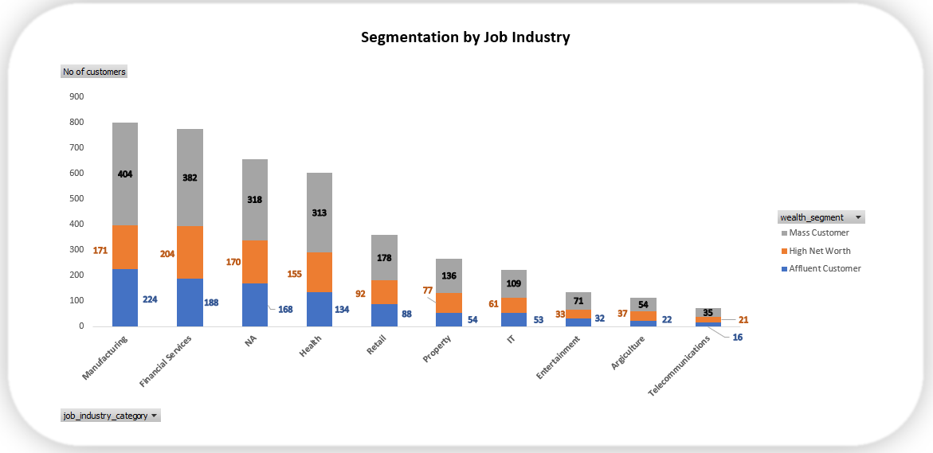

1. **Mass Customers** are the majority across all industry which is expected
2. **Financial Services** attracts most of **High Net Worth** Individuals
3. **Manufacturing** attracts a higher number of **Affluent** and **Mass** Customers probably because it employs a large number of Population on the base of diverse incomes.

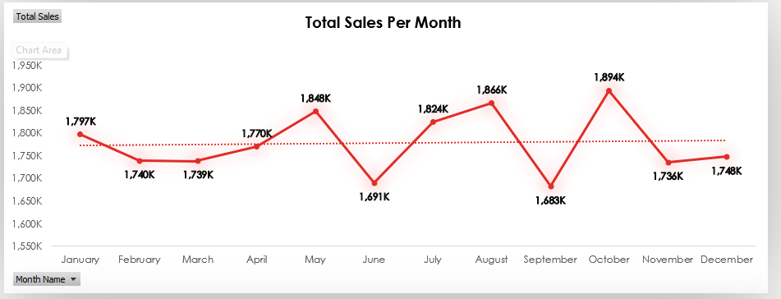

**1. May, August and October Spikes**

There is noticeable spike in month may, August and highest at October!   
  
**2. June and September drops**

There is sales drop on June and September lowest on June.

possibly due to off-season effects or reduced consumer activity

October records the **Highest Monthly Sales**, suggesting seasonal demand or promotions.

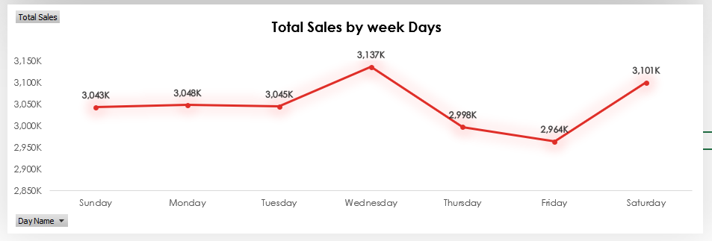

**3. Wednesday Spike**  
There is a noticeable peak on Wednesday, indicating higher mid-week activity.

Wednesday is a **Strong Sales Day**, potentially due to customer behaviour patterns.

**4. Thursday - Friday drops**

sales drops on Thursday and hit the lowest on Friday indicating fewer purchases on these days.

possibly due to weekend anticipation or reduced marketing.

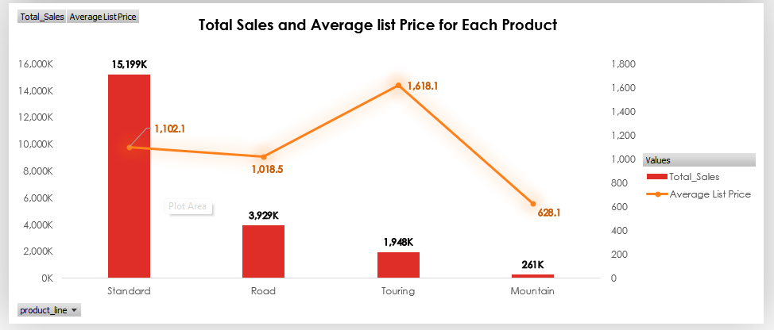

1. **Standard product** sales are the highest among all with a slightly low **average list** price compare to **Touring**
2. **Mountain** being the lowest in sales with average **lowest price** as well
3. **Touring being** the highest Average price list with **last second** total sales much lower than Standard Product

**Recommendations:**

# **Marketing Strategies Targeting High-Value Customer Segments**

Most **High Net Worth** with **higher tenure** are lies in **financial** and **Manufacturing** job category!  
  
**Action:**   
1. Offers Exclusive Perks can be early access to products or personalized product recommendations, email content and financial related products  
  
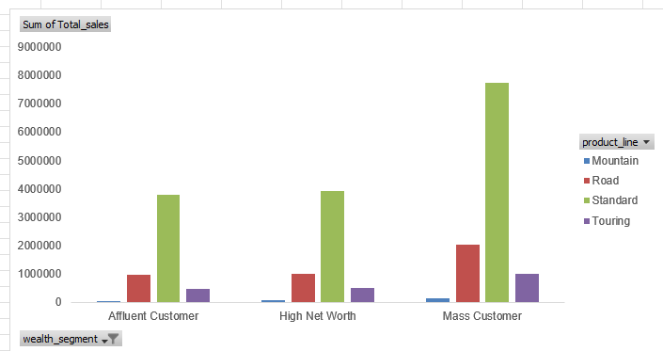  
  
2. Most **Least famous Products** in Overall and **High Net Worth** among Individuals are **Mountain and Touring**  
  
**High Light** and marketing of high end products **Touring** and **Mountain** their quality level and offering bundles with services for increasing average sales amount for them

* **Potential Areas for Business Expansion**

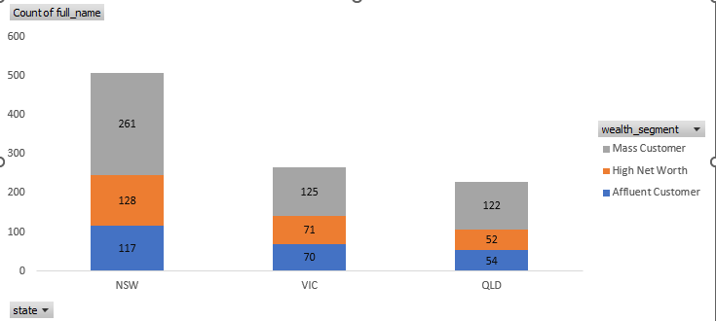

1. Majority of High Net Worth Individuals and over all populations are from **NSW** state will provide the **most revenue** for business expansions
2. Another place can be considered in Vlc where almost half of the individuals stays   
   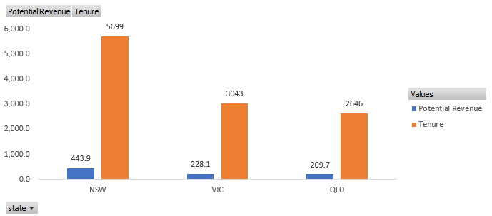
3. Most Potential **Revenue generated** state is **NSW** leading all state
4. **strong Tenure** indicates loyal and long-term Customers

Indicating best for business growth area Focusing on the upselling Premium Products services.

* **Product Offerings Based on Transaction Analysis**

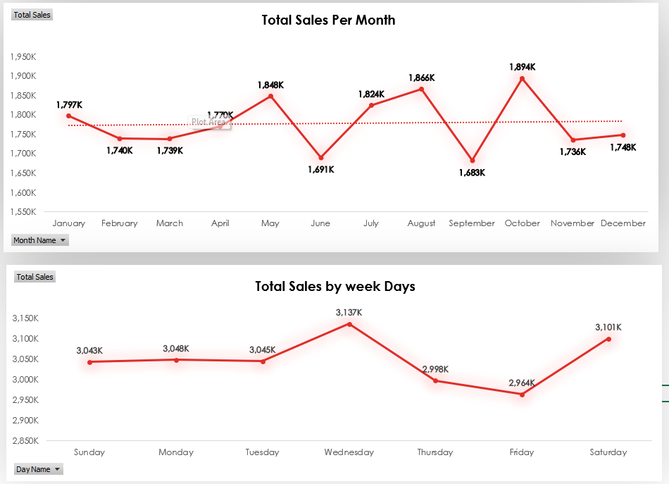

1. **Weekday Sales Patterns: Midweek Strength, Endweek Weakness**

**Highest sales** on **Wednesday hits**: ₹3,137K  
  
**Drop begins on Thursday** (₹2,998K), and **lowest on Friday**: ₹2,964K   
  
Possibly due to customer purchasing behaviour as the weekend approaches OR Possible reduction in marketing efforts late in the week!

**Action:**

**For Spikes Increase warehouse and delivery team availability** on **Wednesday** to ensure faster fulfilment and maintain customer satisfaction!   
  
For **Drops** Evaluate marketing presence on **Thursdays** and **Fridays** considering offers and sales and Discounted Products.

**Drops on June & September**

**Lowest sales in**:

* **June: ₹1,691K**
* **September: ₹1,683K (Lowest of all months)**

Possibly because Off-season period or reduced customer activity.  
  
**Action:**Consider running targeted offers and discounts on these days to balance the week