## Machine Learning Assignment 2 - Jovey Dovey

## 

## Objective

We are training a binary classifier, attempting to get good generalization performance.

## Algorithms Tried

1. Logistic Regression

2. K means - Unsupervised Algorithm

3. Random Forest

4. Support Vector Machine

5. Convolutional Neural Network

### Detailed Analysis of Algorithms

Here we have detailed analysis of all given algorithms including **UNSUPERVISED K-MEANS**  with Accuracy, Confusion Matrix and ROC

1. **Logistic Regression**

**Accuracy** : 0.50005

**Confusion matrix**:

[[9947 52]

[9947 54]]

**ROC**

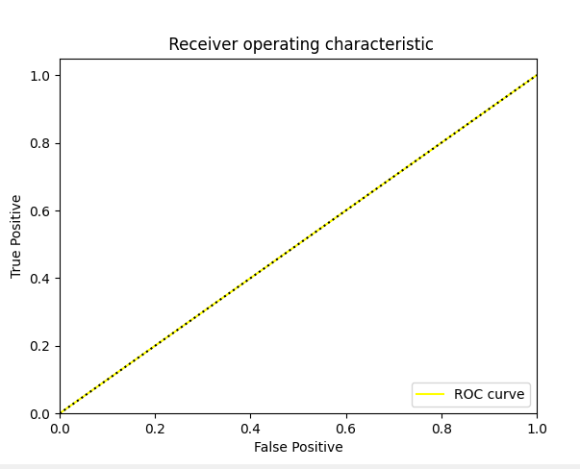

2. **K means - Unsupervised Algorithm**

**Accuracy** : 0.49765

**confusion matrix:**

[[4965 5034]

[5013 4988]]

**ROC**

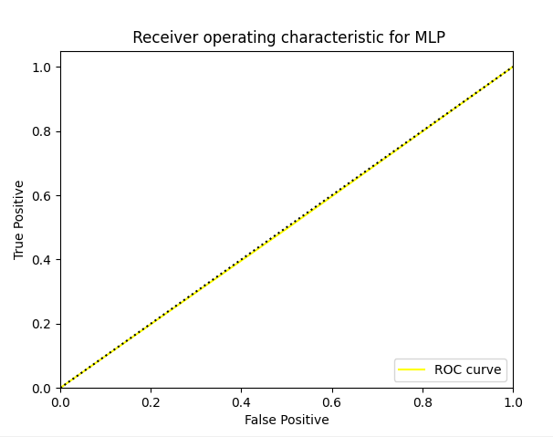

**3. Random Forest**

**Accuracy : 0.53455**

**confusion matrix:**

[[5947 4052]

[5257 4744]]

**ROC**

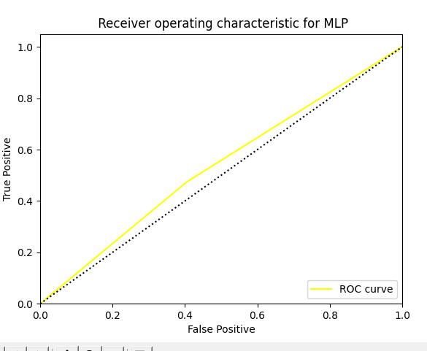

4. Support Vector Machine

For support vector machine we used [Radial basis function](https://en.wikipedia.org/wiki/Radial_basis_function_kernel) as the kernel to get the maximum accuracy

**5. CNN**

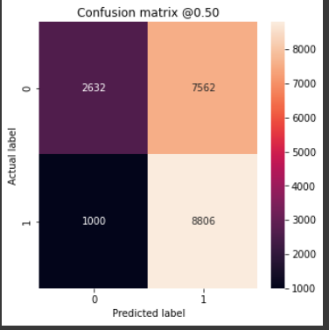

**6.** Multi Layer Perceptron

Accuracy: 0.72115

confusion matrix:

[[6689 3310]

[2267 7734]]

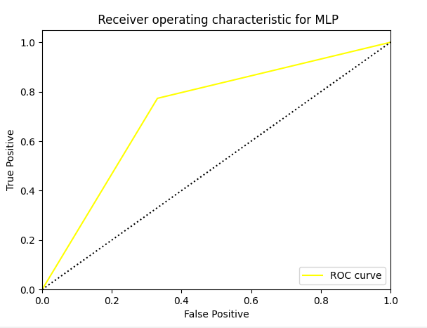

**Conclusion**

Among all the classifiers, we found that highest accuracy of 0.72 was achieved for MultiLayer Perceptron