7COM1079 – Team Research and Development Project

Final Report Title: Investigating Differences in Online Activity Across Student Performance Levels in the xAPI-Edu-Data Dataset
Group ID: [Insert Group ID]
Dataset Number: xAPI-Edu-Data
Prepared By:
- [Your Name – Student ID]
- [Group Member 1 – Student ID]
- [Group Member 2 – Student ID]
- [Additional members]

University of Hertfordshire
Hatfield, 2025

Table of Contents
1. Introduction 4
1.1 Problem Statement and Research Motivation 4
1.2 The Dataset 4
1.3 Research Question 4
1.4 Hypotheses 4
2. Background Research 5
2.1 Relevant literature Review 5
2.2 Why the Research Question Is interesting 5
3. Visualisation 6
3.1 Main Plot and Explanation 6
3.2 Additional Information Relating to Understanding the Data 6
3.3 Helpful Information to Data Understanding 6
4. Analysis 7
4.1 Statistical Test to be used to test the Hypotheses 7
4.2 Decision on hypothesis based on p-value 7
5. Evaluation – Group’s Experience at 7COM1079 7
5.1 What Went Well 7
5.2 Points for Improvement 8
5.3 Group’s Time Management 8
5.4 Project’s Overall Judgement 8
5.5 Comment on GitHub Log Output 8
6. Conclusions 9
6.1 Results Explained 9
6.2 Interpretation of the Results 9
6.3 Limitations and Future Work 9
7. Reference 10
8. Appendix A — R Code Used for Analysis and Visualisation 10

1. Introduction

1.1 Problem Statement and Research Motivation
Learning analytics data is becoming more popular in educational institutions to gain an insight into student use of digital learning environments. Raised hands, resource visits, announcement views and discussion participation are some of the measurable behavioural indicators that could be associated with academic results of students. Determining whether there is a difference in engagement between higher and lower levels of performance is necessary in the design of early-warning systems and interventions (Tora et al., 2025). Previous studies have always documented that pattern of online activity correlates with student success, but few studies have made elaborate statistical comparisons with the xAPI-Edu-Data benchmark dataset. This paper hence tests the question of whether there is any significant difference in distribution of online activity within performance classes.

1.2 The Dataset
The data set, which is the xAPI-Edu-Data, has 480 records of students and 17 variables, such as demographic, engagement behaviour, and performance classes (Low, Medium, High). The variables of numeric activities that were analysed were raised hands, VisITedResources, Announcements View, and Discussion. R was used to clean the data by removing text fields and changing the right variables into numeric or factor. The analysis of descriptive statistics indicates that there are distinct differences in the mean level of engagement with the different performance classes and this warrants further hypothesis testing.

1.3 Research Question
RQ: Do students’ online activity measures (raised hands, visited resources, announcements viewed, and discussion participation) differ significantly across the three performance classes (Low, Medium, High) in the xAPI-Edu-Data dataset?
The question aims at the identification of the fact that the engagement behaviours have a systematic correlation with level of student performance.

1.4 Hypotheses
To test the research question, the hypotheses that were tested under each variable of activities were: Null Hypothesis (H 0) The distribution of the online activity variable is not significantly different between the classes of Low, Medium, and High performance (Althaqafi, Saleem and AL-Ghamdi, 2025). H1: There exists a significant difference in distribution of online activity variable across the three performance classes. Since initial diagnostics revealed the breach of normality and homogeneity, the hypotheses were tested with the Kruskal Wallis non-parametric test, and the Dunn post-hoc tests with Bonferroni correction.

2. Background Research

2.1 Relevant literature Review
The interest of students in the academic outcomes is a long-established predictor of academic performance, and various studies have shown how behavioural interaction data may be used to facilitate early-warning and intervention systems. Some of the most common measures used in research based on online learning environments include access to resources, engagement in discussions, and engagement with an instructor as key predictors of student performance. Research on the analysis of datasets similar to xAPI-Edu-Data indicates that high performing students tend to have more regular patterns of activities and a higher level of interaction intensity compared to low performing students. The variables of engagement like VisITedResources, raisedhands, etc., tend to be among the most effective predictors in machine learning models that assess the result of students (Alkan et al., 2025).
A number of studies have employed a behavioural log within learning management system to establish the relationship between level of activities and overall final achievement categories. These reports indicate statistically significant differences in activity by performance level, which supports the idea that student activity does not happen randomly, but it is significantly correlated with academic level. It is also observed by the literature in the past that non-normal distributions exist in behavioural data, hence the application of non-parametric techniques to compare data. Results in the area encourage hypothesis-based statistical analysis of behavioural indicators especially in structured educational data as is available through xAPI-Edu-Data.

2.2 Why the Research Question Is interesting
Though previous literature is always consistent in associating engagement behaviour with academic performance, most of the studies are concerned with predictive modelling as compared to statistical comparison of performance groups. As a result, a limited analysis is conducted to study the existence of specific engagement variables that vary significantly in Low, Medium, and High-performance classes in the xAPI-Edu-Data benchmark dataset. This gap would give a better understanding of the behavioural patterns that define the levels of performance and would be useful in making informed decisions based on data to the educators. The results of the current research can be used to explain the importance of engagement behaviours that demonstrate the highest levels of variation across performance groups, and, therefore, their use in strategies and monitoring students and creating specific academic support.

3. Visualisation

3.1 Main Plot and Explanation
Boxplots were created to compare the performance variable of each engagement variable (raisedhands, VisITedResources, AnnouncementsView, Discussion) to the three performance classes. Boxplots are suitable since they indicate variation in medians, forms of distribution and outliers between groups. These generated R-visualisations are good initial evidence as to whether there is consistent variation in patterns of activities by class.
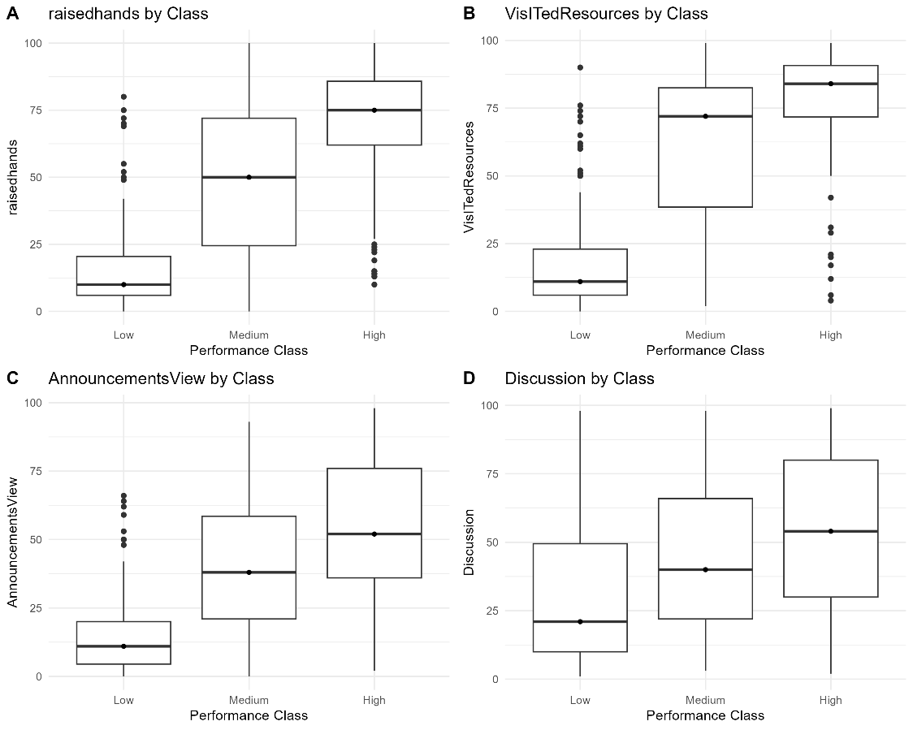
Figure 1: Boxplots of Activity Variables by Performance Class

3.2 Additional Information Relating to Understanding the Data
Where further details are necessary in order to comprehend the data, they are presented here (roughly 50 words). Additional visualisation was made to facilitate interpretation of distribution shapes and categorical patterns (Geeksforgeeks, 2024). The non-parametric tests are motivated by a non-parametric histogram of raisedhands. Gender grouped bar chart by class gives an insight on demographic composition that may affect engagement.
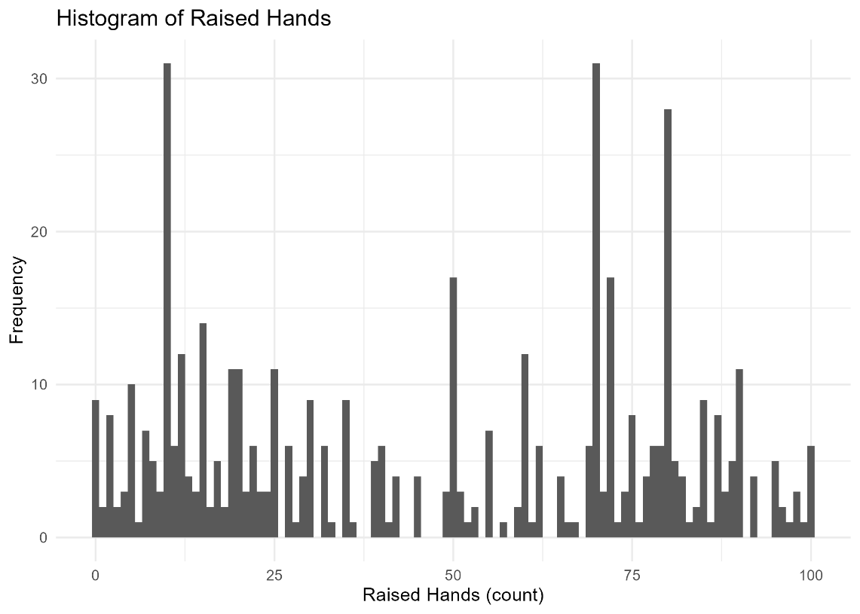
Figure 2: Histogram of Raised Hands
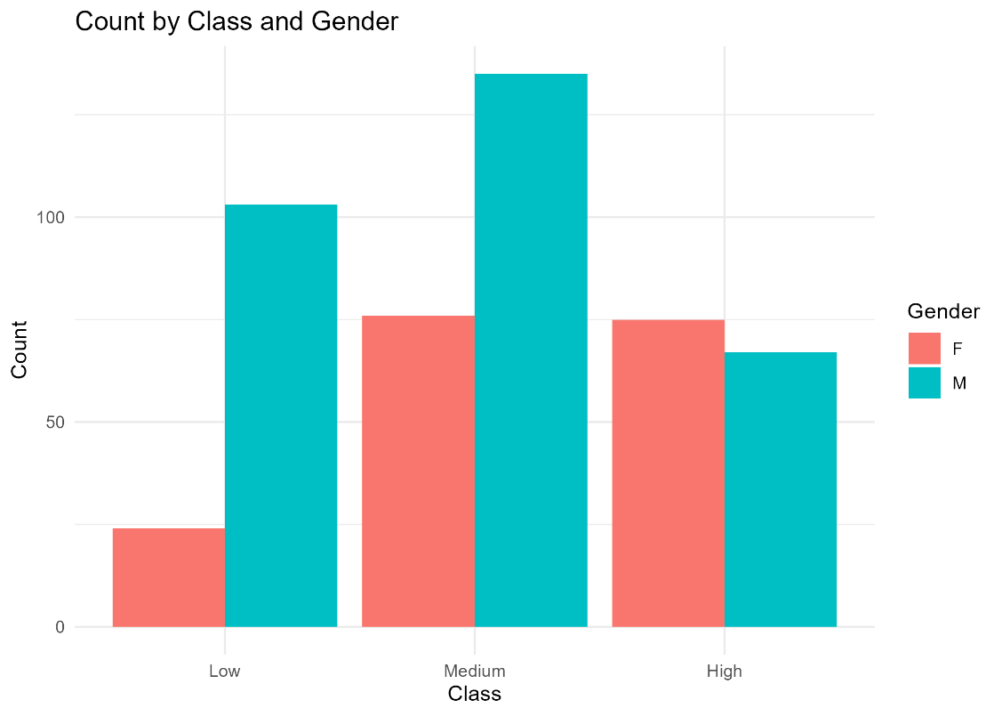
Figure 3: Bar Plot of Gender by Class

3.3 Helpful Information to Data Understanding
In all four boxplots, the engagement rises with the Low classes to the Medium and the Higher classes, implying high behavioural segregation between classes. The histogram contains a multi-modal distribution, with a high level of variability and the gender-class bar chart indicates the disproportionate gender distribution within the categories provided as the supplementary information to the Chi-square test.

4. Analysis

4.1 Statistical Test to be used to test the Hypotheses
Initial diagnostics has demonstrated that all the four variables of engagement were not normative (Shapiro. Wilk p-values less than 0.001 in all classes) and three variables were not homogeneous of variances (Levene test p less than 0.001). Thus, Kruskal-Wallis test was chosen as a suitable non-parametric alternative of one-way ANOVA. In every variable of activity, Kruskal-Wallis was used to compare the distribution of the variable amongst Low, Medium and High-performance classes (Geeksforgeeks, 2020). Dunn has used post-hoc tests with Bonferonni correction when there is significant difference to determine the specific pair-wise differences.

4.2 Decision on hypothesis based on p-value
The differences in all four variables of activities were highly significant in the performance classes.
- raisedhands: KW 2 = 207.82, p < 2.2e-16; all pairwise comparisons significant (e.g., Low High p. Adjust = 5.13e-46).
- VisITedResources: KW 2 = 222.10, p = less than 2.2e-16; all pairwise p. Adjust = less than 1e-7.
- AnnouncementsView: KW 2 =154.85, p<2.2e-16; all pairwise comparisons significant.
- Discussion: KW 2 = 49.648, p = 1.656e-11; all pairwise differentials significant on adjustment.
The p-values of all engagement variables are rejected because all the tests yield p-values much less than 0.05. There are high differences in the engagement behaviour with Low, Medium, and High-performance classes.

5. Evaluation – Group’s Experience at 7COM1079

5.1 What Went Well
The project was a pleasant experience, and the team was able to share duties in the areas of data cleaning, visualisation, statistical testing, and documentation. R enhanced the accuracy of the analytical results of the report and made the outputs reproducible. Teamwork was also enhanced by checking in frequently and checking in on files. The workflow also enabled team members to confirm each other on their work, particularly with the statistical tests, which made the final results more credible and the entire quality of the report more effective.

5.2 Points for Improvement
Early agreement on the research question and analytical focus is one of the areas of improvement because initial exploration generated scope expansion before narrowing on the final hypothesis (Casula, Rangarajan and Shields, 2021). The staff also might do better in terms of coding style and documentation to help new members of the team to follow the script. More time would have been spent on polishing visuals and verifying assumption diagnostics. Projects in future must have set milestones to prevent the last-minute workload congestion.

5.3 Group’s Time Management
Once the group had good time management because of the establishment of clear task ownership. Even though the initial work was slow, the next level of coordination significantly enhanced the efficiency of work. Meetings were made more formal with quicker decision making. In general, the group achieved all the in-house deadlines and finished statistical analysis and report writing within the period of time.

5.4 Project’s Overall Judgement
The module requirements were achieved with the project as a result of generating clean and reproducible R analysis and interpretable results. The results evidently indicate differences in behaviour between performance classes as well as good group cooperation. The major report is coherent, analytically sound, and meaningful insights have been given which are in line with the research question.

5.5 Comment on GitHub Log Output
The GitHub history shows regular commitments by all the members, which show a gradual progress within the project. Three commits of noteworthy commits would be:
- Data Cleaning/ Factor Conversion - came up with a trustworthy base dataset.
- Visualisation Updates - boxplots and histograms of R-generated boxplots and histograms are added.
- Statistical Testing Implementation - completed Kruskal Wallis and Dunn.
These establish open and reproducible cooperation.

6. Conclusions

6.1 Results Explained
The statistical test revealed significant and obvious difference in engagement behaviours among the three classes of performance. The Kruskal-Walli’s test outputs of all four activity variables raisedhands, VisITedResources, AnnouncementsView, and Discussion showed a highly significant result (p < 0.001), and Dunn post-hoc results indicated that each of the classes was significantly different. Also, descriptive statistics revealed a steady upward trend between Low and Medium and High-performance groups on all engagement measures that also supported the strength of the observed relationships.

6.2 Interpretation of the Results
The results show that students with better achievements have been recorded to exhibit high degrees of online activities compared to their underperformers. This indicates that academic performance is closely correlated with the exposure to learning materials and involvement in activities in the classroom. Such behavioural patterns can include better study habits, greater motivation or greater engagement in the learning process. The findings indicate that the tracking of engagement indicators can be a valuable component of institutional early-warning systems that may help to predict students that are vulnerable to academic failure.

6.3 Limitations and Future Work
This research only uses observation as its data and thus cannot be able to draw a causal conclusion. The comparative analysis did not concentrate on additional demographic or contextual variables, which can affect results. The multivariate modelling, effect-size analysis, cross-dataset validation, and fairness assessments should be introduced into future works to provide fair interpretation of engagement-based interventions.

7. Reference
Alkan, B.B., Serafettin Kuzucuk, Alkan, N. and Sinan, A. (2025). Using machine learning to predict student outcomes for early intervention and formative assessment. Scientific Reports, [online] 15(1). doi:https://doi.org/10.1038/s41598-025-23409-w.
Althaqafi, T., Saleem, F. and AL-Ghamdi, A.A.-M. (2025). Enhancing student performance prediction: the role of class imbalance handling in machine learning models. Discover Computing, 28(1). doi:https://doi.org/10.1007/s10791-025-09576-4.
Casula, M., Rangarajan, N. and Shields, P. (2021). The Potential of Working Hypotheses for Deductive Exploratory Research. Quality & Quantity, 55(1), pp.1703–1725. doi:https://doi.org/10.1007/s11135-020-01072-9.
GeeksforGeeks (2020). KruskalWallis test in R Programming. [online] GeeksforGeeks. Available at: https://www.geeksforgeeks.org/r-language/kruskal-wallis-test-in-r-programming/.
GeeksforGeeks (2024). Charts and Graphs for Data Visualization. [online] GeeksforGeeks. Available at: https://www.geeksforgeeks.org/data-visualization/charts-and-graphs-for-data-visualization/.
Tora, T.T., Andarge, L.T., Abebe, A.T., Utallo, A.U., Meshesha, D.T. and Wubie, A.F. (2025). An expert-based assessment of early warning systems effectiveness in South Ethiopia Regional State. Discover Sustainability, 6(1). doi:https://doi.org/10.1007/s43621-025-00943-1.

8. Appendix A — R Code Used for Analysis and Visualisation
The full R script used in this project is included below.
A.1 Full R Script
# ---- 0. Setup ----
packages <- c("tidyverse", "ggplot2", "car", "nnet", "broom", "rstatix", "ggpubr")
installed <- rownames(installed.packages())
for(p in packages){
if(!(p %in% installed)) install.packages(p, repos = "https://cloud.r-project.org")
}

library(tidyverse)
library(ggplot2)
library(car)
library(nnet)
library(broom)
library(rstatix)
library(ggpubr)

# ---- 1. Load data ----
data_path <- "D:/HEN Harrier/Material/MZ52064/xAPI-Edu-Data.csv"
df <- read.csv(data_path, stringsAsFactors = FALSE)

# Quick structure check
str(df)
summary(df)

# ---- 2. Basic cleaning & factor conversions ----
# Trim whitespace from all character columns
df <- df %>%
mutate(across(where(is.character), ~ trimws(.)))

# Convert variables used in analysis to appropriate types
df <- df %>%
mutate(
gender = factor(gender),
StageID = factor(StageID),
GradeID = factor(GradeID),
SectionID = factor(SectionID),
Topic = factor(Topic),
Semester = factor(Semester),
Relation = factor(Relation)
)

# Fix Class: map "L" -> "Low", "M" -> "Medium", "H" -> "High" safely
df$Class <- toupper(df$Class)
df$Class <- ifelse(df$Class == "L", "Low",
ifelse(df$Class == "M", "Medium",
ifelse(df$Class == "H", "High", NA)))
df$Class <- factor(df$Class, levels = c("Low","Medium","High"))

# Numeric variables for activity
activity_vars <- c("raisedhands","VisITedResources","AnnouncementsView","Discussion")
df[activity_vars] <- lapply(df[activity_vars], function(x) as.numeric(as.character(x)))

# ---- 3. Descriptive statistics ----
cat("Total rows:", nrow(df), "\n")
cat("Class distribution:\n")
print(table(df$Class))

desc_by_class <- df %>%
group_by(Class) %>%
summarize(
n = n(),
mean_raisedhands = mean(raisedhands, na.rm = TRUE),
sd_raisedhands = sd(raisedhands, na.rm = TRUE),
mean_resources = mean(VisITedResources, na.rm = TRUE),
sd_resources = sd(VisITedResources, na.rm = TRUE),
mean_announcements = mean(AnnouncementsView, na.rm = TRUE),
sd_announcements = sd(AnnouncementsView, na.rm = TRUE),
mean_discussion = mean(Discussion, na.rm = TRUE),
sd_discussion = sd(Discussion, na.rm = TRUE)
)

cat("\n=== Descriptive statistics by Class ===\n")
print(desc_by_class)
write.csv(desc_by_class, "descriptive_by_class.csv", row.names = FALSE)
cat("Descriptive statistics saved as 'descriptive_by_class.csv'\n")

# ---- 4. Visualisations ----
p_list <- lapply(activity_vars, function(var){
ggplot(df, aes_string(x = "Class", y = var)) +
geom_boxplot() +
stat_summary(fun = median, geom = "point", shape = 20, size = 2, color = "black") +
labs(title = paste(var, "by Class"),
x = "Performance Class",
y = var) +
theme_minimal()
})

main_plot <- ggarrange(plotlist = p_list, ncol = 2, nrow = 2, labels = "AUTO")
print(main_plot) # Display in RStudio Plots pane
ggsave("boxplots_activity_by_class.png", main_plot, width = 10, height = 8)

hist_plot <- ggplot(df, aes(x = raisedhands)) +
geom_histogram(binwidth = 1, closed = "left") +
labs(title = "Histogram of Raised Hands",
x = "Raised Hands (count)",
y = "Frequency") +
theme_minimal()
print(hist_plot) # Display in Plots pane
ggsave("hist_raisedhands.png", hist_plot, width = 7, height = 5)

tab_gender_class <- table(df$gender, df$Class)
cat("\n=== Gender vs Class table ===\n")
print(as.data.frame(tab_gender_class))
write.csv(as.data.frame(tab_gender_class), "gender_class_table.csv", row.names = FALSE)
cat("Gender-Class table saved as 'gender_class_table.csv'\n")

bar_gender_class <- as.data.frame(tab_gender_class) %>%
ggplot(aes(x = Var2, y = Freq, fill = Var1)) +
geom_bar(stat = "identity", position = "dodge") +
labs(title = "Count by Class and Gender", x = "Class", y = "Count", fill = "Gender") +
theme_minimal()
print(bar_gender_class) # Display in Plots pane
ggsave("bar_gender_class.png", bar_gender_class, width = 7, height = 5)

# ---- 5. Statistical testing ----
test_results <- list()

for(var in activity_vars){
cat("\n\n=== Analysis for:", var, "===\n")

if(length(levels(df$Class)[!is.na(levels(df$Class))]) < 2){
cat("Skipping", var, "- Class factor has less than 2 levels.\n")
next
}

shapiro_by_class <- df %>%
group_by(Class) %>%
summarize(
n = sum(!is.na(.data[[var]])),
shapiro_p = ifelse(n >= 3, shapiro.test(.data[[var]])$p.value, NA_real_)
)
print(shapiro_by_class)

lev <- leveneTest(as.formula(paste(var, "~ Class")), data = df)
print(lev)

shapiro_ok <- all(na.omit(shapiro_by_class$shapiro_p) > 0.05)
levene_p <- lev$`Pr(>F)`[1]

if(!is.na(shapiro_ok) && shapiro_ok && levene_p > 0.05){
cat("Using one-way ANOVA for", var, "\n")
aov_mod <- aov(as.formula(paste(var, "~ Class")), data = df)
print(summary(aov_mod))
tuk <- TukeyHSD(aov_mod)
print(tuk)
test_results[[var]] <- list(method = "ANOVA", model = aov_mod, posthoc = tuk)
} else {
cat("Using Kruskal-Wallis for", var, "\n")
kw <- kruskal.test(as.formula(paste(var, "~ Class")), data = df)
print(kw)
dunn <- dunn_test(df, as.formula(paste(var, "~ Class")), p.adjust.method = "bonferroni")
print(dunn)
test_results[[var]] <- list(method = "Kruskal-Wallis", test = kw, posthoc = dunn)
}
}

# ---- 6. Chi-square test ----
cat("\n\n=== Chi-square test: Gender vs Class ===\n")
if(length(levels(df$Class)[!is.na(levels(df$Class))]) < 2){
cat("Cannot perform Chi-square: Class factor has less than 2 levels.\n")
} else {
chi <- chisq.test(tab_gender_class)
print(chi)
if(any(chi$expected < 5)){
cat("Some expected counts < 5; running Fisher's Exact Test:\n")
fisher_res <- fisher.test(tab_gender_class, simulate.p.value = TRUE)
print(fisher_res)
}
}

# ---- 7. Multinomial logistic regression ----
mod_df <- df %>%
select(Class, all_of(activity_vars), gender) %>%
drop_na()

if(length(levels(mod_df$Class)[!is.na(levels(mod_df$Class))]) >= 2){
multinom_mod <- multinom(Class ~ raisedhands + VisITedResources + AnnouncementsView + Discussion + gender,
data = mod_df, trace = FALSE)

cat("\n\n=== Multinomial logistic regression tidy results ===\n")
tidy_multinom <- broom::tidy(multinom_mod, exponentiate = FALSE, conf.int = FALSE)
print(tidy_multinom)
write.csv(tidy_multinom, "multinom_model_results.csv", row.names = FALSE)
cat("Multinomial regression results saved as 'multinom_model_results.csv'\n")

# Odds ratios
or <- exp(coef(multinom_mod))
cat("\nOdds ratios:\n")
print(or)

} else {
cat("Cannot fit multinomial regression: Class factor has less than 2 levels.\n")
}

# ---- 8. Summary / Quick Interpretations ----
cat("\n\n=== Summary for report ===\n")
for(var in activity_vars){
res <- test_results[[var]]
if(!is.null(res)){
if(res$method == "ANOVA"){
p_anova <- summary(res$model)[[1]][["Pr(>F)"]][1]
cat(sprintf("%s: ANOVA p = %.4g\n", var, p_anova))
} else {
p_kw <- res$test$p.value
cat(sprintf("%s: Kruskal-Wallis p = %.4g\n", var, p_kw))
}
}
}
if(exists("chi")) cat("\nChi-square Gender vs Class p =", chi$p.value, "\n")

cat("\nAll plots displayed in Plots pane. Descriptive tables and model outputs saved as CSV.\n")

A.2 Generated Files from R
The following files were produced by the script and must be attached as separate files or inserted into the Appendix:
- descriptive_by_class.csv
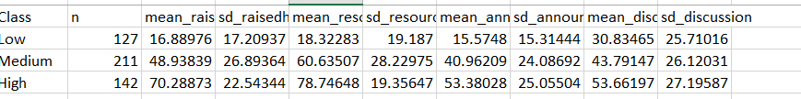
- gender_class_table.csv
Var1 | Var2 | Freq
F | Low | 24
M | Low | 103
F | Medium | 76
M | Medium | 135
F | High | 75
M | High | 67
- multinom_model_results.csv
y.level | term | estimate | std. error | statistic | p. Value
Medium | (Intercept) | -2.045899 | 0.4837503 | -4.2292462 | 2.34E-05
Medium | raisedhands | 0.028762 | 0.008626 | 3.33432971 | 0.000855052
Medium | VisITedResources | 0.033099 | 0.0067268 | 4.92042282 | 8.64E-07
Medium | AnnouncementsView | 0.029932 | 0.0098828 | 3.02868534 | 0.002456204
Medium | Discussion | 0.006815 | 0.0065231 | 1.04474398 | 0.296141314
Medium | gender | -0.718883 | 0.3637104 | -1.9765257 | 0.048095271
High | (Intercept) | -5.506629 | 0.7113733 | -7.7408431 | 9.88E-15
High | raisedhands | 0.051962 | 0.0099642 | 5.21490199 | 1.84E-07
High | VisITedResources | 0.055626 | 0.0088614 | 6.27733849 | 3.44E-10
High | AnnouncementsView | 0.030122 | 0.0112008 | 2.68928304 | 0.007160568
High | Discussion | 0.015561 | 0.0077746 | 2.00146866 | 0.045341908
High | genderM | -1.426689 | 0.4221847 | -3.3793016 | 0.000726702

