Advanced Logistics Data Analysis and Visualization
Week 3 internship report | Ajay Veerabadhran | 25 September 2026
This report analyzes a reproducible hypothetical delivery dataset for the same online retailer scenario used in Weeks 1 and 2. All 840 shipments, costs, times and findings below are simulated. The purpose is to demonstrate exploratory analysis, visualization and interpretation before comparable real dispatch records become available.

1 Dataset design and method
The Python simulation uses a fixed random seed and creates 840 shipment rows over 12 weeks, from 6 April to 28 June 2026. Each shipment has an ID, dispatch date, delivery zone, travel distance, shipment weight, traffic index, delivery duration, promised duration and transport cost. There are four zones: Central, North, South and Outer. The Outer zone receives longer simulated distances and an additional travel time penalty; Central has somewhat heavier traffic. Promised duration is 75 minutes for most zones and 105 minutes for Outer.
Variable | Unit and interpretation
delivery_min and promise_min | Minutes from dispatch; late when delivery_min exceeds promise_min
distance_km and weight_kg | Trip distance and shipment weight
traffic_index | Synthetic relative traffic condition
cost_inr | Synthetic transport cost in Indian rupees
week and zone | Calendar week and delivery region
The cost generator includes distance, weight and a modest long duration term, plus noise. Consequently, a strong distance to cost association is expected by construction. The artificial rows are suitable for teaching plots and calculations, but cannot establish actual company performance or causal effects.

2 Exploratory summary
Measure | Simulated result | Meaning
Shipments | 840 over 12 weeks | Average 70 per week
Delivery time | Mean 67.2 min; median 63.2 min; SD 24.6 min | Right tail raises the mean above the median
Late deliveries | 190 of 840, or 22.6% | Based on each zone’s promise threshold
Trip distance | Mean 15.0 km | Input to route and cost analysis
Transport cost | Mean ₹130.69; median ₹124.10 | Synthetic trip level cost
Pearson correlation | Distance with cost 0.929; traffic with time 0.243 | Associations in generated data, not causal estimates
Daily records were checked for unique shipment IDs, nonnegative distance and cost, and valid dates. The simulated data contain no deliberately injected missing values. Mean, median, standard deviation and zone group summaries describe central tendency and spread. Pearson correlations summarize linear relationships and are interpreted alongside the known simulation formula.

3 Trends and distributions
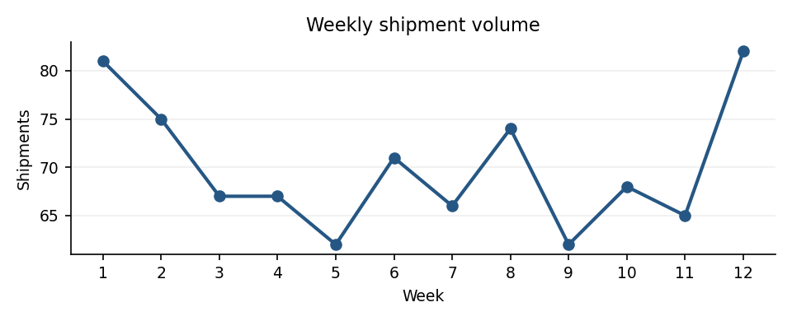
Figure 1 Line chart of weekly shipment counts
A line chart keeps the 12 weeks in order and exposes changes in workload. Weekly counts range from 62 to 82, with peaks in weeks 1 and 12. The sample does not show a sustained upward trend. A dispatcher would compare this variation with planned driver capacity; the simulation does not model seasonal demand.
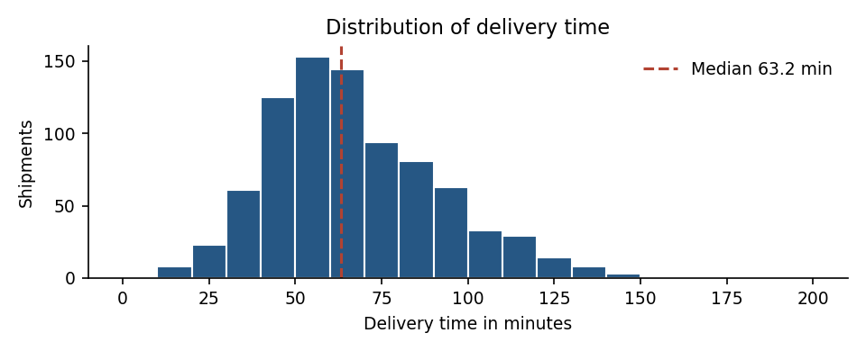
Figure 2 Histogram of delivery duration with its median
A histogram displays the spread and longer duration tail that a single average hides. The median is 63.2 minutes, below the mean of 67.2 minutes. Inspecting long trips and their zones is more useful for scheduling than treating the overall mean as a promise for every stop.

4 Geographic service and cost relationships
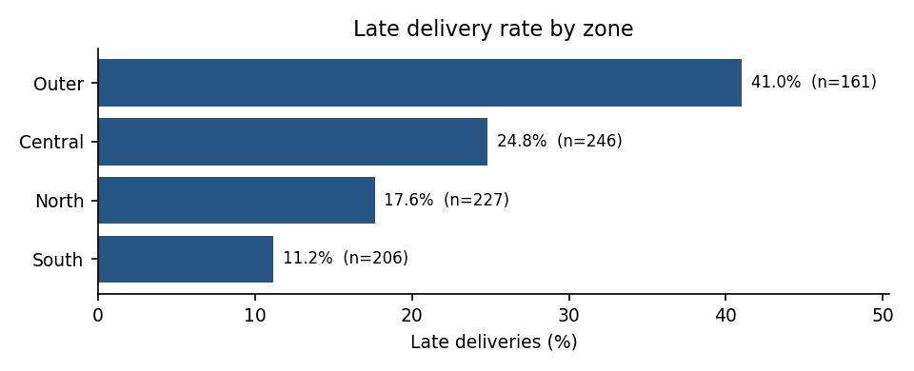
Figure 3 Late delivery percentage and sample size by zone
The horizontal bars allow direct comparison of zone service levels. Outer has 41.0% late among 161 shipments, compared with South at 11.2% among 206. North is 17.6% and Central 24.8%. Outer remains the largest bottleneck despite its longer 105 minute promise. A targeted review should examine trip distances, realistic promises and available vehicle capacity. Because Outer receives an extra simulated time penalty, this difference is partly built into the example.
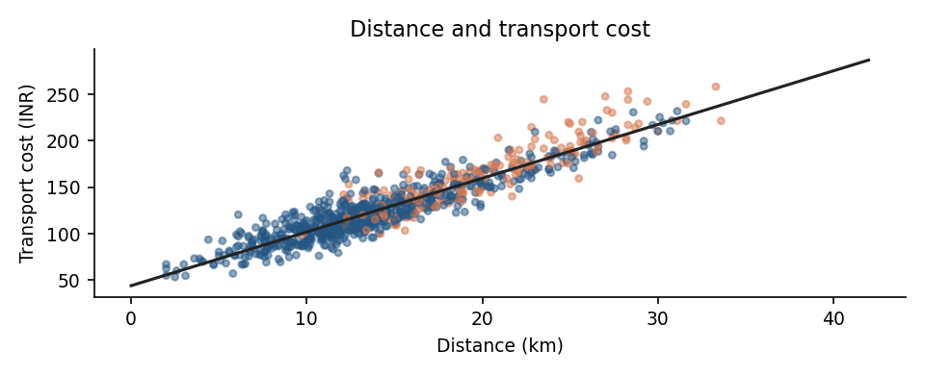
Figure 4 Scatterplot of trip distance and transport cost
A scatterplot shows individual trip variation and the overall positive relationship. Distance and cost have a Pearson correlation of 0.929 in this simulation. The relationship follows directly from the cost generating formula, so it supports a demonstration of cost sensitivity, not a claim that changing distance alone would save that amount in real operations.

5 Python analysis and plotting excerpts
import pandas as pd
import matplotlib.pyplot as plt
x = pd.read_csv("simulated_deliveries.csv", parse_dates=["dispatch_date"])
x["late"] = x["delivery_min"] > x["promise_min"]
summary = x["delivery_min"].agg(["mean", "median", "std"])
zone = x.groupby("zone").agg(n=("shipment_id", "size"),
late_rate=("late", "mean"))
weekly = x.groupby("week")["shipment_id"].size()
r = x[["distance_km", "cost_inr"]].corr().iloc[0, 1]
weekly.plot(marker="o", title="Weekly shipment volume")
plt.xlabel("Week"); plt.ylabel("Shipments"); plt.tight_layout()
plt.savefig("weekly_volume.png", dpi=150)
The full simulation uses numpy.random.default_rng with seed 20260925, and matplotlib creates the four embedded figures. The excerpt shows the key aggregation and plotting pattern; the figures and numerical results in this report were generated by the same reproducible simulation run.

6 Recommendations and limits
For a real pilot, prioritize reviewing Outer zone trips and compare promised windows with observed travel time distributions. Track weekly volume and late rate together so staffing decisions account for service quality. Examine distance, weight and vehicle loading before estimating cost savings. Use shipment level data and matched operating conditions to test any new route plan.
Next, replace simulated rows with permissioned dispatch data, document missing records and cancellations, and recompute every chart with confidence intervals or operationally meaningful time periods. No decision to change promised delivery times or staffing should rest on this synthetic example alone.

