Predictive Modeling and Optimization in Logistics
Week 4 internship report | Ajay Veerabadhran | 25 September 2026
This report extends the Week 3 synthetic delivery dataset to predict each shipment’s delivery duration before dispatch. It compares a simple baseline with Ridge regression and two random forest settings, evaluates them with chronological validation, and proposes a dispatcher review rule. Every result is from hypothetical generated data; it is not evidence of performance at a real retailer.

1 Problem definition and data
Prediction target: delivery duration in minutes from dispatch to arrival. The example has 840 simulated shipments over 12 weeks, four zones, trip distance, shipment weight, a traffic index, dispatch weekday, promise duration and a generated transport cost. The model uses only distance, weight, traffic index, zone and weekday. Promise duration is reserved for the later risk decision, while actual delivery time is the target. Cost is excluded because it was generated partly from delivery time and could leak target information.
For deployment, distance, weight, zone, weekday and a real forecast of traffic must be available when a plan is made. The synthetic traffic index is known in advance by assumption; if real traffic is only observed after the trip, replace it with a predispatch estimate. Rows are sorted by week and date. Weeks 1 to 9 (625 shipments) form the training period; weeks 10 to 12 (215) are untouched until final evaluation.

2 Model choice and validation
A training median baseline establishes whether a learned model adds value. Ridge regression offers a simple linear benchmark with stable coefficients. Random forests allow nonlinear interactions between distance, traffic and zone. One hot encoding converts zones to numeric indicators; numerical variables pass through unchanged. Each model is fitted inside a preprocessing pipeline so the encoder is learned from the training fold only.
Three expanding window folds train on weeks 1–3, 1–5 and 1–7 and validate on weeks 4–5, 6–7 and 8–9 respectively. The holdout weeks 10–12 do not influence model choice. The two forest configurations are fixed candidates, not an exhaustive search. Mean absolute error (MAE) selects the model because it has a direct minutes interpretation. Root mean squared error (RMSE) adds sensitivity to large errors; R² describes variance explained relative to a constant mean predictor.
Candidate | Validation MAE by fold | Mean MAE
Ridge alpha 10 | 8.81, 8.90, 8.97 min | 8.89 min
Forest depth 5 leaf 3 | 8.90, 9.15, 9.21 min | 9.09 min
Forest depth 8 leaf 8 | 8.95, 9.17, 9.25 min | 9.12 min
Ridge has the lowest average validation MAE and is refitted on all training weeks. Tuning remains limited to these declared candidates; additional search should use the same chronological folds and retain the final holdout.

3 Held out model performance
Model | MAE | RMSE | R²
Training median baseline | 20.11 min | 25.15 min | −0.002
Selected Ridge | 8.72 min | 10.81 min | 0.815
The synthetic target was generated mainly from distance, traffic and zone, so a model using those variables is expected to perform well. The 11.39 minute reduction in MAE against the baseline describes only the simulated holdout. R² can be slightly negative for the median baseline because it is compared with the holdout mean. Evaluate errors separately for each zone and for long trips before relying on an operational forecast.
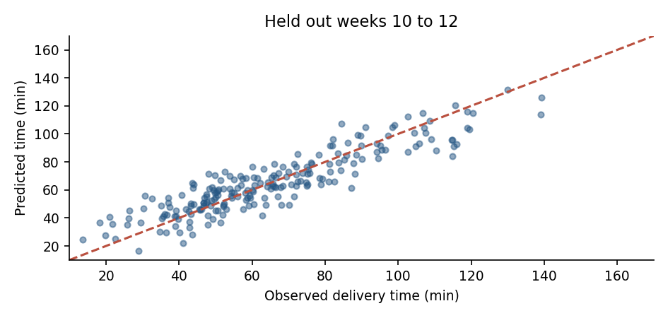
Figure 1 Observed versus predicted delivery duration in held out weeks
The dashed diagonal represents perfect prediction. Scatter around it shows remaining errors, which matter especially near a customer promise threshold.

4 Python implementation excerpts
import pandas as pd
from sklearn.pipeline import Pipeline
from sklearn.compose import ColumnTransformer
from sklearn.preprocessing import OneHotEncoder
from sklearn.linear_model import Ridge
from sklearn.metrics import mean_absolute_error, mean_squared_error, r2_score
x = pd.read_csv("simulated_deliveries.csv", parse_dates=["dispatch_date"])
x["weekday"] = x["dispatch_date"].dt.dayofweek
cols = ["distance_km", "weight_kg", "traffic_index", "zone", "weekday"]
train, test = x[x.week <= 9], x[x.week >= 10]
prep = ColumnTransformer([("zone", OneHotEncoder(handle_unknown="ignore"), ["zone"]),
("numeric", "passthrough", cols[:3] + ["weekday"])])
model = Pipeline([("prep", prep), ("reg", Ridge(alpha=10.0))])
model.fit(train[cols], train["delivery_min"])
pred = model.predict(test[cols])
mae = mean_absolute_error(test["delivery_min"], pred)
rmse = mean_squared_error(test["delivery_min"], pred) ** 0.5
r2 = r2_score(test["delivery_min"], pred)
The full run compared candidates using expanding week folds before executing this final fit. A reproducible random seed was used for the Week 3 simulation and the forest candidates. Code inputs are synthetic and require the simulated CSV to reproduce the numbers.

5 Optimization proposal based on forecasts
A low risk first use is a dispatcher review queue. On each planned shipment, add a 12.89 minute uncertainty buffer to predicted duration; flag the shipment if this conservative estimate exceeds its promised duration. The buffer is the 75th percentile of absolute validation residuals, estimated before looking at the final holdout. Dispatchers can review flagged trips for earlier departure, vehicle reassignment, a feasible route change or a revised promise before committing to any change.
buffer_min = 12.89 # calculated from validation residuals only
at_risk = pred + buffer_min > test["promise_min"].to_numpy()
# Human dispatcher checks route, capacity and service impact for flagged trips.
On the simulated holdout, this rule flags 96 of 215 shipments, including 44 of the 46 that were actually late. The remaining 52 flagged shipments arrived on time, and 2 late shipments were not flagged. These are detection counts, not prevented delays. The review workload is substantial, so a real pilot should vary the buffer and compare staffing cost, false alarms and missed delays.
Route optimization would require stop coordinates, a road travel time matrix, vehicle capacities, driver hours and customer time windows. A vehicle routing solver could minimize total travel time subject to those constraints. A predicted trip duration alone cannot generate a feasible multi stop route. Compare any proposed routes against dispatcher plans on matched days and track distance, cost and on time performance together.

6 Recommendation and limitations
The modeled relationship suggests that long Outer zone trips and congestion deserve early review, but this pattern is encoded in the simulation. The recommended next step is to obtain permissioned dispatch records, rebuild features available before departure, quantify prediction error by zone and week, and run the review rule in shadow mode before a field trial. Retain the baseline if the real model fails to improve service or adds excessive review work.

