Supplementary Methods, Tables, and Figure Legends
A Catalog of Noncanonical HTH and RHH DNA-Binding Domain Families in Archaea

Supplementary Methods

Operational scope and terminology
The discovery universe comprises archaeal proteins detected by profiles in Pfam clans CL0123 and CL0057. “Noncanonical” means not explained by a nineteen-family reference set under the stated reciprocal-exclusion rule. It does not mean previously undescribed in all databases, nor does it establish transcription-factor activity.

Panel construction
Assemblies were grouped into seven major lineage categories. All genomes from five underrepresented groups were retained. Euryarchaeota and Crenarchaeota were capped at 140 and 70; subgroup allocations were proportional and genomes were sampled without replacement using seed 42. The final count of 331 was the output of that rule.

Reciprocal exclusion
For each protein, the best-scoring candidate-domain interval was compared with the best canonical hit. Overlap was shared aligned residues divided by candidate-interval length. A candidate was excluded when overlap exceeded 0.5 and the canonical domain score was at least the candidate score minus 5 bits. The highest-scoring retained candidate was used when multiple candidates remained.

Family construction
Retained proteins were clustered with MMseqs2 at minimum identity 0.30 and coverage 0.60, coverage mode 0, cluster mode 1. Clusters required occurrence in at least five genomes, median length below 250 amino acids, at least 60 percent of members below 250 amino acids, and absence of clearly nonregulatory annotation keywords.

Panel and projection sensitivity
Five hundred seeded within-panel resamples tested three alternative sampling schemes using fixed family membership. A separate 500-replicate analysis sampled 331 lineage-matched genomes from the independent 3,192-genome projection matrix after removing discovery-panel accessions. These analyses test retention and HMM transfer, not de novo rediscovery.

Genome-quality sensitivity
The 3,192 accession-resolved projection genomes were stratified by origin, assembly level, and reported completeness/contamination. Per-family prevalence and detected-family counts were reported. Contrasts are descriptive because strata are confounded with lineage and sampling.

Motif holdout
For twelve families, PWMs were fitted to 70 percent training partitions and evaluated on 30 percent held-out partitions for 30 seeded replicates. Controls were dinucleotide-shuffled versions of held-out sequences and GC-matched upstreams from other families. Genome-blocked splits held out genomes; genus-blocked splits held out complete genera. Overlapping resamples were summarized descriptively, without treating them as independent hypothesis-test replicates.

Evidence limits
Neighborhood enrichment is treated as association, motif prediction as sequence-level prediction, and structure matching as similarity to a curated reference set. None alone demonstrates direct DNA binding or transcriptional regulation.

Confirmatory and exploratory analysis classification
Analysis | Role | Question | Principal limit
Catalog size and membership | Primary descriptive | Prespecified released pipeline summaries | Bounded to two Pfam clans
Held-out family HMM assignment | Confirmatory validation | Withheld sequence assignment | Only families with ≥20 members
Independent-genome projection | Confirmatory validation | Zero accession overlap | Fixed HMMs; no rediscovery
Genome/genus-blocked motif AUC | Confirmatory sensitivity | Out-of-sample discrimination | Predictive, not biochemical
Genome-quality stratification | Sensitivity | Robustness across deposited strata | Descriptive; confounded
Neighborhood enrichment | Exploratory | Functional hypothesis generation | No direct target claim
Haloferax expression | Exploratory | Expression context | Three replicates; simple transformed-count tests
Experimental validation plan | Future work | Direct binding and in vivo regulation | Not performed

Data artifact definitions
Artifact | Scope | Permitted interpretation
Discovery panel | 331 accessions | Family discovery and fixed-member sensitivity
Legacy projection matrix | 250 × 3,192 | Accession-resolved projection sensitivity
Final genome accounting | 3,526 genomes | Final fates and denominators
Corrected prevalence | 250 families × 7 groups | Final group-level prevalence only
Family upstreams | 12 families; 250-nt sequences | Genome/genus-blocked motif validation

Figure S5
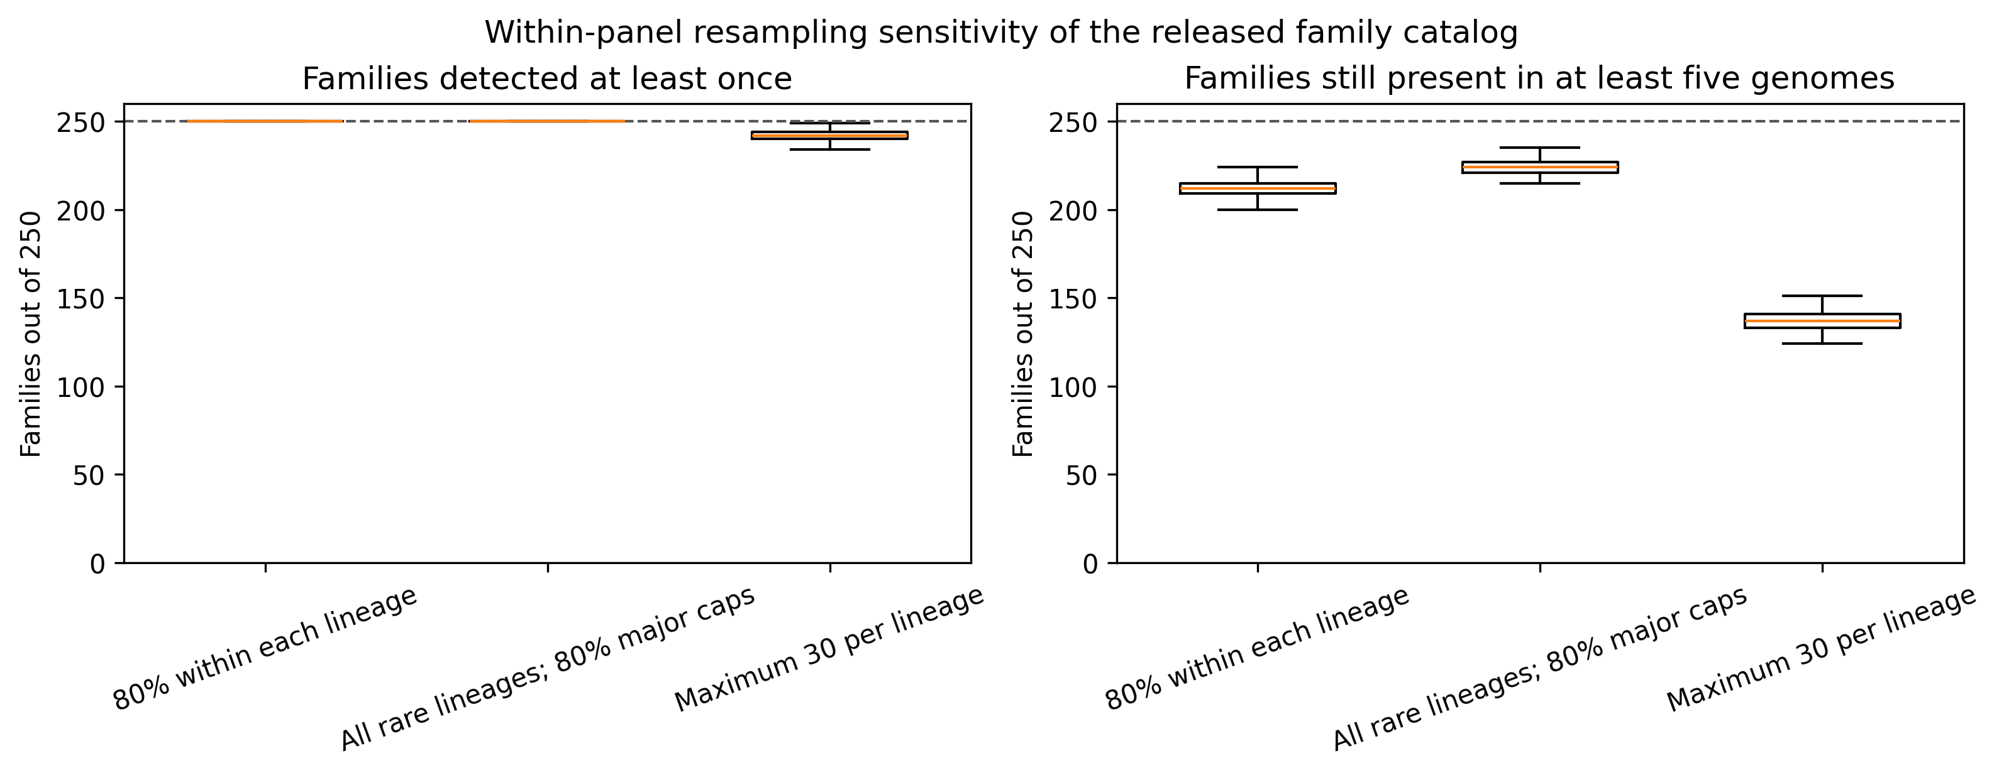
Figure S5. Within-panel fixed-family retention under three alternative sampling schemes. Boxes summarize 500 seeded replicates. This analysis asks whether already-defined families remain represented; it is not a de novo clustering sensitivity analysis.

Figure S6
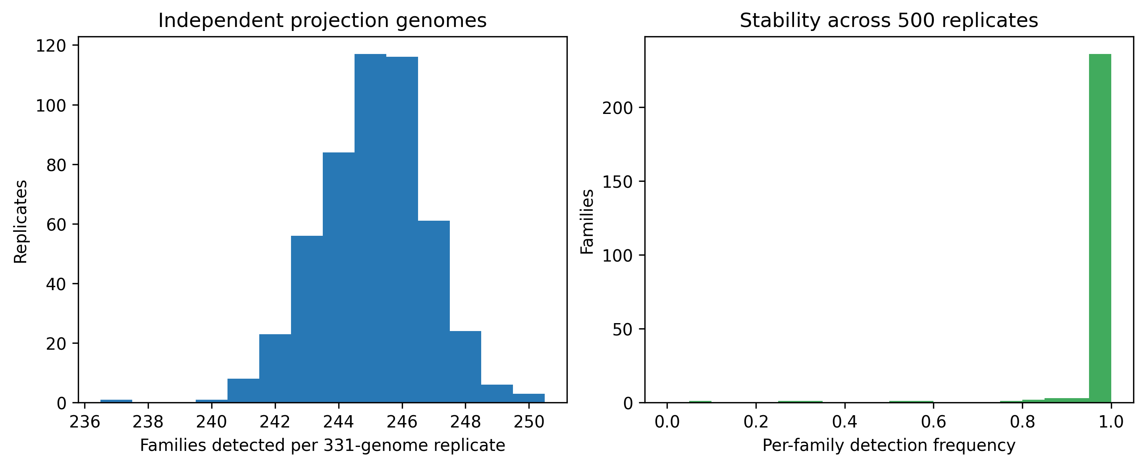
Figure S6. Projection of released family HMMs to 500 lineage-matched samples of 331 independent genome accessions. The discovery/projection accession overlap is zero. Results test HMM transfer, not independent family discovery.

Figure S7
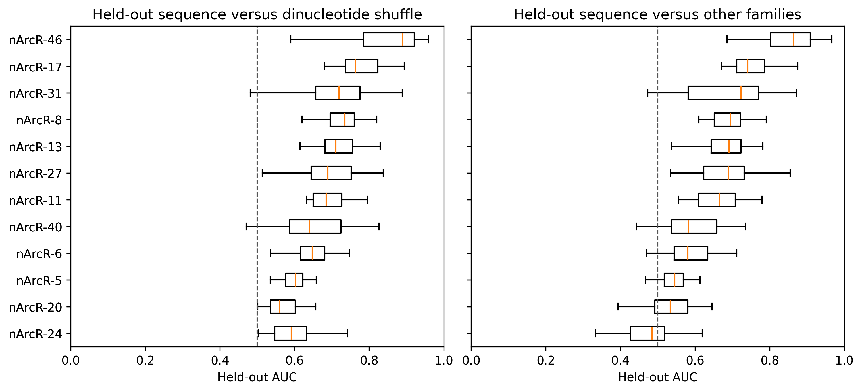
Figure S7. Genome-level motif holdout for 12 families. PWMs were fitted only to training genomes and scored against held-out family upstreams, dinucleotide shuffles, and GC-matched other-family upstreams. Repeated splits overlap and are interpreted descriptively.

Figure S8
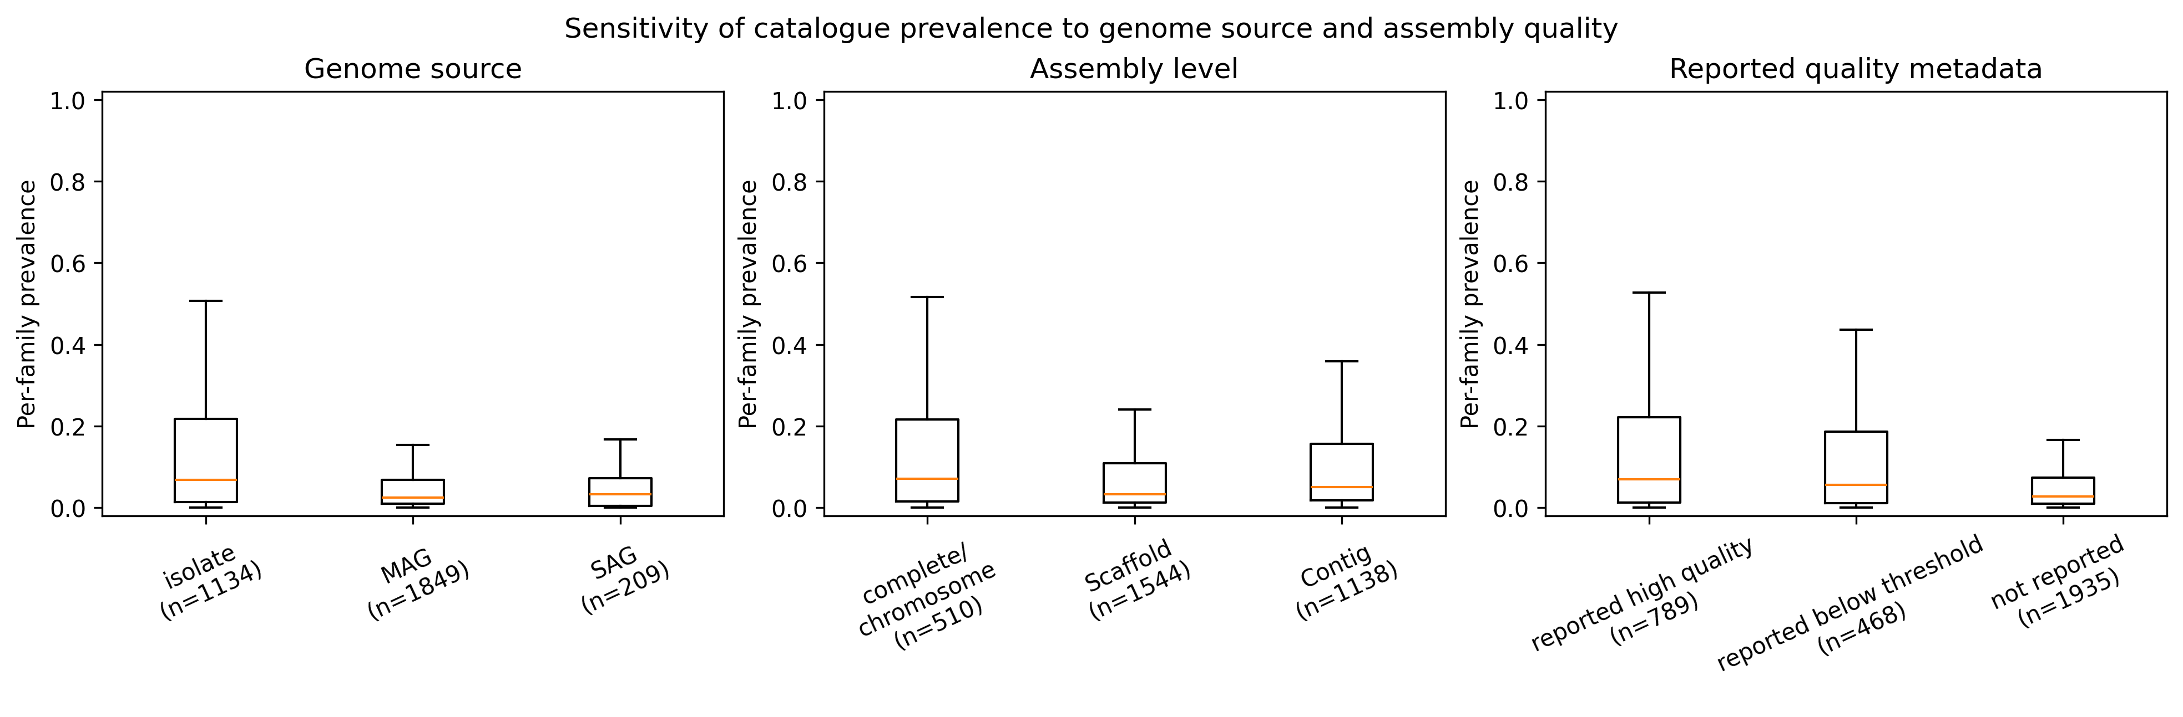
Figure S8. Sensitivity of per-family prevalence to genome source, assembly level, and reported completeness/contamination. Boxes summarize the 250 family prevalence values within each stratum. Differences are descriptive because strata are confounded with lineage and sampling.

Figure S9
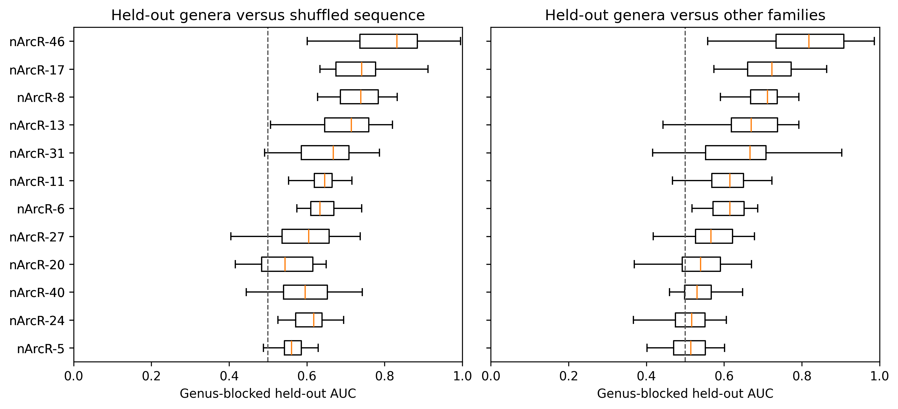
Figure S9. Genus-blocked motif holdout with zero train/test genus overlap. Seven of 12 families exceeded AUC 0.5 against other-family controls in at least 26 of 30 resamples. This stricter result shows that some genome-level signal is lineage-associated.

Figure S10
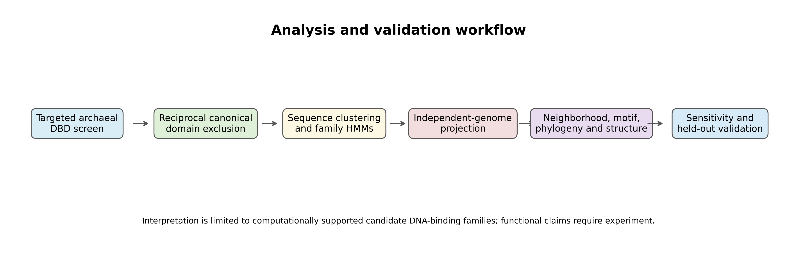
Figure S10. Workflow from the targeted two-clan scan through family construction, projection, contextual analyses, and sensitivity validation. The endpoint is a bounded candidate-family catalog, not an experimentally confirmed regulome.

