A catalog of noncanonical HTH and RHH DNA-binding domain families in Archaea
Ajay Vellanki¹,* and Shaurya Dosapati¹,*
¹Independent researchers, West Windsor, New Jersey, United States of America
*Correspondence: ajayvellanki0720@gmail.com; devshaurya25@gmail.com
Ajay Vellanki ORCID: 0009-0008-7994-152X
These authors contributed equally.
Keywords: Archaea; DNA-binding domain; helix-turn-helix; ribbon-helix-helix; comparative genomics; protein structure

Abstract
Archaeal regulatory annotation relies heavily on familiar helix-turn-helix and ribbon-helix-helix families, leaving the organization of related but noncanonical sequences unclear. We therefore asked how much additional family-level diversity is detectable within the two Pfam clans containing these domain classes after removal of a nineteen-family reference set. A transparent, lineage-aware sampling and filtering workflow applied to 331 genomes identified 250 candidate families. Held-out sequence assignment and projection to independent genome accessions showed that most family profiles were separable and transferable. Upstream-sequence signals weakened when entire genera or major lineages were held out, indicating that some apparent motif performance reflects taxonomic structure. Broader sequence and structural comparisons resolved most families initially lacking a Pfam characterization; nine remained unresolved by the resources tested. The central result is a bounded, reproducible organization of noncanonical members of two archaeal DNA-binding-domain clans, not a comprehensive map of archaeal DNA-binding proteins or proof of transcription-factor activity. The catalog provides a focused set of families for biochemical and genetic validation.

Introduction
Archaea combine a eukaryote related basal transcription apparatus with many compact bacterial type regulators. Most annotated archaeal one component regulators are assigned to a familiar set of HTH, RHH, and metal responsive families [1–6]. That reference set is useful, but it can also make the recognizable fraction appear more complete than it is.
A protein that carries a small DNA-binding fold is not necessarily a transcription factor. Related domains occur in antitoxins, defense and mobile element proteins, chromosome proteins, and enzymes involved in DNA transactions. Sequence, structure, genomic neighborhood, motif, phylogenetic, and expression evidence therefore answer different questions. In this study, DNA-binding domain protein denotes a sequence assigned to the targeted HTH or RHH Pfam clans. Candidate regulator denotes a family with additional contextual evidence. Transcription factor is reserved for experimentally demonstrated regulatory activity.
Our question is deliberately narrower than a survey of every archaeal DNA-binding protein. We examine members of Pfam clans CL0123 and CL0057 that are not explained by a nineteen-family reference set, group them into reproducible families, map their distribution and prioritize families for experiments. Proteins outside these clans, highly diverged sequences missed by their profiles and non-HTH or non-RHH DNA-binding mechanisms are outside the search universe. Because no complete reference universe of archaeal DNA-binding proteins exists, the fraction of total DNA-binding-domain space captured by these two clans cannot be estimated from the present data.

Results

A rule based discovery panel
The discovery panel was generated by an explicit rule rather than by selecting a target of 331 genomes. All genomes available for Thaumarchaeota, DPANN, Asgardarchaeota, other deep TACK lineages, and Korarchaeota were retained. Euryarchaeota and Crenarchaeota were capped at 140 and 70 genomes, respectively; genomes within those two groups were sampled in proportion to subgroup abundance with random seed 42. The rule produced 331 genomes: 140 Euryarchaeota, 70 Crenarchaeota, 51 Thaumarchaeota, 33 DPANN, 19 Asgardarchaeota, 15 other deep TACK, and 3 Korarchaeota. The caps are pragmatic controls for database imbalance rather than biologically optimal values. Panel composition and the selection rule are summarized in Table 1.
Table 1. Discovery-panel composition
Major group | Genomes | Panel rule
Euryarchaeota | 140 | Proportional sampling within group; cap 140
Crenarchaeota and TACK | 70 | Proportional sampling within group; cap 70
Thaumarchaeota | 51 | All available genomes retained
DPANN | 33 | All available genomes retained
Asgardarchaeota | 19 | All available genomes retained
Other deep TACK | 15 | All available genomes retained
Korarchaeota | 3 | All available genomes retained
The panel includes 155 complete assemblies, 4 chromosome level assemblies, 58 scaffolds, and 114 contig level assemblies. This mixture broadens lineage representation but makes absence calls conservative, especially in incomplete genomes.

A bounded search reveals extensive sequence diversity beyond the reference set
We scanned the 331 proteomes against profiles from Pfam clans CL0123 and CL0057 after removing the twenty profile models used to represent the nineteen canonical families. Candidate and canonical matches were compared on the aligned protein-domain interval, not on an upstream DNA regulatory region. For each protein, the highest-scoring candidate interval was retained. A canonical hit excluded that candidate only when it overlapped more than half of the candidate interval and its domain bit score was no more than 5 bits below the candidate score. The 5-bit tolerance was inherited from the original pipeline and was not chosen by prospective performance optimization. Because the released archive lacks the complete prefilter hit tables, its sensitivity cannot be recomputed; the threshold is therefore an operational assignment rule, not a biological cutoff.
Within this defined universe, 38,153 proteins carried a targeted domain. Of these, 16,535 (43.3 percent) matched the nineteen family reference set, 14,451 (37.9 percent) matched another characterized family, and 7,167 (18.8 percent) were assigned to a DUF or lacked a Pfam annotation. These numbers quantify diversity relative to the chosen reference and clans; they do not imply that 56.7 percent of all archaeal transcription factors are unknown.
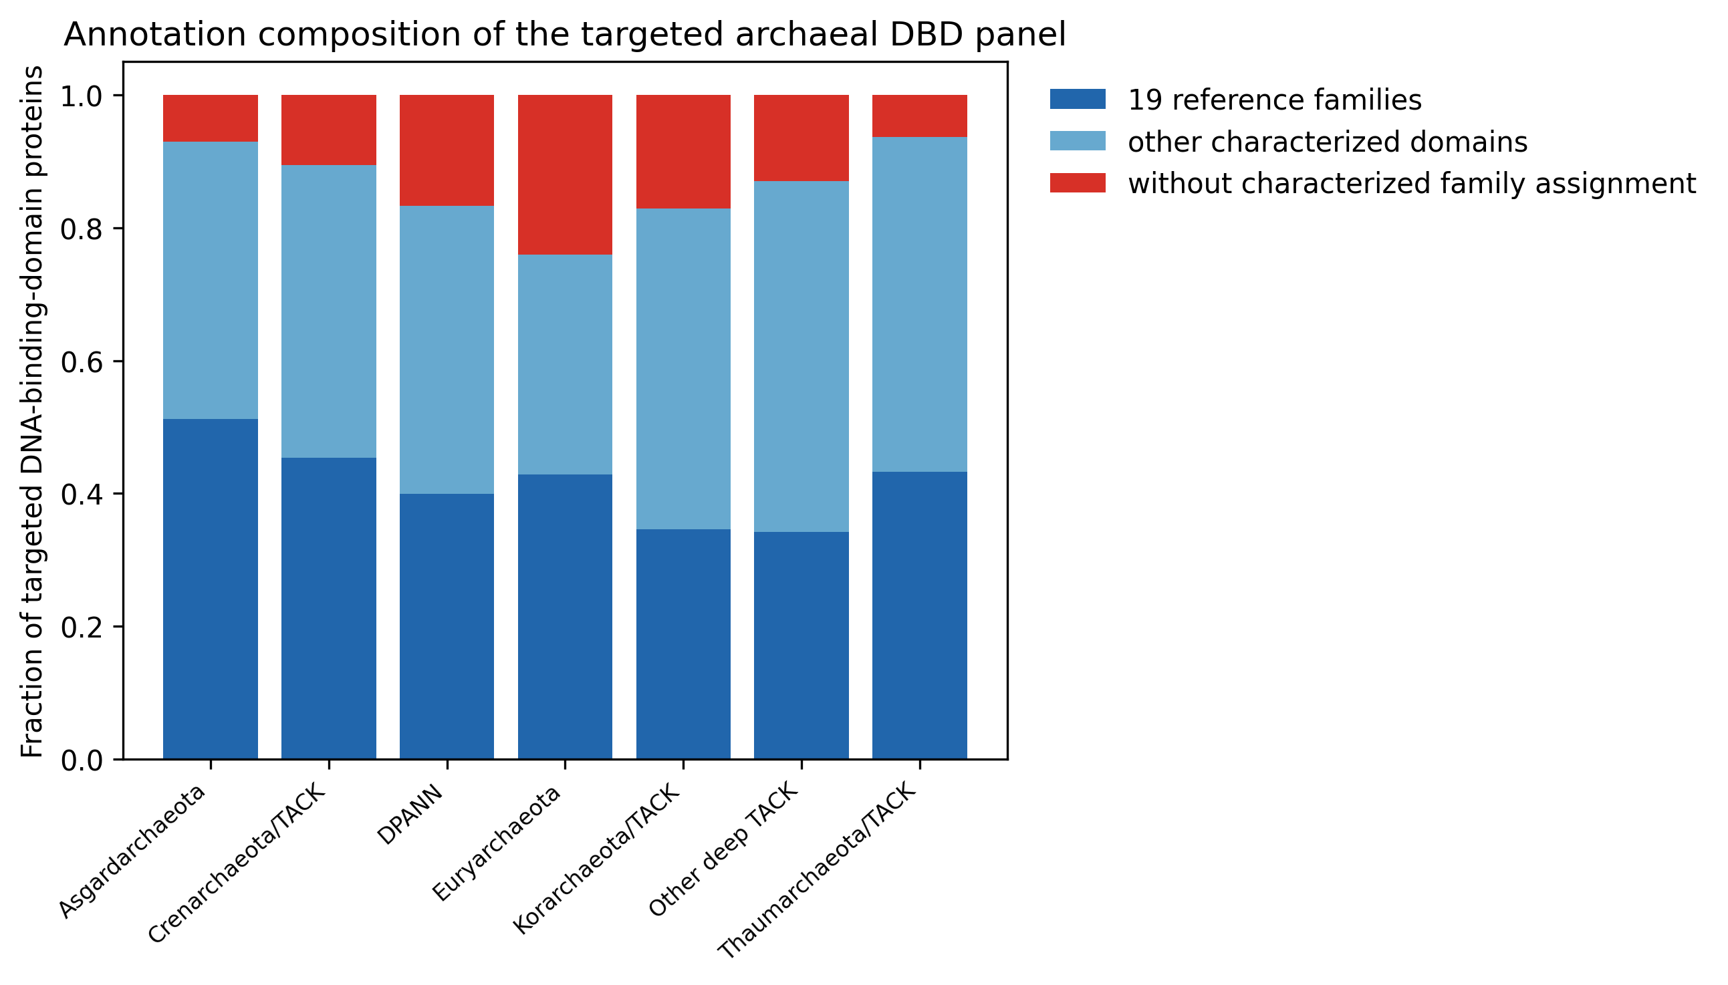
Figure 1. Annotation composition of the targeted archaeal DBD panel. Fractions are calculated only among proteins detected through Pfam clans CL0123 and CL0057. “Without characterized family assignment” is an operational annotation category, not evidence of a new fold or function.

Sequence clustering defines 250 candidate families
The noncanonical proteins were clustered with MMseqs2 at 30 percent sequence identity and 60 percent coverage. We retained clusters with a median protein length below 250 amino acids, at least 60 percent of members below 250 amino acids, and occurrence in at least five panel genomes, then removed clusters carrying keywords associated with clearly nonregulatory functions. This produced 250 candidate families, nArcR 1 through nArcR 250, comprising 13,237 proteins. Of the families, 171 have a characterized domain outside the reference set and 79 were uncharacterized by Pfam. Accordingly, the main novelty is the family level organization and archaeal distribution of noncanonical clan members, not 250 newly discovered DNA-binding folds.
A previously completed 24 setting clustering sweep showed that 130 families remained stable across at least half the settings and 80 across at least 20 settings. Higher identity thresholds usually split families into pure subfamilies, whereas lower thresholds merged some boundaries. No family collapsed into a canonical cluster. Family existence is therefore more stable than exact granularity.

Within panel resampling separates detection from abundance threshold sensitivity
We added a 500 replicate resampling analysis using the released panel and membership table. In stratified samples retaining 80 percent of each lineage, all 250 families were detected at least once in every replicate; a median of 212 retained membership in at least five sampled genomes (95 percent interval 204 to 220). When all rare groups were retained and the two capped groups were reduced to 80 percent, all families were again detected and a median of 224 retained five genomes (218 to 231). A deliberately smaller panel capped every major group at 30 genomes, producing 157 genomes, recovered a median of 242 families at least once (235 to 247) and 137 at five genomes (127 to 148). The analysis supports the robustness of catalog detection to moderate within panel resampling, while showing that the five genome inclusion rule is sensitive to panel size. It cannot substitute for full rediscovery from alternative draws of the unreleased 1,069 genome candidate pool. (Supplementary Fig. S1).
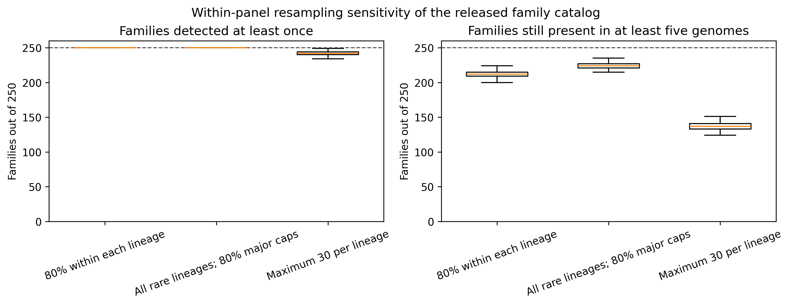
Figure 2. Within panel resampling sensitivity. Boxes summarize 500 replicates per scheme. The dashed line marks the complete 250 family catalog. Family detection is robust to moderate stratified resampling, whereas retention above the five genome criterion declines with sample size.

Family profiles are separable and distributions span broad to restricted
For 96 families with at least 20 members, 30 percent of sequences were withheld, family HMMs were rebuilt, and the withheld sequences were reassigned. The correct family was recovered for 3,444 of 3,538 sequences (97.3 percent); the median best versus second best score margin was 85.9 bits. This tests assignment separability after the families have been defined, not whether the initial search universe was exhaustive.
The only released protein-sequence collection suitable for an additional boundary check contains 782 sequences from ten phylogenetic example families. In leave-one-sequence-out classification using dipeptide-composition centroids, family-specific accuracies ranged from 0.775 to 0.963. This alignment-free result supports compositional separability in that subset only; it does not validate the remaining 240 family boundaries. (Supplementary Fig. S8).
Projection placed the families across an accounting set of 3,526 archaeal genomes: 1,324 isolates, 1,986 metagenome-assembled genomes, and 216 single-amplified genomes. Corrected prevalence was recomputed against the full lineage denominators after 379 initially zero hit genomes were rescued by HMM scanning. The released raw presence absence and copy number matrices contain only the earlier 3,192 genome pass; therefore corrected prevalence tables, not those legacy matrices, support the 3,526 genome summaries. Because MAGs and SAGs may be incomplete, no confident hit is not equivalent to confirmed biological absence.
We tested profile transfer on accessions outside the discovery panel by drawing 500 lineage-matched samples of 331 genomes from the released 3,192 genome projection matrix. The samples used the discovery panel lineage counts and had zero accession overlap with the discovery set. A median of 245 of 250 families was detected at least once in each sample (95 percent interval 242 to 248), and a median of 206 occurred in at least five genomes (198 to 215). This result supports transferability of the released family HMMs to independent genomes. It does not test whether the full scan and clustering workflow would rediscover the same family boundaries. (Supplementary Fig. S2).
We next stratified the accession-resolved 3,192-genome projection by genome origin, assembly level, and reported completeness/contamination. Each stratum retained 242–249 of the 250 families, except the smaller single-amplified-genome stratum, which retained 205. Median per-family prevalence varied from 0.025 in MAGs to 0.068 in isolates and from 0.034 in scaffold assemblies to 0.072 in complete/chromosome assemblies. These descriptive shifts are confounded by lineage and sampling, but they show why non-detection and cross-stratum prevalence differences must be interpreted conservatively. (Supplementary Fig. S4).
To reduce genome-level pseudoreplication, we inferred 533 genus labels from the deposited organism names and resampled genera as clusters for 1,000 replicates. Genome-weighted and genus-balanced prevalence differed appreciably for some families, and the versioned table reports both estimates with cluster-bootstrap intervals. Because the release lacks a versioned taxonomy and species tree, this is a taxonomic-cluster sensitivity analysis rather than formal phylogenetic comparative inference. (Supplementary Fig. S7).
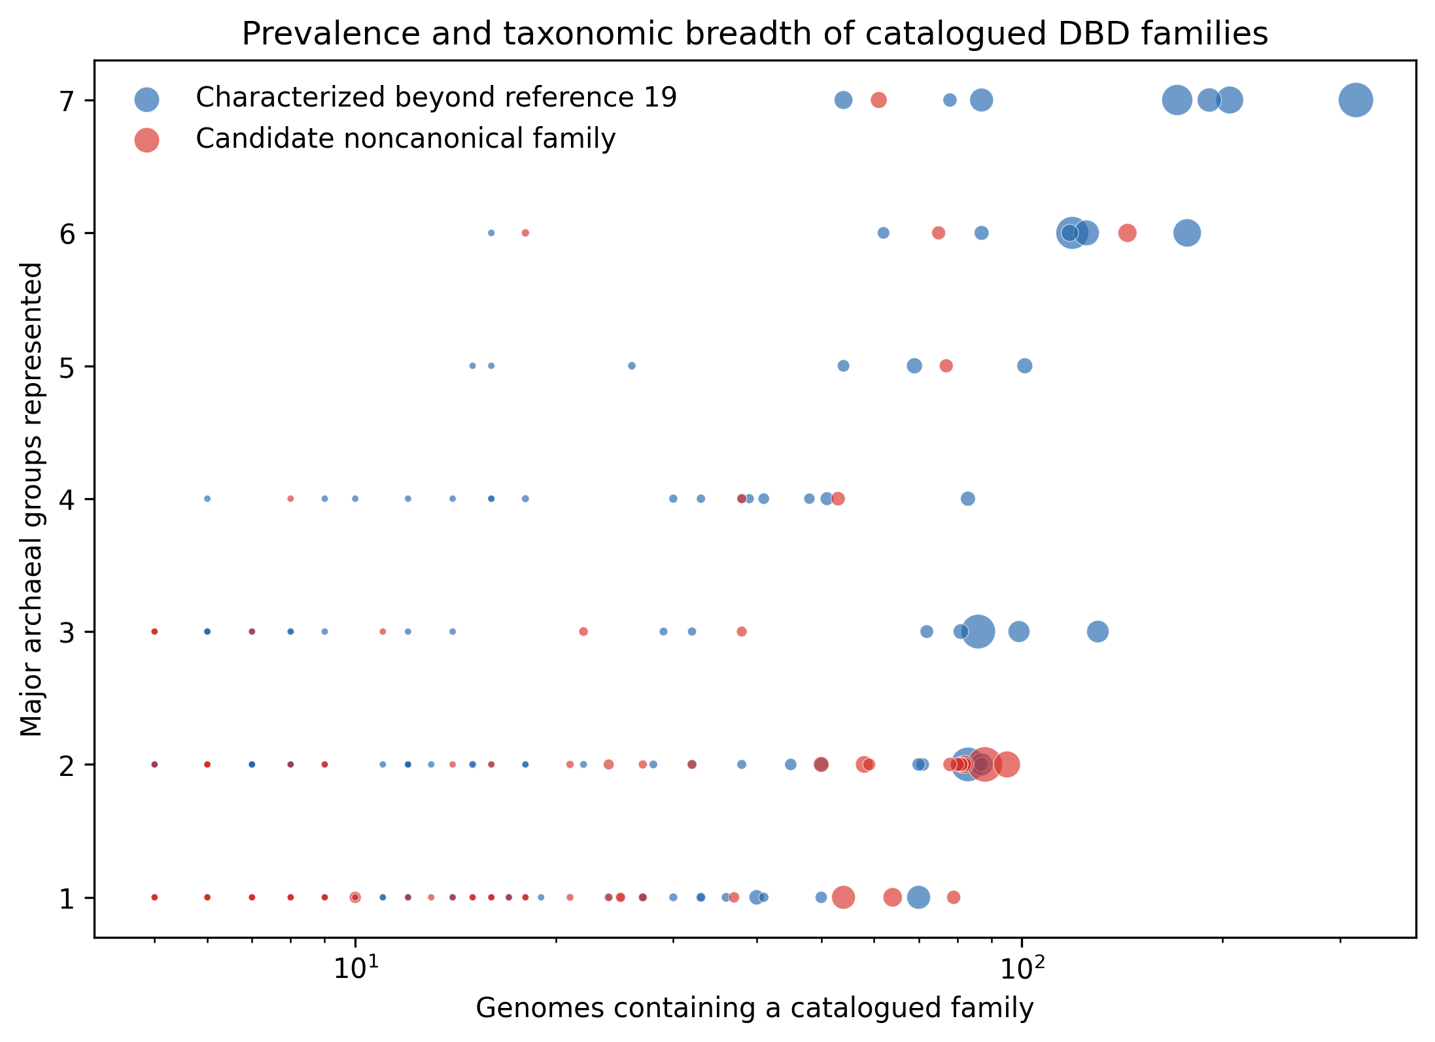
Figure 3. Prevalence and taxonomic breadth of catalogued DBD families. Point size reflects family membership. “Candidate noncanonical family” means outside the nineteen-family reference set within the two-clan search universe; it does not imply experimentally demonstrated regulatory function.
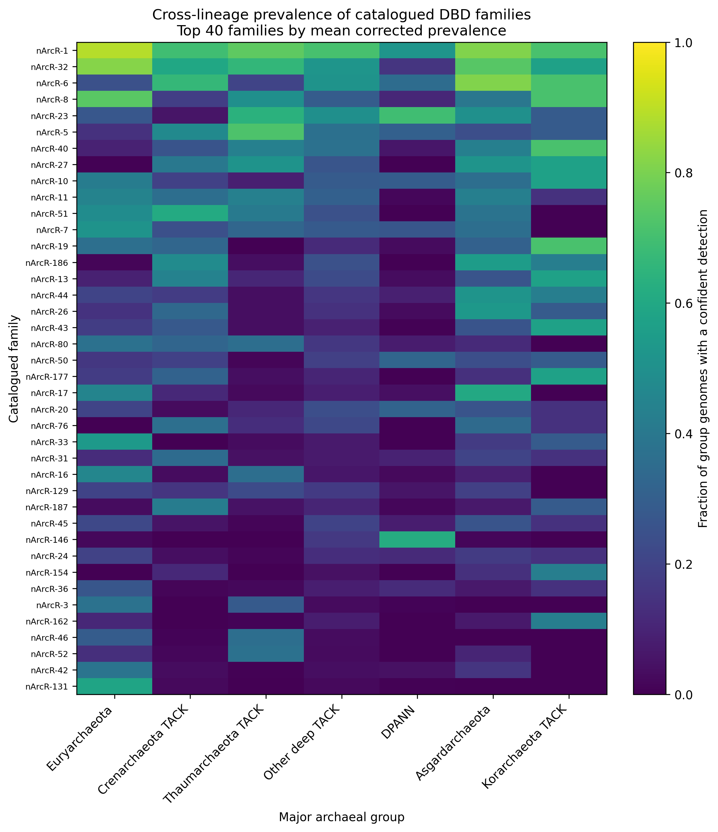
Figure 4. Corrected cross-lineage prevalence for the 40 catalogued families with the highest mean prevalence. Values use the full 3,526-genome group denominators and should be interpreted as confident detections rather than definitive absences.

Genomic neighborhoods generate hypotheses rather than confirmed regulons
An initial genome shuffled enrichment screen found at least one neighboring category for 178 families. The most frequent top categories included toxin antitoxin systems, HalOD1 type signaling, DNA repair and replication, transport, oxidoreductases, methyltransferases, and metallohydrolases. A stricter genus collapsed and whole neighborhood block permutation analysis was used to reduce phylogenetic nonindependence and locus pseudoreplication. Strong associations for nArcR 10, 13, 20, 28, and 50 near toxin antitoxin loci; nArcR 107 near CRISPR and defense loci; nArcR 9 near peptidase and kinase genes; and nArcR 2 near HalOD1 signaling survived at the empirical permutation floor. Other associations weakened under the dependence aware analysis.
Upstream motif discovery provides a separate line of evidence. Eleven of twelve tested families produced a motif that exceeded mononucleotide, dinucleotide, and shuffled family assignment nulls after multiple testing correction. nArcR 6 failed the assignment null. In a deeper analysis of six flagship families, motifs derived from regulator upstreams were generally not enriched upstream of their predicted neighboring targets; five of six tests had p greater than 0.5 and nArcR 20 was marginal at p equals 0.04. These negative results rule out a direct regulon claim from the present data. The neighborhood and motif results instead nominate protein families and loci for binding assays and genetic perturbation.
We next relearned each motif after splitting genomes into 70 percent training and 30 percent test sets for 30 seeded replicates. All 12 motifs had median held out AUC above 0.5 against dinucleotide shuffled versions of the same sequences. Ten of 12 produced an AUC above 0.5 against GC matched upstreams of other families in at least 26 resamples. nArcR 20 and nArcR 24 did not. The repeated splits overlap, so we report their distributions descriptively rather than treat them as independent observations for hypothesis testing. nArcR 6 showed weak but directionally consistent discrimination from other families (median AUC 0.580), which does not override its failure under the earlier shuffled family assignment null. These results provide out of sample sequence evidence for most tested motifs, but do not demonstrate protein binding or regulation. (Supplementary Fig. S3).
To reduce phylogenetic leakage further, we repeated motif learning while holding out complete genera. Train and test sets had zero genus overlap in every split. Seven of 12 families discriminated held-out family upstreams from GC-matched other-family upstreams in at least 26 of 30 resamples; eleven of 12 did so against dinucleotide-shuffled controls. The reduced support relative to genome-level splitting indicates that some apparent signal is lineage-associated and narrows the set of motifs prioritized for experiment. (Supplementary Fig. S5).
We then left out one major archaeal lineage at a time and used only same-lineage other-family controls. Ten of 12 families had at least one evaluable block under the minimum sample-size rules; nArcR-17 and nArcR-46 did not. Performance varied substantially among lineages, so block-level values rather than a pooled significance claim are reported. This is the most conservative deposited motif transfer analysis and further limits any general binding interpretation. (Supplementary Fig. S9).
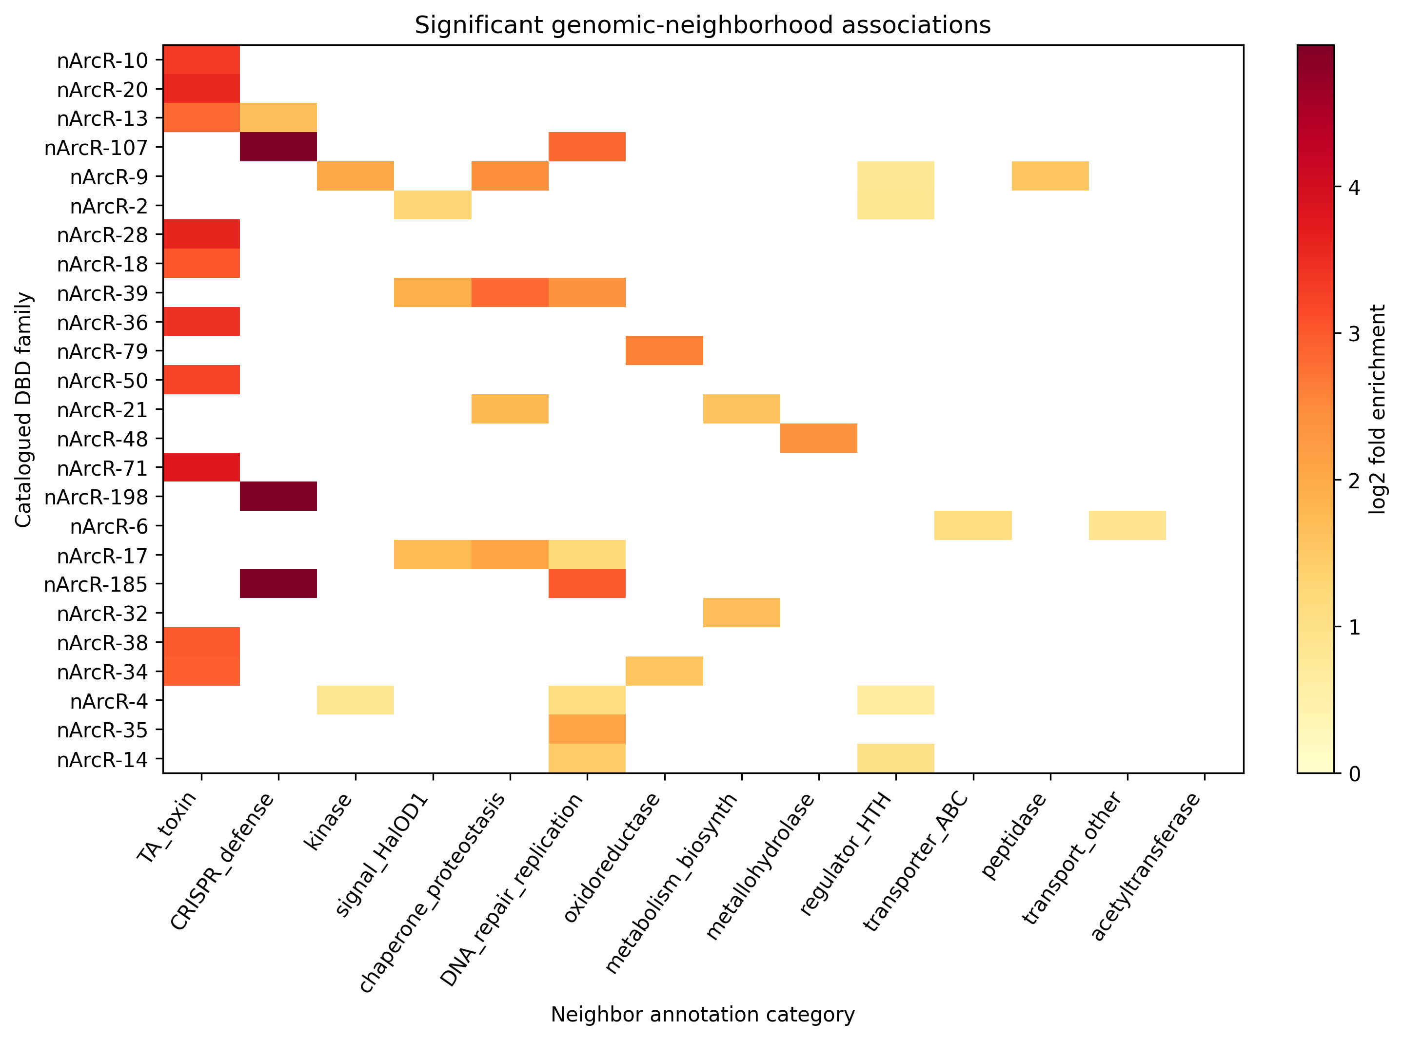
Figure 5. Significant genomic-neighborhood associations for selected catalogued families. Color encodes log2 fold enrichment in the initial deposited table. Associations generate functional hypotheses and do not establish direct transcriptional regulation; dependence-corrected source tables remain a documented deposition gap.

Most apparently dark families resolve to known sequence or fold classes
Structural comparisons were available for 184 family representatives. Using a curated reference of 66 DNA-binding and non DNA-binding folds and a TM score threshold of 0.55, 175 representatives matched a known DNA-binding fold and nine had no match among the tested references. The latter are candidates for further structural investigation, not established new folds. The reference library is curated rather than exhaustive, and nine families lacked a scored structure.
Among the 79 families uncharacterized by Pfam, Conserved Domain Database searches resolved 56, including 44 to a functionally named orthologous group. Structural comparison resolved 14 additional families. Nine remained unresolved by both resources. These nine are the highest priority experimental targets because they survive both sequence and fold based annotation attempts.
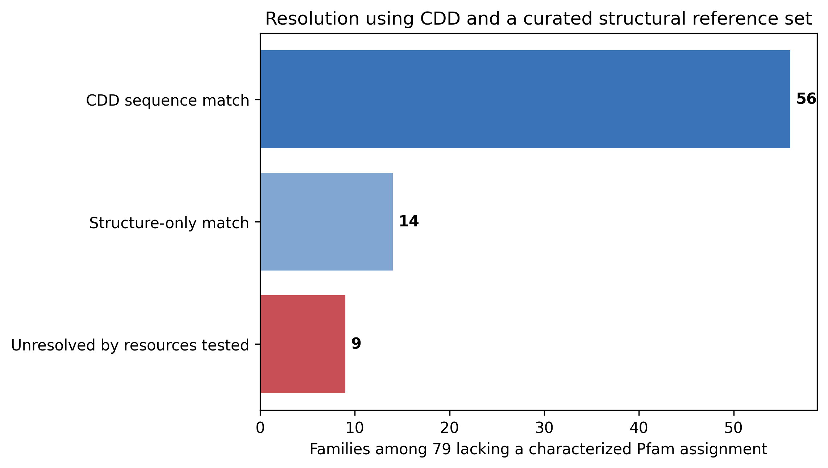
Figure 6. Reassessment of the 79 Pfam uncharacterized families using the Conserved Domain Database and structural comparisons. Most are resolved by broader sequence databases or a known fold; nine remain unresolved by the resources tested.

Discussion
The two targeted Pfam clans contain substantial archaeal diversity outside a standard nineteen family reference set. That excess is not a collection of isolated sequences: it forms separable families, many recur across genomes and lineages, and most representatives map to recognized domain or fold classes. The strongest conclusion is therefore that familiar annotations underdescribe the family structure of archaeal HTH and RHH clan proteins.
The result is narrower than the original framing of a domain wide map of transcription factors. The workflow begins with CL0123 and CL0057, so it cannot discover DNA-binding proteins outside those clans or proteins too diverged to match their profiles. It also cannot infer transcription factor activity from a domain alone. Recasting the study around a bounded catalog makes its quantitative claims testable and its novelty more precise.
The 331 genome panel is the deterministic output of a lineage balancing rule, except for the seeded proportional samples within the two capped groups. Its purpose is to prevent heavily sequenced clades from dominating family discovery while retaining all genomes from five underrepresented groups. The particular caps remain pragmatic. Within panel resampling shows that moderate reductions preserve detection of every family, but smaller panels disproportionately remove families near the five genome threshold. Independent projection samples recovered a median of 245 families, showing that most profiles transfer beyond the discovery accessions. A stronger future test should rerun the complete scan and clustering workflow on alternative panels drawn from the full candidate pool and quantify family matching across runs.
The evidence is strongest for family coherence and for the conclusion that most proteins adopt known DNA-binding folds. Genomic context suggests biological settings, but direct regulatory relationships remain unproven. Held out motif prediction strengthens the case that most tested families have recurrent family specific upstream sequence patterns. The negative target enrichment tests and the failures for nArcR 20 and nArcR 24 prevent a direct regulon claim. The phylogenetic analysis of ten families indicates within phylum clustering for eight, which is compatible with vertical inheritance or ancient origin but does not distinguish these mechanisms. The Haloferax volcanii transcriptomic analysis confirms expression for most mapped loci; its oxidative stress comparison is exploratory because the released script uses simple tests on three replicates per condition rather than a count based dispersion model.
The nine families unresolved by both CDD and the curated structural library, together with the strongest dependence corrected neighborhood associations, provide a focused experimental agenda. Electrophoretic mobility shift assays, DNA affinity measurements, knockouts or CRISPR interference, and transcriptome profiling after perturbation would establish which families are transcription factors, their operators, and their direct targets.
First, the search universe is restricted to two Pfam clans. Second, the 5-bit reciprocal exclusion tolerance and the lineage caps lack a full de novo sensitivity analysis because the released archive omits the complete raw candidate and canonical domain hit tables and the 1,069 genome candidate pool. The independent projection analysis tests existing HMMs, not family rediscovery. Third, the final 3,526 genome prevalence summaries are supported by corrected tables, while the released raw matrices contain 3,192 genomes and should be treated as legacy intermediates. Fourth, the dependence corrected neighborhood and deep motif source tables cited in the manuscript are absent from the archive even though their figures are present. Fifth, computational motif prediction cannot replace direct binding assays. These limitations constrain claims of exhaustiveness, regulation, and full raw to figure reproducibility. Sixth, source and assembly-quality strata differ in lineage composition, so their prevalence contrasts are descriptive. Seventh, genus- and lineage-blocked motif validation attenuates support for several motifs and confirms that genome-level holdout alone does not eliminate phylogenetic signal. Eighth, the genus-clustered prevalence analysis uses organism-name labels rather than a versioned taxonomy or species tree. Ninth, the additional family-separability check covers only the ten families with released protein sequences.
A search bounded to two major archaeal HTH and RHH Pfam clans identifies 250 coherent sequence families outside a nineteen family reference set. Most apparent novelty resolves to known sequence or structural classes, while nine families remain unresolved by the resources tested. The catalog expands the documented diversity of archaeal DNA-binding domains and prioritizes experiments, but it does not by itself establish 250 transcription factor families or a comprehensive archaeal regulome.

Methods

Study design and interpretation
This computational comparative-genomics study had a primary descriptive objective: construct a bounded family catalog within Pfam clans CL0123 and CL0057 after excluding a predefined nineteen-family reference set. Held-out assignment and independent-genome projection were confirmatory validation analyses. Panel resampling, genome-quality stratification, clustered prevalence, taxonomically blocked motif tests and the ten-family sequence check were sensitivity analyses. No biological effect-size or power calculation was applicable to deterministic catalog construction; resampling counts and random seeds are reported for all stochastic analyses. Supplementary Table S1 lists each analysis and its permitted interpretation, and Supplementary Fig. S6 summarizes the workflow.

Genome panel assembly
Archaeal assemblies were grouped into seven major lineage categories. All genomes in the five underrepresented categories were retained. Euryarchaeota and Crenarchaeota were capped at 140 and 70, respectively. For each capped group, subgroup sample sizes were allocated in proportion to their abundance and genomes were sampled without replacement with random seed 42. The resulting panel contained 331 genomes and 804,755 predicted proteins.

Targeted domain scan and reciprocal exclusion
Pfam profiles in clans CL0123 and CL0057 defined the search universe. Twenty models representing the nineteen-family reference set were separated from 747 candidate profiles. HMMER searches used each model's gathering threshold. For every protein, the highest-domain-score candidate interval (ali_from to ali_to) was compared with the highest-scoring canonical hit. Interval overlap was the number of shared aligned residues divided by candidate-interval length. A candidate was excluded when overlap exceeded 0.5 and the canonical score was at least the candidate score minus 5 bits; otherwise it was retained. The 5-bit value was an inherited operational tolerance without a preserved prospective calibration. When multiple candidate domains remained, the highest-scoring retained candidate was used for family construction.

Family construction and sensitivity analyses
Retained proteins were clustered with MMseqs2 using minimum sequence identity 0.30, coverage 0.60, coverage mode 0 and cluster mode 1 [19,20]. Clusters required a median length below 250 amino acids, at least 60% of members shorter than 250 amino acids and occurrence in at least five genomes. Clusters whose dominant Pfam label matched the explicit nonregulatory exclusion list in Supplementary Methods were removed. The clustering sensitivity analysis varied identity from 0.25 to 0.40, coverage from 0.50 to 0.80 and clustering mode across 24 settings.
For the new panel sensitivity analysis, genomes were resampled without replacement for 500 replicates under three schemes: 80 percent of every lineage; all rare lineages plus 112 Euryarchaeota and 56 Crenarchaeota; and a maximum of 30 genomes per lineage. For every replicate we counted catalog families detected at least once and families retaining at least five genomes. This analysis uses fixed released family memberships and therefore measures catalog retention, not de novo rediscovery. (Supplementary Fig. S1).

Family projection and validation
A profile HMM was built for each family. In held out validation for families with at least 20 members, 30 percent of sequences were removed, HMMs were rebuilt from the remaining members, and withheld sequences were assigned by their best score. Assignments were summarized by correct family and best versus second best margin. Projection used the family HMM library and corrected lineage denominators for 3,526 genomes. The final origin composition was 1,324 isolates, 1,986 MAGs, and 216 SAGs.
For the released ten-family sequence subset, each protein was represented by normalized dipeptide frequencies. The sequence was removed from its own family centroid, cosine similarities to all family centroids were calculated, and the highest-scoring family was assigned. Exact binomial 95 percent intervals and the own-family minus nearest-other-family similarity margin were reported. The analysis was not extrapolated beyond the released subset. (Supplementary Fig. S8).
For independent genome validation, discovery panel accessions were removed from the legacy 3,192 genome presence absence matrix. Five hundred samples were then drawn without replacement using the discovery panel lineage counts: 140 Euryarchaeota, 70 Crenarchaeota and other TACK, 51 Thaumarchaeota, 33 DPANN, 19 Asgardarchaeota, 15 other deep TACK, and 3 Korarchaeota. For each sample we counted families detected at least once and in at least five genomes. The procedure used fixed family HMM projections and therefore measures transferability rather than de novo discovery. (Supplementary Fig. S2).
For the quality sensitivity analysis, projection genomes were grouped by isolate, metagenome-assembled genome, or single-amplified genome status; by complete/chromosome, scaffold, or contig assembly; and by whether reported completeness was at least 90 percent with contamination at most 5 percent. We reported denominators, per-family prevalence, and the number of detected families for each stratum. No inferential comparison was made because these variables are confounded with lineage and database sampling. (Supplementary Fig. S4).
For clustered prevalence uncertainty, genus labels were inferred from deposited organism names, with Candidatus names retaining the following token. Genera were sampled with replacement for 1,000 seeded replicates. We calculated genus-balanced prevalence and a cluster-weighted prevalence interval for each family. This analysis addresses clustered sampling but does not model a species phylogeny.

Genomic neighborhood and motif analyses
Genes within five coding sequences of family members were assigned functional categories. Initial family category enrichment used genome conditioned label sampling, binomial tests, and Benjamini Hochberg correction [35]. Strong links were retested after collapse to one observation per genus and by shuffling whole neighborhood blocks for 2,000 permutations with seed 42. Up to 250 strand aware upstream nucleotides were used for motif discovery under a zero or one occurrence model. Motif information content was tested against mononucleotide shuffle, dinucleotide shuffle, and shuffled family assignment nulls with 100 replicates each and false-discovery-rate control. Six flagship family motifs were additionally assessed with 1,000 permutations and scanned against upstream regions of predicted target genes.
For the genome-level motif holdout analysis, genomes within each of 12 families were randomly divided into 70 percent training and 30 percent testing sets for 30 seeded replicates. A position weight matrix was learned only from training sequences under a zero or one occurrence model and scored in both orientations on held out upstreams. Each held out set was compared with dinucleotide shuffled versions of the same sequences and with equally sized, GC matched upstream sets from other families. Discrimination was summarized by area under the receiver operating characteristic curve, its 2.5 and 97.5 percent resampling quantiles, and the fraction of splits with AUC above 0.5. Because the splits overlap, no inferential test treats them as independent observations.
For genus-blocked validation, genera rather than genomes were randomly assigned to the 70/30 training and testing partitions. All upstream sequences from a held-out genus remained in the test set. The same PWM fitting, dinucleotide-shuffle control, GC-matched other-family control, AUC summaries, 30 replicate count, and descriptive interpretation were used. Train/test genus overlap was checked and was zero for every family and replicate. (Supplementary Fig. S5).
For leave-one-major-lineage-out validation, each lineage with at least five target sequences was held out in turn. Training required at least twenty sequences, and the comparison required enough other-family upstreams from the same held-out lineage. A PWM learned from all remaining lineages was evaluated against dinucleotide-shuffled targets and GC-matched same-lineage controls. Blocks failing any minimum were reported as unevaluable rather than pooled. (Supplementary Fig. S9).

Phylogenetic structural and transcriptomic analyses
For ten selected families, sequences were aligned with MAFFT, trimmed with trimAl, and analyzed with IQ TREE 2 using model selection and 1,000 ultrafast bootstrap replicates [22–27]. Phylum clustering was measured by Fitch parsimony and compared with 500 tip label shuffles. AlphaFold Database structures were available for 193 representatives, of which 184 produced scored Foldseek comparisons against 66 curated reference folds [30–32]. A TM score of at least 0.55 was treated as a reference fold match. Representatives of the 79 Pfam uncharacterized families were also searched against CDD version 3.21 at E value 0.01.
Haloferax volcanii featureCounts data from GSE293312 were used only as an exploratory expression analysis [14,34]. The released script transforms counts as log2 counts per million plus one, performs per gene two sample tests between three control and three oxidative stress replicates, and applies Benjamini Hochberg correction. We therefore do not describe this analysis as edgeR style or use it as evidence of family wide stress regulation.

Ethics statement
This computational study used publicly available genomic, structural and transcriptomic data and involved no human participants, identifiable human data, human tissue or live animals. Institutional ethics approval and informed consent were therefore not applicable.

Reproducibility, software and use of generative AI
The deposited reproduction environment uses Python 3.12 with NumPy 2.0.2, pandas 2.3.3, SciPy 1.13.1 and Matplotlib 3.9.4, and pins HMMER 3.4, MMseqs2 15.6f452, MAFFT 7.526, trimAl 1.4.1, IQ-TREE 2.3.6 and Foldseek 9.427df8a. Exact historical Pfam and GTDB releases, database download dates and the complete genome-download manifest were not preserved in the supplied source archive; this provenance gap is documented and no version was inferred retrospectively. Generative artificial-intelligence tools assisted language editing, code drafting, reproducibility packaging and document formatting. The authors inspected the underlying data, executed and checked the analyses, verified citations and outputs, and take responsibility for the final text, code, results and conclusions.

Data availability
The deposited datasets and versioned analysis outputs supporting this study are available in the Zenodo repository at https://doi.org/10.5281/zenodo.23461090 [41]. The repository records the distinct 3,192- and 3,526-genome scopes and includes accession-resolved inputs where they were preserved. The complete 1,069-genome candidate pool, raw discovery HMM hit tables, corrected 3,526-genome raw matrices, several dependence-corrected source tables and complete sequences for all 250 families were not present in the supplied source archive and are explicitly listed as unavailable; the corresponding claims are limited accordingly. Third-party database records remain subject to their source terms.

Code availability
Custom code, automated tests, locked software environments, a container recipe, checksums and a worked example are available under the MIT License at https://github.com/ajayvellanki0720-boop/archaeal-dbd-catalog and in the immutable version 0.4.0 archive at https://doi.org/10.5281/zenodo.23461090 [41]. The portable analyses require Python 3.12; external-tool versions are pinned in environment.yml.

References
1. Aravind, L. DNA-binding proteins and evolution of transcription regulation in the archaea. Nucleic Acids Research 27, 4658–4670 (1999). https://doi.org/10.1093/nar/27.23.4658
2. Dodd, I. B. & Egan, J. B. Improved detection of helix-turn-helix DNA-binding motifs in protein sequences. Nucl Acids Res 18, 5019–5026 (1990). https://doi.org/10.1093/nar/18.17.5019
3. Schreiter, E. R. & Drennan, C. L. Ribbon–helix–helix transcription factors: variations on a theme. Nat Rev Microbiol 5, 710–720 (2007). https://doi.org/10.1038/nrmicro1717
4. Guerra, A. J., Dann III, C. E. & Giedroc, D. P. Crystal Structure of the Zinc-Dependent MarR Family Transcriptional Regulator AdcR in the Zn(II)-Bound State. J. Am. Chem. Soc. 133, 19614–19617 (2011). https://doi.org/10.1021/ja2080532
5. Thaw, P. Structural insight into gene transcriptional regulation and effector binding by the Lrp/AsnC family. Nucleic Acids Research 34, 1439–1449 (2006). https://doi.org/10.1093/nar/gkl009
6. Reichelt, R., Gindner, A., Thomm, M. & Hausner, W. Genome-wide binding analysis of the transcriptional regulator TrmBL1 in Pyrococcus furiosus. BMC Genomics 17, 40 (2016). https://doi.org/10.1186/s12864-015-2360-0
7. Makarova, K. S., Wolf, Y. I. & Koonin, E. V. Comprehensive comparative-genomic analysis of Type 2 toxin-antitoxin systems and related mobile stress response systems in prokaryotes. Biol Direct 4, 19 (2009). https://doi.org/10.1186/1745-6150-4-19
8. Makarova, K. S., Grishin, N. V. & Koonin, E. V. The HicAB cassette, a putative novel, RNA-targeting toxin-antitoxin system in archaea and bacteria. Bioinformatics 22, 2581–2584 (2006). https://doi.org/10.1093/bioinformatics/btl418
9. Arcus, V. L., McKenzie, J. L., Robson, J. & Cook, G. M. The PIN-domain ribonucleases and the prokaryotic VapBC toxin-antitoxin array. Protein Engineering Design and Selection 24, 33–40 (2011). https://doi.org/10.1093/protein/gzq081
10. Liu, T. et al. Coupling transcriptional activation of CRISPR–Cas system and DNA repair genes by Csa3a in Sulfolobus islandicus. Nucleic Acids Research 45, 8978–8992 (2017). https://doi.org/10.1093/nar/gkx612
11. Sorek, R., Lawrence, C. M. & Wiedenheft, B. CRISPR-Mediated Adaptive Immune Systems in Bacteria and Archaea. Annu. Rev. Biochem. 82, 237–266 (2013). https://doi.org/10.1146/annurev-biochem-072911-172315
12. Xie, R. et al. Expanding Asgard members in the domain of Archaea sheds new light on the origin of eukaryotes. Sci. China Life Sci. 65, 818–829 (2022). https://doi.org/10.1007/s11427-021-1969-6
13. Dombrowski, N. et al. Undinarchaeota illuminate DPANN phylogeny and the impact of gene transfer on archaeal evolution. Nat Commun 11, 3939 (2020). https://doi.org/10.1038/s41467-020-17408-w
14. Allers, T., Ngo, H. P., Mevarech, M. & Lloyd, R. G. Development of Additional Selectable Markers for the Halophilic Archaeon Haloferax volcanii Based on the leuB and trpA Genes. Appl Environ Microbiol 70, 943–953 (2004). https://doi.org/10.1128/AEM.70.2.943-953.2004
15. Chaumeil, P. A., Mussig, A. J., Hugenholtz, P. & Parks, D. H. GTDB-Tk: a toolkit to classify genomes with the Genome Taxonomy Database. Bioinformatics 36, 1925–1927 (2020). https://doi.org/10.1093/bioinformatics/btz848
16. O'Leary, N. A. et al. Reference sequence (RefSeq) database at NCBI: current status, taxonomic expansion, and functional annotation. Nucleic Acids Res 44, D733–D745 (2016). https://doi.org/10.1093/nar/gkv1189
17. Eddy, S. R. Accelerated Profile HMM Searches. PLoS Comput Biol 7, e1002195 (2011). https://doi.org/10.1371/journal.pcbi.1002195
18. Mistry, J. et al. Pfam: The protein families database in 2021. Nucleic Acids Research 49, D412–D419 (2021). https://doi.org/10.1093/nar/gkaa913
19. Steinegger, M. & Söding, J. MMseqs2 enables sensitive protein sequence searching for the analysis of massive data sets. Nat Biotechnol 35, 1026–1028 (2017). https://doi.org/10.1038/nbt.3988
20. Steinegger, M. & Söding, J. Clustering huge protein sequence sets in linear time. Nat Commun 9, 2542 (2018). https://doi.org/10.1038/s41467-018-04964-5
21. Buchfink, B., Reuter, K. & Drost, H. G. Sensitive protein alignments at tree-of-life scale using DIAMOND. Nat Methods 18, 366–368 (2021). https://doi.org/10.1038/s41592-021-01101-x
22. Katoh, K. & Standley, D. M. MAFFT Multiple Sequence Alignment Software Version 7: Improvements in Performance and Usability. Molecular Biology and Evolution 30, 772–780 (2013). https://doi.org/10.1093/molbev/mst010
23. Capella-Gutiérrez, S., Silla-Martínez, J. M. & Gabaldón, T. trimAl: a tool for automated alignment trimming in large-scale phylogenetic analyses. Bioinformatics 25, 1972–1973 (2009). https://doi.org/10.1093/bioinformatics/btp348
24. Price, M. N., Dehal, P. S. & Arkin, A. P. FastTree 2 – Approximately Maximum-Likelihood Trees for Large Alignments. PLoS ONE 5, e9490 (2010). https://doi.org/10.1371/journal.pone.0009490
25. Minh, B. Q. et al. IQ-TREE 2: New Models and Efficient Methods for Phylogenetic Inference in the Genomic Era. Molecular Biology and Evolution 37, 1530–1534 (2020). https://doi.org/10.1093/molbev/msaa015
26. Kalyaanamoorthy, S., Minh, B. Q., Wong, T. K. F., von Haeseler, A. & Jermiin, L. S. ModelFinder: fast model selection for accurate phylogenetic estimates. Nat Methods 14, 587–589 (2017). https://doi.org/10.1038/nmeth.4285
27. Hoang, D. T., Chernomor, O., von Haeseler, A., Minh, B. Q. & Vinh, L. S. UFBoot2: Improving the Ultrafast Bootstrap Approximation. Molecular Biology and Evolution 35, 518–522 (2018). https://doi.org/10.1093/molbev/msx281
28. Bailey, T. L., Johnson, J., Grant, C. E. & Noble, W. S. The MEME Suite. Nucleic Acids Res 43, W39–W49 (2015). https://doi.org/10.1093/nar/gkv416
29. Hyatt, D. et al. Prodigal: prokaryotic gene recognition and translation initiation site identification. BMC Bioinformatics 11, 119 (2010). https://doi.org/10.1186/1471-2105-11-119
30. Jumper, J. et al. Highly accurate protein structure prediction with AlphaFold. Nature 596, 583–589 (2021). https://doi.org/10.1038/s41586-021-03819-2
31. Varadi, M. et al. AlphaFold Protein Structure Database: massively expanding the structural coverage of protein-sequence space with high-accuracy models. Nucleic Acids Research 50, D439–D444 (2022). https://doi.org/10.1093/nar/gkab1061
32. van Kempen, M. et al. Fast and accurate protein structure search with Foldseek. Nat Biotechnol 42, 243–246 (2024). https://doi.org/10.1038/s41587-023-01773-0
33. Kunzmann, P. & Hamacher, K. Biotite: a unifying open source computational biology framework in Python. BMC Bioinformatics 19, 346 (2018). https://doi.org/10.1186/s12859-018-2367-z
34. Liao, Y., Smyth, G. K. & Shi, W. featureCounts: an efficient general purpose program for assigning sequence reads to genomic features. Bioinformatics 30, 923–930 (2014). https://doi.org/10.1093/bioinformatics/btt656
35. Benjamini, Y. & Hochberg, Y. Controlling the False Discovery Rate: A Practical and Powerful Approach to Multiple Testing. Journal of the Royal Statistical Society Series B: Statistical Methodology 57, 289–300 (1995). https://doi.org/10.1111/j.2517-6161.1995.tb02031.x
36. Harris, C. R. et al. Array programming with NumPy. Nature 585, 357–362 (2020). https://doi.org/10.1038/s41586-020-2649-2
37. Virtanen, P. et al. SciPy 1.0: fundamental algorithms for scientific computing in Python. Nat Methods 17, 261–272 (2020). https://doi.org/10.1038/s41592-019-0686-2
38. McKinney, W. Data Structures for Statistical Computing in Python. Proceedings of the Python in Science Conference, 56–61 (2010). https://doi.org/10.25080/Majora-92bf1922-00a
39. Seabold, S. & Perktold, J. Statsmodels: Econometric and Statistical Modeling with Python. Proceedings of the Python in Science Conference, 92–96 (2010). https://doi.org/10.25080/Majora-92bf1922-011
40. Cock, P. J. A. et al. Biopython: freely available Python tools for computational molecular biology and bioinformatics. Bioinformatics 25, 1422–1423 (2009). https://doi.org/10.1093/bioinformatics/btp163
41. Vellanki, A. & Dosapati, S. Archaeal DBD catalog: reproducibility package (version 0.4.0). Zenodo https://doi.org/10.5281/zenodo.23461090 (2026).

Acknowledgements
This research received no specific grant from any funding agency in the public, commercial, or not-for-profit sectors.

Author contributions
AV and SD jointly contributed to conceptualization, methodology, investigation, formal analysis, validation, visualization, data curation, software and writing. Both authors reviewed and approved the final manuscript.

Additional information

Competing interests
The authors declare no competing interests.

