Supplementary Information
A catalog of noncanonical HTH and RHH DNA-binding domain families in Archaea
Ajay Vellanki and Shaurya Dosapati

Supplementary Methods

Operational scope and terminology
The discovery universe comprises archaeal proteins detected by profiles in Pfam clans CL0123 and CL0057. “Noncanonical” means not explained by a nineteen-family reference set under the stated reciprocal-exclusion rule. It does not mean previously undescribed in all databases, nor does it establish transcription-factor activity.

Panel construction
Assemblies were grouped into seven major lineage categories. All genomes from five underrepresented groups were retained. Euryarchaeota and Crenarchaeota were capped at 140 and 70; subgroup allocations were proportional and genomes were sampled without replacement using seed 42. The final count of 331 was the output of that rule.

Reciprocal exclusion
For each protein, the best-scoring candidate-domain interval was compared with the best canonical hit. Overlap was shared aligned residues divided by candidate-interval length. A candidate was excluded when overlap exceeded 0.5 and the canonical domain score was at least the candidate score minus 5 bits. The highest-scoring retained candidate was used when multiple candidates remained.

Family construction
Retained proteins were clustered with MMseqs2 at minimum identity 0.30 and coverage 0.60, coverage mode 0, cluster mode 1. Clusters required occurrence in at least five genomes, median length below 250 amino acids, at least 60 percent of members below 250 amino acids, and absence of clearly nonregulatory annotation keywords.

Nonregulatory exclusion list
A cluster was excluded when its dominant Pfam label exactly matched or began with one of the following patterns: eIF-5_eIF-2B, Ribosomal_S19e, TFIIE_alpha, SRP19, TFIIE_beta, RNA_pol_Rpb, S10_plectin, Ribosomal_L29, Ribosomal_S13, tRNA_bind, RuvA_N, RuvA_C, DNA_pol, Rad51, RecA, DEAD, Helicase_C, ResIII, HNH, GIY-YIG, Homeodomain, Pou, Ets, Fork_head, CBFD_NFYB_HMF, Myb_DNA-binding, Myb_DNA-bind, HTH_psq, zf-, Integrase, rve, Recombinase, Resolvase, Terminase, Phage, DNA_binding_1, Sigma54_activat, Sigma70_r2, Sigma70_r3, Sigma70_r1, AAA, Cdc6_C, Mor, CsrA, KH, OB_, RRM, dsrm, PAZ or Piwi. This rule removes obvious non-target families but cannot establish regulatory activity for retained clusters.

Panel and projection sensitivity
Five hundred seeded within-panel resamples tested three alternative sampling schemes using fixed family membership. A lineage-stratified accumulation analysis sampled 10 to 100 percent of each major group in 10 percent increments, with 500 replicates below the complete panel. A separate 500-replicate analysis sampled 331 lineage-matched genomes from the independent 3,192-genome projection matrix after removing discovery-panel accessions. These analyses test fixed-catalog observation, retention and HMM transfer, not de novo rediscovery.

Genome-quality sensitivity
The 3,192 accession-resolved projection genomes were stratified by origin, assembly level, and reported completeness/contamination. Per-family prevalence and detected-family counts were reported. Contrasts are descriptive because strata are confounded with lineage and sampling.

Taxonomic clustered prevalence
Organism names defined 533 inferred genus clusters. Genera were resampled with replacement for 1,000 seeded replicates to obtain genus-balanced and cluster-weighted prevalence intervals. This addresses cluster sampling but is not a species-tree model.

Motif holdout
For twelve families, PWMs were fitted on taxonomically separated training data. Genome-blocked splits held out genomes, genus-blocked splits held out complete genera, and the strictest analysis left out one major lineage at a time with same-lineage other-family controls. Minimum sample-size failures were reported as unevaluable. Results remain predictive rather than biochemical.

Sequence-family separability
For 782 released proteins from ten families, normalized dipeptide frequencies were classified by leave-one-sequence-out family centroids. Exact binomial intervals and separation margins were reported. This subset analysis does not validate all 250 families.

Evidence limits
Neighborhood enrichment is treated as association, motif prediction as sequence-level prediction, and structure matching as similarity to a curated reference set. None alone demonstrates direct DNA binding or transcriptional regulation.

Supplementary Table S1. Analysis classification
Analysis | Role | Question | Principal limit
Catalog size and membership | Primary descriptive | Prespecified released pipeline summaries | Bounded to two Pfam clans
Held-out family HMM assignment | Confirmatory validation | Withheld sequence assignment | Only families with ≥20 members
Independent-genome projection | Confirmatory validation | Zero accession overlap | Fixed HMMs; no rediscovery
Genome/genus/lineage-blocked motif AUC | Confirmatory sensitivity | Out-of-sample discrimination | Predictive, not biochemical
Genome-quality stratification | Sensitivity | Robustness across deposited strata | Descriptive; confounded
Genus-clustered prevalence | Sensitivity | Taxonomic sampling imbalance | Organism-name genera; no species tree
Ten-family sequence separability | Sensitivity | Subset boundary coherence | Only ten released families
Neighborhood enrichment | Exploratory | Functional hypothesis generation | No direct target claim
Haloferax expression | Exploratory | Expression context | Three replicates; simple transformed-count tests
Experimental validation plan | Future work | Direct binding and in vivo regulation | Not performed

Supplementary Table S2. Data artifact definitions
Artifact | Scope | Permitted interpretation
Discovery panel | 331 accessions | Family discovery and fixed-member sensitivity
Legacy projection matrix | 250 × 3,192 | Accession-resolved projection sensitivity
Final genome accounting | 3,526 genomes | Final fates and denominators
Corrected prevalence | 250 families × 7 groups | Final group-level prevalence only
Family upstreams | 12 families; 250-nt sequences | Genome/genus/lineage-blocked motif validation
Phylogenetic sequence subset | 782 proteins; 10 families | Subset sequence separability only

Supplementary Figure S1
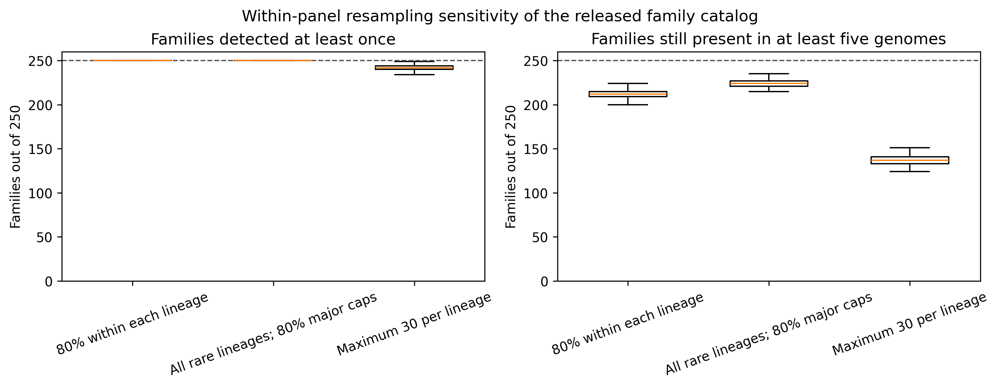
Supplementary Figure S1. Within-panel fixed-family retention under three alternative sampling schemes. Boxes summarize 500 seeded replicates. This analysis asks whether already-defined families remain represented; it is not a de novo clustering sensitivity analysis.

Supplementary Figure S2
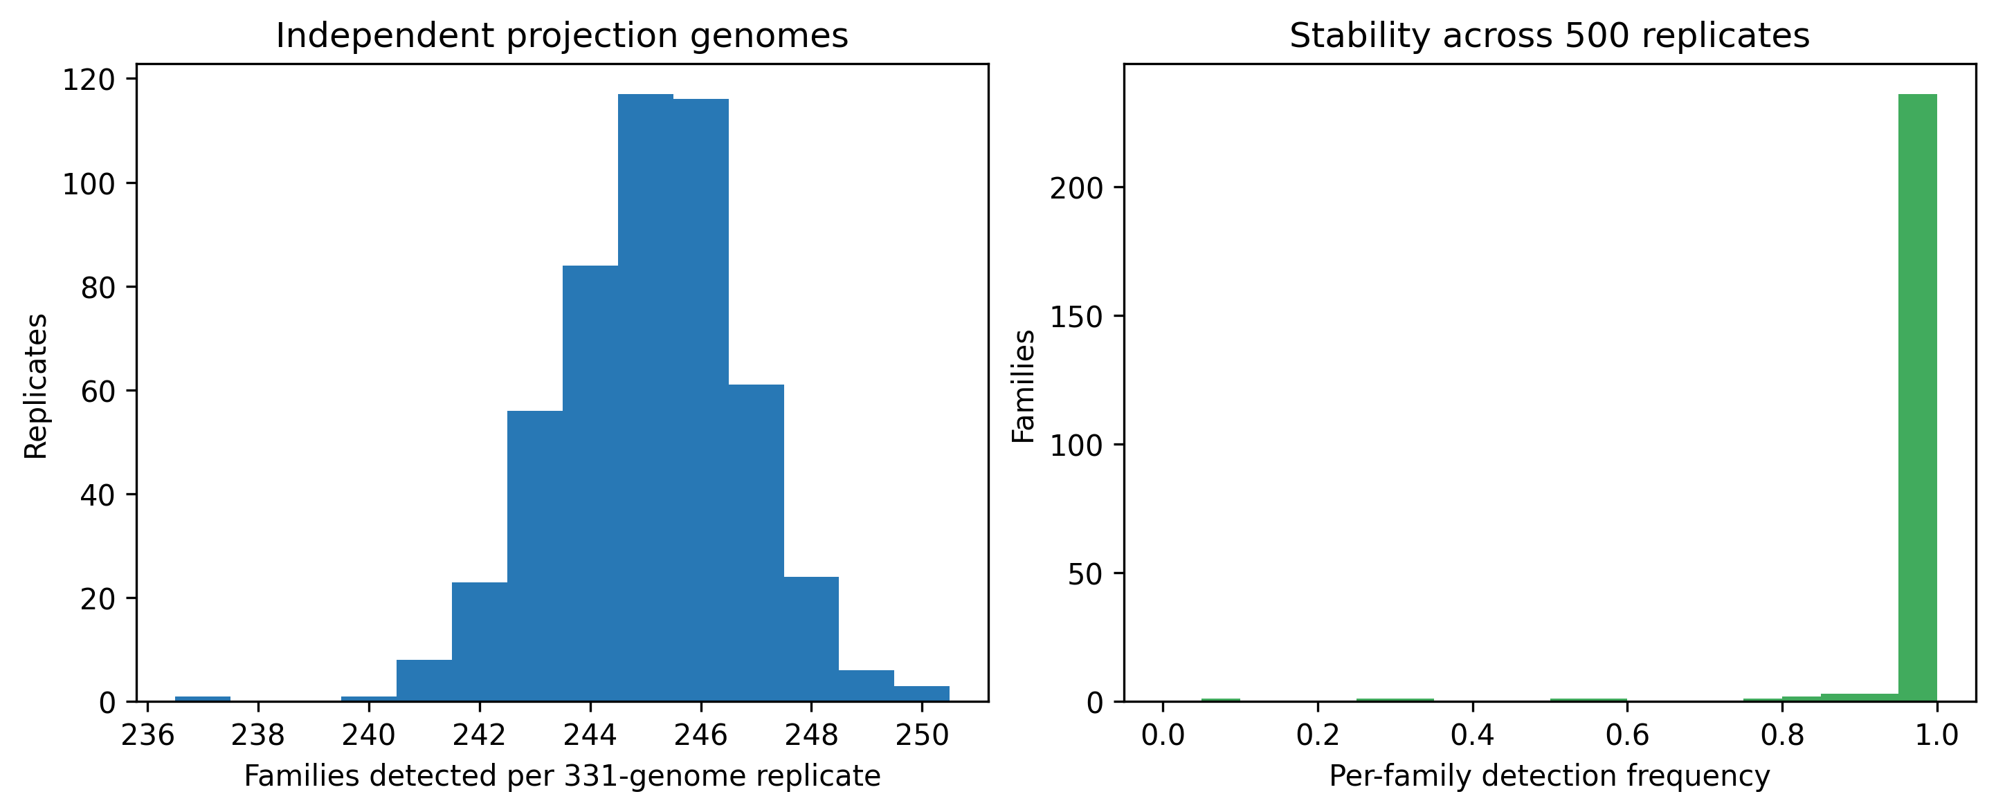
Supplementary Figure S2. Projection of released family HMMs to 500 lineage-matched samples of 331 independent genome accessions. The discovery/projection accession overlap is zero. Results test HMM transfer, not independent family discovery.

Supplementary Figure S3
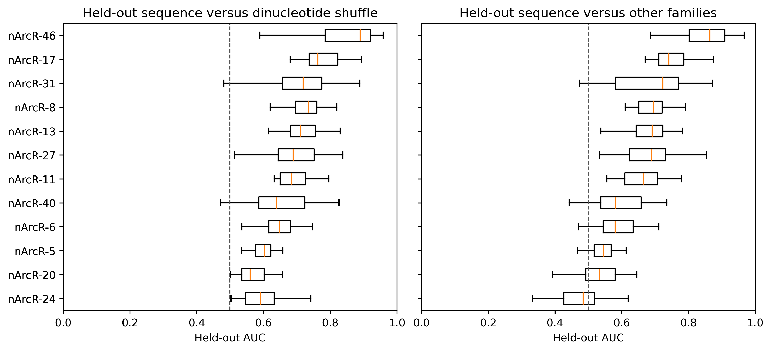
Supplementary Figure S3. Genome-level motif holdout for 12 families. PWMs were fitted only to training genomes and scored against held-out family upstreams, dinucleotide shuffles, and GC-matched other-family upstreams. Repeated splits overlap and are interpreted descriptively.

Supplementary Figure S4
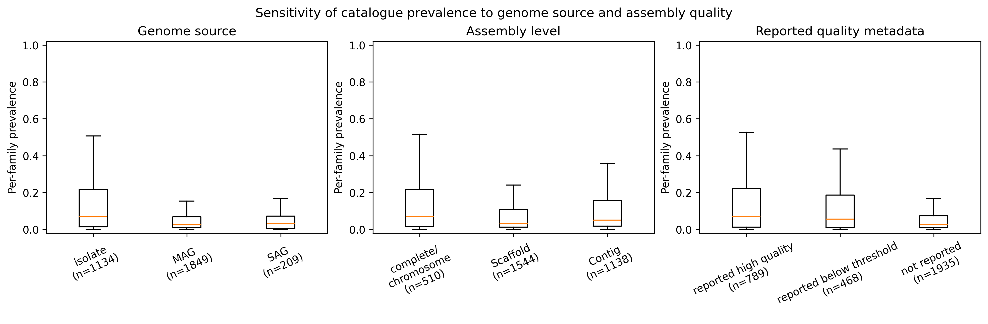
Supplementary Figure S4. Sensitivity of per-family prevalence to genome source, assembly level, and reported completeness/contamination. Boxes summarize the 250 family prevalence values within each stratum. Differences are descriptive because strata are confounded with lineage and sampling.

Supplementary Figure S5
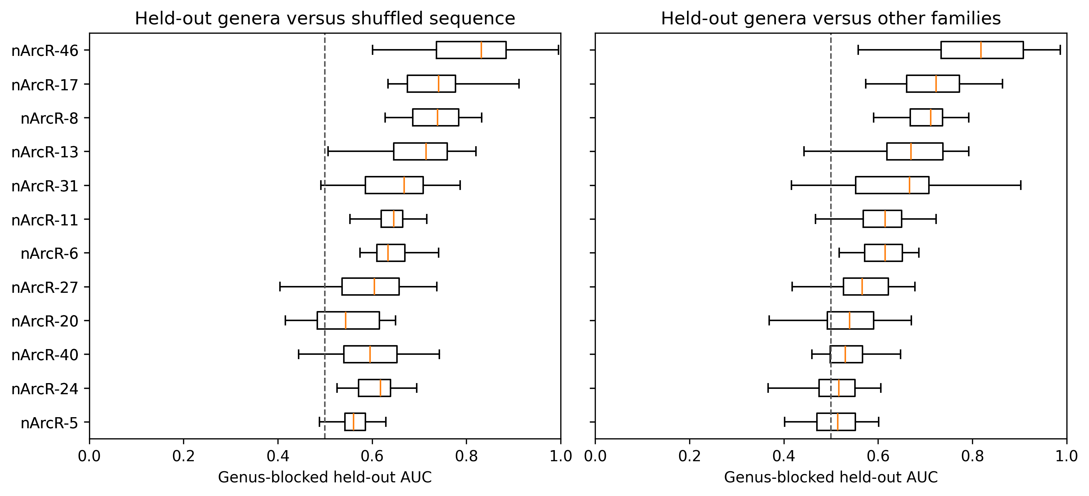
Supplementary Figure S5. Genus-blocked motif holdout with zero train/test genus overlap. Seven of 12 families exceeded AUC 0.5 against other-family controls in at least 26 of 30 resamples. This stricter result shows that some genome-level signal is lineage-associated.

Supplementary Figure S6
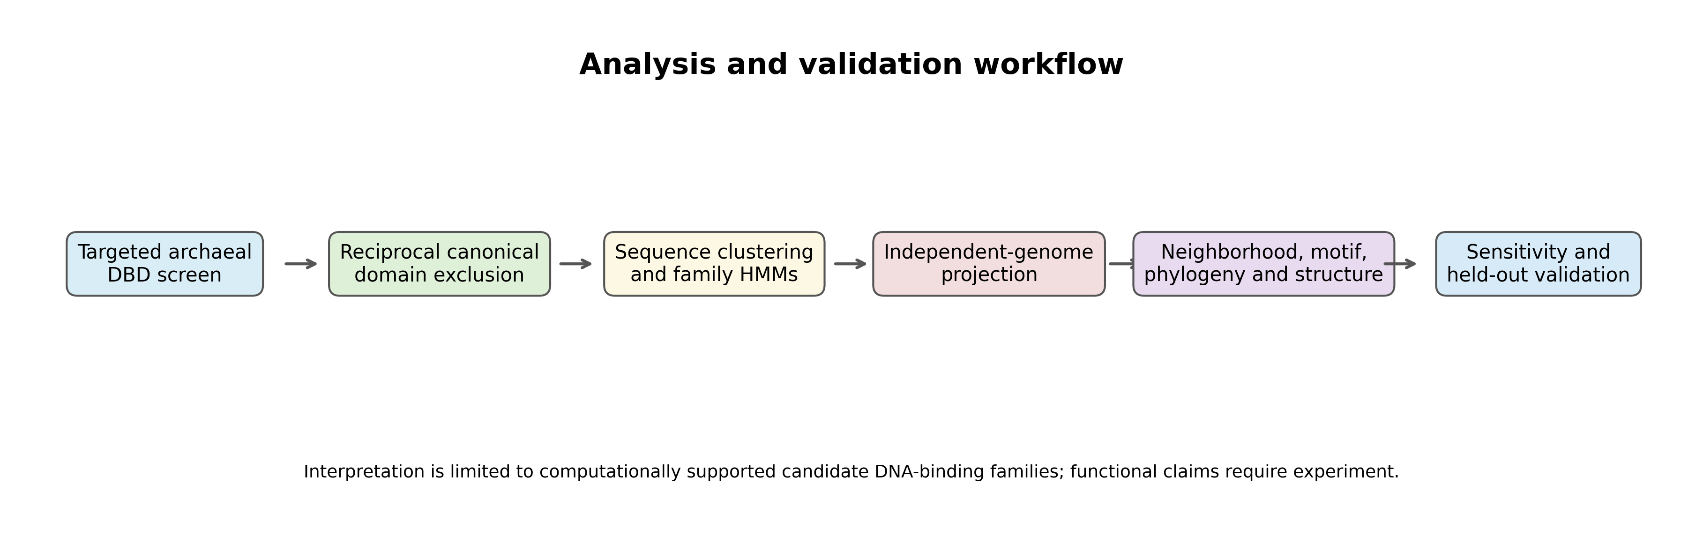
Supplementary Figure S6. Workflow from the targeted two-clan scan through family construction, projection, contextual analyses, and sensitivity validation. The endpoint is a bounded candidate-family catalog, not an experimentally confirmed regulome.

Supplementary Figure S7
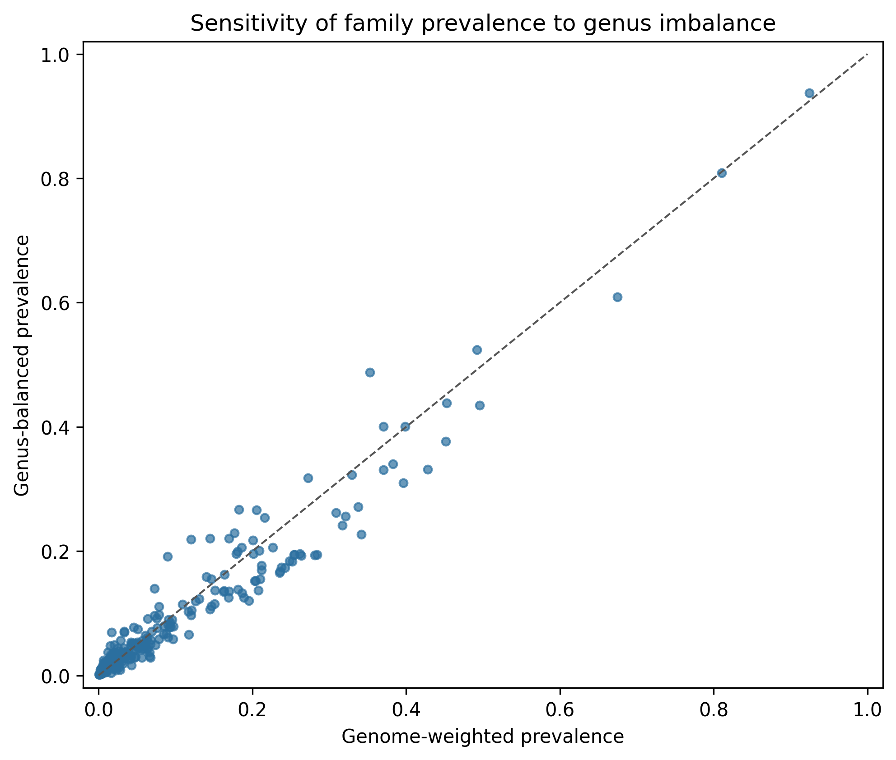
Supplementary Figure S7. Comparison of genome-weighted and genus-balanced prevalence for 250 families. Genus clusters were inferred from deposited organism names. Deviations from the diagonal show sensitivity to uneven genus representation.

Supplementary Figure S8
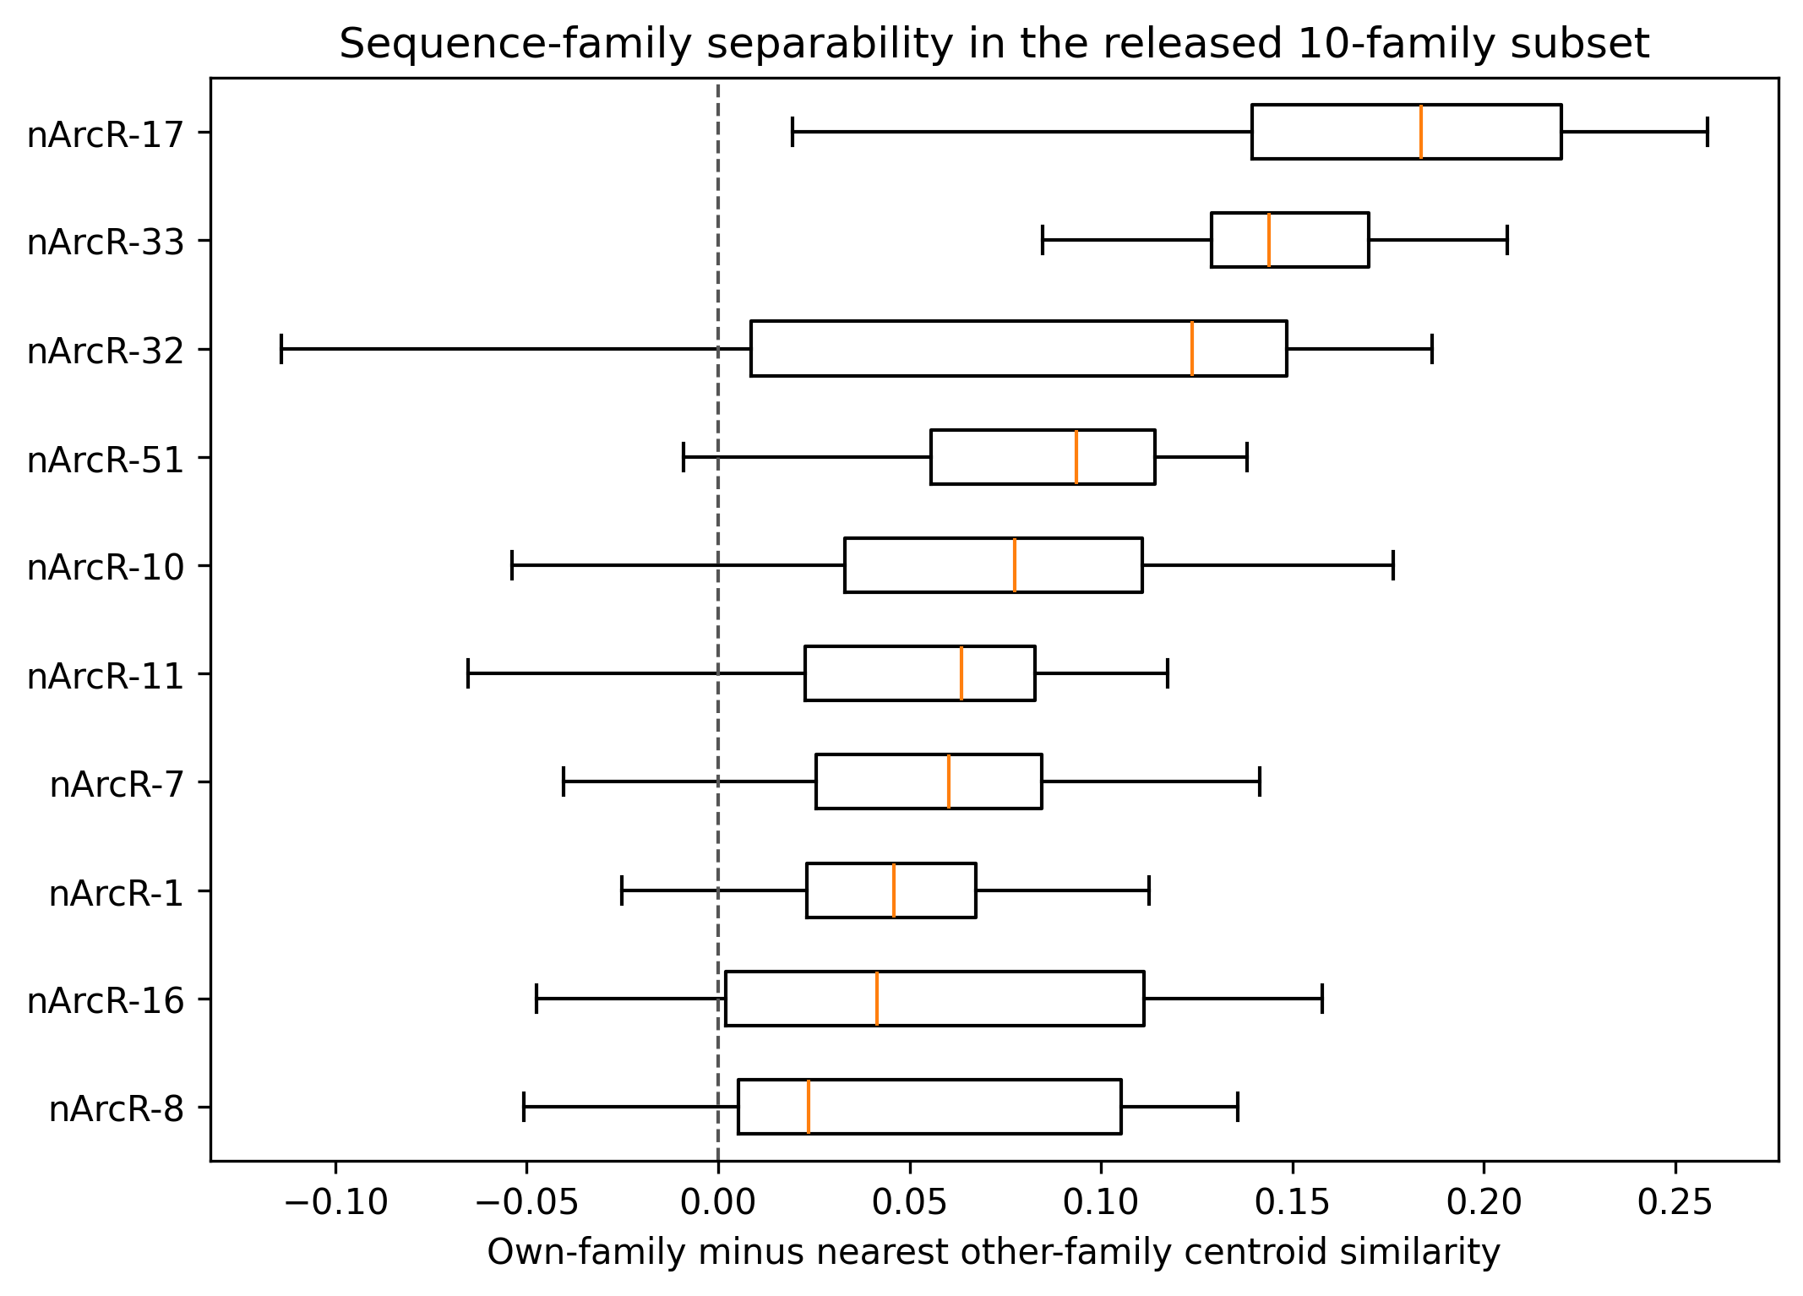
Supplementary Figure S8. Leave-one-sequence-out dipeptide-composition separability for the ten families with released protein sequences. Positive margins favor the sequence's own family over the nearest other-family centroid. Results are not catalog-wide.

Supplementary Figure S9
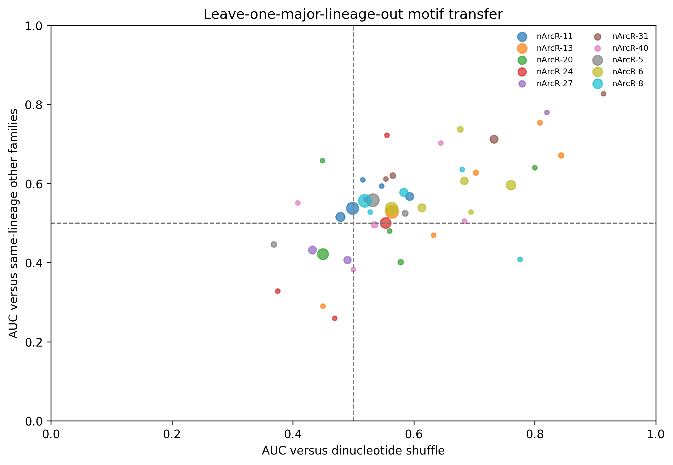
Supplementary Figure S9. Leave-one-major-lineage-out motif transfer. Point size reflects held-out sequence count. Only blocks satisfying prespecified target, training, and same-lineage control minima are plotted; two families have no evaluable block.

Supplementary Figure S10
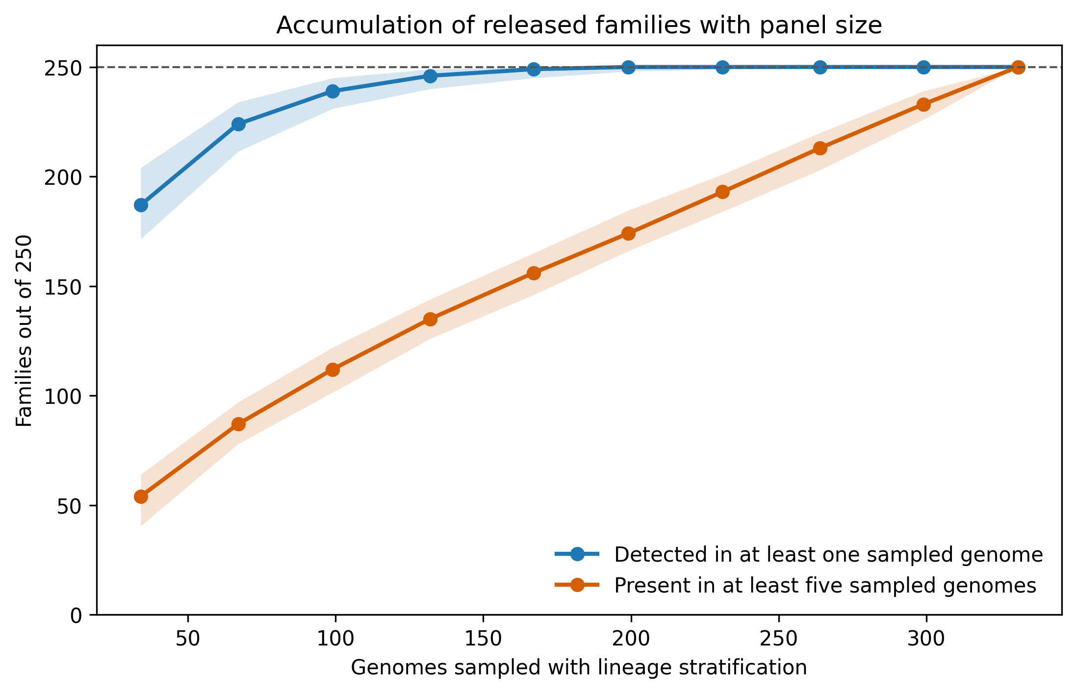
Supplementary Figure S10. Lineage-stratified accumulation of the released families as panel size increases. Lines show medians and shaded regions show 95 percent resampling intervals. The blue curve counts families observed at least once; the orange curve counts families represented in at least five sampled genomes. This is a fixed-catalog sensitivity analysis and does not repeat candidate scanning or de novo clustering.

