RabbitMQ Hello World – Program for .NET Developer
RabbitMQ is a messaging broker - an intermediary for messaging. It gives your applications a common platform to send and receive messages, and your messages a safe place to live until received.

RabbitMQ vs MSMQ
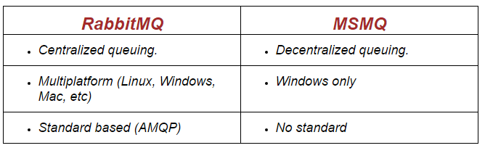

Benefits over having messaging broker in design
Decoupling:
It can decouple/separate the core components of the application. There is no need to bring all the benefits of the decoupled architecture here. I just want to point it out that this is one of the main requirement of writing a quality and maintainable software.
Flexibility:
It is actually very easy to connect two very different applications written on different languages together by using AMQP protocol. These applications will talk to each other by the help of a "translator" which is MOM.
Scalability:
By using MOM, we can scale the system horizontally. One message producer can transmit to unlimited number of message consumers a task, a command or a message for processing and for scaling this system, all we need to do is just create new message consumers. Let us say we are getting 1000 pictures per second and we must resize them. Solving this problem with traditional methods could be a headache. With MOM, we can transmit images to the message consumers that can do their job asynchronously and make sure data integrity is intact.

Erlang | Erlang client for RabbitMQ (Advanced Message Queuing Protocol - AMQP 0-9-1)

Basic uses of this library
- Establish a connection to a broker
- Create a new channel within the open connection
- Execute AMQP commands with a channel such as sending and receiving messages, creating exchanges and queue or defining routing rules between exchanges and queue
- When no longer required, close the channel and the connection
- Implement Messaging pattern
- Serialization
- Threading Strategy (Producer and Consumer)
- Handling connection losses
- Error handling strategy

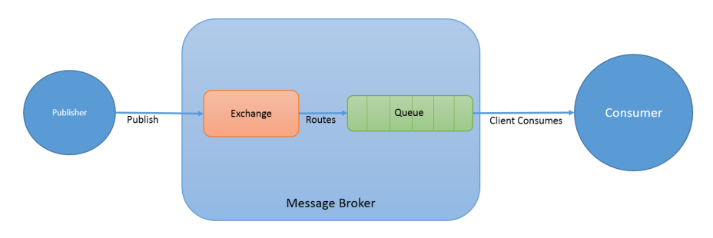

Note:
The AMQ model consists of a set of components that route and store messages within the broker service, plus a set of rules for wiring these components together
AMQP, that lets client applications talk to the server and interact with the AMQ model it implements

To download Erlang, click on links below as per machine windows configuration as:
32 Bit 64 Bit

Run and follow the setup wizard as:

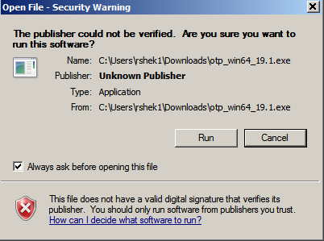

Rabbit MQ Setup
Click Here to download Rabbit MQ exe file and run the installation wizard as :

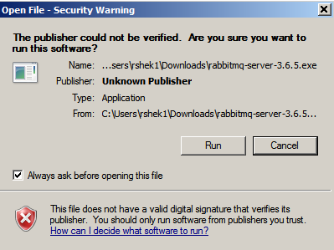

Steps to enable UI of RabbitMQ for further tracking of request and response
Copy the .erlang.cookie file from “C:\Windows” location
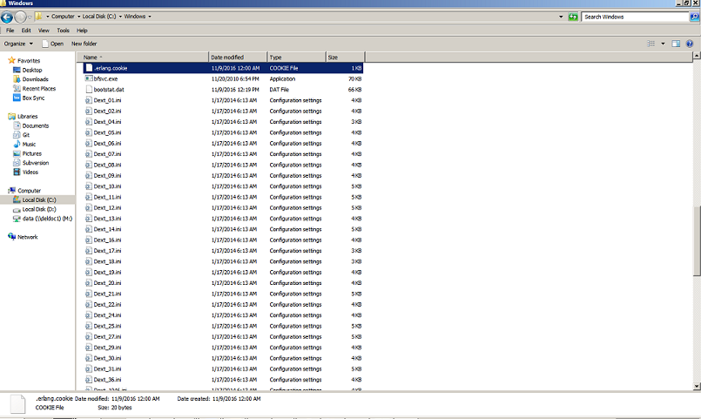

Replace the existing one on the following location “c:\Users\(UserName)” with this as:

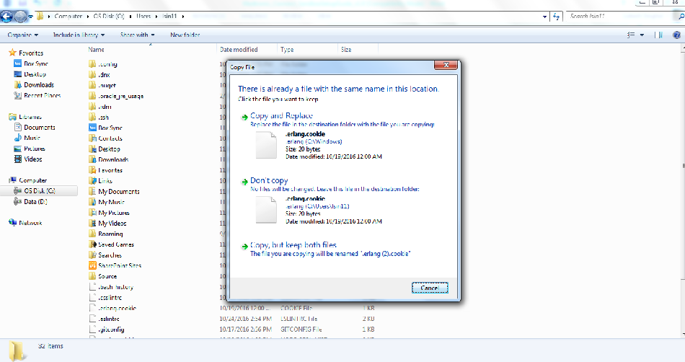

Further click on Start button and type RabbitMQ in search box as:

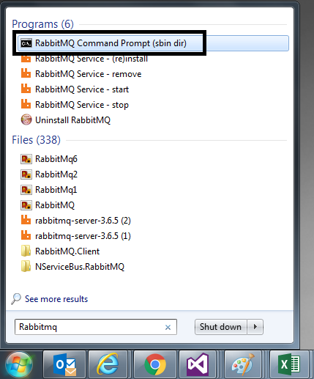

Click on RabbitMQ Command Prompt and execute following commands in a successive order:

rabbitmq-plugins enable rabbitmq_management
rabbitmqctl add_user test test
rabbitmqctl set_user_tags test administrator
rabbitmqctl set_permissions -p / test ".*" ".*" ".*"
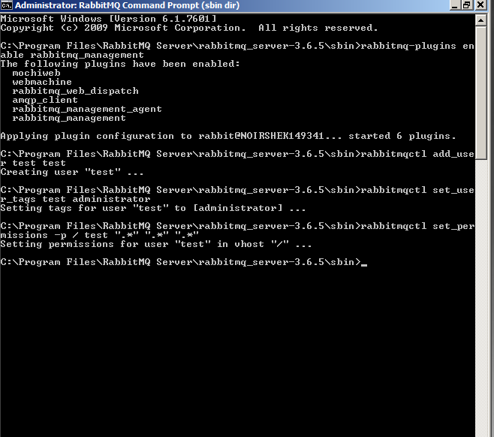

Again click on start button and type rabbitmq in search box as:
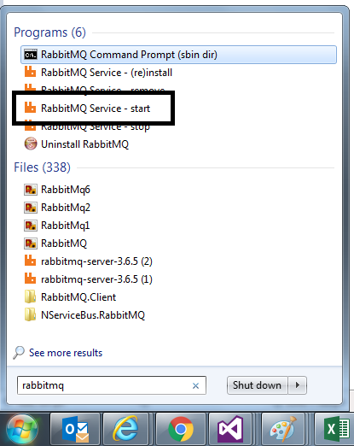

Click on RabbitMq Service Start. Now you are finished with the installation.

Local RabbitMQ management console is accessible on following URL:
localhost:15672

Username : test
Password : test

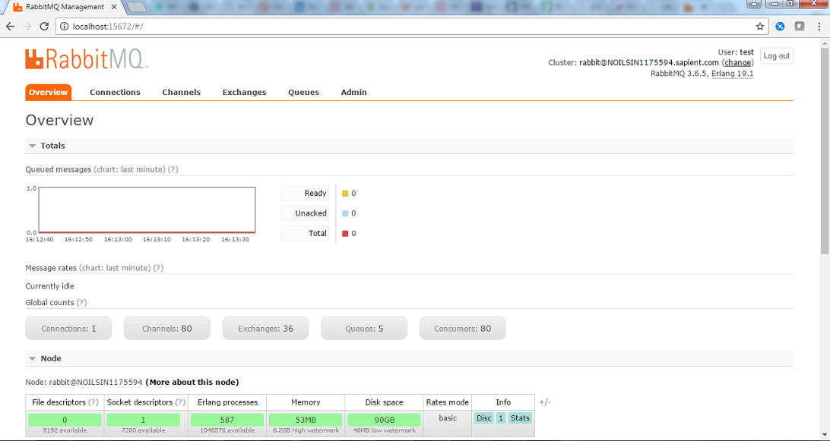

Hello World C# code

Install RabbitMQ .NET Client in visual studio project
Install-Package RabbitMQ.Client -Version 4.1.1
Reference namespace in class file
using RabbitMQ.Client;
using RabbitMQ.Client.Events;
Create a method/action that will publish the message
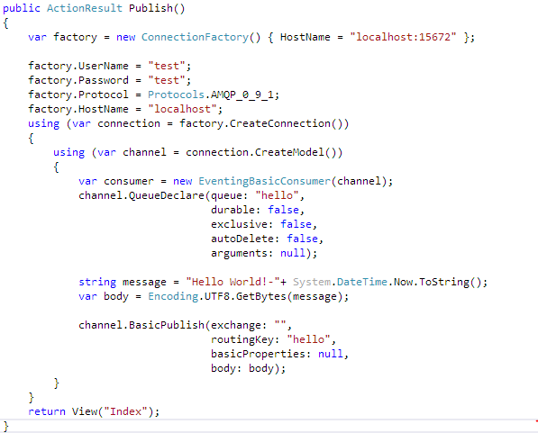
This is how message looks at RabbitMQ end after publish
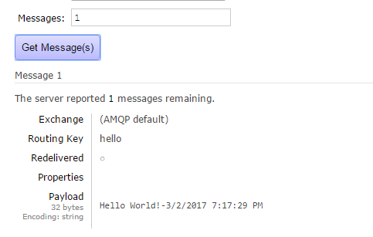
How to consume item/details from RabbitMQ
