-- understanding the date range we are dealing with

Code:
SELECT
MIN(created_on) AS first_ticket_created,
MAX(created_on) AS last_ticket_created,
MIN(sla_deadline) AS first_sla_deadline,
MAX(sla_deadline) AS last_sla_deadline,
MIN(resolved_at) AS first_ticket_resolved,
MAX(resolved_at) AS last_ticket_resolved
FROM hr_tickets;

Output:

-- summary of overall ticket volume and SLA performance baseline
Code:

SELECT
COUNT(*) AS total_tickets,
SUM(CASE WHEN ticket_status = 'Closed' THEN 1 ELSE 0 END) AS closed_tickets,
ROUND(AVG(CASE WHEN ticket_status = 'Closed' THEN TIMESTAMPDIFF(HOUR, created_on, resolved_at) END), 2) AS avg_resolution_hours,
SUM(CASE WHEN ticket_status = 'Closed' AND resolved_at > sla_deadline THEN 1 ELSE 0 END) AS total_breaches,
ROUND(
SUM(CASE WHEN ticket_status = 'Closed' AND resolved_at > sla_deadline THEN 1 ELSE 0 END) * 100.0 /
NULLIF(SUM(CASE WHEN ticket_status = 'Closed' THEN 1 ELSE 0 END), 0), 2
) AS overall_breach_rate_pct
FROM hr_tickets;

Output:

Code:
-- Checking if priority levels have different SLA time allowances
SELECT
priority_level,
COUNT(ticket_id) AS ticket_count,
ROUND(AVG(TIMESTAMPDIFF(HOUR, created_on, sla_deadline)), 2) AS avg_hours_allowed,
MIN(TIMESTAMPDIFF(HOUR, created_on, sla_deadline)) AS min_hours_allowed,
MAX(TIMESTAMPDIFF(HOUR, created_on, sla_deadline)) AS max_hours_allowed
FROM hr_tickets
GROUP BY priority_level
ORDER BY avg_hours_allowed DESC;

Output:
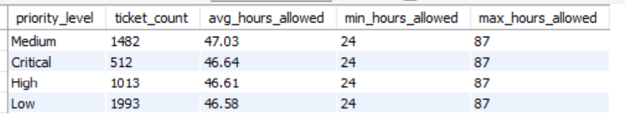

-- Checking if priority levels are randomly distributed across request topics

Code:
SELECT
request_topic,
COUNT(ticket_id) AS total_tickets,
SUM(CASE WHEN priority_level = 'Low' THEN 1 ELSE 0 END) AS low_count,
SUM(CASE WHEN priority_level = 'Medium' THEN 1 ELSE 0 END) AS medium_count,
SUM(CASE WHEN priority_level = 'High' THEN 1 ELSE 0 END) AS high_count,
SUM(CASE WHEN priority_level = 'Critical' THEN 1 ELSE 0 END) AS critical_count
FROM hr_tickets
GROUP BY request_topic;

Output:
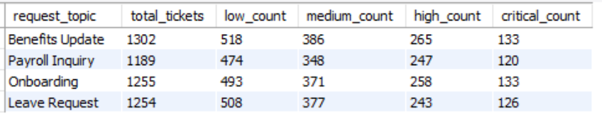

-- breaking down volume, status, and SLA performance by request topic

Code:

SELECT
request_topic,
COUNT(ticket_id) AS total_tickets,
SUM(CASE WHEN ticket_status = 'Closed' THEN 1 ELSE 0 END) AS closed_tickets,
SUM(CASE WHEN ticket_status = 'In Progress' THEN 1 ELSE 0 END) AS in_progress_tickets,
ROUND(AVG(CASE WHEN ticket_status = 'Closed' THEN TIMESTAMPDIFF(HOUR, created_on, resolved_at) END), 2) AS avg_resolution_hours,
SUM(CASE WHEN ticket_status = 'Closed' AND resolved_at > sla_deadline THEN 1 ELSE 0 END) AS total_breaches,
ROUND(
SUM(CASE WHEN ticket_status = 'Closed' AND resolved_at > sla_deadline THEN 1 ELSE 0 END) * 100.0 /
NULLIF(SUM(CASE WHEN ticket_status = 'Closed' THEN 1 ELSE 0 END), 0), 2
) AS breach_rate_pct
FROM hr_tickets
GROUP BY request_topic
ORDER BY breach_rate_pct DESC;

Output:
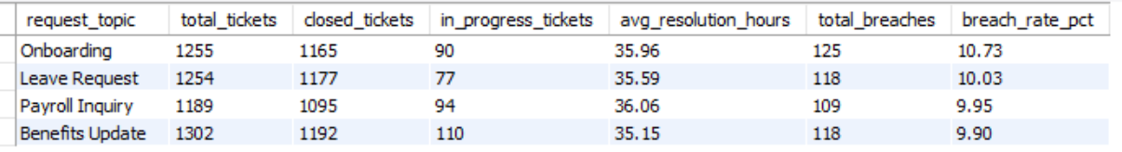

-- analyzing downstream impact by employee department

Code:
SELECT
e.dept AS employee_department,
COUNT(t.ticket_id) AS total_tickets,
SUM(CASE WHEN t.ticket_status = 'Closed' THEN 1 ELSE 0 END) AS closed_tickets,
ROUND(AVG(CASE WHEN t.ticket_status = 'Closed' THEN TIMESTAMPDIFF(HOUR, t.created_on, t.resolved_at) END), 2) AS avg_resolution_hours,
SUM(CASE WHEN t.ticket_status = 'Closed' AND t.resolved_at > t.sla_deadline THEN 1 ELSE 0 END) AS breached_tickets,
ROUND(
SUM(CASE WHEN t.ticket_status = 'Closed' AND t.resolved_at > t.sla_deadline THEN 1 ELSE 0 END) * 100.0 /
NULLIF(SUM(CASE WHEN t.ticket_status = 'Closed' THEN 1 ELSE 0 END), 0), 2
) AS breach_rate_pct
FROM hr_tickets t
LEFT JOIN employees e
ON t.emp_id = e.emp_id
GROUP BY e.dept
ORDER BY breach_rate_pct DESC;

Output:
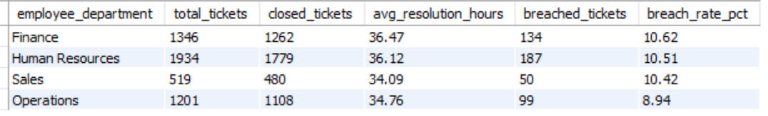

-- analyzing SLA performance by employee office location

Code:
SELECT
e.office_location,
COUNT(t.ticket_id) AS total_tickets,
SUM(CASE WHEN t.ticket_status = 'Closed' THEN 1 ELSE 0 END) AS closed_tickets,
ROUND(AVG(CASE WHEN t.ticket_status = 'Closed' THEN TIMESTAMPDIFF(HOUR, t.created_on, t.resolved_at) END), 2) AS avg_resolution_hours,
SUM(CASE WHEN t.ticket_status = 'Closed' AND t.resolved_at > t.sla_deadline THEN 1 ELSE 0 END) AS breached_tickets,
ROUND(
SUM(CASE WHEN t.ticket_status = 'Closed' AND t.resolved_at > t.sla_deadline THEN 1 ELSE 0 END) * 100.0 /
NULLIF(SUM(CASE WHEN t.ticket_status = 'Closed' THEN 1 ELSE 0 END), 0), 2
) AS breach_rate_pct
FROM hr_tickets t
LEFT JOIN employees e
ON t.emp_id = e.emp_id
GROUP BY e.office_location
ORDER BY breach_rate_pct DESC;

Output:
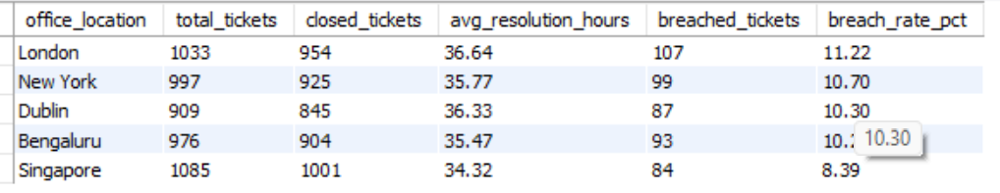

-- identifying the operational bottleneck by analyzing agent group and priority

Code:

SELECT
agent_group,
priority_level,
COUNT(ticket_id) AS total_tickets,
SUM(CASE WHEN ticket_status = 'Closed' THEN 1 ELSE 0 END) AS closed_tickets,
ROUND(AVG(CASE WHEN ticket_status = 'Closed' THEN TIMESTAMPDIFF(HOUR, created_on, resolved_at) END), 2) AS avg_resolution_hours,
SUM(CASE WHEN ticket_status = 'Closed' AND resolved_at > sla_deadline THEN 1 ELSE 0 END) AS breached_tickets,
ROUND(
SUM(CASE WHEN ticket_status = 'Closed' AND resolved_at > sla_deadline THEN 1 ELSE 0 END) * 100.0 /
NULLIF(SUM(CASE WHEN ticket_status = 'Closed' THEN 1 ELSE 0 END), 0), 2
) AS breach_rate_pct
FROM hr_tickets
GROUP BY agent_group, priority_level
ORDER BY breach_rate_pct DESC;

Output:
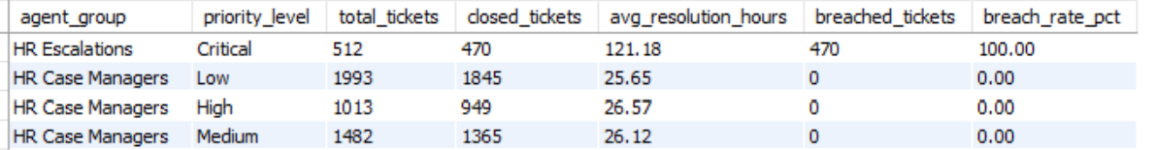

-- evaluating individual agent workload and performance across all priority tiers

Code:
SELECT
assigned_agent,
COUNT(ticket_id) AS total_assigned,
SUM(CASE WHEN priority_level = 'High' THEN 1 ELSE 0 END) AS high_priority_assigned,
SUM(CASE WHEN priority_level = 'Medium' THEN 1 ELSE 0 END) AS medium_priority_assigned,
SUM(CASE WHEN priority_level = 'Low' THEN 1 ELSE 0 END) AS low_priority_assigned,
SUM(CASE WHEN ticket_status = 'Closed' THEN 1 ELSE 0 END) AS total_closed,
ROUND(AVG(CASE WHEN ticket_status = 'Closed' THEN TIMESTAMPDIFF(HOUR, created_on, resolved_at) END), 2) AS overall_avg_resolution_hours
FROM hr_tickets
WHERE agent_group = 'HR Case Managers'
GROUP BY assigned_agent
ORDER BY total_assigned DESC;

Output:
