1. Understanding output for Conv2D model summary

from tensorflow import keras

from tensorflow.keras.models import Sequential

from tensorflow.keras.layers import Dense, Flatten,Conv2D

model = Sequential()

model.add(Conv2D(32,kernel_size=(6,5),strides=(3, 4),input_shape=(28,28,2)))

#(6*5*2+1)*32=1952 ; '1' added for bias

#[(28-6)+1]/3 ~ 8 ; '1' added for bias

#[(28-5)+1]/4 =6 ; '1' added for bias

model.add(Flatten())

#(8*6*32 = 1536)

model.add(Dense(10,activation='relu'))

#[(1536*10)+10=15370]; ‘10’ added as bias for 10 neurons declared in #Dense layer

model.summary()

OUTPUT:

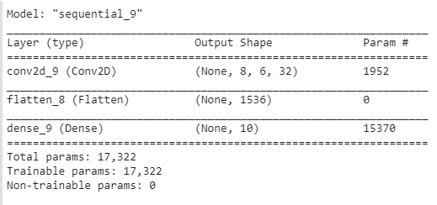

1. Uploading .csv file in Colab and access it after converting to numpy array.

import os

import numpy as np

from tensorflow import split

path = "/content/sample_data/sampletest.csv"

if os.path.exists(path):

  df = pd.read_csv(path)

  print(f"Got file {path}")

  print(df)

else:

    print(f"Unable to find the file at {path}")

z = np.array(df, dtype='float32')

print(f"Shape for z ->", shape(z))

x = z[1,0:5:2]

print(f"Output for x ->", x)

var1,var2,var3 = split(z,[5,2,3],0)

print(var1)

print(var2)

print(var3)

OUTPUT:

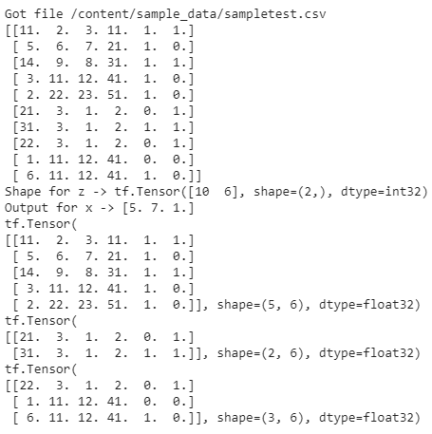

The output specifies tensor of [10,6] representing 10 rows and 6 columns.

Shape is (2,) specifying that tensor is a ‘vector’ having 2 values 10 & 6.

z[1,0:5:2] >> to access values starting at row 1,

column starting at ‘0’,

consider upto ‘5’ elements,

‘2nd’ element considered from previous value.

Thereby output of x being ‘[5 7 1]’

The ‘split’ function splits the tensor z into three variables var1, var2, var3 with lengths 5,2,3.

Since we have given the third parameter axis=0, the split will happen considering the number of rows in the tensor. In this case the number of rows is ‘10’ and the lengths of var1, var2, var3 should add upto ‘10’ (5+2+3=10).

If we specify the third parameter axis=1, then split will happen considering the number of columns in the tensor. In this case the number of columns is ‘6’.

If we specify the code as >> var1,var2,var3 = split(z,[3,1,2],1)

Then the 3 variables will be of lengths 3,1,2 (which when added will be ‘6’ corresponding to number of columns).

Output for this split would be-

