**Steps to Create Exe in Visual Studio.**

1. Run Visual Studio as an Administrative mode
2. Clean and Build the project.
3. Make sure no error
4. Right click in solution explorer and add new project /

Click on file -> New-> Project

1. Click on Setup Project and click next

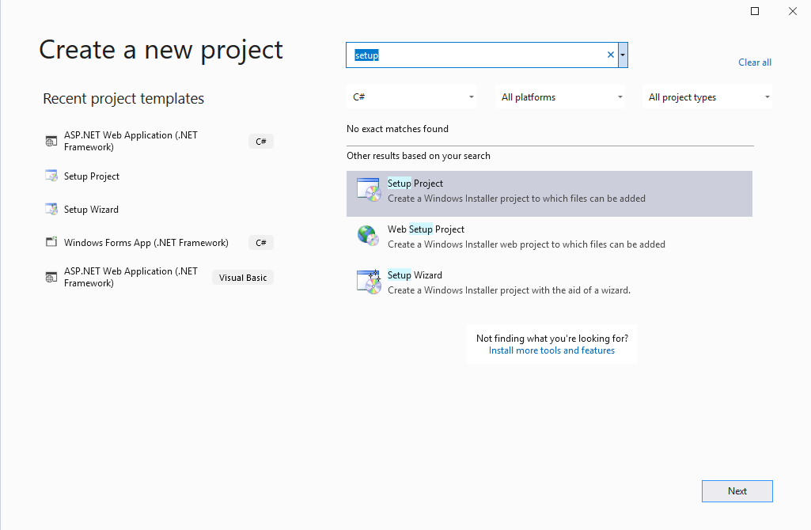

1. Enter name and select setup path and click on create.

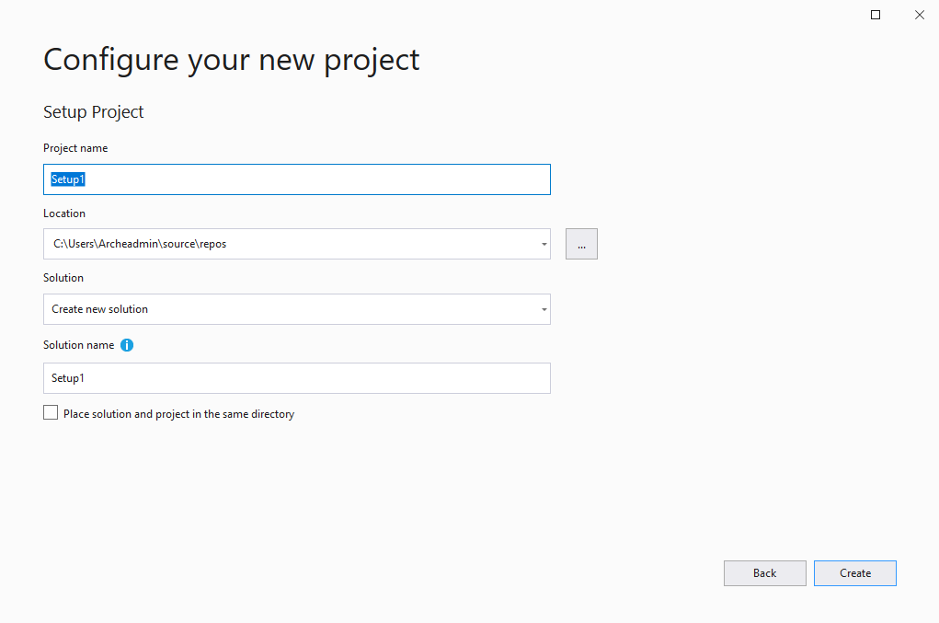

1. A). On left hand side click on application folder

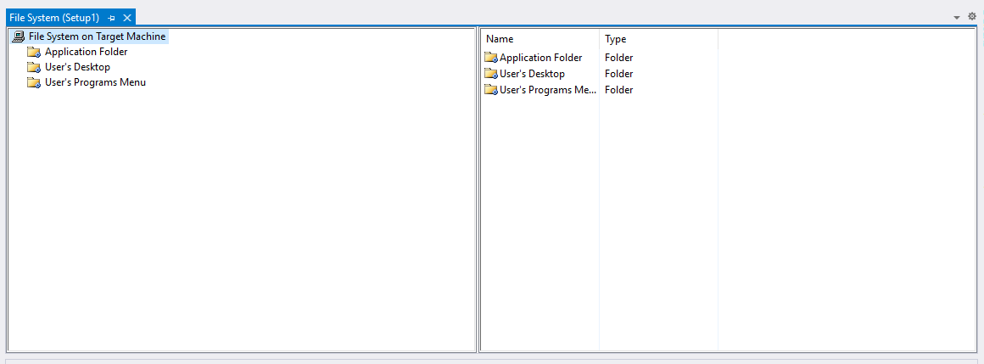

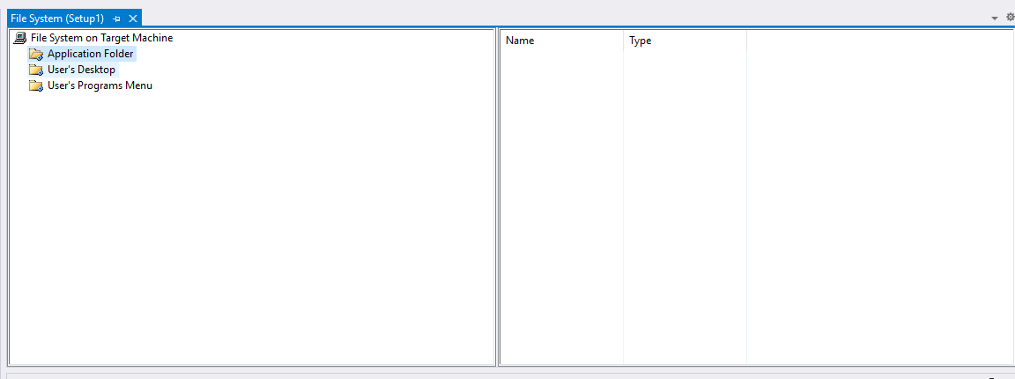

b) on the right hand side right click and click on add->Project output file.

New popup window open select Primary Output and click ok.

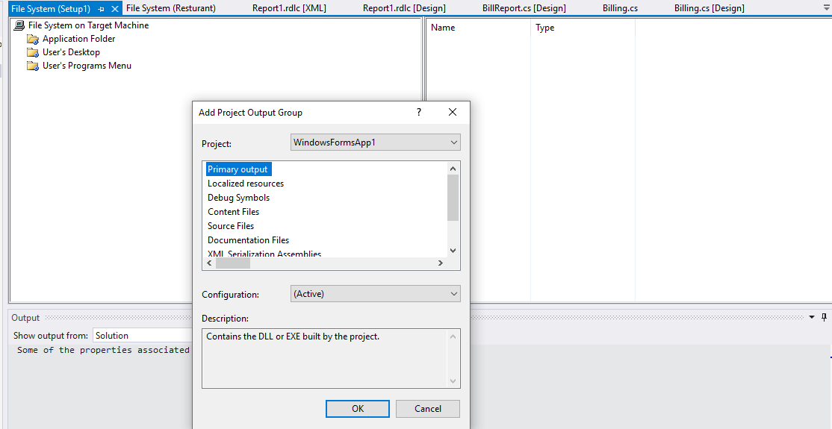

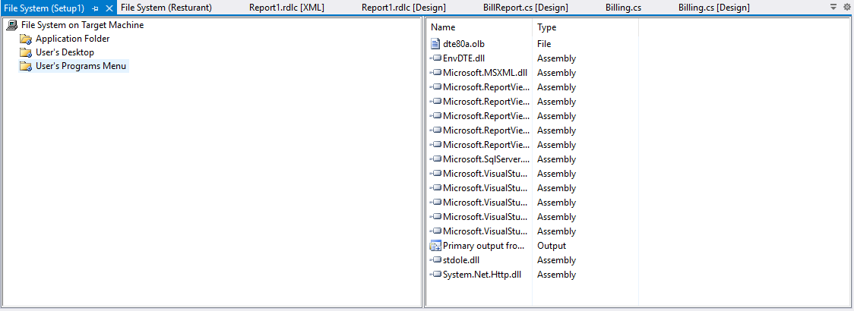

Now same way on right hand side white space right click and add your App_Data Folder and Report Folder If you have any.

(**Note**: You can’t add folder directly so you have to create folder. Then add files one by one.)

C). Now Click left hand side User’s Desktop. Than on right hand side blank white space right click and Create shortcut. New Popup open than double click on Application folder.

Now select primary output file and click ok. And rename the file as per your requirement.

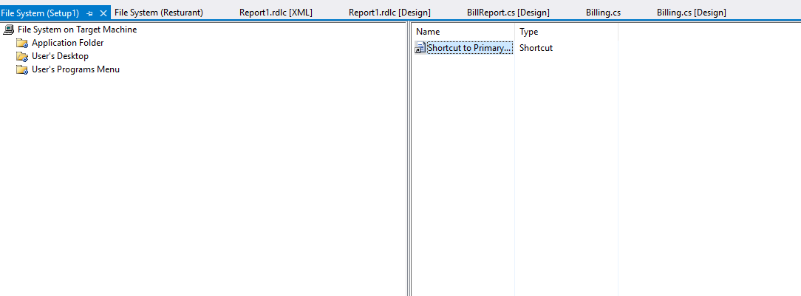

d) Repeat same process for User’s Programs menu.

1. Now go to solution explorer and right click on setup name and click on build.
2. After Build Successful. Setup file is ready for execute.
3. If setup require any prerequisites. To add prerequisites right click setup project in solution explorer and select property. Click On Prerequisites button and select setup requirements and rebuild the project.

[ Note : make sure Sql Express allows allows remote database connection. Allow full control to App_Data Folder after installing exe.]