Practical 4:- To determine maximum temperature using Hadoop MapReduce

Map Reduce : works by breaking the processing into two phases: the map phase and the reduce phase. Each phase has key-value pairs as input and output, the types of which may be chosen by the programmer. The programmer also specifies two functions: the map function and the reduce function.
Hadoop MaxTemprature operation occurs in 3 stages –
Mapper Phase
Reducer Phase
Driver code

Dataset – temperature.txt
0067011990999991950051507004+68750+023550FM-12+038299999V0203301N00671220001CN9999999N9+00001+99999999999
0043011990999991950051512004+68750+023550FM-12+038299999V0203201N00671220001CN9999999N9+00221+99999999999
0043011990999991950051518004+68750+023550FM-12+038299999V0203201N00261220001CN9999999N9-00111+99999999999
0043012650999991949032412004+62300+010750FM-12+048599999V0202701N00461220001CN0500001N9+01111+99999999999
0043012650999991949032418004+62300+010750FM-12+048599999V0202701N00461220001CN0500001N9+00781+99999999999
These lines are presented to the map function as the key-value pairs
(0, 0067011990999991950051507004...9999999N9+00001+99999999999...) (106, 0043011990999991950051512004...9999999N9+00221+99999999999...) (212, 0043011990999991950051518004...9999999N9-00111+99999999999...) (318, 0043012650999991949032412004...0500001N9+01111+99999999999...) (424, 0043012650999991949032418004...0500001N9+00781+99999999999...)
The keys are the line offsets within the file, which we ignore in our map function. The map function merely extracts the year and the air temperature (indicated in bold text), and emits them as its output (the temperature values have been interpreted as integers):
(1950, 0)
(1950, 22)
The output from the map function is processed by the MapReduce framework before being sent to the reduce function. This processing sorts and groups the key-value pairs by key. So, continuing the example, our reduce function sees the following input:
(1949, [111, 78])
(1950, [0, 22, −11])
Each year appears with a list of all its air temperature readings. All the reduce function has to do now is iterate through the list and pick up the maximum reading:
(1949, 111)
(1950, 22)
- Open virtual box and then start cloudera quickstart


- Open Eclipse present on the cloudera desktop

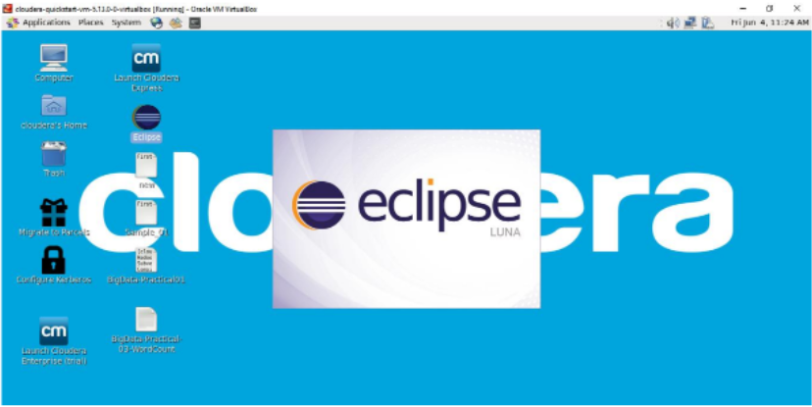

- Create a new Java project clicking: File -> New -> Project -> Java Project -> Next (“MaxTemp” is
the project name).
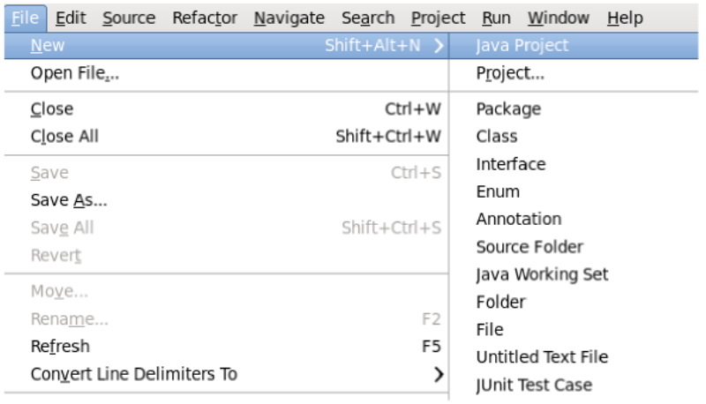
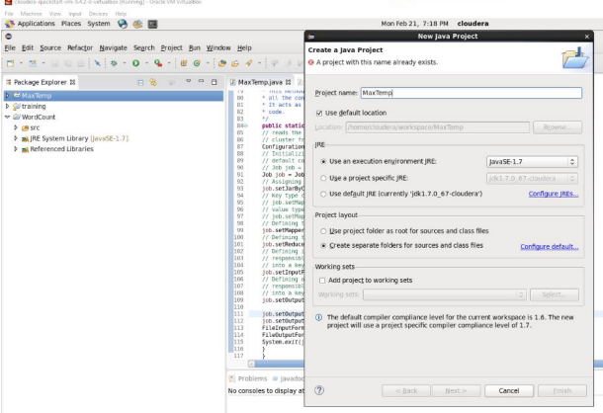

- Adding the Hadoop libraries to the project Click on Libraries -> Add External JARs
Click on File System -> usr -> lib -> Hadoop Select all the libraries (JAR Files) -> click
OK Click on Add External jars, -> client -> select all jar files -> ok -> Finish.
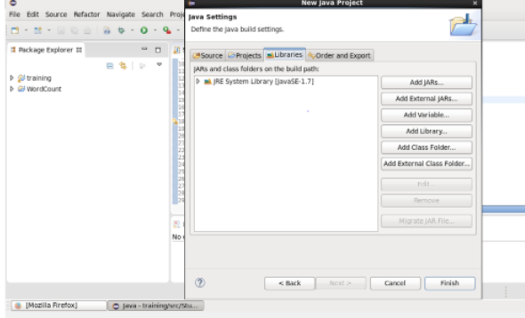

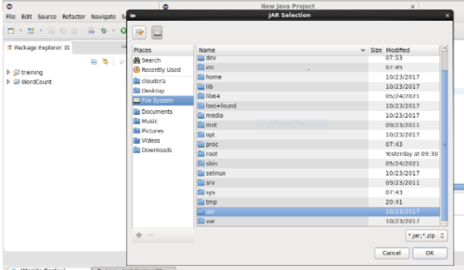

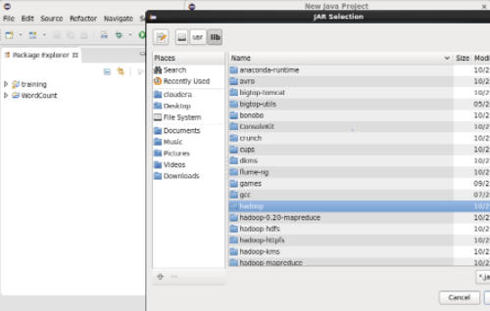

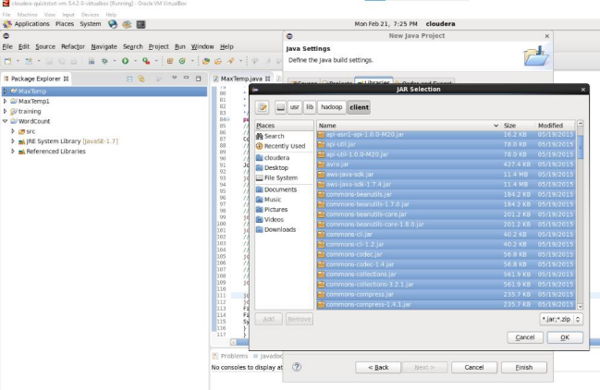
- Right Click on the name of Project “MaxTemp” -> New -> class don’t write anything for package Write Name Textbox write “MaxTemp” -> Finish Then MaxTemp.java window will pop up.
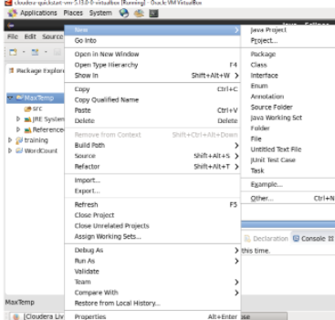
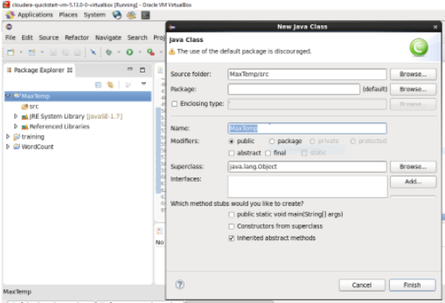

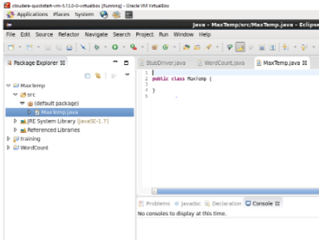
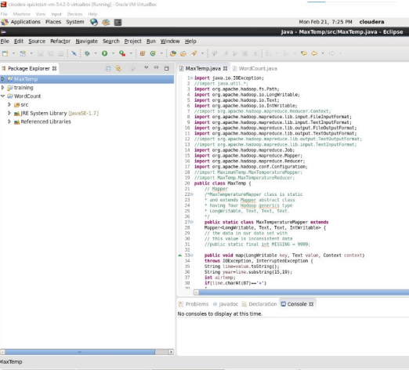
Source code:
import java.io.IOException;
//import java.util.*;
import org.apache.hadoop.fs.Path;
import org.apache.hadoop.io.LongWritable;
import org.apache.hadoop.io.Text;
import org.apache.hadoop.io.IntWritable;
//import org.apache.hadoop.mapreduce.Reducer.Context;
import org.apache.hadoop.mapreduce.lib.input.FileInputFormat;
import org.apache.hadoop.mapreduce.lib.input.TextInputFormat;
import org.apache.hadoop.mapreduce.lib.output.FileOutputFormat;
import org.apache.hadoop.mapreduce.lib.output.TextOutputFormat;
//import org.apache.hadoop.mapreduce.lib.output.TextOutputFormat;
//import org.apache.hadoop.mapreduce.lib.input.TextInputFormat;
import org.apache.hadoop.mapreduce.Job;
import org.apache.hadoop.mapreduce.Mapper;
import org.apache.hadoop.mapreduce.Reducer;
import org.apache.hadoop.conf.Configuration;
//import MaximumTemp.MaxTemperatureMapper;
//import MaxTemp.MaxTemperatureReducer;
public class MaxTemp {
// Mapper
/*MaxTemperatureMapper class is static
* And extends Mapper abstract class
* having four Hadoop generics type
* Long Writable, Text, Text, Text.
*/
public static class MaxTemperatureMapper extends
Mapper<LongWritable, Text, Text, IntWritable> {
// the data in our data set with
// this value is inconsistent data
//public static final int MISSING = 9999;

public void map(LongWritable key, Text value, Context context)
throws IOException, InterruptedException {
String line=value.toString();
String year=line.substring(15, 19);
int airtemp;
if(line.charAt(87)=='+')
{
airtemp=Integer.parseInt(line.substring(88,92));
}
else
airtemp=Integer.parseInt(line.substring(87,92));
String q=line.substring(92,93);
if(airtemp!=9999 && q.matches("[01459]"))
{

context.write(new Text(year), new IntWritable(airtemp));
}
}
}
// Reducer
/*MaxTemperatureReducer class is static
and extends Reducer abstract class
having four Hadoop generics type
Text, Text, Text, Text.
*/
public static class MaxTemperatureReducer extends
Reducer<Text, IntWritable, Text, IntWritable> {
/**
* @method reduce
* This method takes the input as key and
* list of values pair from the mapper,
* it does aggregation based on keys and
* produces the final context.
*/
public void reduce(Text key,Iterable<IntWritable> values, Context context)
throws IOException, InterruptedException {
int maxvalue= Integer.MIN_VALUE;
for (IntWritable value : values) {
maxvalue=Math.max(maxvalue, value.get());
}
context.write(key, new IntWritable(maxvalue));
}
}

/**
* @method main
* This method is used for setting
* all the configuration properties.
* It acts as a driver for map-reduce
* code.
*/
public static void main(String[] args) throws Exception {
// reads the default configuration of the
// cluster from the configuration XML files
Configuration conf = new Configuration();
// initializing the job with the
// default configuration of the cluster
// Job job = new Job(conf, "weather example");
Job job = Job.getInstance(conf, "weather example");
// Assigning the driver class name
job.setJarByClass(MaxTemp.class);
// Key type coming out of mapper
// job.setMapOutputKeyClass(Text.class);
// value type coming out of mapper
// job.setMapOutputValueClass(Text.class);
// Defining the mapper class name
job.setMapperClass(MaxTemperatureMapper.class);
// Defining the reducer class name
job.setReducerClass(MaxTemperatureReducer.class);
// defining input Format class which is
// responsible to parse the dataset
// into a key value pair
job.setInputFormatClass(TextInputFormat.class);
// Defining output Format class which is
// responsible to parse the dataset
// into a key value pair
job.setOutputFormatClass(TextOutputFormat.class);

job.setOutputKeyClass(Text.class);
job.setOutputValueClass(IntWritable.class);
FileInputFormat.addInputPath(job, new Path(args[0]));
FileOutputFormat.setOutputPath(job, new Path(args[1]));
System.exit(job.waitForCompletion(true) ? 0 : 1);
}
}
- Right Click on the project name MaxTemp -> Export -> Java -> JAR File -> Next -> for select the export destination for JAR file: browse -> Name : MaxTemp.jar -> save in folder - > cloudera -> Finish -> OK
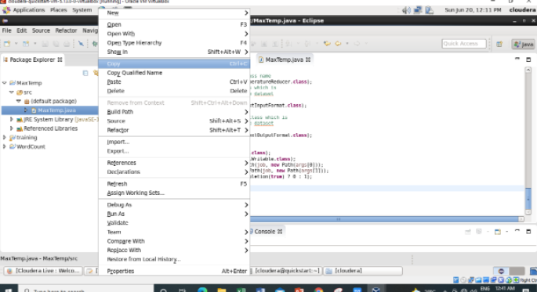

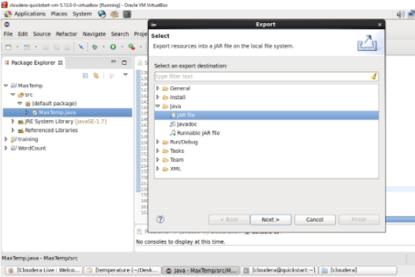

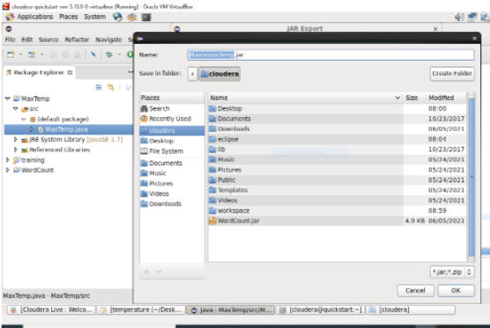

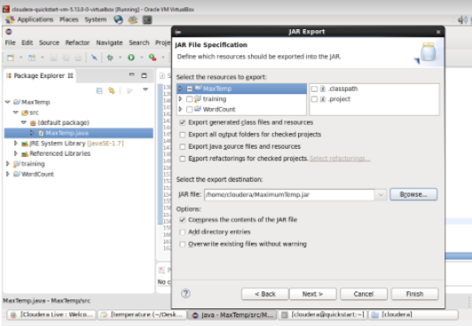
- Open terminal & type ->hdfs dfs -ls /
HDFS Command to display the list of Files and Directories in HDFS. It lists the contents of the directory specified by path, showing the names, permissions, owner, size and modification date for each entry.
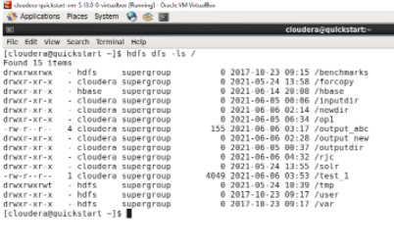
- Input file named as temperature which is present on desktop i.e. in local file system.
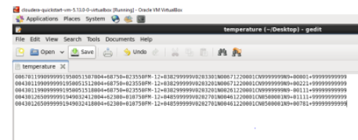
- Now we have to move this input file to hdfs. For this we create a direcory on hdfs using command
->hdfs dfs -mkdir /tempip.
So here I create tempip directory.
Then we can verify whether this directory is created or not using ls command hdfs dfs -ls /
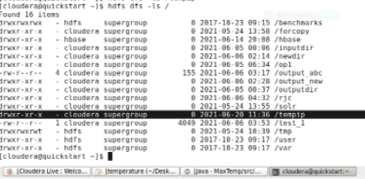
- Move the input file i.e. temperature to this directory created in hdfs by using either put command or copyFromLocal command.
hdfs dfs –put /home/cloudera/Desktop/temperature /tempip/

- Now checking whether the “temperature” present in /tempip directory of hdfs or not using
hdfs dfs –ls/tempip command

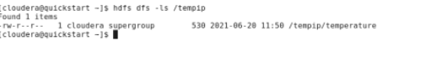
- As we can see “temperature” file is present in /tempip directory of hdfs. Now we will see the content of this file using hdfs dfs –cat /tempip/temperature command.

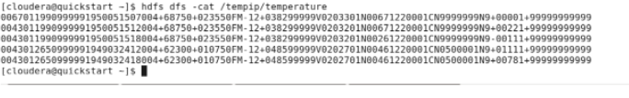

- Running Mapreduce Program on Hadoop, syntax is hadoop jar jarFileName.jar ClassName /InputFileAddress /outputdir
i.e. hadoop jar /home/cloudera/MaximumTemp.jar MaxTemp /tempip/temperature
/tempop1

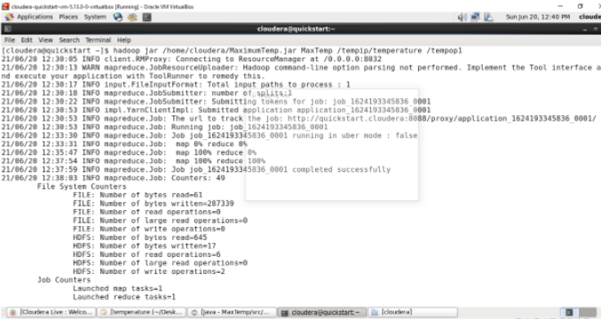

Map-Reduce Framework
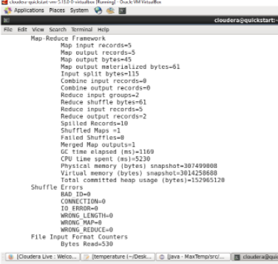

- Verify the content of tempop1 directory and in that part-r file has the actual output by using the command Hdfs dfs -cat /tempop1/part-r-00000. This will give us final output. The same file can also be accessed using a browser. For every execution of this program we need to delete the output directory or give a new name to the output directory every time.
- checking whether the tempop1 directory is created in hdfs or not using command
-> hdfs dfs -ls /
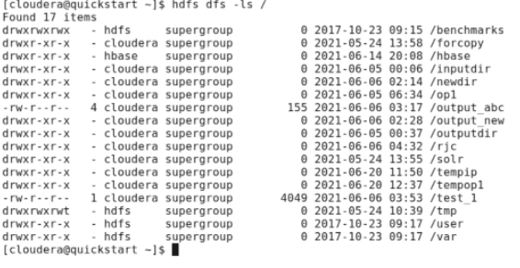

Check what we have inside this tempop1 directory using command as
->hdfs dfs –ls/tempop1
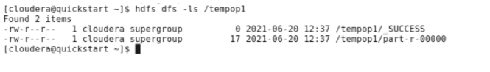

Now we want to read the content of the part-r-00000 file which present inside the tempop1
using command
- hdfs dfs -cat /tempop1/part-r-00000
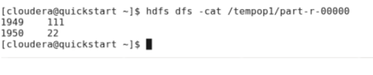
So the maximum temperature for the year 1949 is 111 and for the year 1950 is 22.
- The same file can also be accessed using a browser.
Browse the Directory by
Hadoop->HDFS Namenode->Ultilities ->Browse the file system

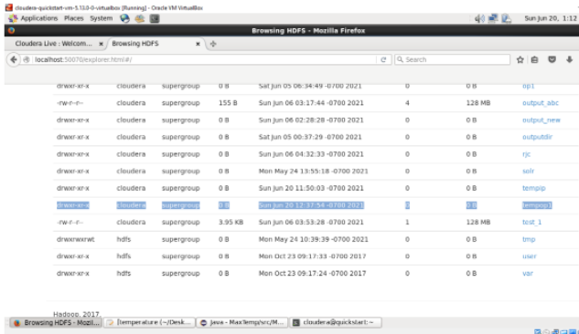

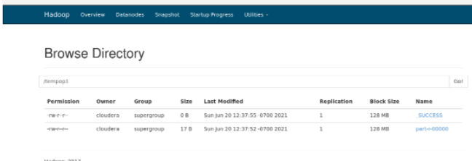

Now downloading the part-r-00000 file.

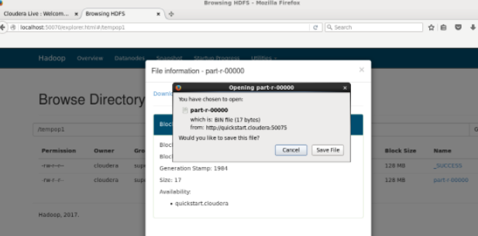

Inside the part-r-00000 file it will have the same output as we are getting after executing using
command.
-hadoop jar /home/cloudera/MaximumTemp.jar MaxTemp /tempip/temperature/tempop1

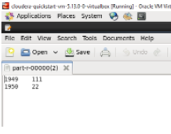

NOTE: - For every execution of this program we need to delete the output directory or give a new name to the output directory every time.

