Steps for Word Count in Cloudera: (Without Combiner)

- Open virtual box and then start cloudera quickstart.
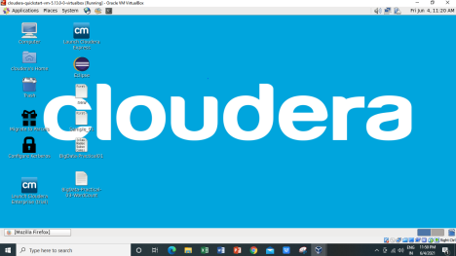

- Open Eclipse present on the cloudera desktop.

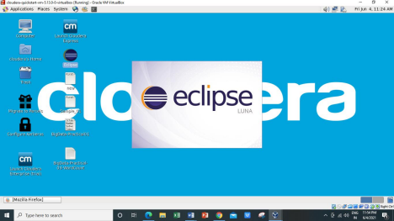

3) Create a new Java project clicking: File -> New -> Project -> Java Project -> Next (“WordCount” is the project name).

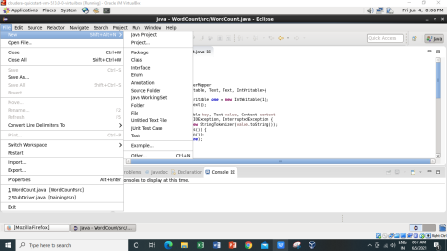

4)Adding the Hadoop libraries to the project Click on Libraries -> Add External JARs Click on File System -> usr -> lib -> hadoop Select all the libraries (JAR Files) -> click OK Click on Add External jars, -> client -> select all jar files -> ok -> Finish
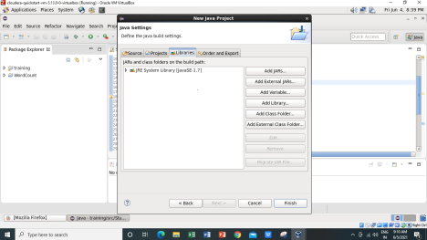
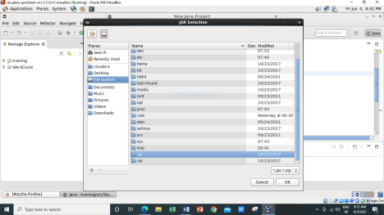

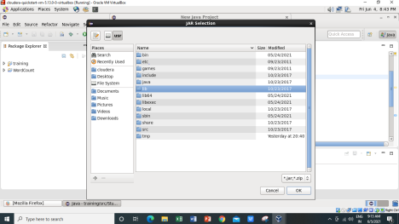
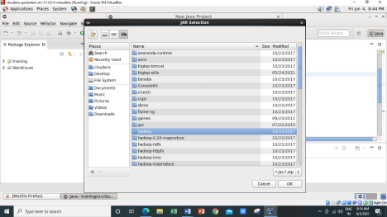

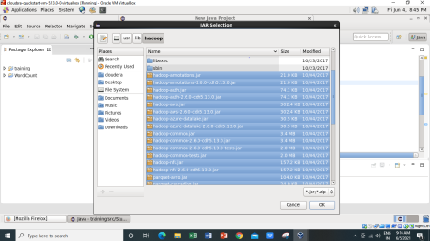

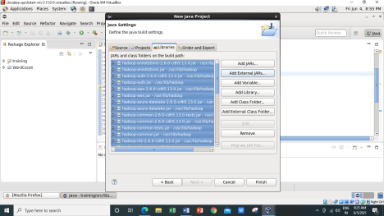

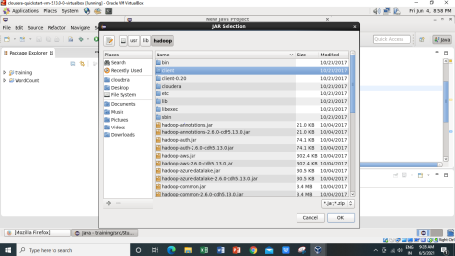

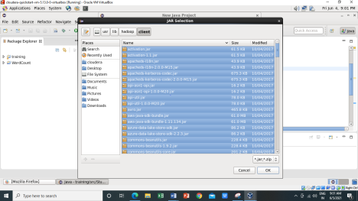

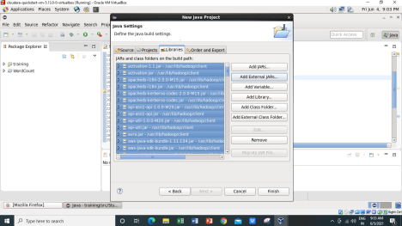

5) Right Click on the name of Project “WordCount” -> New -> class Don’t write anything for package Write Name Textbox write “WordCount” -> Finish Then WordCount.java window will pop up
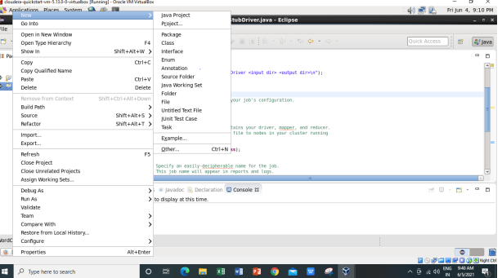

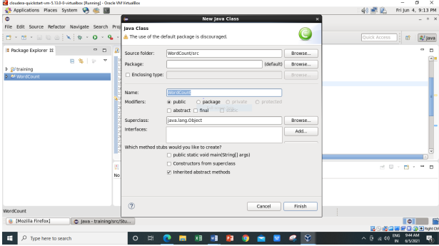

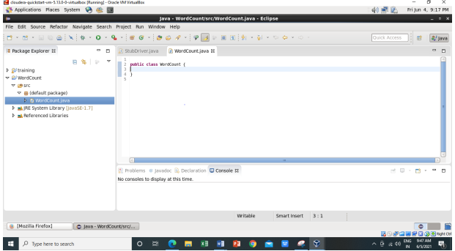

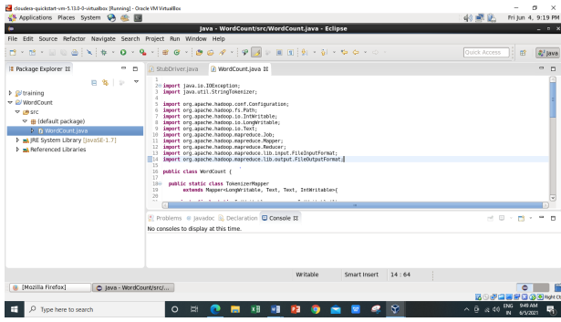

6) Right Click on the project name WordCount -> Export -> Java -> JAR File -> Next -> for select the export destination for JAR file: browse -> Name : WordCount.jar -> save in folder -> cloudera -> Finish -> OK
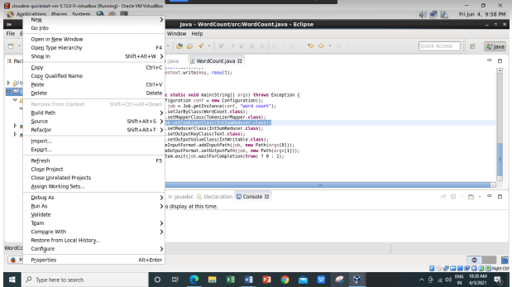
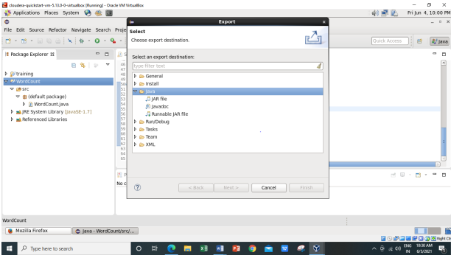
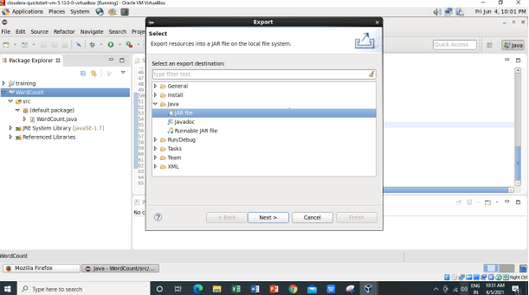
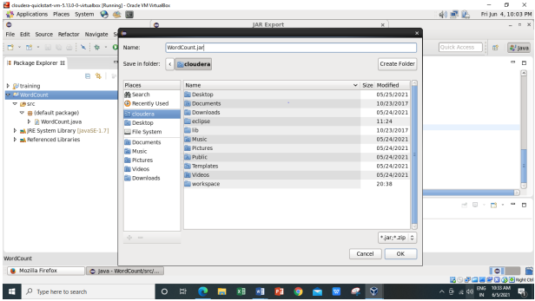
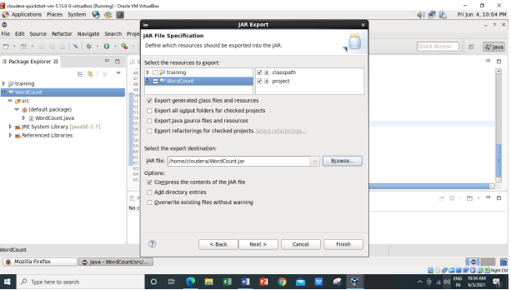

7) Verify jar file from terminal by using Open terminal & type “ ls ” There it will show WordCount.jar
Check current working directory ->pwd
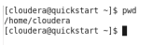
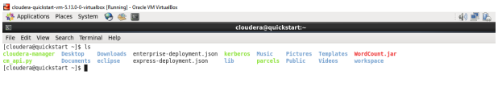
8) We need to create an input file in local file system
Creating an input file named as “abc”.
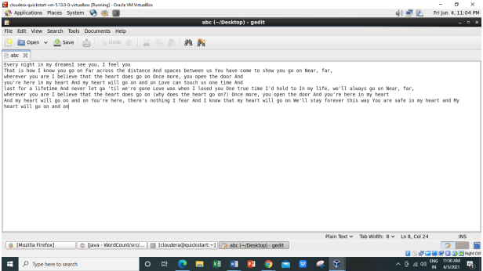
Here listing all the directory present in hdfs using hdfs dfs -ls / command
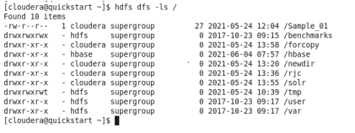
9) Now we have to move this input file to hdfs. For this we create a direcory on hdfs using
command hdfs dfs -mkdir /inputnew.
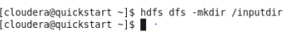
Then we can verify whether this directory is created or not using ls command hdfs dfs -ls /
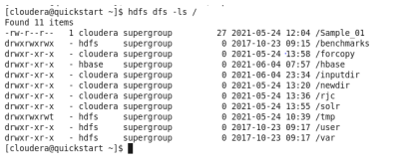
Move the input file to this directory created in hdfs by using either put command or copyFromLocal command.
Now checking whether the “abc” present in /inputdir directory of hdfs or not using hdfs dfs -ls /inputdir command
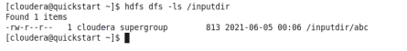
As we can see “abc” file is present in /inputdir directory of hdfs. Now we will see the content of this file using hdfs dfs –cat /inputdir/abc command
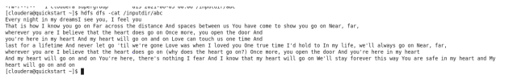
10) Running Mapreduce Program on Hadoop, syntax is hadoop jar jarFileName.jar ClassName /InputFileAddress /outputdir
i.e. hadoop jar /home/cloudera/WordCount.jar WordCount /inputdir/abc /outputdir
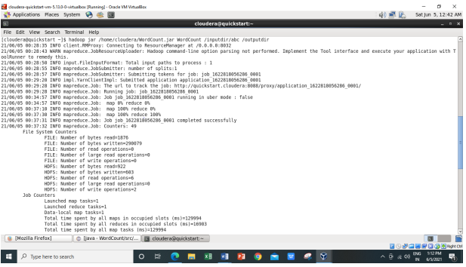
Map-Reduce Framework
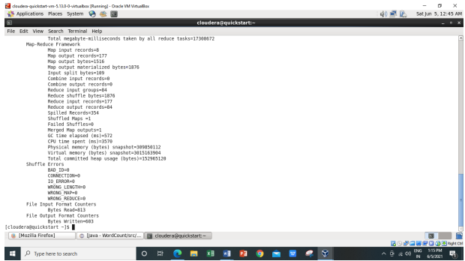
As we can see in the above output,
Combine input records=0
Combine output records=0
We are getting this because we have commented the Combiner line in main function.
And Reduce shuffle bytes coming as,
Reduce shuffle bytes=1876
So when we are not using combiner 1876 bytes acting as an input for the reducer.
11) Then we can verify the content of outputdir directory and in that part-r file has the actual
output by using the command Hdfs dfs -cat /outputdir/part-r-00000 This will give us final output.
The same file can also be accessed using a browser. For every execution of this program we need
to delete the output directory or give a new name to the output directory every time.
1st we are checking whether the outputdir directory is created in hdfs or not using command
hdfs dfs -ls /
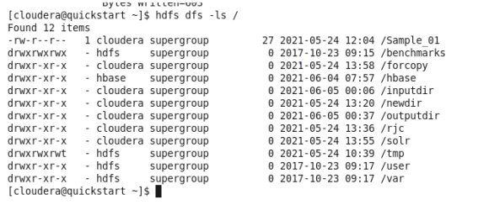
Now let’s check what we have inside this outputdir directory using command as hdfs dfs -ls
/outputdir
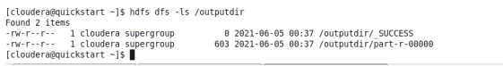
Now we want to read the content of the part-r-00000 file which present inside the outputdir
using command hdfs dfs -cat /outputdir/part-r-00000
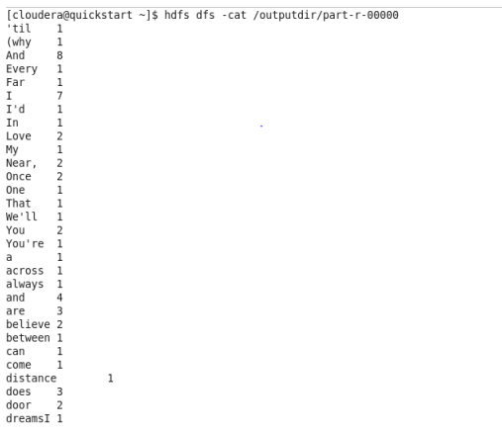
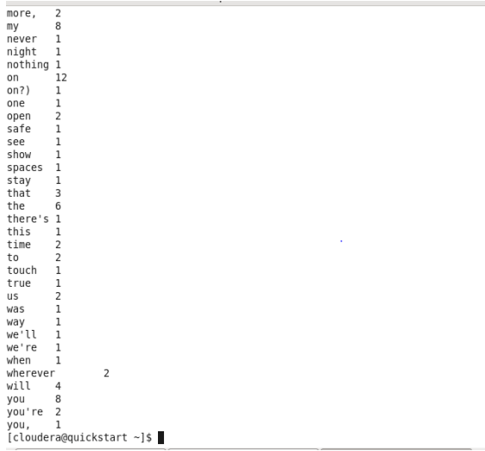
It will give the count of number of times each word has occurred as output.
12) The same file can also be accessed using a browser.
Browse the Directory by
Hadoop->HDFS Namenode->Ultilities ->Browse the file system
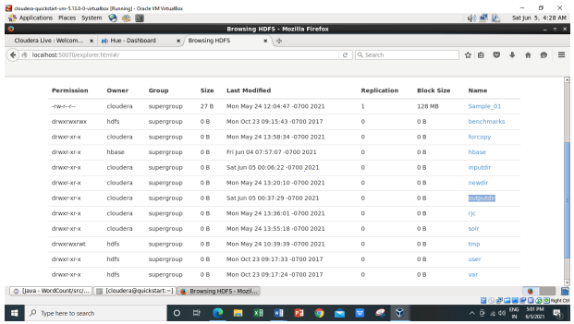
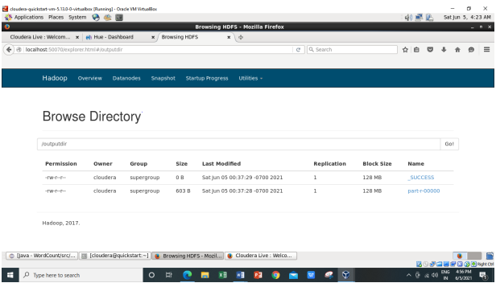
Now downloading the part-r-00000 file.
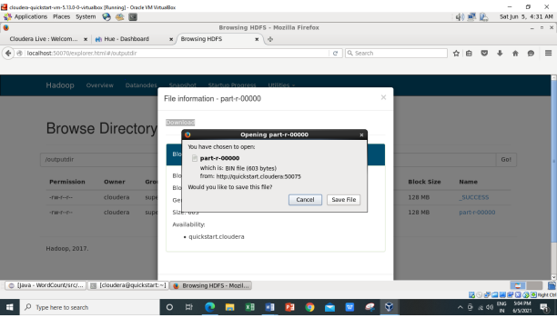
Inside the part-r-00000 file it will have the same output as we are getting after executing using
command hadoop jar /home/cloudera/WordCount.jar WordCount /inputdir/abc /op1
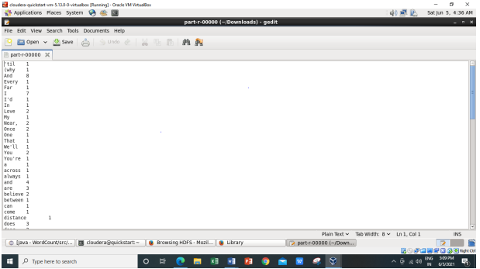
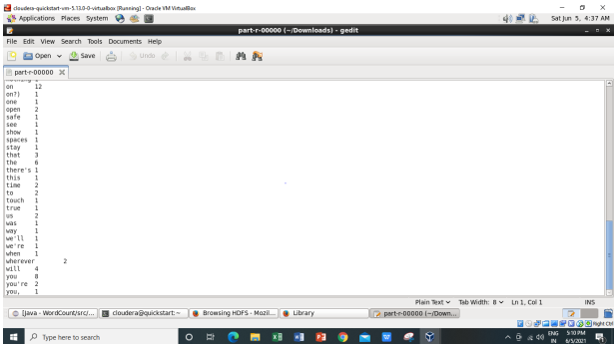
For every execution of this program we need to delete the output directory or give a new
name to the output directory every time.
Implementation of WordCount problem using Hadoop MapReduce (With Combiner) in Eclipse:
1) We will perform the same steps as we have done above for WordCount (without using
combiner) in that we just uncommenting the combiner line in main function.
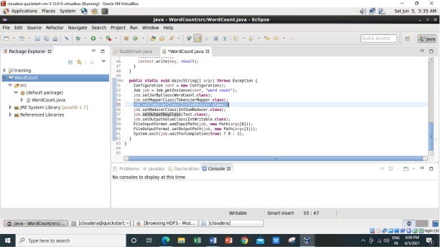
2)And will delete the WordCount.jar file in which all jar files are present from /home/cloudera.
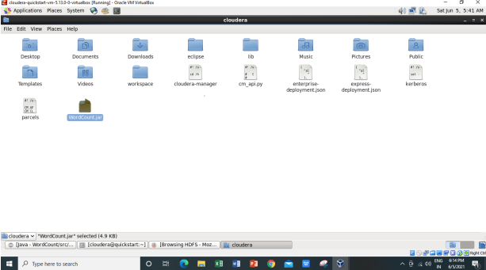
We have successfully deleted the WordCount.jar file.
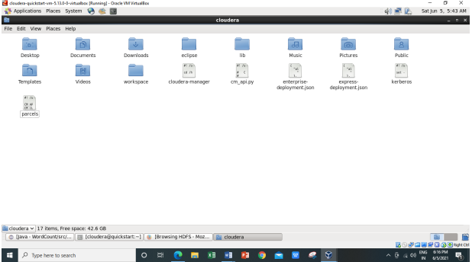

- Now exporting the jar files Right Click on the project name WordCount -> Export -> Java ->JAR File -> Next -> for select the export destination for JAR file: browse -> Name : WordCount.jar -> save in folder -> cloudera -> Finish -> OK
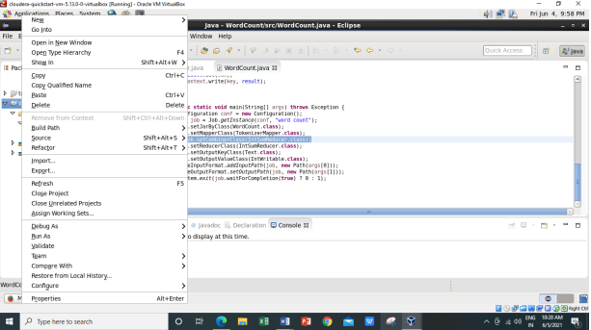
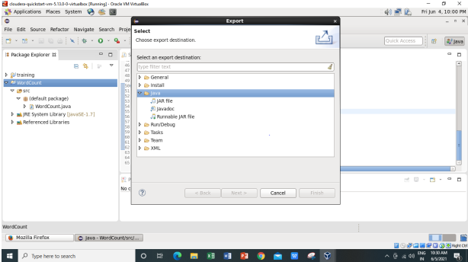
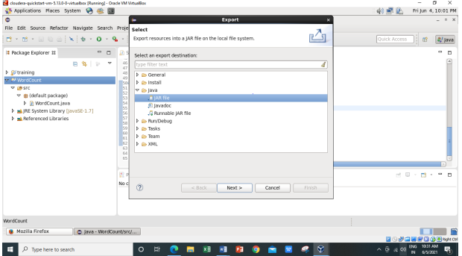
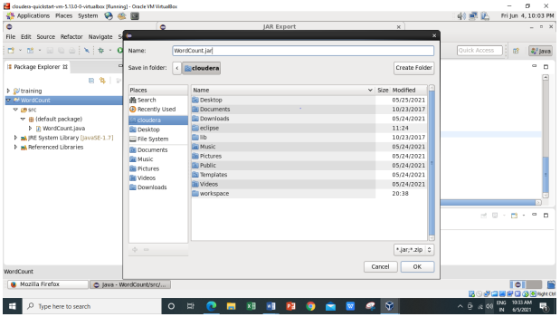
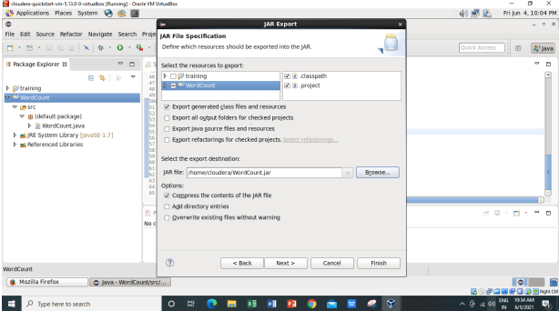

4)Now checking the WordCount.jar file is created or not using –ls command
5) Running Mapreduce Program on Hadoop, syntax is hadoop jar jarFileName.jar ClassName
/InputFileAddress /outputdir
i.e. hadoop jar /home/cloudera/WordCount.jar WordCount /inputdir/abc /op1
here I am using the same input file ‘abc’ which I have created earlier for WordCount
example (Without Combiner). For every execution of this program we need to delete the
output directory or give a new name to the output directory every time. So here I am
giving the new name to the output directory as ‘op1’.
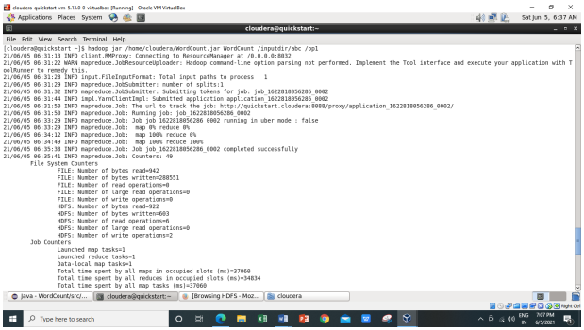
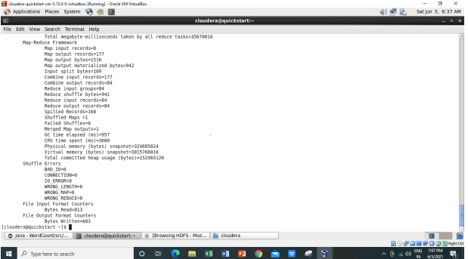
- As we can see from above image the the combiner input and output records coming out as,
Combine input records=177
Combine output records=84
- Earlier it was coming out as “zero” while executing WordCount (without combiner).
Combine input records=0
Combine output records=0

- And also here we are getting the Reduce Shuffle bytes as,
Reduce shuffle bytes=942
Earlier while executing WordCount (without combiner) it is coming out as,
Reduce shuffle bytes=1876
- So Combiner is used to save the Network Bandwidth. So for saving the Network
bandwidth we make use of combiner. So instead of sending every word over the
network what we do is we incorporate the logic of the reducer at the combiner side so
that the less amount of information can be transmitted over the network.
- So when we are not using combiner 1876 bytes acting as an input for the reducer. And
when we are making use of the combiner so 942 bytes acting as input for the reducer.
6) The same file can also be accessed using a browser.
Browse the Directory by
Hadoop->HDFS Namenode->Ultilities ->Browse the file system
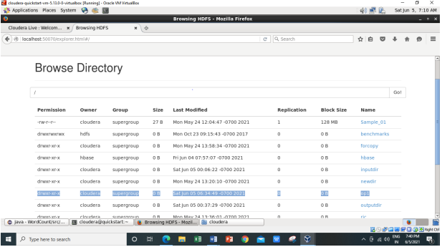
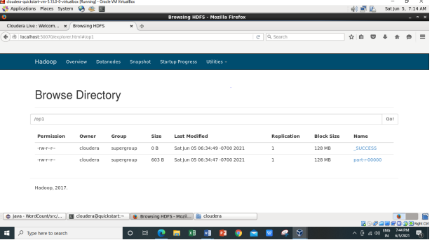
Now downloading the part-r-00000 file.
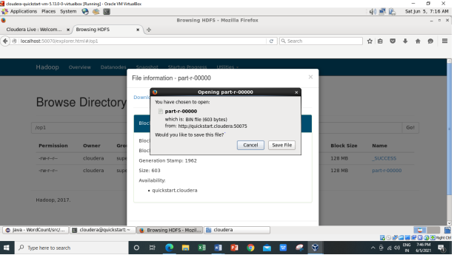
Inside the part-r-00000 file it will have the same output as we are getting after executing using
command hadoop jar /home/cloudera/WordCount.jar WordCount /inputdir/abc /op1
