MATH 609
Anthony Barcio

Code for qs. 4 and 5 is available in relevant folder at https://github.com/ajbarcio/609HWs.git

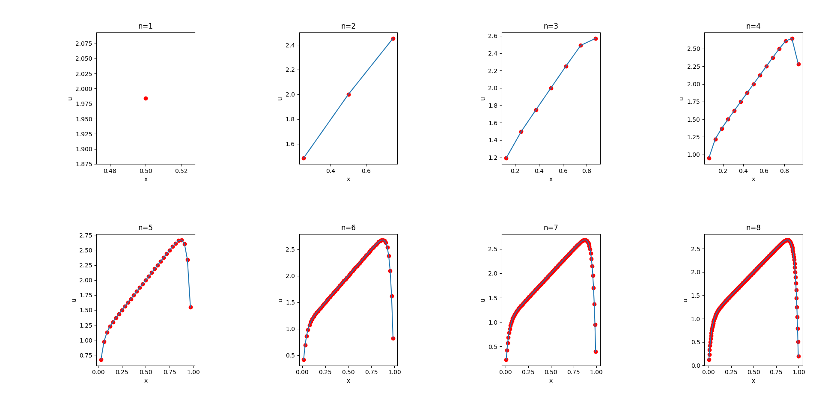
4. Plotted results:
5a.

L = [[ 1.41421356 0. 0. 0. ]
[-0.70710678 1.22474487 0. 0. ]
[ 0. -0.81649658 1.15470054 0. ]
[ 0. 0. -0.8660254 1.11803399]]
L.T = [[ 1.41421356 -0.70710678 0. 0. ]
[ 0. 1.22474487 -0.81649658 0. ]
[ 0. 0. 1.15470054 -0.8660254 ]
[ 0. 0. 0. 1.11803399]]

5b.

L = [[1. 0. 0. 0. ]
[0.5 0.28867513 0. 0. ]
[0.33333333 0.28867513 0.0745356 0. ]
[0.25 0.25980762 0.1118034 0.01889822]]
L.T = [[1. 0.5 0.33333333 0.25 ]
[0. 0.28867513 0.28867513 0.25980762]
[0. 0. 0.0745356 0.1118034 ]
[0. 0. 0. 0.01889822]]

