Task 2.7

Charts by cooking time  
Search by difficulty

**Data Analysis:** RecipeApp users will be able to sort recipes by difficulty level and see the results in three different chart types.

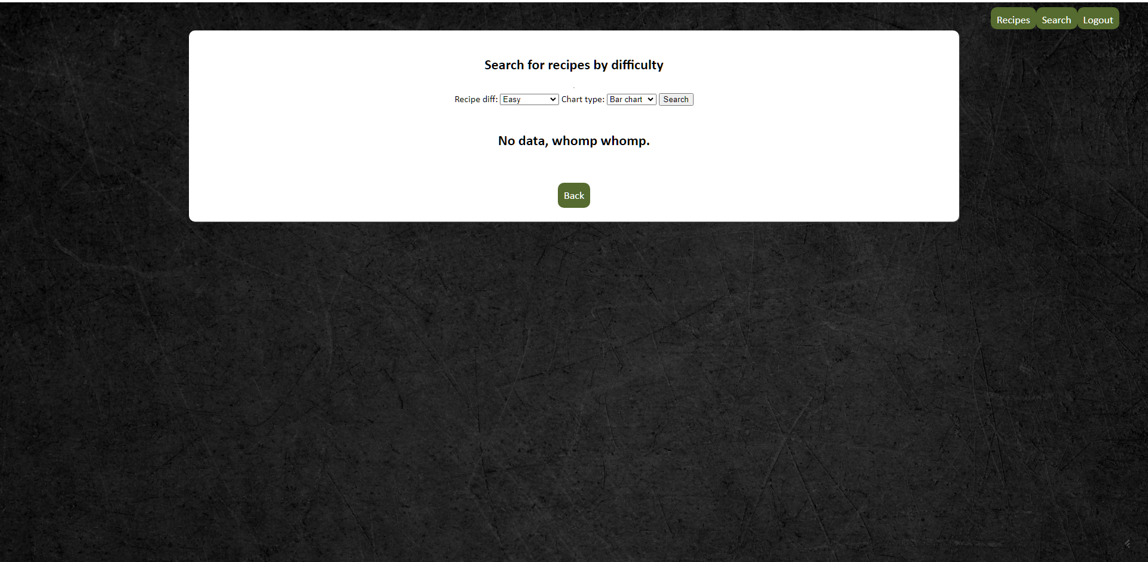

The users set their search criteria in the app, and the app takes the recipes from the database as a QuerySet, convert the QuerySet to a pandas DataFrame and display the results in the table.

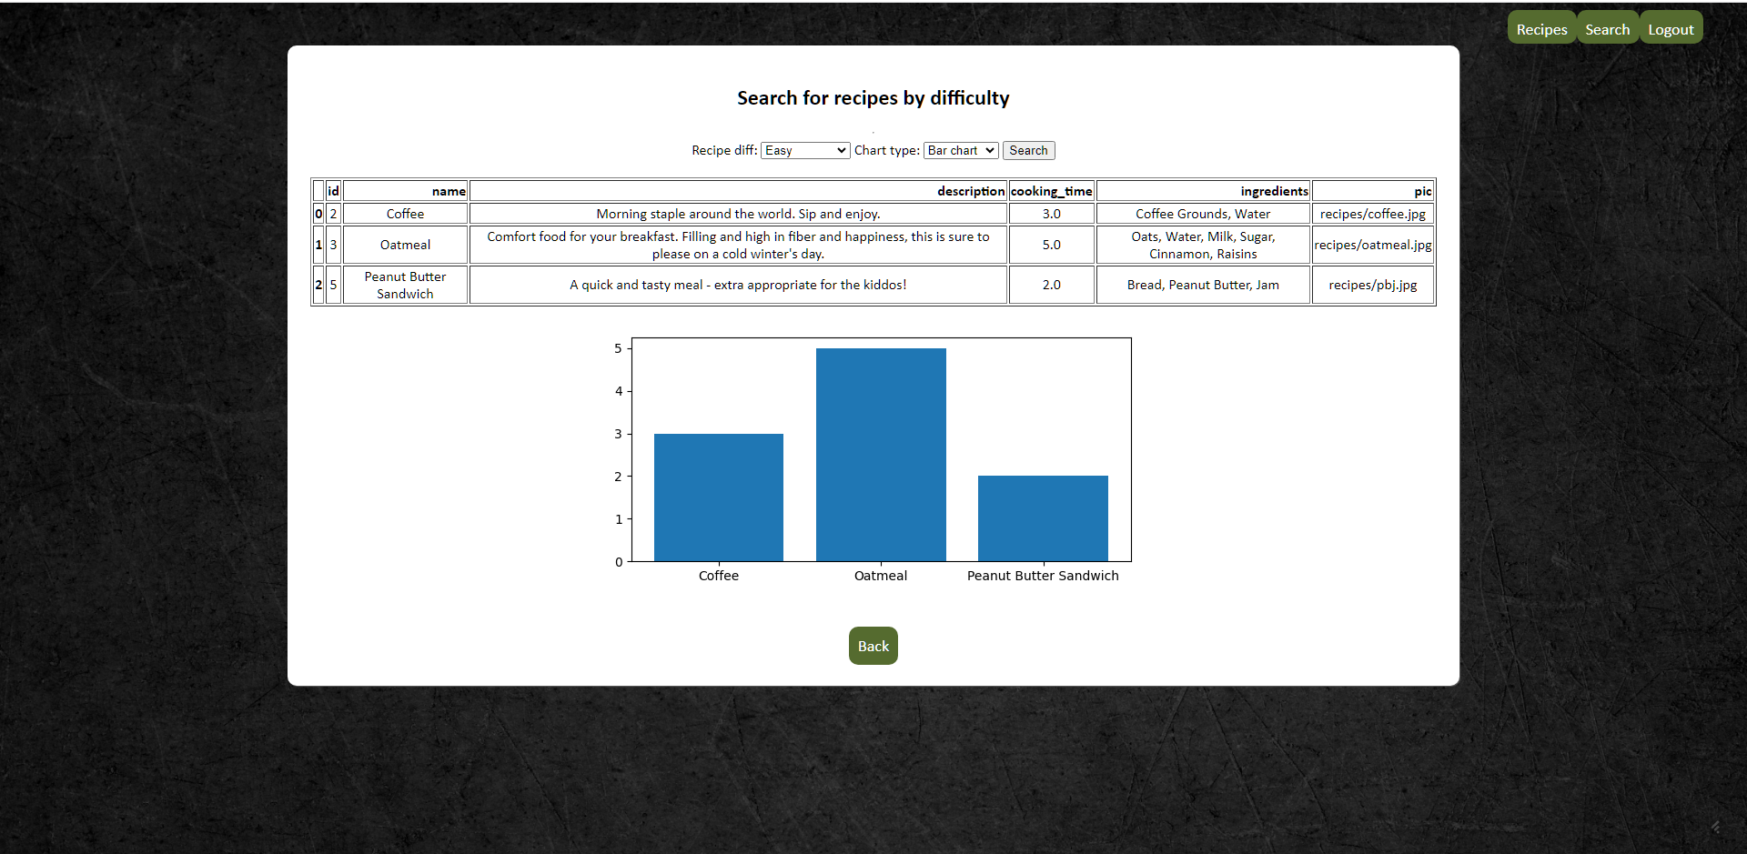

The bar chart above shows the recipes indicated as “Easy” and the visualization is provided through the matplotlib library. The bar chart shows the recipes on the x-axis with the corresponding cooking times on the y-axis. The pie and line charts below also use the recipe names visualized with their respective cooking times.

