The following were methods that were explored for video interpretations into Unity. I explored various methods as many are outdated, Unity provides little explanation in their tools and I needed one method to pull through. If someone has experience with encoding and decoding video it may be possible though one would have to write custom scripts and be well versed in C#. Many of the libraries are deprecated. I had spent approximately four weeks on these methods and Vuforia was the only applicable free solution. Also note you need a significant amount of memory for both installing and running VR applications. My C drive consistently had issues from the data Windows stored and would drop below 10GB memory which is required.

Unity’s documentation is sparse and doesn’t describe it’s own methods well. The following link is an example for it’s videoweb player using a URL. It seems this method may only take files and not constant packet data of a video. It’s unknown what kind of file it takes as well.

<https://docs.unity3d.com/ScriptReference/Video.VideoPlayer-url.html>

**Webcam Import Directly from Windows Devices** (Failed, didn’t work)

Tried running the script and setup the items. Nothing would display from the webcam.

<https://www.youtube.com/watch?v=nADTdV8wsXQ>

<https://www.youtube.com/watch?v=vtM-kqaTUso&t>

**Webcam Import Directly from Windows Devices with OpenCV** (Failed, didn’t work)

This was the most disappointing as the OpenCV aspect was very appealing. The support for this package was dropped and code is deprecated though some users were able to use it a few months ago.

<https://www.youtube.com/watch?v=ZV5eejYG6NI&t=835s>

**Webcam Import From URL Webserver** (Failed, didn’t work) – Running on RaspberryPi streaming private server

I tried importing a URL and displaying from various webcam IP sites with the texture overlayed on objects using Unity’s built in video player object. The URL’s could never be read as Unity’s console stated. This was interesting though to see I could stream a webcam to a server and view locally or externally for additional applications. It seems this URL method is best suited for .mp4 files and prerecorded videos. The application could’ve done recording however I wanted a live application to see the light for confirmation. The system picture listed below was for the render streaming component which isn’t available in versions of Unity 2019+. I found the render item within Unity but the bidirectional ability isn’t described or found. Some tutorials streamed from one Unity App to another Unity instance but it’s beyond my expertise how to encode the Video for Unity.

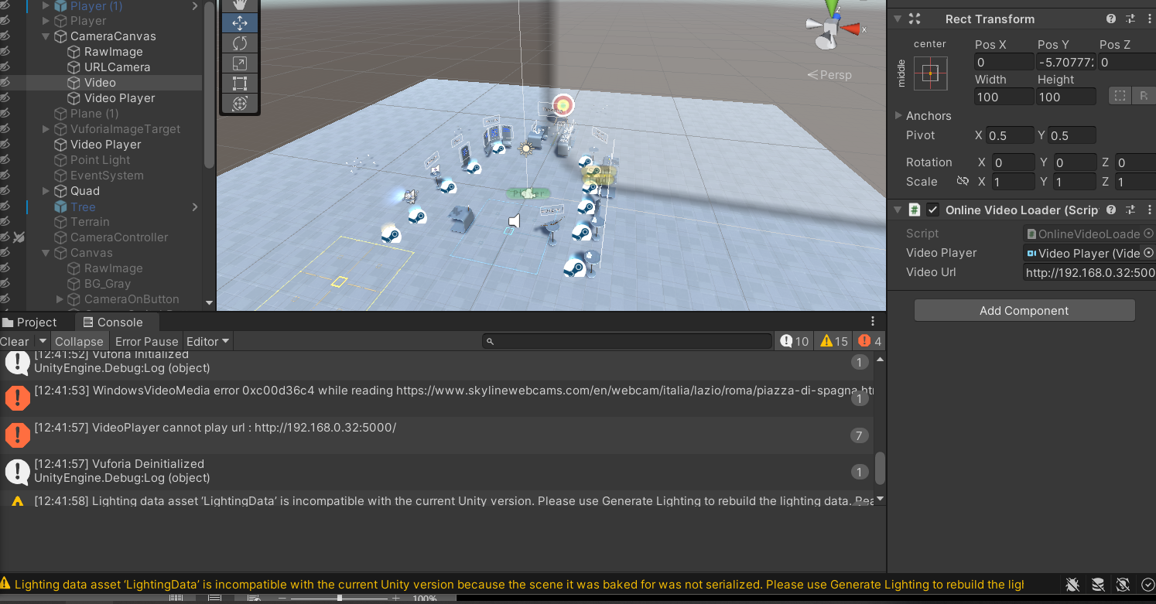

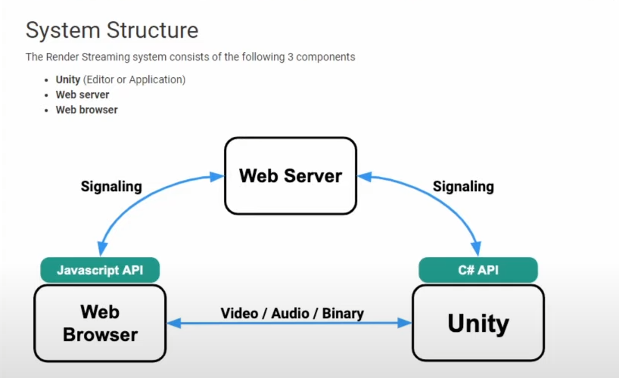

<https://www.youtube.com/watch?v=nADTdV8wsXQ>

<https://www.youtube.com/watch?v=cRycXUIK07g> (Couldn’t get any Youtube live videos to render)

<https://pimylifeup.com/raspberry-pi-webcam-server/> (Method for setting up RBPI stream server)

**Webcam Import from remote desktop** ( ) – Running on RaspberryPi, streaming Twitch/Youtube/Vimeo

Rather than trying to import from a URL, communicate and decode across a com port or web server, I explored the possibility of using a script to render texture the user’s desktop and also various streaming plug ins for websites.

<https://assetstore.unity.com/packages/tools/video/nexplayer-video-streaming-player-with-drm-free-demo-197902>

<https://www.youtube.com/watch?v=zfBHD4v8hD0> (Deprecated code. Tried updating and could not fix)

**Webcam Import Vuforia Workaround** (Success, Minimal Capabilities)

This method can display the webcam though Vuforia’s script is hidden behind private methods. I had to modify some items such as the background display to depth or solid color to display the webcam. Overlaying with the skybox normal background causes the video to not appear. This was the only solution I could find. Note this method is for AR display for target objects if the image is in view. Note this method was designed for displaying 3D objects in AR, not video in VR however it did allow me to broadcast the webcam directly from my pc.

<https://www.youtube.com/watch?v=Z4bBMpa4xWo>

**Streaming Site Asset Workaround** (Paid feature)

This asset can be downloaded and used for free. I didn’t want to pay for the full version but I was able to show their demo video from a website. I figure the tutorial should feature a method that works for anyone without buying additional packages. Simply instantiate a UI asset using their manager after importing and paste a URL as their textbox doesn’t allow typing. The video input is in the manager sub asset which is destroyed when clicking play.

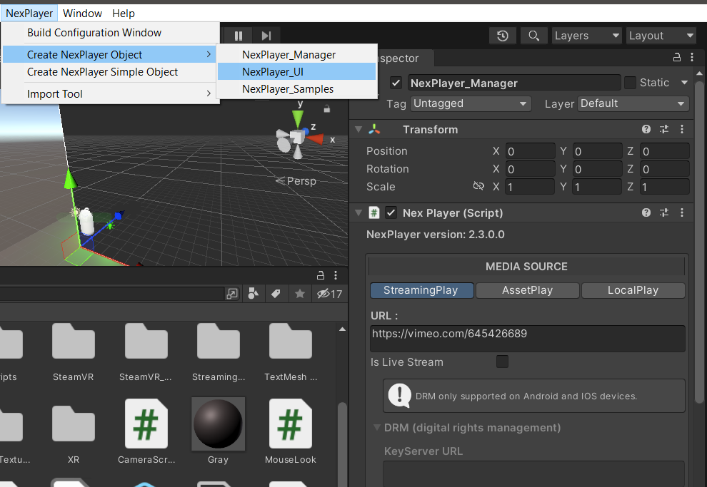

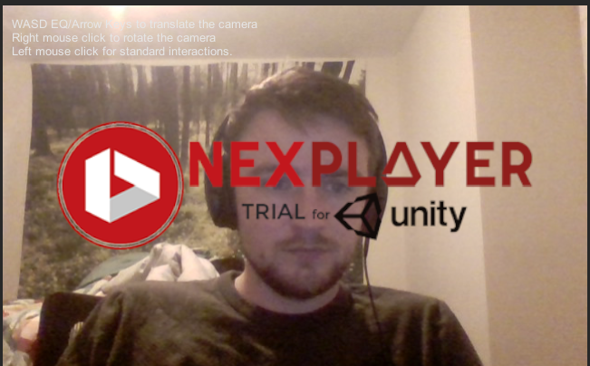

<https://assetstore.unity.com/packages/tools/video/nexplayer-video-streaming-player-with-drm-free-demo-197902>