**Lab 6: Arrays**

**Lab 6.1 – Pseudocode**

In this portion of the lab you will analyze the problem listed below. You will figure out what the inputs and outputs are as well as develop a problem statement. You will also determine what variables you will use and create some pseudocode.

**Your parents live in a subdivision called Botany Bay. Your father is the president of the homeowners association and has a project for you. He would like to report out at a yearly meeting what is the average or mean selling price of all the homes sold over the past year. Since he plans on doing this often, he has asked you to create a computer program. Since the number of homes sold in a year varies from year to year, your program will need to ask the user for the number of homes sold in the past year (HINT: This will tell you how many items are going to be stored in your array). You will then need to prompt the user for the selling price of each of these homes. These values will need to get stored in an array. Your program will determine what the average selling price was or the mean, the number of homes that sold above the average and the number of homes that were sold below the average. Your output needs to include the average selling price, the number of homes above average and the number of homes below average.**

**Step 1**: Analyze the problem. In the table below list the inputs, outputs and a one sentence description of the problem.

|  |  |
| --- | --- |
| Input: | Number of homes sold, selling price for the homes |
| Problem Statement: | Need to calculate the average selling price for the home sold. |
| Output: | Average selling price, homes sold above average, homes sold below average |
|  |  |

**Step 2:** What variables are you going to need and what will be their datatype. (The number of spaces in this table does not necessarily mean these are the only variables\constants. This problem can be solved a number of different ways.)

|  |  |
| --- | --- |
| **Variable\Constant Name** | **Datatype** |
| Homes sold | Integer |
| Home prices | List |
| Homes sold above | Integer |
| Homes sold below | Integer |
| Count | Integer |
| Sum | Float |
| Average price | float |
|  |  |

Step 3: Create a 30,000 view outline of the problem. How would you break this problem into numerous smaller units? Place your outline below:

|  |
| --- |
| * Declare Variables * Print a greeting * Gather inputs * Start a loop to input the home prices into the list * Find the average price * Start another loop to find the number of homes sold above and below the average * Output the results |
|  |

**Step 4:** In looking at your overall outline of the problem. Break apart your larger portions into smaller ones. Place your revised outline below: And be more detailed.

|  |
| --- |
| * Declare Variables   + Set homes sold as an integer   + Set home prices as a list   + Set homes sold above as an integer   + Set homes sold below as an integer   + Set count as an integer   + Set sum as a float   + Set average price as a float * Print a greeting * Gather inputs   + Ask for how many homes were sold * Start a loop to input the home prices into the list   + Iterate until count is = to homes sold   + Ask for the price of the home and append it to the list   + Add 1 to count * Find the average price   + Find the sum of the list and divide it by homes sold * Start another loop to find the number of homes sold above and below the average   + Start a for loop to iterate over the elements in home prices     - Start an if statement to figure out if the element value is greater than or less than the average       * If greater than add 1 to homes sold aove       * If less than add 1 to homes sold below * Output the results |

**Lab 6.2 – Raptor**

In this portion of the lab you will take the pseudocode you developed above and test it using Raptor.

**Step 1:** Code in Raptor. Open up Raptor and code this problem. Remember in Raptor the index starts at 1

**Step 2**: Test your program using the following data. At this point don’t worry about getting your prices to display only 2 decimal places. We will learn how to do that later.

|  |  |
| --- | --- |
| Home | Selling Price |
| 1 | $85,000 |
| 2 | $97,500 |
| 3 | $115,000 |
| 4 | $150,000 |
| 5 | $125,900 |
| 6 | $105,900 |
| 7 | $155,249 |

My output looked like the following:

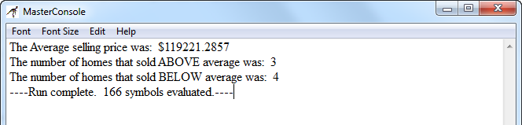

**Step 3**: If your results match the test, then hand in your Raptor program and this lab. Otherwise go back over your Raptor program and correct any errors.

**Lab 6.3 – Translating into Python**

In this section you will translate the solution for section 6.2 from Raptor to Python. To refresh your memory, this was the problem you were attempting to solve.

**Your parents live in a subdivision called Botany Bay. Your father is the president of the homeowners association and has a project for you. He would like to report out at a yearly meeting what is the average or mean selling price of all the homes sold over the past year. Since he plans on doing this often, he has asked you to create a computer program. Your program will need to store the selling prices in an array. Additionally your program will determine what the average selling price was or the mean, the number of homes that sold above the average and the number of homes that were sold below the average. Your output needs to include the average selling price, the number of homes above average and the number of homes below average.**

Additionally make the following structural changes to your code:

* Swap out the UNTIL (WHILE in Python) loops and use the FOR loop structure.
* Preload your Sales array so that the user does not need to enter each Sale item individually.
* Sort your array so the highest value is first
* Print out the contents of your pre loaded array before you sort and after you sort.
* Use formatting to display the sales and average sales.
* Print out the highest and lowest sale.

**Step 1:** Open up your Raptor file and resize the window so that it takes up half of your computer screen.

**Step 2:** Open IDLE (Python compiler). Click on File and select New Window. In the new window click on Save. Give your file a name. Resize it so that it takes up half of your screen just like you did previously in this lab.

**Step 3:** Translate your Raptor file into Python code. Remember in Raptor we cannot utilize WHILE or FOR loops. However, we have both syntaxes available to us in Python. Also don’t forget that lists in Python have indexes that start at 0.

**Step 4:** Test and Debug your Python code using the following test data. Try to utilize some of the formatting characters we have used to get your output to display only 2 decimal places and tabbed.

|  |  |
| --- | --- |
| Home | Selling Price |
| 1 | $125,900 |
| 2 | $115,000 |
| 3 | $105,900 |
| 4 | $85,000 |
| 5 | $150,000 |
| 6 | $155,249 |
| 7 | $97,500 |

My output looked like the following:

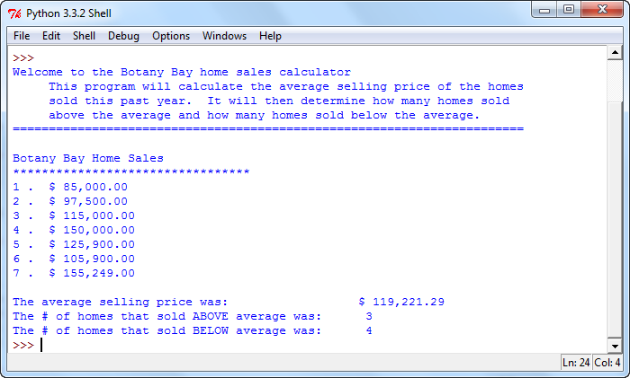

**Step 7**: If your results match the test, then you are done. Otherwise go back over your code and correct any errors.

**How Will I Be Graded**

You will be graded based off of the following rubric

|  |  |  |  |  |  |
| --- | --- | --- | --- | --- | --- |
|  | **Exemplary** | **80 % of total** | **Competent** | **60% of total** | **Developing** |
| 4 | Completed the analysis of inputs and outputs, developed a correct problem statement and developed thorough pseudocode. | 3.2 | Did not complete the input and output analysis or the problem statement was not detailed enough. | 2.4 | Did not develop the analysis of the inputs and outputs and problem statement or the pseudocode was lacking detail. |
| 6 | Correctly coded the problem in Raptor. Includes comments, variable declarations, input statements, process statements and correct output | 4.8 | Coded problem in Raptor but missing comments, an input statement or an output statement. | 3.6 | Completed the problem in Raptor but there was an error in the processing |
| 2 | Correctly Calculated the average selling price using the array. | 1.6 | Utilized the array for the calculation with a minor error. | 1.2 | Utilized the array for the calculation with a major error or used some other technique to solve the problem. |
| 2 | Correctly determined the number of homes that sold above and below the average using the array | 1.6 | Utilized the array to determine above and below average with a minor error. | 1.2 | Utilized the array to determine above and below average prices with a major error or used some other technique to solve the problem. |
| 2 | Correctly sorted the array | 1.2 | List was sorted but contained a minor error. | 0.9 | List was sorted with a major error. |
| 2 | Correctly determined the highest and lowest Sale | 1.2 | Highest and Lowest values determined but with a minor error. | 0.9 | Determined Highest and Lowest values but with a major error. |
| 2 | Output was correctly formatted utilizing format masks and tabs | 1.6 | Output contains format masks and tabs with a minor error. | 1.2 | Output contains format masks and tabs with a major error. |
| 20 | TOTAL POINTS | 16 |  | 12 |  |

**Handing it all in**

1. Log on to canvas and our course shell.
2. Upload this lab sheet along with your Raptor and Python files to the Lab #6 drop box.