**3. Approach**

The ALLDET device provides a non-invasive solution for restaurants and bars that allows them the ability to monitor the liquid level inside their beer kegs. Using Wi-Fi technology through a mobile application, the user is able to save multiple keg profiles for simple inventory tracking. A microcontroller activates a solenoid that controls a “thump arm” which strikes the side of the keg and resonates the container. The signal is then processed through piezoelectric sensor(s), amplified through an op-amp, and the Fourier transform is then taken which converts the signal from the time domain to the frequency domain. This information is used to determine the level of liquid inside the container.

**3.1 System overview**

ALLDET uses several systems working in conjunction to determine the liquid level in a container. The hardware components include a solenoid to vibrate the container, piezoelectric sensors to read the generated signal, and a microcontroller to capture and transmit the signal from the sensors, and a battery. This device also has several software components which are used to transmit the data from the device to the server, to analyse the signal to determine the liquid level, and to present the data to the users via a mobile application.

The users attach the device to their kegs and turn them on. The device then periodically activates the solenoid so that the piezoelectric sensors can capture the vibration of the container. Once the signal has been captured by the microcontroller, it is transmitted to a server. The user can then access that data at any time via a smartphone application.

**3.2 Hardware**

The following section highlights the hardware components of ALLDET’s design. The design includes a microcontroller, attachment mechanism, battery, vibration sensors, vibration generator, and the chassis. The microcontroller is used to control the vibration generator and to read the data from the sensors. The attachment mechanism is to ensure that the device does not become detached from the keg and that it is positioned correctly. The vibration sensors detect movement of the keg created by the vibration generator. These components were selected based on budget, compatibility, and size.

**3.2.1 Microcontroller**

Raspberry Pi Zero W is chosen due to the programming capabilities of Python, which is a more robust language equipped with server communication libraries that are necessary to program the device. Though the most expensive, the Raspberry Pi Zero W also has wireless and Bluetooth capabilities, making it the clear option for our design. Table 3.1.1 below shows a comparison of different microcontrollers.

**Table 3.2.1 - Microcontroller options**

|  |  |  |
| --- | --- | --- |
| Device | Description | Price |
| Arduino Uno | Lacks built-in Bluetooth or Wi-Fi capability. | $16.22 |
| Pic33 | Does not come with development board like Arduino or Raspberry Pi. Lacks built-in Wi-Fi or Bluetooth capability. | $17.88  (PicKit3) |
| Raspberry Pi Zero W | Has Bluetooth Low-Energy and Wi-Fi capability. Uses Python, making it the more powerful microcontroller. | $18 |

*The selected choice: 

**3.2.2 Attachment Mechanism**

ALLDET requires a means of physically attaching the device to the container. Mounting magnets and a clamp mechanism are chosen because they are easy-to-use and ensure a reliable method of measurement. Table 3.1.2 highlights some of the pros and cons of various methods of attachment.

**Table 3.2.2 - Device attachment options**

|  |  |  |  |
| --- | --- | --- | --- |
| **System** | **Description** | **Pros** | **Cons** |
| Mounting magnets | Magnetic feet are attached to the main unit housing to fit device to the side of the keg. | Easy to attach | Magnets could interfere with microcontroller and other sensors |
| Elastic strap | A strap is attached to the casing to affix the device to the side of the keg, sensors are possibly incorporated into the strap if necessary. | No magnetic interference  Could embed sensors into the strap itself | A bit cumbersome  Sensors in the strap may not be practical |
| Clamp mechanism | A clamping device is affixed to the top of the device to ensure a consistent distance from the top of the keg. | Ensures reliable measurements every time | Adds some mechanical complexity and size |

**3.2.3 Li-Ion Battery**

Below is the mathematical breakdown that shows the required battery capacity:

= + + = 120mA [19] + 250mA +<1mA ≈ 0.371mA

30 seconds/measurement * 4 measurements per hour * 16 operation hours = 32 minutes in operation

0.371A * 0.53 hours = 197.9 mAh for operation

0.3mA low-power mode * 15.47 hours = 4.6 mAh total power during low-power mode

197.9 + 4.6 = 202.5 mAh , total battery requirement

For the needed current equation, all the current values are for active states. Thirty seconds is the estimated worst-case time it would take for the device to hit the keg and transmit the signal to the server. These values are assuming the device will hit the keg four times within an hour while operating for 16 hours. The needed current for the time the device is in operation is 197.9 mAh. While the device is in a low-power mode, the device will operate for the remaining 15.47 hours and only use 4.6 mAh. In total, the battery can withstand a minimum of 202.5 mAh.

**Table 3.2.3 - Battery options**

|  |  |  |
| --- | --- | --- |
| Device | Description | Price |
| Jauch Quartz LP705176JS + PCM + WIRES 70MM [20] | BATT LITH POLY 1S1P 3150MAH 3.7V | $22.30 |
| Adafruit Industries LLC 1578 [21] | BATTERY LITHIUM 3.7V 500MAH | $7.95 |
| Adafruit Industries LLC 354 [22] | BATTERY LITHIUM 3.7V 4.4AH | $19.95 |

ALLDET supplies power to the device with the selected option based on the physical appearance, the rated capacity, and the cost. The battery’s dimension is 1.14” and 1.42” [21] , which allows the device to remain small and compact. The math details prove that the minimum capacity required for the device is 202.5 mAh. This breakdown allows us to get a battery with a smaller capacity and that is more cost effective.

**3.2.4 Vibration Sensors**

ALLDET measures the vibration of the keg after being struck to determine the level of the liquid. The device uses piezoelectric sensors because these are the most accurate as they maintain contact with the container. Piezoelectric sensors measure changes in force by converting them to an electrical charge [12]. There are several piezoelectric sensors inside the main unit housing, that have to maintain contact with the side of the container. The data from these sensors is sent to the server for processing.

**Table 3.1.4 - Vibration sensor options**

|  |  |  |
| --- | --- | --- |
| **Type** | **Description** | **Price** |
| Piezoelectric sensor [13] | Converts mechanical energy into electric current | $1.70 |
| Potentiometer sensor [14] | Measures the displacement of an object in linear or rotary motion and converts it into an electrical signal [15]. | $1.40 |

**3.1.5 Vibration Generator**

Solenoid is used as a vibration generator or “thump” mechanism that strikes the side of the container with the same velocity every time. Though larger than a stepper or servo motor, using a solenoid is the clear choice for our project based on power draw and functionality.

Refer to the table below to see the comparison between different motors and solenoid.

**Table 3.1.5 - Vibration generator options**

|  |  |  |  |
| --- | --- | --- | --- |
| Mechanism | Description | Price | Size |
| DC Stepper Motor [18] | Can accurately move in “steps”. Allows full rotation, but would need “thump arm” mechanism. Though cheap, it only operates at 25 RPM which is insufficient to make an adequate “thump” for our sensors to indicate. | $4.95 | Roughly the size of a quarter |
| Continuous Rotation Micro Servo Motor [17] | Operates on position versus “steps”. Would need “thump arm” mechanism which would require more parts to manufacture. | $7.50 | Almost the same size as a Stepper Motor, which is roughly larger than a quarter |
| 12V, 31N Solenoid [16] | Internal metal “slug” has “punch” feature which allows for consistent, accurate striking and eliminates the need for external arm. At 31N, it provides enough force to strike the container giving an adequate reading for the sensor(s).  Easily retracted after activation when voltage no longer engages magnet. | $17.84 | Largest of the three, but at a length of approximately 4” when fully retracted, it still fits our size constraint. |

**3.1.6 3-D Printed Chassis**

The figure below is not to scale but is used to demonstrate the location that the device is intended to sit on the container, which is approximately the middle of the container.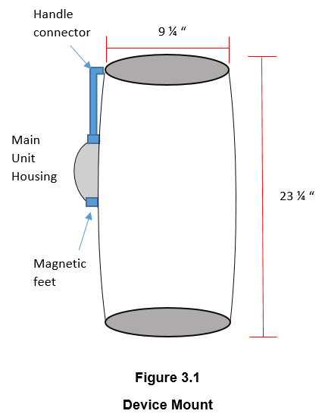

The main unit housing is 3-D printed to IP52 standard to ensure substantial amounts of water do not enter the unit and damage the components. The case is equipped with a connector rod that attaches to the handle in order to ensure that every device is mounted at an appropriate distance from the top of the container to maintain consistent measurements. Also, the case has magnetic “feet” that maintain a firm connection to the side of the container in order to get accurate data. A 3-D printed case is used mainly due to the inexpensive cost of production.

**3.3 Software**

The software components of this project can be broken into three parts: the microcontroller, the server, and the mobile application. The microcontroller is responsible for reading the signal generated by the solenoid. It then transmits that signal to the server. The server stores that data until a smartphone connects with authorization to access the information. Once the server has received the signal, it then performs the analysis to compute the liquid level. When the phone connects to the server, it passes that data to the phone. The mobile application displays that data to the user in an ergonomic way.

**3.3.1 Microcontroller**

The Raspberry Pi Receives the signal from the piezoelectric sensor(s) and transmits the signal over Wi-Fi. The data processing is done on the server to preserve the device’s battery. The software on the Raspberry Pi is solely responsible for sending the signal from the sensors to the server. This code is written in Python, which has specific libraries for data transmission over Wi-Fi.

**3.3.2 Server**

ALLDET uses a server to communicate with the device, store the data readings, and compute the liquid level using a fast fourier transform. The mobile application pulls this information and display it to the user. To accomplish this, a linux server retrieves the data from the device and uses python to process the data and determine the liquid level. The server also uses a SQL database to store the processed data.

**3.3.3 Smartphone application**

ALLDET’s mobile application is created using Flutter, Google’s mobile app SDK. Flutter has been chosen for application development for multiple reasons. Firstly, one team member has prior experience with this SDK. In addition, Flutter allows for development on Android and iOS with one codebase, while other software development kits require a separate codebase for each mobile operating system.

The application has a variety of pages to maximize the user experience. These pages are the login screen, a list view of all ALLDET devices and the current liquid level detected by each, an in depth statistics page for each individual device, and a settings page. The login screen is to make sure that the user has proper access to view the data. After the users log into the app, they are taken to the main screen which shows a list of all devices and each device’s most recent liquid level reading. Clicking on each device takes the users to another page that displays more specific information about that device such as liquid level history, how long the keg has been in use, device name, and estimated end-of-life.

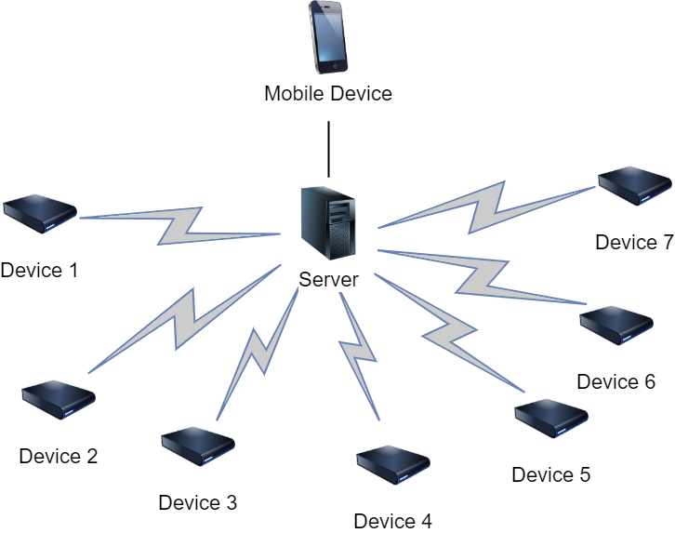

**Figure 3.2 Device Communication Path**

**References**

1. “A Brief Introduction to Piezoelectric Sensor Switch and its Working Procedure.” edgefx.in.<https://www.edgefx.in/piezoelectric-sensor-switch-working/> (accessed Oct. 1, 2019).
2. “HiLetgo 5pcs Piezoelectric Sensor Analog Ceramic Vibration Sensor Module Piezoelectricity for Arduino DIY KIT: Amazon.com Industrial & Scientific.” amazon.com. [https://www.amazon.com/HiLetgo-Piezoelectric-Ceramic-Vibration-Piezoelectricity/dp/B07Q9J5C4G/ref=sr_1_2?keywords=piezoelectric+sensor&qid=1569957549&sr=8-2](https://www.amazon.com/HiLetgo-Piezoelectric-Ceramic-Vibration-Piezoelectricity/dp/B07Q9J5C4G/ref=sr_1_2?keywords=piezoelectric+sensor&qid=1569957549&sr=8-2.) (accessed Oct. 1, 2019).
3. “Amazon.com: WINGONEER 5pcs SW-420 NC Type Vibration Sensor Module Vibration Switch for Arduino Smart Car.” amazon.com. <https://www.amazon.com/WINGONEER-SW-420-Vibration-Sensor-Arduino/dp/B06XHFFPL6/ref=sr_1_10?keywords=vibration+sensor&qid=1569956060&sr=8-10> (accessed Oct.1, 2019).
4. “Potentiometer Sensors | TE Connectivity.” te.com. <https://www.te.com/usa-en/products/sensors/position-sensors/potentiometric-sensors.html> (accessed Oct. 1, 2019).
5. “Amazon.com: uxcell DC 12V 31N 10mm Push Pull Type Solenoid Electromagnet, Open Frame Type, Linear Motion” amazon.com. <https://www.amazon.com/uxcell-Solenoid-Electromagnet-Linear-Motion/dp/B07VG3M5WV/ref=sxbs_sxwds-stvp?keywords=solenoid&pd_rd_i=B07VG3M5WV&pd_rd_r=38591ee0-9478-475e-9755-307f30997c85&pd_rd_w=lIOQO&pd_rd_wg=7cDHy&pf_rd_p=a6d018ad-f20b-46c9-8920-433972c7d9b7&pf_rd_r=77HC621MMNX27G2T23AH&qid=1569966667&th=1> (accessed Oct. 1, 2019).
6. “Adafruit.com: Continuous Rotation Micro Servo - FS90R”. Adafruit.com. <https://www.adafruit.com/product/2442> (accessed Oct. 1, 2019).
7. “Adafruit.com: Small Reduction Stepper Motor - 5VDC 32-Step 1/16 Gearing”. Adafruit.com. <https://www.adafruit.com/product/858> (accessed Oct. 1, 2019).
8. “Power Consumption Benchmarks | Raspberry Pi Dramble.” pidramble.com. <http://www.pidramble.com/wiki/benchmarks/power-consumption> (accessed Oct. 1, 2019).
9. “LP705176JS + PCM + WIRES 70MM Jauch Quartz | Battery Products | DigiKey.” Digikey.com. <https://www.digikey.com/product-detail/en/jauch-quartz/LP705176JS-PCM-WIRES-70MM/1908-1375-ND/9560997> (accessed Oct. 1 2019).
10. “1578 Adafruit Industries LLC | Battery Products | DigiKey.” Digikey.com. <https://www.digikey.com/product-detail/en/adafruit-industries-llc/1578/1528-1841-ND/5054539>(accessed Oct. 1 2019).
11. “354 Adafruit Industries LLC | Battery Products | DigiKey.” Digikey.com. <https://www.digikey.com/products/en/battery-products/batteries-rechargeable-secondary/91?k=rechargeable+battery&k=&pkeyword=rechargeable+battery&sv=0&pv33=553&sf=0&FV=ffe0005b%2C670004a&quantity=&ColumnSort=0&page=1&pageSize=25> (accessed Oct. 1 2019).