**3.** **APPROACH**

ALLDET provides a non-invasive solution for restaurants and bar owners or managers that allows them to monitor the liquid level inside their beer kegs. Using Wi-Fi technology through a mobile application, the user is able to save multiple keg profiles for simple inventory tracking. A microcontroller activates a solenoid that strikes the side of the keg, causing it to resonate. The resonance of the container is processed through a piezoelectric sensor and the Fourier transform is taken to convert the signal from the time domain to the frequency domain. This information is used to determine the level of liquid inside the container. Figure 3.0a shows the process flow of the product.

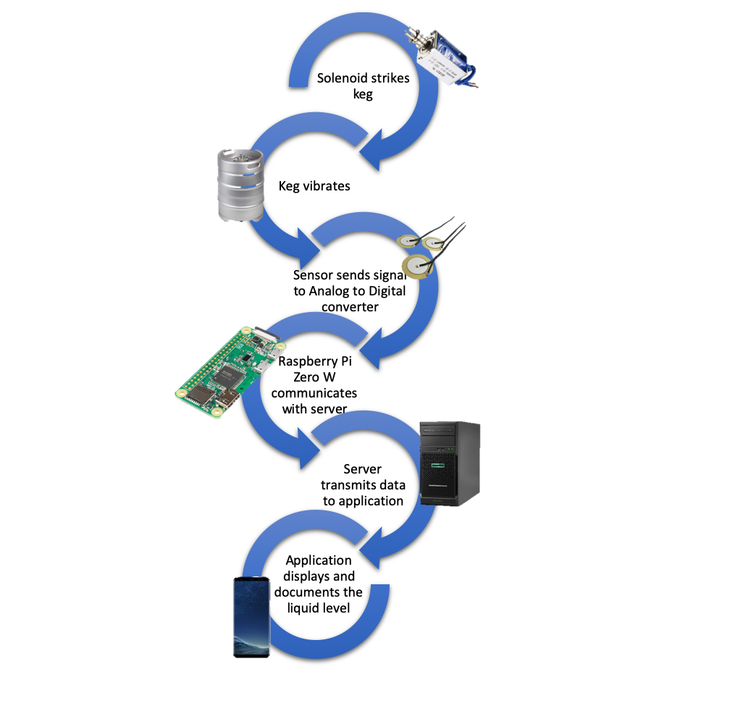

**Figure 3.0a System Overview**

This approach was chosen because it does not require the users to interact with the container in any way to determine the current liquid level. Other methods for determining the volume of liquid in a metal container generally involve weighing the container. The major benefit of using the resonance of the container is that it does not necessitate the interaction of the user in any way. Figure 3.0b shows the relationship between the resonance frequency and the volume within a metal container.

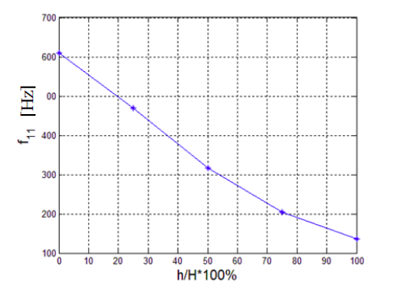

**Figure 3.0b Graph of frequency vs. volume within a metal container [32]**

**3.1. Hardware**

The following section highlights the hardware components of ALLDET’s design. The design includes a microcontroller, attachment mechanism, battery, vibration sensor, vibration generator, and chassis. The microcontroller is used to control the vibration generator and to read the data from the sensor. The attachment mechanism ensures that the device does not become detached from the keg and that it is positioned correctly. The vibration sensor detects movement of the keg created by the vibration generator. The chassis protects each component and is designed to ensure proper contact with the keg and the vibration sensor and solenoid. These components were selected based on budget, compatibility, and size.

**3.1.1. Microcontroller**

Raspberry Pi Zero W was chosen due to the programming capabilities of Python, which is a robust language equipped with server communication libraries that are necessary to program the device. In addition to being the least expensive, the Raspberry Pi Zero W also has wireless and Bluetooth capabilities, making it the clear choice for the design. Table 3.1.1 shows a comparison of considered microcontrollers.

**Table 3.1.1. - Microcontroller Options**

|  |  |  |  |  |
| --- | --- | --- | --- | --- |
| Device | Description | Wi-Fi (must be included) | Serial bus (must have I2C) | Price (must be less than $20) |
| Arduino Uno [27] | Lacks built-in Bluetooth or Wi-Fi capability | No | SPI/I2C | $16.22 |
| Pic33 [30] | Does not come with development board like Arduino or Raspberry Pi. Lacks built-in Wi-Fi or Bluetooth capability | No | SPI/I2C | $17.88  (PicKit3) |
| Raspberry Pi Zero W [31] | Has Bluetooth Low-Energy and Wi-Fi capability. Has built-in Python interpreter | Yes | SPI/I2C | $10 |

**3.1.2. Attachment Mechanism**

ALLDET requires a means of physically attaching to the container. Mounting magnets and a clamp mechanism were chosen because they are easy-to-use and ensure a reliable method of measurement. Table 3.1.2 highlights some of the pros and cons of various methods of attachment.

**Table 3.1.2. - Device Attachment Options**

|  |  |  |  |
| --- | --- | --- | --- |
| System | Description | Pros | Cons |
| Mounting magnets | Magnetic feet are attached to main unit housing to fit device to side of keg | Easily attached  Works for all metal kegs | Magnets could interfere with microcontroller and sensor |
| Elastic strap | Strap attached to casing to affix device to side of keg | No magnetic interference  Could embed sensor into the strap itself | Cumbersome to attach  Sensor in the strap may not be practical |
| Clamp mechanism | Clamping device affixed to top of device to ensure a consistent distance from top of keg | Ensures reliable measurements every time | Adds mechanical complexity and size |
| Suction cup | Suction cups attached to main unit housing to provide a means of mounting | No magnetic interference | Unreliable means of attachment |

**3.1.3.** **Li-Ion Battery**

A lithium-ion battery, also known as Li-Ion battery is the battery of choice for the ALLDET device. The Li-ion battery is a commonly-used rechargeable battery in the electronics industry. Also, the Li-Ion battery is very efficient in power and charging efficiency while remaining a small, sleek look.

Equation (1) shows the mathematical breakdown that shows the required battery capacity:

(1) ${ I}_{needed}$ = $I_{Raspberry Pi- Zero W}$ + $I_{solenoid}$ + $I_{sensor}$

While using equation (1), below is the complete breakdown of what current draw needed for the operation requirements of the device. This breakdown gives the justification of the battery chosen:

1. $I_{needed}$ = 120mA [19] + 250mA +<1mA ≈ 0.371mA

30 seconds/measurement * 4 measurements per hour * 16 operation hours

= 32 minutes in operation

0.371A * 0.53 hours = 197.9 mAh for operation

0.3mA low-power mode * 15.47 hours = 4.6 mAh total power during low-power mode

197.9 + 4.6 = 202.5 mAh , total battery requirement

For the needed current equation (1), all the current values are for active states. Thirty seconds is the estimated worst-case time it would take for the device to hit the keg and transmit the signal to the server. These values are assuming the device will hit the keg four times within an hour while operating for 16 hours. The needed current for the time the device is in operation is 197.9 mAh. While the device is in a low-power mode, the device will operate for the remaining 15.47 hours and use only 4.6 mAh. In total, the battery must supply a minimum of 202.5 mAh. Table 3.1.3 shows batteries that were considered and which one was chosen based on our requirements.

**Table 3.1.3 - Battery Options**

|  |  |  |  |  |  |
| --- | --- | --- | --- | --- | --- |
| Device | Description (must have 202.5 mAh) | Active Current | Sleep Current | Duty Cycle | Price (must be less than $20) |
| Jauch Quartz LP705176JS [20] | Battery Lith Poly 1S1P 3150 mAH 3.7 V | 0.2 C | 0.2 C | 500 | $22.30 |
| Adafruit Industries LLC 1578 [21] | Battery Lithium 3.7V 500mAH | 0.2 C | 0.2 C | >500 | $7.95 |
| Adafruit Industries LLC 354 [22] | Battery Lithium 3.7V 4.4AH | 0.5 C | 0.2 C | >= 500 | $19.95 |

ALLDET supplies power to the device with the selected option based on the physical appearance, the rated capacity, and the cost. The battery’s dimension is 1.14” and 1.42” [21], which allows the device to remain small and compact. The minimum capacity required for the device is 202.5 mAh, as shown in the calculations above. 202.5 mAh is achievable with a small, cost-effective battery. Since the battery chosen is above the required voltage, there will be a circuit that will account for the 0.4V that is not required. Therefore, there will be no damage to the battery and other electronic components.

**3.1.4 Vibration Sensor**

ALLDET measures the vibration of the keg after being struck to determine the level of the liquid. The device uses a piezoelectric sensor because these are the most accurate as they maintain contact with the container. Piezoelectric sensors measure changes in force by converting these changes to an electrical charge; these charges can potentially range up to ±50 V [12], [15]. Because of these high voltage ranges, a large resistor is used to “load down” the sensor. A piezoelectric sensor is inside the main unit housing that has to maintain contact with the side of the container. The signal from this sensor is sent an analog-to-digital converter for processing.

**Table 3.1.4 - Vibration Sensor Options**

|  |  |  |  |
| --- | --- | --- | --- |
| Type | Description | Output | Price  (must be less than $5) |
| Piezoelectric sensor [13] | Converts mechanical energy into electric current | Can vary, potentially upwards of ±50 V | $1.70 |
| Vibration sensor [14] | Uses a stability circuit to monitor output | Digital output (0 or 1) | $1.40 |

**3.1.5 Vibration Generator**

The solenoid is used as a vibration generator or “thump” mechanism that strikes the side of the container with the same velocity every time. Though larger than a stepper or servo motor, a solenoid is a clear choice for the project based on power draw and functionality. The solenoid is powered directly from the battery and controlled using a transistor. The signal to activate the solenoid is sent from the Raspberry Pi.

Table 3.1.5 shows a comparison between different motors and a solenoid.

**Table 3.1.5a - Vibration Generator Options**

|  |  |  |  |
| --- | --- | --- | --- |
| Mechanism | Description | Price (must be less than $20) | Size  (must be less than 4” in overall length) |
| DC Stepper Motor [18] | Can accurately move in “steps.” Allows full rotation, but needs a “thump arm” mechanism. Operates only at 25 RPM, which is insufficient to make an adequate “thump” for our sensor to detect | $4.95 | Roughly the size of a quarter |
| Continuous Rotation Micro Servo Motor [17] | Operates on position versus “steps.” Would need “thump arm” mechanism, which would require more parts to manufacture | $7.50 | Almost the same size as a stepper motor, which is roughly larger than a quarter |
| 12V, 31N Solenoid [16] | Internal metal “slug” has “punch” feature, which allows for consistent striking and eliminates need for external arm. Provides 31 N of force per punch  Easily retracted after activation when voltage no longer engages magnet | $17.84 | Largest of the three, but at a length of 3.5” when fully retracted, it still fits our size constraint |

**Table 3.1.5b Solenoid Comparison**

|  |  |  |  |
| --- | --- | --- | --- |
| Solenoid | Power Draw  ($P=I*V$) | Strike Force | Price (must be less than $20) |
| 12V 31N 450mA uxcell solenoid [16] | $$0.45^{}*12 = 5.4W$$ | 31N | $17.84 |
| 5V push pull solenoid [29] | $$0.83*5=4.15W$$ | 0.5N | $5.99 |
| 12V 1A uxcell solenoid [28] | $$1*12=12W$$ | 6N | $5.99 |

**3.1.6 3-D Printed Chassis**

Figure 3.1 is not to scale but is used to demonstrate the location that the device is intended to sit on the container, which is approximately the middle of the container.

The main unit housing is 3-D printed to IP52 standard to ensure substantial amounts of water do not enter the unit and damage the components. The case is equipped with a connector rod that attaches to the handle to ensure that every device is mounted at an appropriate distance from the top of the container to maintain consistent measurements. Also, the case has magnetic “feet” that maintain a firm connection to the side of the container to obtain an accurate reading. A 3-D printed case is used mainly due to the inexpensive cost of production.

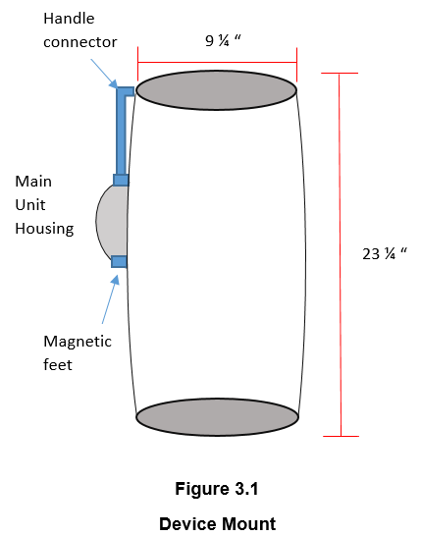

**Figure 3.1 Device mount**

**3.1.7 A/D Converter**

In order to convert the analog signal from the piezoelectric sensor to a digital signal that can be read by the Raspberry Pi, an analog-to-digital converter is needed. Using a sample clock, the ADC samples a signal on the falling or rising edge of the clock, and converts that value to a digital value [23]. For this device, it is required that the ADC have a high sampling rate, high bit precision, and preferably use the I2C serial bus, which only uses two wires for ease of communication.

Table 3.1.6 shows a comparison between the considered A/D converters.

**Table 3.1.7 - A/D Converter Options**

|  |  |  |  |  |
| --- | --- | --- | --- | --- |
| ADC | Bit Precision | Sampling Rate | Serial Bus  (must be I2C) | Price |
| MCP3008 [24] | 10-bit | 220 ksps | SPI | $3.75 |
| ADS1015 [25] | 12-bit | 3300 samples/s | I2C | $9.95 |
| ADS1115 [26] | 16-bit | 860 samples/s | I2C | $6.99 |

**3.1.8 DC-DC Boost Converter**

The solenoid operates on 12VDC at 450mA with a striking force of 31N. This particular solenoid was chosen to minimize power draw and have a strong enough force to strike the container to get a decent vibration. Unfortunately, the Raspberry Pi Zero W only outputs voltages of 3.3V or 5V. Therefore, in order to power the solenoid from the Raspberry Pi, a boost converter is used that takes an input voltage between 3-30V and outputs a voltage between 5-35V. In order to make sure the converter is outputting the correct voltage, the potentiometer within the converter will need to be adjusted to the proper 12V output to power the solenoid.

**3.1.9 Battery Charging/Monitoring Circuit**

Since the device is battery operated, charging is necessary. A battery charging module is needed not only to charge the battery but to also ensure that the battery is not over-charged, which would damage the battery. Along with the charging module, a battery monitoring module is needed to prevent the battery from discharging too much, thus preventing damage to the battery.

**3.2 Software**

The software components of this product consist of three parts: the microcontroller, the server, and the mobile application. The microcontroller is responsible for reading the signal generated by the solenoid. It then transmits that signal to the server. The server stores that data until a smartphone connects with authorization to access the information. Once the server has received the signal, it then performs an analysis to compute the liquid level. When the phone connects to the server, the server passes that data to the phone. The mobile application displays the data to the user in an ergonomic way. Figure 3.2 shows the connection between the various software components of the product.

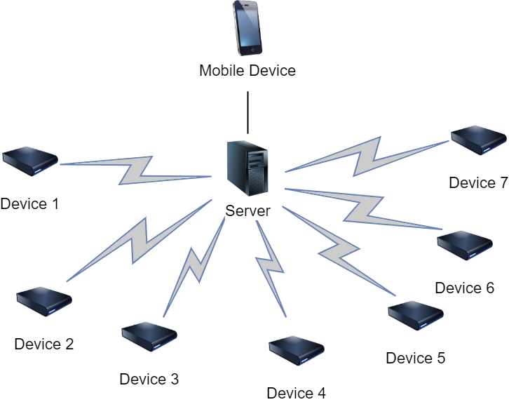

**Figure 3.2 Device communication path**

**3.2.1 Microcontroller**

The Raspberry Pi receives the signal from the piezoelectric sensor through an analog to digital converter and uses a fast Fourier transform to convert the received signal to a frequency. This calculation is handled by the Raspberry Pi to avoid having to transmit large amounts of sensor data to the server. Instead, the result and the device ID will be the only information that needs to be transmitted. The software on the Raspberry Pi is responsible for both the calculation of the liquid level and transmission of the result to the server to be stored by the SQL database. This code is written in Python, which has specific libraries for data transmission over Wi-Fi and for calculating the Fourier transform of a signal.

**3.2.2 Wireless Communication**

Originally, Bluetooth was considered for wireless communication. This was due to the fact that the phone application would connect directly to each ALLDET device individually. After considering adding a server to store the data readings and compute the liquid level, Wi-Fi was chosen as a better alternative. Wi-Fi would not only allow for the application to only have to connect to one server instead of multiple ALLDET devices, it also provides a much greater range. While Bluetooth allows for use in areas without a Wi-Fi connection, Wi-Fi is so ubiquitous that it will not significantly limit our customer base.

**3.2.3 Server**

ALLDET uses a server to communicate with the device, store the data readings, and perform user authentication. The mobile application pulls the liquid level history from the server and displays it to the user. To accomplish the data storage, a Linux server retrieves the data from the device and uses Python to process the data and determine the liquid level. The server also uses a SQL database to store the processed data. Python and SQL were chosen because the team has prior development experience with them. Additionally, Python has open source libraries for wireless transmission.

**3.2.4 Smartphone application**

ALLDET’s mobile application is created using Flutter, Google’s mobile app software development kit (SDK). Flutter was chosen for application development for multiple reasons. Firstly, one team member has prior experience with this SDK. In addition, Flutter allows for development on Android and iOS with one codebase, while other software development kits require a separate codebase for each mobile operating system.

The application has a variety of pages to maximize user experience. These pages are the login screen, a list view of all ALLDET devices and the current liquid level detected by each, an in-depth statistics page for each individual device, and a settings page. The login screen is to ensure that the user is authorized to view the data. After the users log into the app, they are taken to the main screen which shows a list of all devices and each device’s most recent liquid level reading. Each device has a unique ID number that identifies it, which the users can nickname. This allows users to customize and easily identify which container to which the shown device is attached. Clicking on each device takes the users to another page that displays more specific information about that device, such as liquid level history, how long the keg has been in use, device ID, and estimated end-of-life.

**References**

1. “A Brief Introduction to Piezoelectric Sensor Switch and its Working Procedure.” edgefx.in.<https://www.edgefx.in/piezoelectric-sensor-switch-working/> (accessed Oct. 1, 2019).
2. “HiLetgo 5pcs Piezoelectric Sensor Analog Ceramic Vibration Sensor Module Piezoelectricity for Arduino DIY KIT: Amazon.com Industrial & Scientific.” amazon.com. [https://www.amazon.com/HiLetgo-Piezoelectric-Ceramic-Vibration-Piezoelectricity/dp/B07Q9J5C4G/ref=sr_1_2?keywords=piezoelectric+sensor&qid=1569957549&sr=8-2](https://www.amazon.com/HiLetgo-Piezoelectric-Ceramic-Vibration-Piezoelectricity/dp/B07Q9J5C4G/ref=sr_1_2?keywords=piezoelectric+sensor&qid=1569957549&sr=8-2.) (accessed Oct. 1, 2019).
3. “Amazon.com: WINGONEER 5pcs SW-420 NC Type Vibration Sensor Module Vibration Switch for Arduino Smart Car.” amazon.com. <https://www.amazon.com/WINGONEER-SW-420-Vibration-Sensor-Arduino/dp/B06XHFFPL6/ref=sr_1_10?keywords=vibration+sensor&qid=1569956060&sr=8-10> (accessed Oct.1, 2019).
4. “Piezo Vibration Sensor Hookup Guide - learn.sparkfun.com.” learn.sparkfun.com. <https://learn.sparkfun.com/tutorials/piezo-vibration-sensor-hookup-guide/all> (accessed Oct. 29, 2019).
5. “Amazon.com: uxcell DC 12V 31N 10mm Push Pull Type Solenoid Electromagnet, Open Frame Type, Linear Motion” amazon.com. <https://www.amazon.com/uxcell-Solenoid-Electromagnet-Linear-Motion/dp/B07VG3M5WV/ref=sxbs_sxwds-stvp?keywords=solenoid&pd_rd_i=B07VG3M5WV&pd_rd_r=38591ee0-9478-475e-9755-307f30997c85&pd_rd_w=lIOQO&pd_rd_wg=7cDHy&pf_rd_p=a6d018ad-f20b-46c9-8920-433972c7d9b7&pf_rd_r=77HC621MMNX27G2T23AH&qid=1569966667&th=1> (accessed Oct. 1, 2019).
6. “Adafruit.com: Continuous Rotation Micro Servo - FS90R”. Adafruit.com. <https://www.adafruit.com/product/2442> (accessed Oct. 1, 2019).
7. “Adafruit.com: Small Reduction Stepper Motor - 5VDC 32-Step 1/16 Gearing”. Adafruit.com. <https://www.adafruit.com/product/858> (accessed Oct. 1, 2019).
8. “Power Consumption Benchmarks | Raspberry Pi Dramble.” pidramble.com. <http://www.pidramble.com/wiki/benchmarks/power-consumption> (accessed Oct. 1, 2019).
9. “LP705176JS + PCM + WIRES 70MM Jauch Quartz | Battery Products | DigiKey.” Digikey.com. <https://www.digikey.com/product-detail/en/jauch-quartz/LP705176JS-PCM-WIRES-70MM/1908-1375-ND/9560997> (accessed Oct. 1, 2019).
10. “1578 Adafruit Industries LLC | Battery Products | DigiKey.” Digikey.com. <https://www.digikey.com/product-detail/en/adafruit-industries-llc/1578/1528-1841-ND/5054539>(accessed Oct. 1, 2019).
11. “354 Adafruit Industries LLC | Battery Products | DigiKey.” Digikey.com. <https://www.digikey.com/products/en/battery-products/batteries-rechargeable-secondary/91?k=rechargeable+battery&k=&pkeyword=rechargeable+battery&sv=0&pv33=553&sf=0&FV=ffe0005b%2C670004a&quantity=&ColumnSort=0&page=1&pageSize=25> (accessed Oct. 1, 2019).
12. “Know all about Analog to Digital ADC Converters.” elprocus.com. <https://www.elprocus.com/analog-to-digital-adc-converter/> (accessed Oct. 30, 2019).
13. “MCP3008 - 8-Channel 10-Bit ADC With SPI Interface ID: 856 - $3.75 : Adafruit Industries, Unique &amp; fun DIY electronics and kits.” adafruit.com. <https://www.adafruit.com/product/856> (accessed Oct. 30, 2019).
14. “ADS1015 12-Bit ADC - 4 Channel with Programmable Gain Amplifier ID: 1083 - $9.95 : Adafruit Industries, Unique &amp; fun DIY electronics and kits.” adafruit.com. <https://www.adafruit.com/product/1083> (accessed Oct. 30, 2019).
15. “ADS1115 16-Bit ADC - 4 Channel with Programmable Gain Amplifier ID: 1085 - $14.95 : Adafruit Industries, Unique &amp; fun DIY electronics and kits.” adafruit.com. <https://www.adafruit.com/product/1085> (accessed Oct. 30, 2019).
16. “Arduino Uno Rev3.” store.arduino.cc. <https://store.arduino.cc/usa/arduino-uno-rev3> (accessed Oct. 31, 2019).
17. “Uxcell a13120200ux0916 Push Pull Open Frame Solenoid Electromagnet, 10 mm Stroke, 600 g, DC 12V 1A”. Amazon.com. <https://www.amazon.com/Uxcell-a13120200ux0916-Solenoid-Electromagnet-Stroke/dp/B00HR8H38A/ref=sr_1_2?keywords=12V+uxcell+solenoid&qid=1572546108&s=industrial&sr=1-2> (accessed Oct. 31, 2019).

# “Uxcell a14052800ux0914 Push Pull Type Open Frame Solenoid Electromagnet, 5V, 1 mm, 100 g, 2 mm, 50 g Force.” Amazon.com. <https://www.amazon.com/Uxcell-a14052800ux0914-Frame-Solenoid-Electromagnet/dp/B00NWFVNPQ/ref=sr_1_7?keywords=5V+push+pull+solenoid&qid=1572560465&s=industrial&sr=1-7> (accessed Oct. 31, 2019).

1. “70165d.book.” microchip.com. <http://ww1.microchip.com/downloads/en/DeviceDoc/70165d.pdf> (accessed Oct. 31, 2019).
2. “Buy a Raspberry Pi Zero W - Raspberry Pi.” raspberrypi.org. <https://www.raspberrypi.org/products/raspberry-pi-zero-w/> (accessed Oct. 31, 2019).
3. Farid, M., Levy, N., Gendelman, “Vibration mitigation in partially liquid-filled vessel using passive energy absorbers,” *Journal of Sound and Vibration* vol. 406, pp. 21–22, Oct. 2017.