**4. EVALUATION**

Testing is an essential part of the design process. This section describes the tests performed in order to verify compliance with the technical design constraints discussed previously and listed in Table 4.1 below. This section includes testing of the individual components of the design as well as system tests.

**Table 4.1 Technical Design Constraints**

|  |  |
| --- | --- |
| **Name** | **Description** |
| Temperature | The device must operate at a temperature of 0℃. |
| Accuracy | The device must determine the liquid level with an accuracy of ±5% of the true value. |
| Wireless Transmission Distance | The WiFi connection must reach up to 9 m. |
| Battery Life | The device must run continuously for 16 hours using a battery. |
| Noisy Environment | The readings of the sensor must be accurate within an environment of 80 dB. |

**4.1. Test Certification – Temperature**

Due to kegs often times being refrigerated during use, it is essential that the device operates normally when in low-temperature environments. There is no need for the kegs to be put below freezing temperatures, therefore the device must operate down to 0℃, but not lower. To test this, the output of the device is analyzed when the measurement is taken at various temperatures. The device is tested from slightly above room temperature down to 0°C to verify that the readings are not significantly affected.

In addition to simply testing how temperature affects the readings at one liquid level, the tests are repeated for full, half-full, and empty kegs. These additional tests are performed because the frequency change with respect to volume is non-linear. This non-linearity means that slight changes in output brought on by changes in temperature will be more prominent at low volumes than at high volumes.

**Table 4.1.1 - Temperature Test at 100% Capacity**

|  |  |  |
| --- | --- | --- |
| **Temperature** | **Result** | **% Error** |
| 32°C | N/A | N/A |
| 20°C | N/A | N/A |
| 10°C | N/A | N/A |
| 0°C | N/A | N/A |

**Table 4.1.2 - Temperature Test at 50% Capacity**

|  |  |  |
| --- | --- | --- |
| **Temperature** | **Result** | **% Error** |
| 32°C | N/A | N/A |
| 20°C | N/A | N/A |
| 10°C | N/A | N/A |
| 0°C | N/A | N/A |

**Table 4.1.3 - Temperature Test at 0% Capacity**

|  |  |  |
| --- | --- | --- |
| **Temperature** | **Result** | **% Error** |
| 32°C | N/A | N/A |
| 20°C | N/A | N/A |
| 10°C | N/A | N/A |
| 0°C | N/A | N/A |

## 

**4.2. Test Certification – Solenoid**

Consistent data is needed for precision in acquiring the vibration of the container. A solenoid is used to generate the vibration, and it is desirable for the solenoid to strike the keg with consistency that must be maintained over various levels of battery strength. To test this, a power supply was used to simulate various battery levels. The device was activated from the Raspberry Pi using the circuit shown in Figure 4.2. The solenoid was tested from twelve volts down to ten volts. Although the solenoid activated with less strength as the voltage input dropped, the solenoid is placed so that when it is activated it pulls away from the container and strikes when it is deactivated. This force is generated by the spring, which is nearly constant regardless of voltage used to activate the solenoid.

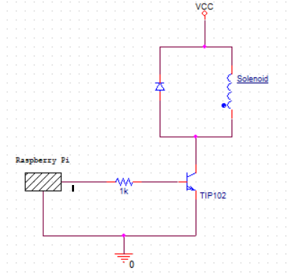

**Figure 4.2 Solenoid Circuit Diagram**

**4.3. Test Certification – Accuracy**

Having precision and accuracy is essential to the success of this device. If the readings are inaccurate or inconsistent, it renders the product unusable. To test the accuracy of the device, and thereby determine the usefulness of the product, the design team borrowed multiple kegs from the Mayhew Junction Brewing Company. The borrowed kegs were all one-sixth barrel kegs and were filled to various known levels. One keg was empty, one filled one-fourth of the way full, another two-fourths of the way full, one three-fourths, and one keg filled completely. This allows for testing against known values.

In addition to testing the kegs filled to various levels, a test was performed to determine if variations in keg manufacturer affect the reading of the device. A one-sixth barrel keg from a different vendor was tested which was one-half of the way full to determine if the slight variance in kegs from different manufacturers affects the performance of the device. This alternate keg was filled to one-half of its capacity not only to retest the device’s accuracy but also to compare with the results from the one-half keg from Mayhew Junction. Table 4.2.1 shows the results of the tests.

**Table 4.2.1 - Accuracy Tests**

|  |  |
| --- | --- |
| **Actual Value** | **Recorded Value** |
| 0% | N/A |
| 25%  (4.875 L) | N/A |
| 50%  (9.75 L) | N/A |
| 75%  (4.625 L) | N/A |
| 100%  (19.5 L) | N/A |

The component most critical to getting a consistent and accurate measurement from the device is the vibration sensor. Before testing the accuracy of the estimated liquid level, the vibration sensor was tested to determine the reading strength and consistency of the sensor when attached to the side of the keg. Because the Raspberry Pi Zero W does not have any analog GPIO pins built-in, an analog to digital converter was needed to read from the sensor. The ADS1015 was selected due to the high sampling rate needed to capture the vibration frequencies of the containers. Figure 4.2a shows the raw signal output of a vibration sensor when the container is struck by the solenoid, showing clear waves, which denotes the strong presence of frequencies.

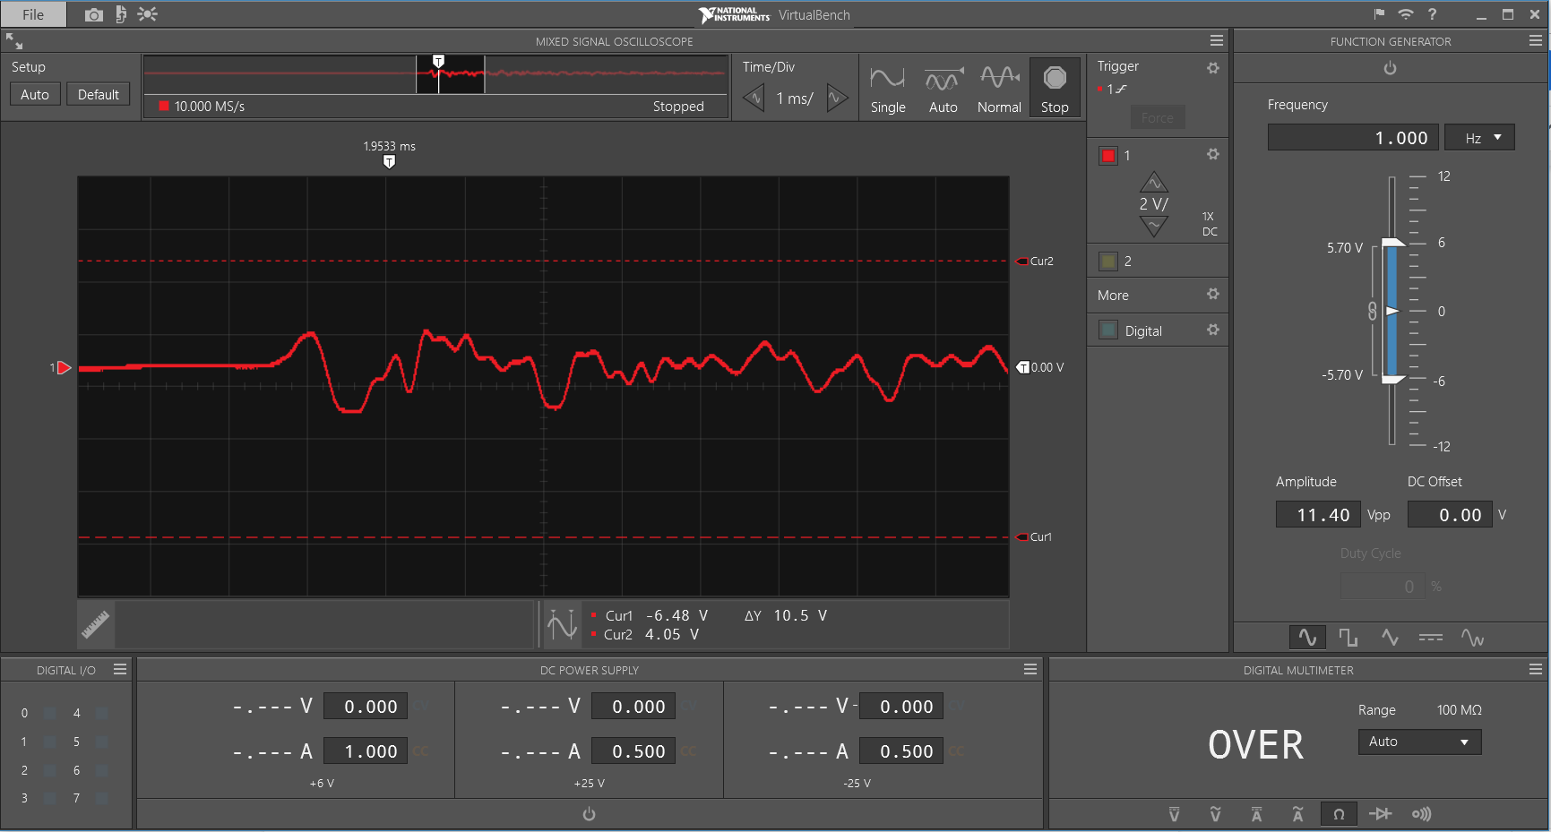

**Figure 4.3a - VirtualBench Output of Vibration Sensor**

Figure 4.2b shows the two images of plotted Fourier transforms. The image clearly shows a difference in the frequency peaks generated on the half-filled keg and the full keg. The top three peaks are all below 250 Hz on the full container, and all around or above 300 Hz on the half-full container. This clearly shows the uniqueness of the vibrations at these liquid levels, which allows for consistent and accurate identification of the volume in the container. Capturing the resonant frequency is the key function of the product, and this test demonstrates the effectiveness of the vibration sensors to capture the frequency at various fill levels.

|  |  |
| --- | --- |
| Magnitude  **(a)** | **(b)**  Magnitude  Hz  Hz |

**Figure 4.3b - Fourier Transforms for (a) Half-filled Container and (b) Full Container**

**4.4. Test Certification – Wireless Transmission Distance**

Testing the wireless distance constraint requires being off-campus with a personal wireless router. With the Raspberry Pi connected to the wireless network, it is taken various distances away from the router. The distance is measured with a tape measure capable of extending 12 meters. Ensuring that the device is still connected to the network demonstrates adherence to the given constraint.

**Table 4.3.1 - Transmission tests**

|  |  |  |
| --- | --- | --- |
| **Distance (meter)** | **Signal Strength (dBm)** | **Link Quality** |
| 3 meters | -51 | 59/70 |
| 6 meters | -53 | 57/70 |
| 9 meters | -63 | 47/70 |
| 12 meters | -75 | 35/70 |

The units of signal strength are given in Decibel-milliwatts(dBm). This means that lower values denote stronger signals. A recommended signal strength level for applications that require very reliable and timely packet delivery is -60 dBm, while -65 dBm is sufficient for less time-sensitive but reliable packet transmission. While there is a significant drop in the signal strength from nine to twelve meters, the signal at nine meters is more than enough for the simple transmissions associated with the communication from the device to the server. These tests show the adherence of the device to the given constraint.

## **4.5. Test Certification – Battery Life**

To test the battery life constraint, the device will operate for 16 continuous hours. During this duration, it must activate the solenoid every hour then process and send the data to the server to be received by the mobile application. The solenoid activation and performance is also measured intermittently to ensure the draining battery does not impact performance over the device’s 16-hour lifespan. Using the equations below, the required mAh is found to be 202.5 mAh. The battery outputs 500 mAh that is suitable to operate within the given condition.

**Table 4.4.1 - Battery Test for Sleep Mode**

|  |  |  |
| --- | --- | --- |
| Time (hr) | Voltage (V) | Percentage Left (%) |
| Hour 1 | N/A | N/A |
| Hour 4 | N/A | N/A |
| Hour 8 | N/A | N/A |
| Hour 12 | N/A | N/A |
| Hour 16 | N/A | N/A |

**Table 4.4.2 - Battery Test for Solenoid Strike**

|  |  |  |
| --- | --- | --- |
| Time (hr) | Voltage (V) | Percentage Left (%) |
| 4 hours | N/A | N/A |
| 8 hours | N/A | N/A |
| 12 hours | N/A | N/A |
| 16 hours | N/A | N/A |
| 20 hours | N/A | N/A |

**Table 4.4.3 - Battery Test for Communication**

|  |  |  |
| --- | --- | --- |
| Time (hr) | Voltage (V) | Percentage Left (%) |
| 4 hours | N/A | N/A |
| 8 hours | N/A | N/A |
| 12 hours | N/A | N/A |
| 16 hours | N/A | N/A |
| 20 hours | N/A | N/A |

**Table 4.4.4 - Battery Test for Processing Results**

|  |  |  |
| --- | --- | --- |
| Time (hr) | Voltage (V) | Percentage Left (%) |
| 4 hours | N/A | N/A |
| 8 hours | N/A | N/A |
| 12 hours | N/A | N/A |
| 16 hours | N/A | N/A |
| 20 hours | N/A | N/A |

**4.6. Test Certification – Noisy Environment**

In order to ensure the device operates properly in a typical environment, it had been tested under conditions up to 80 dB. 80 dB was used because a bar or restaurant is approximately 85 dB loud, and since the device is in a refrigerated casing, this attenuates the noise somewhat [33]. The device was placed near a speaker and the speaker was turned up to a sufficient amount until the proper noise level was reached. To ensure that the sound was at an appropriate volume, an app called Decibel X, made by SkyPaw Co, Ltd, was used. Once the sound pressure level was adequate, a test was performed to verify the device still measured accurately under these conditions.

|  |
| --- |
| *Insert Scope Picture* |

**Figure 4.5a - Signal output of the vibration sensor**

**Table 4.5.1 - Interference tests**

|  |  |  |  |
| --- | --- | --- | --- |
| **Volume in dB** | **Expected Result** | **Actual Result** | **% Error** |
| 20 dB | N/A | N/A | N/A |
| 40 dB | N/A | N/A | N/A |
| 60 dB | N/A | N/A | N/A |
| 80 dB | N/A | N/A | N/A |

**4.7. Test Certification – System Test**

Once each subsystem is in place, a full system test is performed. First, the device is turned on via a switch and set up using the smartphone application. Once this is completed, the device begins to initiate the first test. The Raspberry Pi sends a signal to the relay driver, which diverts power from the battery to the solenoid. This causes the solenoid to fire, striking the side of the container with approximately 31 N of force. As the container resonates, the piezoelectric sensor converts mechanical stress to an electric potential. This current is sent to the analog-to-digital converter for processing.

Using a sample clock, the A/D converter samples the signal at a rate of 3300 samples per second and converts each sample to a digital value. This is sent to the Raspberry Pi over an I2C serial bus. Next, the signal is processed using a Fourier transform, which converts the signal from the time domain to the frequency domain. Based on the frequency response, the liquid level is determined and uploaded to an HTTP server. Finally, the smartphone application retrieves the percentage level and displays it to the user.

**References**

[36] “Sound Effects Decibel Level Chart.” creativefieldrecording.com. <https://www.creativefieldrecording.com/2017/11/01/sound-effects-decibel-level-chart/> (accessed Nov. 10, 2019).

[37] “Why is almost everything negative in Wireless?” community.cisco.com/ <https://community.cisco.com/t5/small-business-support-documents/why-is-almost-everything-negative-in-wireless/ta-p/3159743> (accessed Nov. 20, 2019).