**EXECUTIVE SUMMARY**

In the food-service industry, restaurants and bars have inaccurate or expensive methods for determining the amount of alcohol in their metal keg containers. The methods include using a scale to weigh the kegs, manually lifting the kegs with a spring device, or installing complex and costly equipment that requires downtime for construction. The customers whom Automated Liquid Level Detection (ALLDET) is targeting need a simple, accessible way to retrieve information about their kegs without wasting time and effort.

ALLDET functions in a noisy environment of 80 dB without the resonance changing. All components operate in an environment down to 0°C. Since the device may be housed in an enclosed space, it can wirelessly transmit its data to a mobile device with the ALLDET application beyond 9 meters. Also, since the device is battery-operated, the battery powers all components of the device up to 16 hours. With the possibility of liquid spillage, all the components are made water-resistant, according to the IP52 standard, when enclosed with a 3-D printed case.

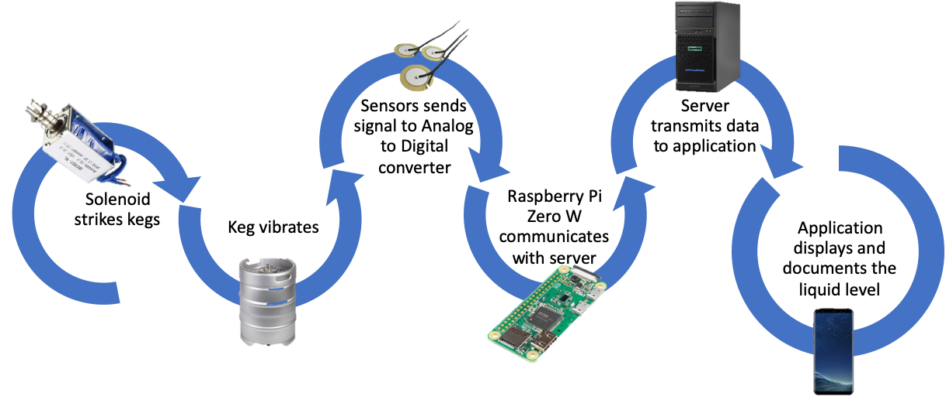

Figure 1. System Overview

ALLDET enables customers to detect the liquid level in their kegs and manage their inventory in a timely manner. It is an attachable, battery-powered device that consists of a solenoid to strike the keg, causing it to vibrate. The piezoelectric sensor captures the vibration and communicates with the Raspberry Pi Zero W through an analog-to-digital converter. The Pi converts the vibration into frequencies for different liquid levels and uses an algorithm to determine the liquid level accurately in percentages of fullness. The device’s accuracy is within 5 percent of the actual amount of liquid inside the keg. With this information, the Raspberry Pi transmits the detected liquid level to the server and then transmits the data to the application, where it is displayed and stored for the customer. This description of the system is depicted in Figure 1.

ALLDET can improve on the overall device to be competitive and marketable to multiple applications. The improvement on the components is using smaller, more powerful components to make the device smaller and lighter. The device caters successfully to customers’ needs by being able to withstand a typical restaurant environment. However, the device needs to be able to operate properly outside in different climates like snow, rain, sleet, high winds, etc. The next improvement can be having a choice of Wi-Fi or Bluetooth depending on the customer’s need. The expansion of industries can lead to custom improvements to ALLDET and its application.