**ALLDET - Automated Liquid Level Detection**

**Department of Electrical and Computer Engineering**

Submitted to:

Dr. Bryan Jones

ECE 4512/ ECE 4532: Senior Design I

Department of Electrical and Computer Engineering

413 Hardy Road, Box 9571

Mississippi State University

Mississippi State, Mississippi 39762

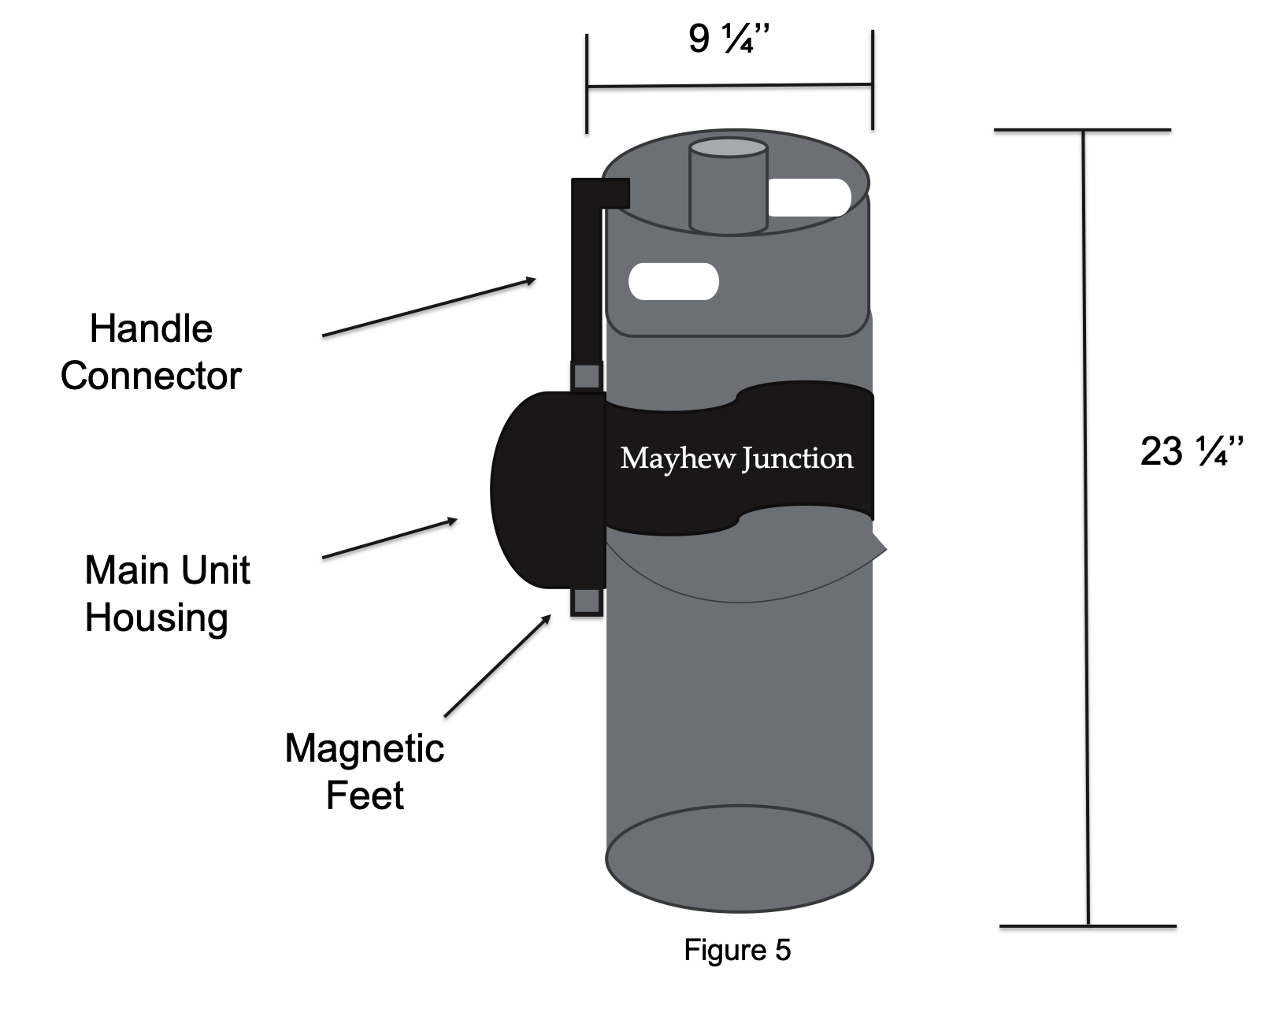

December 4, 2019

Prepared by:

Andrew Bullington, Zachary Fauver, James Ryan Ladd, Khara Robinson, Jesse Tutor

Faculty Advisor: Professor Dr. Jean Mohammadi-Aragh

Industrial Advisor: Mr. and Mrs. Derek Aragh, Mayhew Junction

Department of Electrical and Computer Engineering

Mississippi State University

413 Hardy Road, Box 9571

Mississippi State, Mississippi 39762

Email: {[ajb946](mailto:ajb946@msstate.edu), [ztf13](mailto:ztf13@msstate.edu), jl2223, [knr212](mailto:knr212@msstate.edu), jt1508}@msstate.edu



# **LIST OF ABBREVIATIONS**

# ADC – Analog-to-Digital Converter

# ALLDET – Automated Liquid Level Detection

DC – Direct Current

I2C – Inter-Integrated Circuit

# IEEE – Institute of Electrical and Electronics Engineers

# IP – Ingress Protection

ROI – Return On Investment

# SPI – Serial Peripheral Interface

SDK – Software Development Kit

# SQL – Structured Query Language

# 

# **EXECUTIVE SUMMARY**

In the food-service industry, restaurants and bars have inaccurate or expensive methods for determining the amount of alcohol in their metal keg containers. The methods include using a scale to weigh the kegs, manually lifting the kegs with a spring device, or installing complex and costly equipment that requires downtime for construction. The customers whom Automated Liquid Level Detection (ALLDET) is targeting need a simple, accessible way to retrieve information about their kegs without wasting time and effort.

ALLDET enables customers to detect the liquid level in their kegs and manage their inventory in a timely manner. It is an easily attachable, battery-powered device that vibrates a metal container by striking it with a solenoid. The piezoelectric sensor captures the vibration and communicates with the Raspberry Pi Zero W through an analog-to-digital converter. The Pi converts the vibration into frequencies for different liquid levels and uses an algorithm to determine the liquid level accurately in percentages of fullness. The device’s accuracy is within 5 percent of the actual amount of liquid inside the keg. With this information, the Raspberry Pi transmits the detected liquid level to the server and then transmits the data to the application, where it is displayed and stored for the customer. This description of the system is depicted in Figure 1.

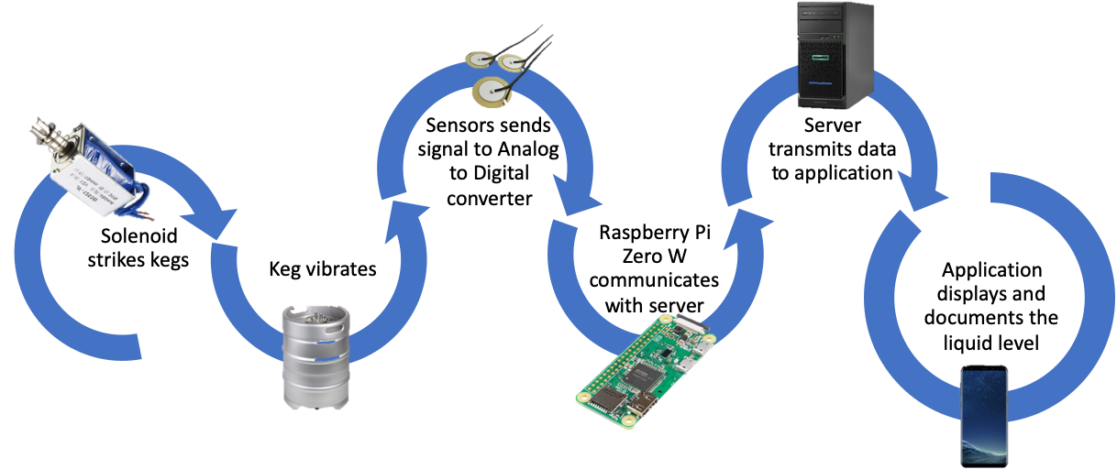

Figure 1. System Overview

ALLDET functions in a noisy environment of 80 dB without the resonance changing. All components operate in an environment down to 0°C. Since the device may be housed in an enclosed space, it can wirelessly transmit its data to a mobile device with the ALLDET application beyond 9 meters. Also, since the device is battery-operated, the battery powers all components of the device up to 16 hours. With the possibility of liquid spillage, all the components are made water-resistant, according to the IP52 standard, when enclosed with a 3-D printed case.

ALLDET can improve on the overall device to be competitive and marketable to multiple industries. The device could be improved by having smaller components, making the device more portable. The device caters successfully to customers’ needs by being able to withstand a typical restaurant environment. However, the device needs to be able to operate properly outside in different climates like snow, rain, sleet, high winds, etc. to be usable in other industries. The next improvement can be having a choice of Wi-Fi or Bluetooth depending on the customer’s desired application. The expansion of industries can lead to custom improvements to ALLDET and its functionality.

**TABLE OF CONTENTS**

**1.** **PROBLEM……………….……………….……..…….……………...………………………. 5**

**1.1. Historical Introduction****……………….………………….……………………………... 5**

**1.2. Market and Competitive Product Analysis****……………….…………...….…………... 5**

**1.3. Concise Problem Statement****……………….…………………….……...…………….... 6**

**1.4. Implications of your Success****……………….…………….…………………………...... 6**

**2.** **DESIGN REQUIREMENTS/CONSTRAINTS……………….…….…….………………... 6**

**2.1. Technical Design Constraints****……………….……………….………………...………. 7**

**2.2. Practical Design Constraints****……………….……………….………………………….. 8**

**2.3. Appropriate Engineering Standards****……………….……………….………………...10**

**3. APPROACH****……………….……………….…………………….……………...….…….…. 10**

**3.1. Hardware****……………….……………….…………………….…………...…….….…. 12**

**3.2 Software****……………….……………….…………………….………………………….18**

**4. EVALUATION……………….………………….……………………..…….……………...20**

**4.1 Test Certification – Temperature……………….…………………………....………..21**

**4.2 Test Certification – Solenoid……………….…………………….…………...………..22**

**4.3 Test Certification – Accuracy……………….………………….……..….…………....22**

**4.4 Test Certification – Wireless Transmission Distance……………….………..……...25**

**4.5 Test Certification – Battery Life……………….……………………..……….……....25**

**4.6 Test Certification – Noisy Environment……………….…..…………….….………...27**

**4.7 Test Certification – System Test……………….…………………….…………...…....27**

**5****. SUMMARY AND FUTURE WORK****……………….……………….……………...…….... 28**

**6****. ACKNOWLEDGEMENTS****……………….………………….………………..….….….…. 29**

**7****. References****……………….……………….……………….…….……………….….…..….... 30**

**1. Problem**

## **1.1 Historical Introduction**

When beer was first developed 4,000 years ago, it was stored in containers such as clay urns and pots. Over time, however, brewers found that storing beer in wooden casks allowed it to be carbonated and fermented more easily. Eventually, stainless steel and aluminum containers, referred to as kegs, became the preferred beer storage method [1], [2].

Kegs were invented to allow pasteurization of liquids inside, such as beer [2]. With these metal beer containers, the way to determine the amount of beer inside without contaminating the contents is to roll the kegs onto a scale or purchase an expensive interior redesign from other companies.

Scales as a tool to weigh commodities date back to ancient Egyptian and Babylonian times. Historically, scales were made using wood, a cord, and pans supported by cord. This “equal arm” balance was used for the next 2000 years until the Roman steelyard scale was developed [3]. Modern-day scales use load cells, which transform pressure into current, and are the main technology used in the modern competition for measuring keg levels [4]. In today’s market, keg scales cost an average of $200-$300 [5].

ALLDET provides a way for keg owners to determine the amount of liquid in their containers without having to move them, weigh them, or spill any liquid. The product provides a non-invasive, hands-free method for level monitoring that requires no new taps or lines, all while maintaining a lower price point than the main competitors.

Numerous companies provide beer inventory tracking and monitoring. Those companies’ solutions, however, require physical reconstruction of tap walls as they use proprietary beer taps to monitor flow control. In addition to the cost of downtime due to reconstruction, this method has an expensive initial cost.

## **1.2 Market and Competitive Product Analysis**

As mentioned above, one popular method currently available for determining the liquid level in a container uses scales to determine the weight of the keg and its contents. This method is not ideal because it requires the customers to lift their containers from their serving station or take them off of the storage rack to place on the scale and manually calculate the amount of liquid remaining. Attaching the device to the side of the containers prevents heavy lifting, making the product more accessible than other options currently on the market. Manual entry of data increases the likelihood of incorrectly recording the liquid level as well as causes employees to spend more time on tedious inventory tracking. the product automates the entry and analysis of data, allowing employees to spend their time on more important issues.

Another method available involves specialized bar taps and/or lines that have flow meters and sensors. This requires new construction of displaying taps to put the new product in place [6]. the product differentiates itself in that it can be easily attached and removed from the container rather than modifying the keg or line.

The restaurant industry is the primary market. The design team aims to target bars, restaurants, alcoholic beverage vendors, and at-home breweries. the customer base can include chain or locally owned businesses. Restaurants have a high enough usage rate that they could greatly benefit both from an automated method of determining the level of liquid in their containers as well as the data analytics associated with usage rates. Several flow monitoring systems are already available. Businesses that have such systems installed are outside of the market, as they already have expensive equipment against which we could not provide a competitive performance alternative.

## **1.3 Concise Problem Statement**

ALLDET’s mission is to provide a simple, easy-to-use solution for liquid level tracking in a container. The team intends for the solution to be affordable, quickly set up, and easily detached and moved to a different keg. Attaching the device to the side of the container prevents heavy lifting and back strain on the customers, which is unavoidable using other methods involving scales. In addition, it does not require invasive procedures like redesign of a storage area or contact with the liquid itself.

The product will utilize a vibration sensor for measuring the resonance that is created by a small mechanical arm that will strike the side of the container. The data from the sensor will be sent to a microprocessor to be analyzed before being passed on to the application. The team will use a Wi-Fi connection between each module and the device running the application to send the data. the application will have a user-friendly interface to provide the customers with many useful features including estimated liquid level, alerts on when to reorder, and usage history. the product is a simple, affordable, non-invasive solution to challenges seen in the restaurant/bar industry.

## **1.4 Implications of your Success**

Many man hours are spent handling kegs in the restaurant/bar industry. This can include moving, stacking, and weighing the kegs for inventory purposes. In 2018, 202.2 million kegs of beer were sold, and over 600,000 retailers were selling alcohol [7]. If the researchers estimate each one of these establishments spending half an hour per week on keg inventory, then each one would spend over three business days per year measuring the liquid level of their beer kegs. Providing a hands-free solution, ALLDET eliminates the time wasted on manual labor for keg inventory, thus saving customers thousands of dollars.

ALLDET is pioneering the way beer keg level is monitored and tracked. Providing an innovative, long overdue solution to an entire industry will set a new standard of how inventory management is accomplished. The device helps customers save time and money spent on inventory, as well as detect overpouring and theft due to free drinks. Upon further success, ALLDET devices can be used for chemical containers, oil drums, propane containers, or any other type of fluid stored in a metal container.

# **2. Design Requirements/Constraints**

ALLDET provides a way for keg owners to determine the amount of liquid in their containers without having to move kegs, weigh kegs, or spill any liquid. The product will provide a non-invasive, hands-free method for liquid level monitoring that does not require new taps or lines, all while maintaining a lower price point than the competition. This section outlines technical and practical constraints required to achieve this goal.

## **2.1 Technical Design Constraints**

The following table lists five technical constraints that must be adhered to upon completion of this product.

**Table 2.1. Technical Design Constraints**

|  |  |
| --- | --- |
| **Name** | **Description** |
| Temperature | The device must operate at a temperature of 0℃. |
| Accuracy | The device must determine the liquid level with an accuracy of ±5% of actual amount. |
| Wireless Transmission Distance | The WiFi connection must reach up to 9 m. |
| Battery Life | The device must run continuously for 16 hours using a battery. |
| Noisy Environment | The readings of the sensor must be accurate within an environment of 80 dB. |

**2.1.1. Temperature**

ALLDET operates at all temperatures that will be exposed to the kegs. Kegs can likely be refrigerated or stored in storage. The ideal temperature for a beer keg is 3.3℃ to make sure that the foam is not too cold, which causes the beer to taste flat, and not too hot, which causes too much foam [8]. Therefore, the device does operate at a temperature range of 25℃ down to freezing (0℃).

**2.1.2. Accuracy**

ALLDET reports the liquid level of a keg to the user. Although the selected method of measurement is convenient and does not require lifting, it is not as accurate as weighing the keg. However, customers do not care about the level being reported to them being accurate down to the single percent. It is more likely that they would care more about having a general idea of how much liquid is left in the keg, especially considering some potential customers that the team are talking to estimate the liquid content by lifting the keg with one finger. Therefore, the constraint for the device to report the liquid level with an accuracy of ±5%, or about two pints, of the actual amount is necessary.

**2.1.3. Wireless Transmission Distance**

ALLDET sends recorded data to a smartphone application for display and processing. This data sends wirelessly through WiFi and should be accessible from a short distance away to ensure that the user does not have to go into the refrigerator holding the kegs to get the data. The effective transmission distance covers a large portion of the restaurant or bar so that the users can access this data at their convenience. Nine meters certainly accomplish this goal, and is achievable using WiFi [9].

**2.1.4. Battery Life**

ALLDET’s battery life matches the expected life of a keg in use. If customers changes or recharges the battery before the container has been fully used, it greatly decreases the value of the product. The benefit of the device is that it is a hands-free, automated method for inventory tracking. If the battery recharges or changes before the keg must be replaced, it takes time away from the users. The device is active until the keg is dry, when it is removed and the battery recharges before being attached to the next container.

**2.1.5. Noisy Environment**

ALLDET measures reliably the level of a keg within an environment that is typical of a bar or a restaurant. A noisy restaurant is approximately 85 dB loud, and since a keg is contained in a refrigerated casing, measuring with background noise of 80 dB is sufficient to make the product usable [12]. In the case where measuring is done outside of the container, it assumes that it will be during non-peak hours in a less noisy environment.

## **2.2. Practical Design Constraints**

Table 2.2 lists five additional constraints that must be adhered to for the product to be considered complete.

**Table 2.2. Practical Design Constraints**

|  |  |  |
| --- | --- | --- |
| Type | Name | Description |
| Economic | Cost | To ensure the customers a short ROI, ALLDET will keep the device cost less than $200. |
| Manufacturability | Size | The physical dimensions should be less than or equal to 30 cm high, 10 cm wide, and 10 cm deep. |
| Environmental | Water tolerance | The device must work in accordance with the IP52 standard. |
| Social | Application enabled | The device will be connected to an application that the user can use for liquid level tracking. |
| Sustainability | Hands-free usage | The device will not need user intervention to operate, but need the user to charge it. |

**2.2.1. Economic**

The ALLDET’s price is under $200 not only to ensure a quick return on investment (ROI) for the users, but also to be competitive within the marketplace. Using inexpensive yet quality components, we will lower production costs. Given an average restaurant manager salary of $50,000 per year, the per diem cost of paying a manager is roughly is $192 [11]. If an estimated 3 days are spent on inventory each year, customers achieves an ROI within 4 months.

**2.2.2. Manufacturability**

The size of the device is not greater than 30 cm high, 10 cm wide, and 10 cm deep, based on the dimensions of commercial kegerators and one-sixth barrel kegs [13], [14]. Since kegs are round, even when kegs are placed side by side there will be some space available. The case is easily attach to the container and be small enough not to impact the storage method.

**2.2.3. Environmental**

The device is able to withstand some precipitation from the keg and possible beer leakage. The casing prevents any liquid from damaging the device in accordance with the IP52 standard [10].

**2.2.4. Social**

ALLDET has an application paired with the hardware provided. The application allows the user to track and monitor the liquid level inside of the keg. Also, the app notifies the user when the keg is within 5%, or about two pints of a one-sixth, of being empty. The app is an easy-to-use and does not require a technical background.

**2.2.5. Sustainability**

ALLDET is a device that does not require the user to interact with it directly for operations. The hardware needs the user to attach and remove it from the keg, but afterward the device is self-sufficient via the application. The application is able to provide the user with the readings from the device’s sensors.

## **2.3. Appropriate Engineering Standards**

|  |  |  |
| --- | --- | --- |
| Specific Standard | Standard Document | Specification/Application |
| IP52 | IP Rating Chart (IEC 60529) | Protects from water spray less than 15 degrees from vertical |
| IEEE 802.11N | WiFi Basic Specification | Used for sending and receiving data from the host device, and a smartphone, compatible with the Raspberry Pi |

**2.3.1. IP52**

The IP52 standard for liquids is to protect from vertically dripping water onto the enclosure tilted up to 15 degrees from its normal position [10].

**2.3.2. IEEE 802.11N**

ALLDET complies with IEEE 802.11 N to ensure connectivity to any smart phone and the Raspberry Pi.

# **3.** **APPROACH**

ALLDET provides a non-invasive solution for restaurant and bar owners or managers that allows them to monitor the liquid level inside their beer kegs. Using Wi-Fi technology through a mobile application, the user is able to save multiple keg profiles for simple inventory tracking. A microcontroller activates a solenoid that strikes the side of the keg, causing it to resonate. The resonance of the container is processed through a piezoelectric sensor and the Fourier transform is taken to convert the signal from the time domain to the frequency domain. This information is used to determine the level of liquid inside the container. Figure 3.0a shows the process flow of the product.

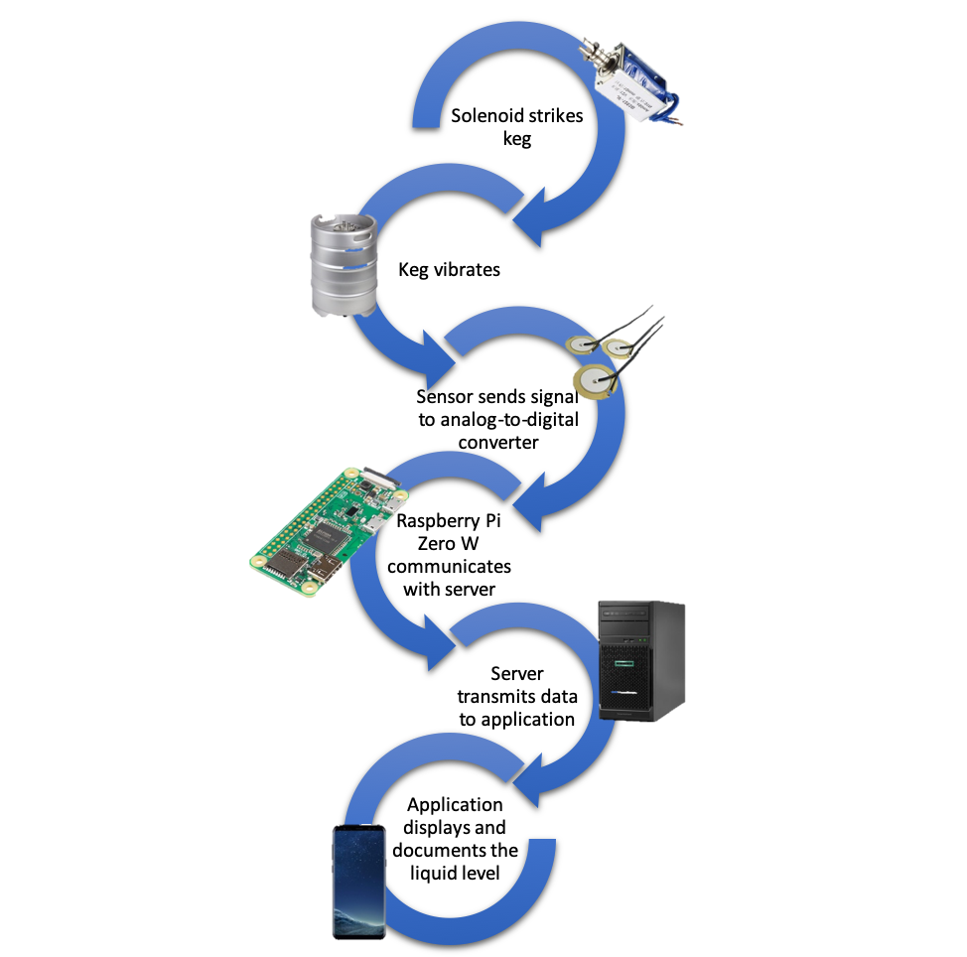

**Figure 3.0a System Overview**

This approach was chosen because it does not require the users to interact with the container in any way to determine the current liquid level. Other methods for determining the volume of liquid in a metal container generally involve weighing the container. The major benefit of using the resonance of the container is that it does not necessitate the interaction of the user in any way. Figure 3.0b shows the relationship between the resonance frequency and the volume within a metal container.

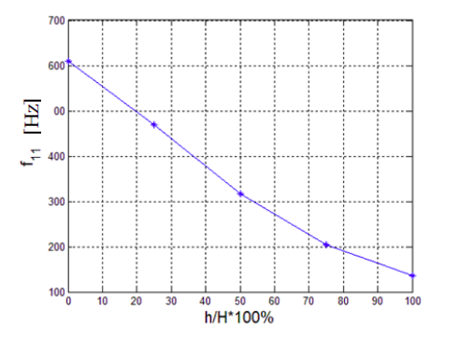

**Figure 3.0b Graph of Frequency vs. Volume Within a Metal Container [35]**

## **3.1. Hardware**

The following section highlights the hardware components of ALLDET’s design. The design includes a microcontroller, attachment mechanism, battery, vibration sensor, vibration generator, chassis, A/D Converter, DC-DC convertor, and Battery Charging or Monitoring Circuit. The microcontroller is used to control the vibration generator and to read the data from the sensor. The attachment mechanism ensures that the device does not become detached from the keg and that it is positioned correctly. The vibration sensor detects movement of the keg created by the vibration generator. The chassis protects each component and is designed to ensure proper contact with the keg and the vibration sensor and solenoid. These components were selected based on budget, compatibility, and size.

**3.1.1. Microcontroller**

Raspberry Pi Zero W was chosen due to the Python programming capabilities, which is a robust language equipped with server communication libraries that are necessary to program the device. In addition to being the least expensive, the Raspberry Pi Zero W also has wireless and Bluetooth capabilities, making it the clear choice for the design. Table 3.1.1 shows a comparison of considered microcontrollers.

**Table 3.1.1. - Microcontroller Options**

|  |  |  |  |  |
| --- | --- | --- | --- | --- |
| Device | Description | Wi-Fi (must be included) | Serial bus (must have I2C) | Price (must be less than $20) |
| Arduino Uno [30] | Lacks built-in Bluetooth or Wi-Fi capability | No | SPI/I2C | $16.22 |
| Pic33 [33] | Does not come with development board like Arduino or Raspberry Pi. Lacks built-in Wi-Fi or Bluetooth capability | No | SPI/I2C | $17.88  (PicKit3) |
| Raspberry Pi Zero W [34] | Has Bluetooth Low-Energy and Wi-Fi capability. Has built-in Python interpreter | Yes | SPI/I2C | $10 |

**3.1.2. Attachment Mechanism**

ALLDET requires a means of physically attaching to the container. Mounting magnets and a clamp mechanism were chosen because they are easy-to-use and ensure a reliable method of measurement. Table 3.1.2 highlights some of the pros and cons of various methods of attachment.

**Table 3.1.2. - Device Attachment Options**

|  |  |  |  |
| --- | --- | --- | --- |
| System | Description | Pros | Cons |
| Mounting magnets | Magnetic feet are attached to the main unit housing to fit device to side of keg | Easily attached  Works for all metal kegs | Magnets could interfere with microcontroller and sensor |
| Elastic strap | Strap attached to casing to affix device to side of keg | No magnetic interference  Could embed sensor into the strap itself | Cumbersome to attach  Sensor in the strap may not be practical |
| Clamp mechanism | Clamping device affixed to the top of the device to ensure a consistent distance from top of keg | Ensures reliable measurements every time | Adds mechanical complexity and size |
| Suction cup | Suction cups attached to the main unit housing to provide a means of mounting | No magnetic interference | Unreliable means of attachment |

**3.1.3. Li-Ion Battery**

A lithium-ion battery, also known as an Li-Ion battery, is the battery of choice for the ALLDET device. The Li-Ion battery is a commonly-used rechargeable battery in the electronics industry. Also, the Li-Ion battery is very efficient in power and charging efficiency with a small, sleek look.

Equation (1) shows the mathematical breakdown that shows the required battery capacity:

(1) = + +

While using equation (1), below is the complete breakdown of the required current draw needed to operate the device. This breakdown gives the justification of the battery chosen:

1. = 120 mA [22] + 250 mA +<1mA ≈ 0.371 mA

30 seconds/measurement * 4 measurements per hour * 16 operation hours

= 32 minutes in operation

0.371 A * 0.53 hours = 197.9 mAh for operation

0.3mA low-power mode * 15.47 hours = 4.6 mAh total power during low-power mode

197.9 + 4.6 = 202.5 mAh, total battery requirement

For the needed current equation (1), all the current values are for active states. Thirty seconds is the estimated worst-case time it would take for the device to hit the keg and transmit the signal to the server. These values are assuming the device hits the keg four times within an hour while operating for 16 hours. The needed current for the time the device is in operation is 197.9 mAh. While the device is in a low-power mode, the device operates for the remaining 15.47 hours and use only 4.6 mAh. In total, the battery must supply a minimum of 202.5 mAh. Table 3.1.3 shows batteries that were considered and which one was chosen based on the requirements.

**Table 3.1.3 - Battery Options**

|  |  |  |  |  |  |
| --- | --- | --- | --- | --- | --- |
| Device | Description (must have 202.5 mAh) | Active Current | Sleep Current | Duty Cycle | Price (must be less than $20) |
| Jauch Quartz LP705176JS [23] | Battery Lith Poly 1S1P 3150 mAH 3.7 V | 0.2 C | 0.2 C | 500 | $22.30 |
| Adafruit Industries LLC 1578 [24] | Battery Lithium 3.7 V 500mAH | 0.2 C | 0.2 C | >500 | $7.95 |
| Adafruit Industries LLC 354 [25] | Battery Lithium 3.7 V 4.4 AH | 0.5 C | 0.2 C | >= 500 | $19.95 |

ALLDET supplies power to the device with the selected option based on the physical appearance, the rated capacity, and the cost. The battery’s dimension is 1.14” and 1.42” [24], which allows the device to remain small and compact. The minimum capacity required for the device is 202.5 mAh, as shown above in the calculations. The targeted current of the small, cost-effective battery is 202.5 mAh. Since the battery chosen is above the required voltage, there is a circuit that accounts for the 0.4 V that is not required. Therefore, there is no damage to the battery and other electronic components.

**3.1.4 Vibration Sensor**

ALLDET measures the vibration of the keg after being struck to determine the level of the liquid. The device uses a piezoelectric sensor because these devices are the most accurate as they maintain contact with the container. Piezoelectric sensors measure changes in force by converting these changes to an electrical charge; these charges can potentially range up to ±50 V [15], [18]. Because of these high voltage ranges, a large resistor is used to “load down” the sensor. A piezoelectric sensor is inside the main unit housing that has to maintain contact with the side of the container. The signal from this sensor is sent an analog signal then, converted into a digital signal for processing.

**Table 3.1.4 - Vibration Sensor Options**

|  |  |  |  |
| --- | --- | --- | --- |
| Type | Description | Output | Price  (must be less than $5) |
| Piezoelectric sensor [16] | Converts mechanical energy into electric current | Can vary, potentially upwards of ±50 V | $1.70 |
| Vibration sensor [17] | Uses a stability circuit to monitor output | Digital output (0 or 1) | $1.40 |

**3.1.5 Vibration Generator**

The solenoid is used as a vibration generator or “thump” mechanism that strikes the side of the container with the same velocity every time. Though larger than a stepper or servo motor, a solenoid is a clear choice for the project based on power draw and functionality. The solenoid is powered directly from the battery and controlled using a transistor. The signal to activate the solenoid is sent from the Raspberry Pi.

Table 3.1.5a and Table 3.1.5b show a comparison between different motors and a solenoid.

**Table 3.1.5a - Vibration Generator Options**

|  |  |  |  |
| --- | --- | --- | --- |
| Mechanism | Description | Price (must be less than $20) | Size (must be less than 4” in overall length) |
| DC Stepper Motor [21] | Can accurately move in “steps.” Allows full rotation, but needs a “thump arm” mechanism. Operates only at 25 RPM, which is insufficient to make an adequate “thump” for the sensor to detect | $4.95 | Roughly the size of a quarter |
| Continuous Rotation Micro Servo Motor [20] | Operates on position versus “steps.” Would need “thump arm” mechanism, which would require more parts to manufacture | $7.50 | Almost the same size as a stepper motor, which is roughly larger than a quarter |
| 12 V, 31 N Solenoid [19] | Internal metal “slug” has “punch” feature, which allows for consistent striking and eliminates the need for external arm. Provides 31 N of force per punch  Easily retracted after activation when voltage no longer engages magnet | $17.84 | Largest of the three, but at a length of 3.5” when fully retracted, it still fits the size constraint |

**Table 3.1.5b Solenoid Comparison**

|  |  |  |  |
| --- | --- | --- | --- |
| Solenoid | Power Draw  () | Strike Force | Price (must be less than $20) |
| 12 V 31 N 450 mA uxcell solenoid [19] |  | 31 N | $17.84 |
| 5 V Uxcell push pull solenoid [32] |  | 0.5 N | $5.99 |
| 12 V 1A uxcell solenoid [31] |  | 6 N | $5.99 |

**3.1.6 3-D Printed Chassis**

Figure 3.1 is not to scale but is used to demonstrate the location that the device is intended to sit on the container, which is approximately the middle of the container.

The main unit housing is 3-D printed to IP52 standard to ensure substantial amounts of water do not enter the unit and damage the components. A 3-D printed case is used mainly due to the inexpensive cost of production. The case is equipped with a connector rod that attaches to the handle to ensure that every device is mounted at an appropriate distance from the top of the container to maintain consistent measurements. Also, the case has magnetic “feet” that maintain a firm connection to the side of the container to obtain an accurate reading.

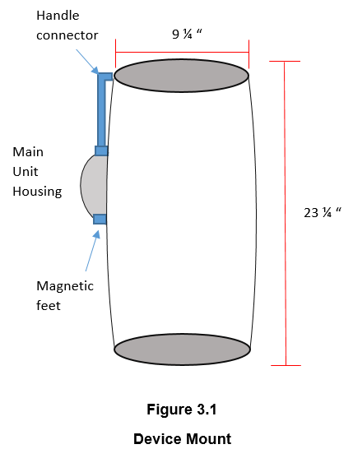

**Figure 3.1 Device Mount**

**3.1.7 A/D Converter**

To convert the analog signal from the piezoelectric sensor to a digital signal that can be read by the Raspberry Pi, an analog-to-digital converter is needed. Using a sample clock, the ADC samples a signal on the falling or rising edge of the clock and converts that value to a digital value [26]. For this device, the ADC must have a high sampling rate, high bit precision, and use the I2C serial bus, which uses only two wires for ease of communication.

Table 3.1.7 shows a comparison between the considered A/D converters.

**Table 3.1.7 - A/D Converter Options**

|  |  |  |  |  |
| --- | --- | --- | --- | --- |
| ADC | Bit Precision | Sampling Rate | Serial Bus  (must be I2C) | Price |
| MCP3008 [27] | 10-bit | 220 ksps | SPI | $3.75 |
| ADS1015 [28] | 12-bit | 3300 samples/s | I2C | $9.95 |
| ADS1115 [29] | 16-bit | 860 samples/s | I2C | $6.99 |

**3.1.8 DC-DC Boost Converter**

The solenoid operates on 12 VDC at 450 mA with a striking force of 31 N. This particular solenoid was chosen to minimize power draw and have a strong enough force to strike the container to get a vibration. Unfortunately, the Raspberry Pi Zero W outputs voltages of only 3.3 V or 5 V. Therefore, to power the solenoid from the Raspberry Pi, a boost converter is used that takes an input voltage between 3-30 V and outputs a voltage between 5-35V . To ensure the converter is outputting the correct voltage, the potentiometer within the converter adjusts to the proper 12 V output to power the solenoid.

**3.1.9 Battery Charging/Monitoring Circuit**

Since the device is battery operated, charging is necessary. A battery-charging module is needed not only to charge the battery but also, to ensure that the battery is not over-charged, which would damage the battery. Along with the charging module, a battery-monitoring module is needed to prevent the battery from discharging too much, thus preventing damage to the battery.

## **3.2 Software**

The software components of this product consists of three parts: the microcontroller, wireless communication, server, and mobile application. The microcontroller is responsible for reading the signal generated by the solenoid. It then transmits that signal to the server. The server stores that data until a smartphone connects with authorization to access the information. Once the server has received the signal, it then performs an analysis to compute the liquid level. When the phone connects to the server, the server passes that data to the phone. The mobile application displays the data to the user in an ergonomic way. Figure 3.2 shows the connection between the various software components of the product.

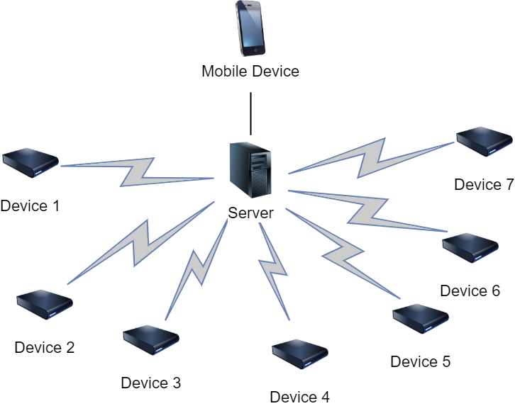

**Figure 3.2 Device Communication Path**

**3.2.1 Microcontroller**

The Raspberry Pi receives the signal from the piezoelectric sensor through an analog-to-digital converter and uses a fast Fourier transform to convert the received signal to a frequency. This calculation is handled by the Raspberry Pi to avoid transmitting large amounts of sensor data to the server. Instead, the result and the device ID is the only information that requires transmission. The software on the Raspberry Pi is responsible for both the calculation of the liquid level and transmission of the result to the server to be stored by the SQL database. This code is written in Python, which has specific libraries to transmits data over Wi-Fi and calculates the Fourier transform of the signal.

**3.2.2 Wireless Communication**

Originally, Bluetooth was considered for wireless communication. This consideration was due to the fact that the phone application would connect directly to each ALLDET device individually. After the consideration to add a server, store the data readings, and compute the liquid level, Wi-Fi was chosen as a better alternative. Wi-Fi not only allows the application to connect to one server instead of multiple ALLDET devices, it also provides a much greater range. While Bluetooth allows for use in areas without a Wi-Fi connection, Wi-Fi is so ubiquitous that it is not significantly limit the customer base.

**3.2.3 Server**

ALLDET uses a server to communicate with the device, store the data readings, and perform user authentication. The mobile application pulls the liquid level history from the server and displays it to the user. To accomplish the data storage, a Linux server retrieves the data from the device and uses Python to process the data and determine the liquid level. The server also uses a SQL database to store the processed data. Python and SQL were chosen because the team has prior development experience with them. Additionally, Python has open source libraries for wireless transmission.

**3.2.4 Smartphone Application**

ALLDET’s mobile application is created using Flutter, Google’s mobile app software development kit (SDK). Flutter was chosen for application development for multiple reasons. Firstly, one team member has prior experience with this SDK. In addition, Flutter allows for development on Android and iOS with one codebase, while other software development kits require a separate codebase for each mobile operating system.

The application has a variety of pages to maximize user experience. These pages are the login screen, a list view of all ALLDET devices and the current liquid level detected by each, an in-depth statistics page for each individual device, and a settings page. The login screen is to ensure that the user is authorized to view the data. After the user logs into the app, he/she is taken to the main screen, which shows a list of all devices and each device’s most recent liquid level reading. Each device has a unique ID number that identifies it, which the users can nickname. The unique ID number allows a user to customize and easily identify the container that the device is attached to. Clicking on each device takes the users to another page that displays more specific information about that device, such as liquid level history, how long the keg has been in use, device ID, and estimated end-of-life.

# **4. EVALUATION**

Testing is an essential part of the design process. This section describes the tests performed in order to verify compliance with the technical design constraints discussed previously and listed in Table 4.1 below. This section includes testing of the individual components of the design as well as system tests.

**Table 4.1 Technical Design Constraints**

|  |  |
| --- | --- |
| **Name** | **Description** |
| Temperature | The device must operate at a temperature of 0℃. |
| Accuracy | The device must determine the liquid level with an accuracy of ±5% of the true value. |
| Wireless Transmission Distance | The WiFi connection must reach up to 9 m. |
| Battery Life | The device must run continuously for 16 hours using a battery. |
| Noisy Environment | The readings of the sensor must be accurate within an environment of 80 dB. |

**4.1. Test Certification – Temperature**

Due to kegs often times being refrigerated during use, it is essential that the device operates normally when in low-temperature environments. There is no need for the kegs to be put below freezing temperatures, therefore the device must operate down to 0℃, but not lower. To test this, the output of the device is analyzed when the measurement is taken at various temperatures. The device is tested from slightly above room temperature down to 0°C to verify that the readings are not significantly affected.

In addition to simply testing how temperature affects the readings at one liquid level, the tests are repeated for full, half-full, and empty kegs. These additional tests are performed because the frequency change with respect to volume is non-linear. This non-linearity means that slight changes in output brought on by changes in temperature will be more prominent at low volumes than at high volumes.

**Table 4.1.1 - Temperature Test at 100% Capacity**

|  |  |  |
| --- | --- | --- |
| **Temperature** | **Result** | **% Error** |
| 32°C | N/A | N/A |
| 20°C | N/A | N/A |
| 10°C | N/A | N/A |
| 0°C | N/A | N/A |

**Table 4.1.2 - Temperature Test at 50% Capacity**

|  |  |  |
| --- | --- | --- |
| **Temperature** | **Result** | **% Error** |
| 32°C | N/A | N/A |
| 20°C | N/A | N/A |
| 10°C | N/A | N/A |
| 0°C | N/A | N/A |

**Table 4.1.3 - Temperature Test at 0% Capacity**

|  |  |  |
| --- | --- | --- |
| **Temperature** | **Result** | **% Error** |
| 32°C | N/A | N/A |
| 20°C | N/A | N/A |
| 10°C | N/A | N/A |
| 0°C | N/A | N/A |

*Due to the lack of resources, the temperature tests cannot be performed. This test requires an enormous amount of time and a refrigerator large enough for ⅙ barrel kegs with a controlled temperature system.

**4.2. Test Certification – Solenoid**

Consistent data is needed for precision in acquiring the vibration of the container. A solenoid is used to generate the vibration, and it is desirable for the solenoid to strike the keg with consistency that must be maintained over various levels of battery strength. To test this, a power supply was used to simulate various battery levels. The device was activated from the Raspberry Pi using the circuit shown in Figure 4.2. The solenoid was tested from twelve volts down to ten volts. Although the solenoid activated with less strength as the voltage input dropped, the solenoid is placed so that when it is activated it pulls away from the container and strikes when it is deactivated. This force is generated by the spring, which is nearly constant regardless of voltage used to activate the solenoid.

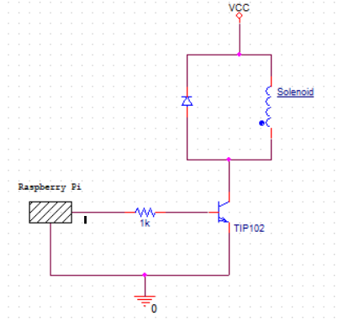

**Figure 4.2 Solenoid Circuit Diagram**

**4.3. Test Certification – Accuracy**

Having precision and accuracy is essential to the success of this device. If the readings are inaccurate or inconsistent, it renders the product unusable. To test the accuracy of the device, and thereby determine the usefulness of the product, the design team borrowed multiple kegs from the Mayhew Junction Brewing Company. The borrowed kegs were all one-sixth barrel kegs and were filled to various known levels. One keg was empty, one filled one-fourth of the way full, another two-fourths of the way full, one three-fourths, and one keg filled completely. This allows for testing against known values.

In addition to testing the kegs filled to various levels, a test was performed to determine if variations in keg manufacturer affect the reading of the device. A one-sixth barrel keg from a different vendor was tested which was one-half of the way full to determine if the slight variance in kegs from different manufacturers affects the performance of the device. This alternate keg was filled to one-half of its capacity not only to retest the device’s accuracy but also to compare with the results from the one-half keg from Mayhew Junction. Table 4.2.1 shows the results of the tests.

**Table 4.3.1 - Accuracy Tests\***

|  |  |
| --- | --- |
| **Actual Value** | **Success Rate** |
| 0% | 90% |
| 25%  (4.875 L) | 100% |
| 50%  (9.75 L) | 100% |
| 75%  (4.625 L) | 100% |
| 100%  (19.5 L) | 100% |

*Due to being unable to empty and refill the kegs, only five discrete liquid levels were able to be modeled. These tests reflect the identification success rate over ten trials for each individual keg available.

The component most critical to getting a consistent and accurate measurement from the device is the vibration sensor. Before testing the accuracy of the estimated liquid level, the vibration sensor was tested to determine the reading strength and consistency of the sensor when attached to the side of the keg. Because the Raspberry Pi Zero W does not have any analog GPIO pins built-in, an analog to digital converter was needed to read from the sensor. The ADS1015 was selected due to the high sampling rate needed to capture the vibration frequencies of the containers. Figure 4.2a shows the raw signal output of a vibration sensor when the container is struck by the solenoid. The figure shows clear waves, which indicates the presence of dominant frequencies.

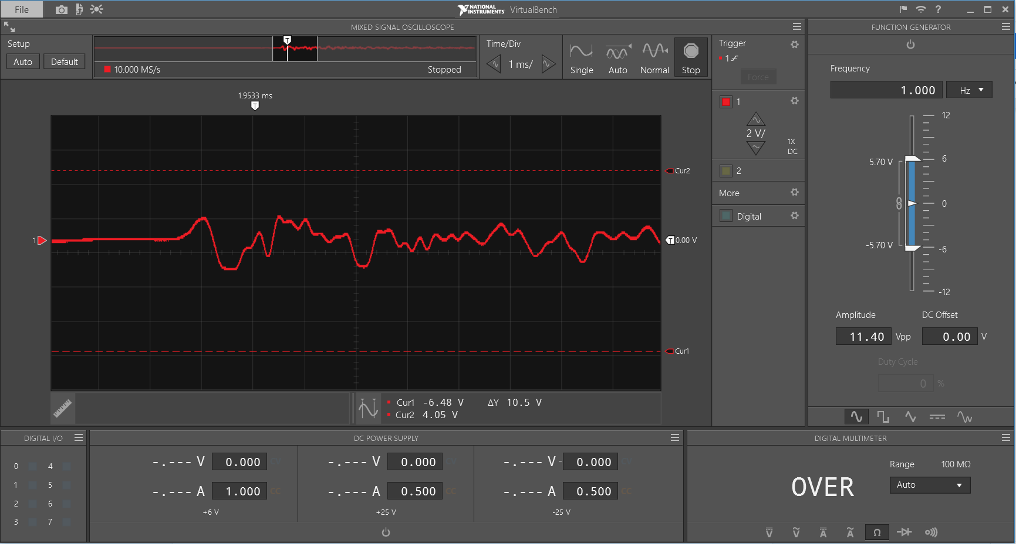

**Figure 4.3a - VirtualBench Output of Vibration Sensor**

Figure 4.2b shows two images of plotted Fourier transforms. The image clearly shows a difference in the frequency peaks generated on the half-filled keg and the full keg. The top three peaks are all below 250 Hz on the full container, and all around or above 300 Hz on the half-full container. This clearly shows the uniqueness of the vibrations at these liquid levels, which allows for consistent and accurate identification of the volume in the container. Capturing the resonant frequency is the key function of the product, and this test demonstrates the effectiveness of the vibration sensors to capture the frequency at various fill levels.

|  |  |
| --- | --- |
| **(a)** | **(b)**  Magnitude  Magnitude  Hz  Hz |

**Figure 4.3b - Fourier Transforms for (a) Half-filled Container and (b) Full Container**

**4.4. Test Certification – Wireless Transmission Distance**

Testing the wireless distance constraint requires being off-campus with a personal wireless router. With the Raspberry Pi connected to the wireless network, it is taken various distances away from the router. The distance is measured with a tape measure capable of extending 12 meters. Ensuring that the device is still connected to the network demonstrates adherence to the given constraint.

**Table 4.4.1 - Transmission tests**

|  |  |  |
| --- | --- | --- |
| **Distance (meter)** | **Signal Strength (dBm)** | **Link Quality** |
| 3 meters | -51 | 59/70 |
| 6 meters | -53 | 57/70 |
| 9 meters | -63 | 47/70 |
| 12 meters | -75 | 35/70 |

The units of signal strength are given in Decibel-milliwatts(dBm). This means that lower values denote stronger signals. A recommended signal strength level for applications that require very reliable and timely packet delivery is -60 dBm, while -65 dBm is sufficient for less time-sensitive but reliable packet transmission [37]. While there is a significant drop in the signal strength from nine to twelve meters, the signal at nine meters is more than enough for the simple transmissions associated with the communication from the device to the server. These tests show the adherence of the device to the given constraint.

## **4.5. Test Certification – Battery Life**

To test the battery life constraint, the device will operate for 16 continuous hours. During this duration, it must activate the solenoid every hour then process and send the data to the server to be received by the mobile application. The solenoid activation and performance is also measured intermittently to ensure the draining battery does not impact performance over the device’s 16-hour lifespan. Using the equations below, the required mAh is found to be 202.5 mAh. The battery outputs 500 mAh that is suitable to operate within the given condition.

**Table 4.5.1 - Battery Test for Sleep Mode**

|  |  |
| --- | --- |
| Time (hr) | Percentage Left (%) |
| Hour 0 | 100% |
| 8 hours | N/A |
| Hour 14 | 69% |
| 16 hours | N/A |
| 20 hours | N/A |

**Table 4.5.2 - Battery Test for Solenoid Strike**

|  |  |  |
| --- | --- | --- |
| Time (hr) | Voltage (V) | Percentage Left (%) |
| Hour 0 | 4.2 | 100% |
| 8 hours | N/A | N/A |
| Hour 14 | 3.9 | 92% |
| Hour 16 | N/A | N/A |
| Hour 24 | N/A | N/A |

**Table 4.5.3 - Battery Test for Communication**

|  |  |
| --- | --- |
| Time (hr) | Percentage Left (%) |
| Hour 0 | 100% |
| 8 hours | N/A |
| Hour 14 | 69% |
| 16 hours | N/A |
| 20 hours | N/A |

**Table 4.5.4 - Battery Test for Processing Results**

|  |  |
| --- | --- |
| Time (hr) | Percentage Left (%) |
| Hour 0 | 100% |
| 8 hours | N/A |
| Hour 14 | 69% |
| 16 hours | N/A |
| 20 hours | N/A |

*Though the battery life was unable to be recorded at some of the intervals, data was recorded in order to conclude that the device operated efficiently throughout 20 hours, 4 hours past our operation constraint.

**4.6. Test Certification – Noisy Environment**

In order to ensure the device operates properly in a typical environment, it had been tested under conditions up to 80 dB. This value was used because a bar or restaurant normally has approximately 85 dB of noise present, and since the device is in a refrigerated casing, it will normally be in a lower noise environment [36]. The device was placed near a speaker and the speaker was turned up to a sufficient volume until the proper noise level was reached. The device was tested in the presence of both white noise and a sine wave at 200 Hz, which is near the resonance frequency of the container. To ensure that the sound was at an appropriate volume, an app called Decibel X, made by SkyPaw Co, Ltd, was used. Once the sound pressure level was adequate, a test was performed to verify the device still measured accurately under these conditions.

**Table 4.6.1 - Interference tests**

|  |  |  |  |
| --- | --- | --- | --- |
| **Volume in dB** | **Expected Result** | **Actual Result** | **% Error** |
| 40 dB | 0% | 0% | 0% |
| 60 dB | 0% | 0% | 0% |
| 80 dB | 0% | 0% | 0% |
| 80 dB | 100% | 100% | 0% |

The interference tests demonstrate that the device is largely unaffected by the presence of both white noise and frequencies similar to the resonance frequency of the containers.

**4.7 Test Certification – System Test**

Once each subsystem is in place, a full system test is performed. First, the device is turned on via a switch and set up using the smartphone application. Once this is completed, the device begins to initiate the first test. The Raspberry Pi sends a signal to the relay driver, which diverts power from the battery to the solenoid. This causes the solenoid to fire, striking the side of the container with approximately 31 N of force. As the container resonates, the piezoelectric sensor converts mechanical stress to an electric potential. This current is sent to the analog-to-digital converter for processing.

Using a sample clock, the A/D converter samples the signal at a rate of 3300 samples per second and converts each sample to a digital value. This is sent to the Raspberry Pi over an I2C serial bus. Next, the signal is processed using a Fourier transform, which converts the signal from the time domain to the frequency domain. Based on the frequency response, the liquid level is determined and uploaded to an HTTP server. Finally, the smartphone application retrieves the percentage level and displays it to the user.

All of the components function together perfectly, consistently, and accurately to determine and display the liquid level in a metal container for the user via the mobile application. The next section summarizes the product and outlines plans for future development.

# **5. SUMMARY AND FUTURE WORK**

ALLDET is an attachable device that can measure the vibration of a metal container to determining the amount of liquid within. It starts by having a solenoid strike a keg, causing it to vibrate. The piezoelectric sensors pick up the vibration and communicate with the Raspberry Pi Zero W to transmit the detected liquid level to the application. This design enables this product to save time and eliminates the need for physically lifting the keg for restaurant and bar employees. For future improvements, ALLDET will have more reliable inventory tracking abilities and can be tailored to track any fluid in a metal container including oil in transformers, chemicals in metal containers, and propane levels in propane tanks. ALLDET will be completely customizable depending on the type of liquid inside, the material the container is made out of, the different sizes, and the type of environment that the container must be in. Also, the future will bring the accuracy to ±1% of what is actually inside the container. This development will help industries that are in more critical situations where more precision and accuracy are necessary.

**6. ACKNOWLEDGEMENTS**

We would like to thank all faculty and staff of the Department of Electrical and Computer Engineering at Mississippi State University for their assistance throughout the senior design experience. A special thanks to Dr. Jean Mohammadi-Aragh, Ph.D. for her guidance in engineering and design of the product along with her partnership with Mayhew Junction Brewery that provided the supplies that assisted the team in completing the product. Also, thank you Dr. Bryan Jones, Ph.D. for assisting the team in all phases of the product design and also Instructor Alexis Nordin for aiding the team with writing technical documentation. Thank you for pushing us to be better in all aspects of engineering and problem solving.

# 

# **7. REFERENCES**

[1] “Evolution of the Beer Keg.” kegerators.com.<https://www.kegerators.com/blog/2009/03/04/evolution-of-the-beer-keg/> (accessed Sept. 3, 2019).

[2] “The Evolution of Beer Packaging.” beveragejournalinc.com. <https://www.beveragejournalinc.com/new/easyblog/entry/the-evolution-of-beer-packaging> (accessed Sept. 3, 2019).

[3] “Brief History of Weights and Measures.” cdfa.ca.gov. <https://www.cdfa.ca.gov/dms/trainingmodules/Module_07.pdf> (accessed Sept. 3, 2019).

[4] “Load Cell & Force Sensor: What Is It?” omega.com. <https://www.omega.com/en-us/resources/load-cells> (accessed Sept. 3, 2019).

[5] “Keg Scale.” alcoholcontrols.com. [https://alcoholcontrols.com/noname.html](https://alcoholcontrols.com/noname.html?gclid=EAIaIQobChMIh7zhrL215AIVFY_ICh2LvA2lEAAYASAAEgLGR_D_BwE) (accessed Sept. 3, 2019).

[6] “Draft Beer Monitoring System, Draft Beer Flow Meter, Beer Tap Control.” usbeersaver.com. <http://www.usbeersaver.com/> (accessed Sept. 3, 2019).

[7] “Industry Fast Facts | NBWA: America’s Beer Distributors.” nbwa.org. <https://www.nbwa.org/resources/industry-fast-facts> (accessed Sept. 10, 2019).

[8] “How Temperature Affects Draft Beer Dispensing.” kegworks.com. <https://www.kegworks.com/blog/temperature-draft-beer-system-dispensing/> (accessed Sept. 15, 2019).

[9] “IEEE 802.11n Standard.”electronic-notes.com. <https://www.electronics-notes.com/articles/connectivity/wifi-ieee-802-11/802-11n.php>(accessed Oct. 15, 2019).

[10] “IP Rating Chart | DSMT.com.” dsmt.com. <http://www.dsmt.com/resources/ip-rating-chart/> (accessed 17 Sep. 2019).

[11] “Restaurant Manager Salary in the United States.” salary.com. <https://www.salary.com/research/salary/benchmark/restaurant-manager-salary> (accessed Sept. 17, 2019).

[12] “Sound Effects Decibel Level Chart.” creativefieldrecording.com. <https://www.creativefieldrecording.com/2017/11/01/sound-effects-decibel-level-chart/> (accessed Sept. 17, 2019).

[13] “True TDD-1 Direct Draw Beer Dispenser - Single Keg.” kegerator.com. <https://www.kegerator.com/true-tdd-1-direct-draw-beer-dispenser/TDD-1.html> (accessed Sept. 26, 2019).

[14] “Beer Keg Sizes - Detailed Guide.” thebeveragechiller.com. <http://thebeveragechiller.com/beer-keg-sizes/> (accessed Sept. 26, 2019).

1. “A Brief Introduction to Piezoelectric Sensor Switch and its Working Procedure.” edgefx.in.<https://www.edgefx.in/piezoelectric-sensor-switch-working/> (accessed Oct. 1, 2019).
2. “HiLetgo 5pcs Piezoelectric Sensor Analog Ceramic Vibration Sensor Module Piezoelectricity for Arduino DIY KIT: Amazon.com Industrial & Scientific.” amazon.com. [https://www.amazon.com/HiLetgo-Piezoelectric-Ceramic-Vibration-Piezoelectricity/dp/B07Q9J5C4G/ref=sr_1_2?keywords=piezoelectric+sensor&qid=1569957549&sr=8-2](https://www.amazon.com/HiLetgo-Piezoelectric-Ceramic-Vibration-Piezoelectricity/dp/B07Q9J5C4G/ref=sr_1_2?keywords=piezoelectric+sensor&qid=1569957549&sr=8-2.) (accessed Oct. 1, 2019).
3. “Amazon.com: WINGONEER 5pcs SW-420 NC Type Vibration Sensor Module Vibration Switch for Arduino Smart Car.” amazon.com. <https://www.amazon.com/WINGONEER-SW-420-Vibration-Sensor-Arduino/dp/B06XHFFPL6/ref=sr_1_10?keywords=vibration+sensor&qid=1569956060&sr=8-10> (accessed Oct.1, 2019).
4. “Piezo Vibration Sensor Hookup Guide - learn.sparkfun.com.” learn.sparkfun.com. <https://learn.sparkfun.com/tutorials/piezo-vibration-sensor-hookup-guide/all> (accessed Oct. 29, 2019).
5. “Amazon.com: uxcell DC 12V 31N 10mm Push Pull Type Solenoid Electromagnet, Open Frame Type, Linear Motion.” amazon.com. <https://www.amazon.com/uxcell-Solenoid-Electromagnet-Linear-Motion/dp/B07VG3M5WV/ref=sxbs_sxwds-stvp?keywords=solenoid&pd_rd_i=B07VG3M5WV&pd_rd_r=38591ee0-9478-475e-9755-307f30997c85&pd_rd_w=lIOQO&pd_rd_wg=7cDHy&pf_rd_p=a6d018ad-f20b-46c9-8920-433972c7d9b7&pf_rd_r=77HC621MMNX27G2T23AH&qid=1569966667&th=1> (accessed Oct. 1, 2019).
6. “Adafruit.com: Continuous Rotation Micro Servo - FS90R.” Adafruit.com. <https://www.adafruit.com/product/2442> (accessed Oct. 1, 2019).
7. “Adafruit.com: Small Reduction Stepper Motor - 5VDC 32-Step 1/16 Gearing.” Adafruit.com. <https://www.adafruit.com/product/858> (accessed Oct. 1, 2019).
8. “Power Consumption Benchmarks | Raspberry Pi Dramble.” pidramble.com. <http://www.pidramble.com/wiki/benchmarks/power-consumption> (accessed Oct. 1, 2019).
9. “LP705176JS + PCM + WIRES 70MM Jauch Quartz | Battery Products | DigiKey.” Digikey.com. <https://www.digikey.com/product-detail/en/jauch-quartz/LP705176JS-PCM-WIRES-70MM/1908-1375-ND/9560997> (accessed Oct. 1, 2019).
10. “1578 Adafruit Industries LLC | Battery Products | DigiKey.” Digikey.com. <https://www.digikey.com/product-detail/en/adafruit-industries-llc/1578/1528-1841-ND/5054539>(accessed Oct. 1, 2019).
11. “354 Adafruit Industries LLC | Battery Products | DigiKey.” Digikey.com. <https://www.digikey.com/products/en/battery-products/batteries-rechargeable-secondary/91?k=rechargeable+battery&k=&pkeyword=rechargeable+battery&sv=0&pv33=553&sf=0&FV=ffe0005b%2C670004a&quantity=&ColumnSort=0&page=1&pageSize=25> (accessed Oct. 1, 2019).
12. “Know all about Analog to Digital ADC Converters.” elprocus.com. <https://www.elprocus.com/analog-to-digital-adc-converter/> (accessed Oct. 30, 2019).
13. “MCP3008 - 8-Channel 10-Bit ADC With SPI Interface ID: 856 - $3.75 : Adafruit Industries, Unique &amp; fun DIY electronics and kits.” adafruit.com. <https://www.adafruit.com/product/856> (accessed Oct. 30, 2019).
14. “ADS1015 12-Bit ADC - 4 Channel with Programmable Gain Amplifier ID: 1083 - $9.95 : Adafruit Industries, Unique & amp; fun DIY electronics and kits.” adafruit.com. <https://www.adafruit.com/product/1083> (accessed Oct. 30, 2019).
15. “ADS1115 16-Bit ADC - 4 Channel with Programmable Gain Amplifier ID: 1085 - $14.95: Adafruit Industries, Unique & amp; fun DIY electronics and kits.” adafruit.com. <https://www.adafruit.com/product/1085> (accessed Oct. 30, 2019).
16. “Arduino Uno Rev3.” store.arduino.cc. <https://store.arduino.cc/usa/arduino-uno-rev3> (accessed Oct. 31, 2019).
17. “Uxcell a13120200ux0916 Push Pull Open Frame Solenoid Electromagnet, 10 mm Stroke, 600 g, DC 12V 1A.” Amazon.com. <https://www.amazon.com/Uxcell-a13120200ux0916-Solenoid-Electromagnet-Stroke/dp/B00HR8H38A/ref=sr_1_2?keywords=12V+uxcell+solenoid&qid=1572546108&s=industrial&sr=1-2> (accessed Oct. 31, 2019).
18. “Uxcell a14052800ux0914 Push Pull Type Open Frame Solenoid Electromagnet, 5V, 1 mm, 100 g, 2 mm, 50 g Force.” Amazon.com. <https://www.amazon.com/Uxcell-a14052800ux0914-Frame-Solenoid-Electromagnet/dp/B00NWFVNPQ/ref=sr_1_7?keywords=5V+push+pull+solenoid&qid=1572560465&s=industrial&sr=1-7> (accessed Oct. 31, 2019).
19. “70165d.book.” microchip.com. <http://ww1.microchip.com/downloads/en/DeviceDoc/70165d.pdf> (accessed Oct. 31, 2019).
20. “Buy a Raspberry Pi Zero W - Raspberry Pi.” raspberrypi.org. <https://www.raspberrypi.org/products/raspberry-pi-zero-w/> (accessed Oct. 31, 2019).
21. Farid, M., Levy, N., Gendelman, “Vibration mitigation in partially liquid-filled vessel using passive energy absorbers,” *Journal of Sound and Vibration* vol. 406, pp. 21–22, Oct. 2017.
22. “Sound Effects Decibel Level Chart.” creativefieldrecording.com. <https://www.creativefieldrecording.com/2017/11/01/sound-effects-decibel-level-chart/> (accessed Nov. 10, 2019).
23. “Why is almost everything negative in Wireless?” community.cisco.com/ <https://community.cisco.com/t5/small-business-support-documents/why-is-almost-everything-negative-in-wireless/ta-p/3159743> (accessed Nov. 20, 2019).