Soil Texture

# Soil Sample

Navigate to the [Soil Texture Calculator](https://agricomputing.com/soil-texture-calculator/) using the provided link, which can be found on canvas.

1.1 Soil Texture Calculator

Using a sample Provided, input the clay and sand percentage found on the label placed inside the bag, into the [Soil Texture Calculator](https://agricomputing.com/soil-texture-calculator/) and click the blue “CALCULATE” button.

1.2 Example of Sample Label

Silty Clay Loam

Sand – Silt – Clay

10 59 31

1.3 Input Labeled Percentages

After the calculator processes the information, the output will be shown below the “CALCULATE” button, displaying the Soil Text Class, Bulk Density, Field Capacity, Wilting Point, Porosity, and Hydraulic Conductivity.

1.4 Soil Texture Calculator Output

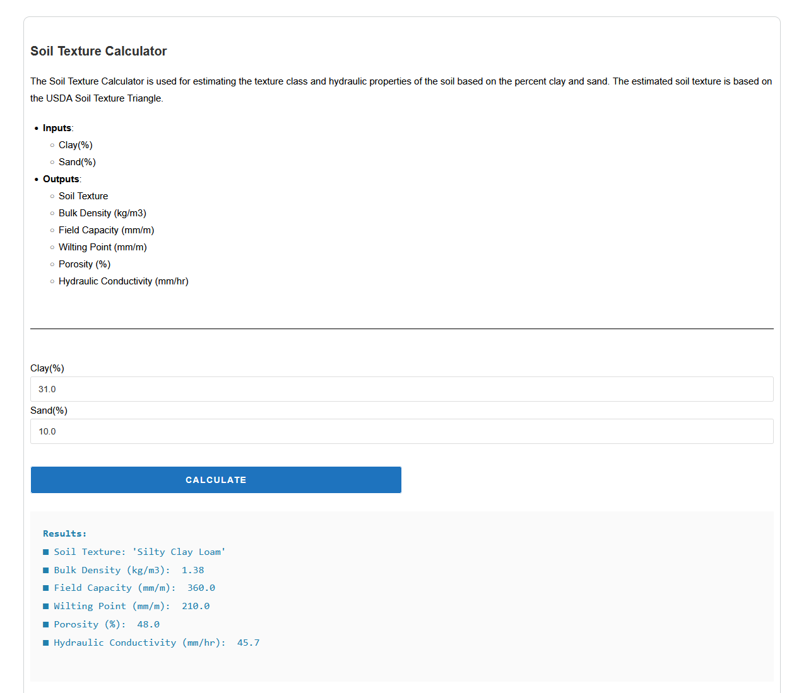

# SSURGO Data

Using the SoilWeb kml file from Activity 1 in google earth pro, or using the online [SoilWeb Map](https://casoilresource.lawr.ucdavis.edu/gmap/) find a few different soil profiles you might interact with, either different areas on campus, where you grew up or just an area of the United State you are curious about.

2.1 Cecil Series Selected in SoilWeb

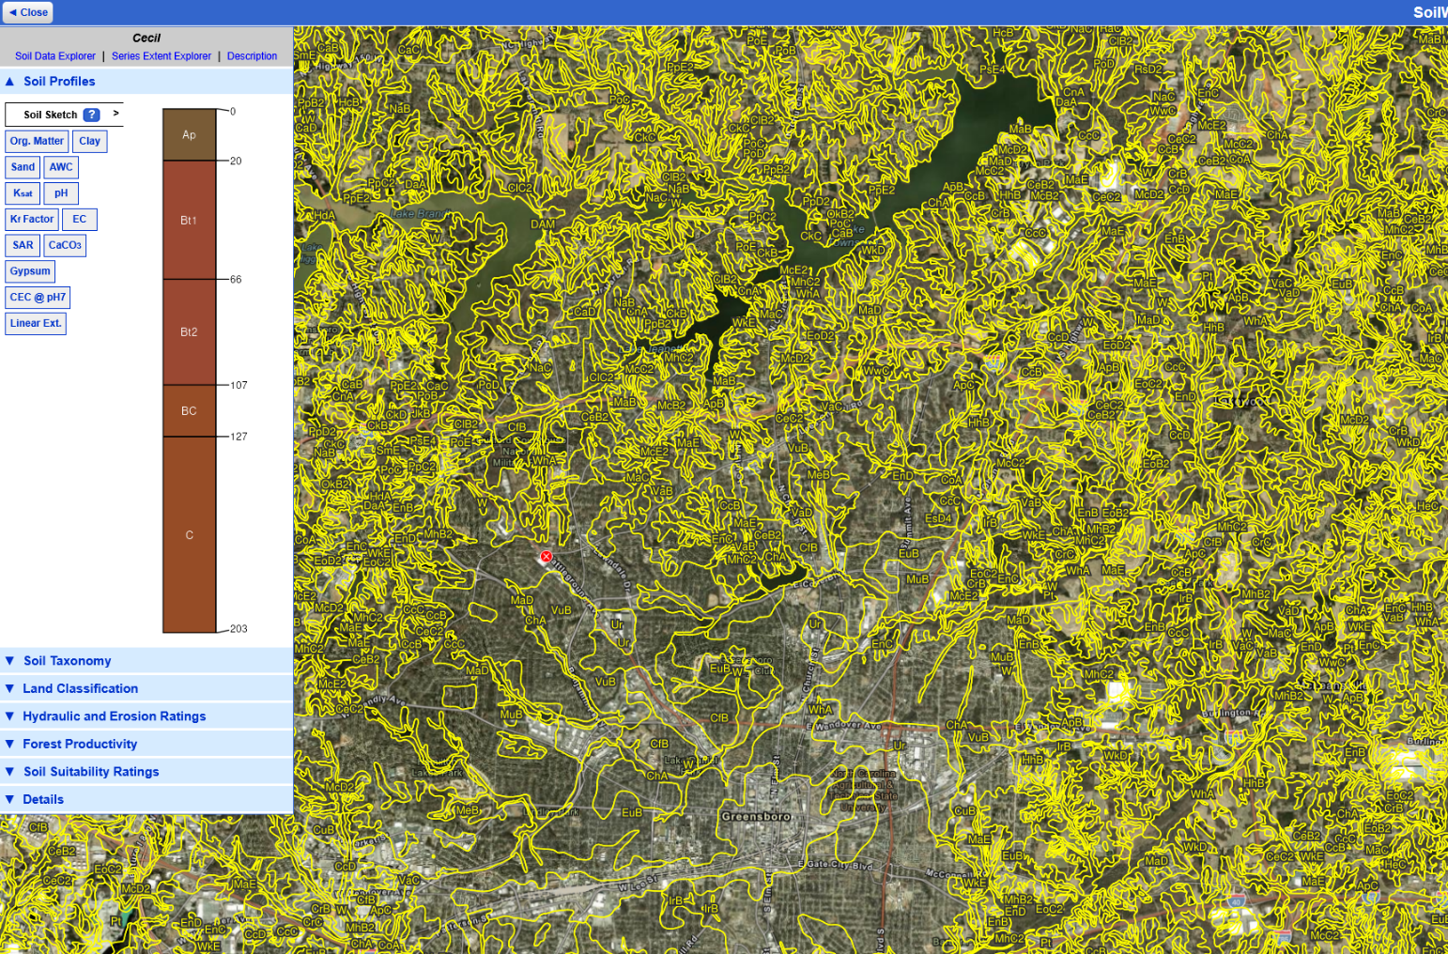

Look at the different textures present in the description tab of the selected profile take note of the variation of color as change location.

2.2 Cecil Series Description

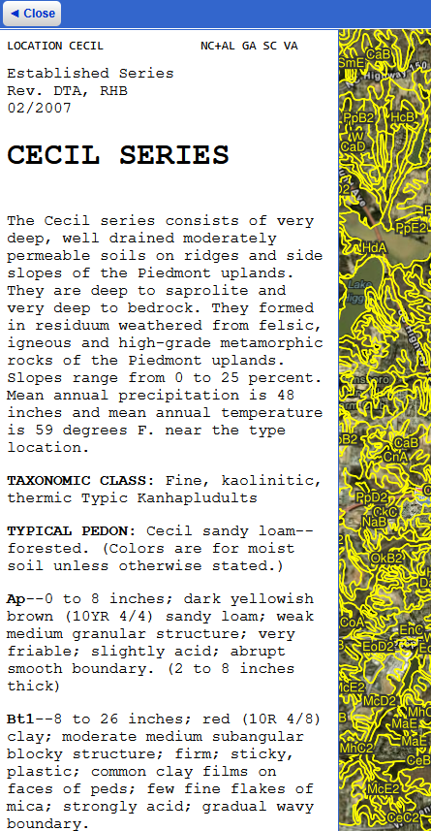

Input a few of the textures present in your series into the Soil Texture Calculator to see the variation not only as you move across the surface but also as you move deeper into the soil using {reference table} for numbers to input for each texture class.

Table 2.1 Median Soil Texture Values

|  |  |  |
| --- | --- | --- |
| **Texture Class** | **Clay (%)** | **Sand (%)** |
| Clay | 60 | 25 |
| Sandy Clay | 45 | 50 |
| Silty Clay | 50 | 5 |
| Clay Loam | 35 | 35 |
| Sandy Clay Loam | 30 | 60 |
| Silty Clay Loam | 35 | 10 |
| Loam | 20 | 40 |
| Sandy Loam | 10 | 65 |
| Silt Loam | 15 | 20 |
| Loamy Sand | 5 | 85 |
| Sand | 5 | 90 |
| Silt | 5 | 10 |

2.3 Cecil Series Ap Horizon Output

2.4 Cecil Series Bt1 Horizon Output

