**Name of the project: PowerUp, Inc.**

**Definitions:**

**Offering** – Offering represents classes or camp or any activity that can be list with various different classifications including schedule

**Provider** – Provider is the person or organization that offers one or more classes as offering. Provider can also offer seasonal classes or camps

**Registration** – This is a process where provider registers with services provided by PowerUp, Inc. There could be contract and pricing agreement in future.

**Enrollment** – This is a process when Provider and Parents of student enroll into offering. This is different from registration.

**Actor:**

**Super Admin**: Super Admin is the person from PowerUp, Inc who would have access and privilege to update all record including password reset.

**Provider Admin**: This is admin user from Provider (in case of person, it’s the same individual) who can register classes in addition to view schedule, payment, customer information, email.

**Provider User**: This is admin user from Provider (if Provider is Organization) who view schedule, payment, and customer information, email. This person is not entitled to create class or renew contract with PowerUp, Inc.

High Level Flow (Provider)

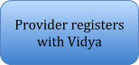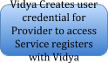

High Level Flow (End user)

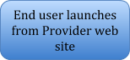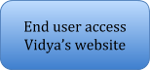

STEP 1: Registration (Manual)

Providers contact Vidya or Viday sales agent contacts Provider and gets into an agreement to use services provided by Vidya, Inc. The first step is to register the provider and activate their account with Vidys so that they can create offerings. This is manual process in first few phases. With all the information supplied by the provider, Admin from Vidya creates the account and user profile so that Provider can login and create offerings.

There will be sql to create this. The SQL will update Provider table with Provider info and create a record in Contacts table with user information.

STEP 2: Create offering

At this stage, Provider can login and create offerings. To create offering following attributes will be required.

**Offering**

|  |  |  |
| --- | --- | --- |
| **Column name** | **Type/Length** | **Description** |
| Offering ID | VARCAHR (30) | This is system generated ID |
| Provider ID | VARCAHR (30) | System linking based on user logged in or provided in context |
| Provider Name | VARCAHR (200) | System linking based on user logged in or provided in context |
| Offering Name * | VARCAHR (30) | Provider supplies the name of the classes / camps. This is a mandatory field |
| Offering Description | VARCAHR (1000) | Description lets provider supply more details about the offering. Some key words may be used for SEO. |
| Category | VARCHAR (30) | Categories are MUSIC, DANCE, ART, MATH, LANGUGAGE, SPORTS, GYM, what else ? |
| Image 1 | LONGBLOB | Images to illustrate class setting |
| Image 2 | LONGBLOB | Images to illustrate class setting |
| Image 3 | LONGBLOB | Images to illustrate class setting |
| Video URL | VARCAHR (100) | Youtube URL |
| Start date * | DATE | Date when the class starts, mandatory |
| End date | DATE | Date when the class endats |
| Duration | NUMBER | Time in minutes |
| Duration Unit | CHAR (10) | MIN, HR, DAY |
| Frequency | CHAR (10) | Weekly, Monthly, Daily |
| Schedule | VARCHAR (1000) | Denormalized character string to display offering schedule |
| No Of Seats | NUMBER | Total number of seats |
| Available Seats | NUMBER | Denormalized, Available number of seats. As the classes get enrolled, this will be updated. |
| Price | DECIMAL (10,2) | Price of the class |
| Credit Card Accepted | BOOLEAN | Y/N. Based on this options will be displayed to end user |
| Enable Review | BOOLEAN | Y/N, Based on this reviews will be allowed |

STEP 3: Edit offering

The provider should be able to open Offering Details and edit. The same screen can be used by end user by clicking Offering Details from Offering Summary page. This page will be displayed in read-only mode if this is accessed by end user.

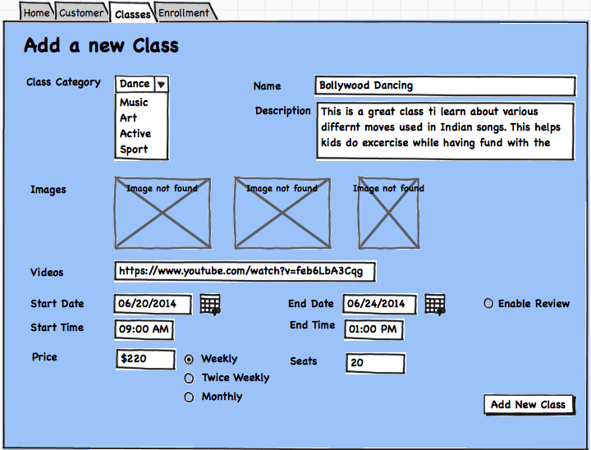

STEP 4: Search/View offering

When provider logs in, provider should be able to review summary of all offerings. The key goal for this is to review price and open slots for specific offerings. Couple of action can be taken from this screen:

1. The user can filter on start date time and end date as well as Open seats.
2. From this screen, user can drill into detail of offering and edit the offering details
3. The user can launch “Create Offering” from this screen as well.

This is a common screen that can be used by end user (student or parents for enrollment). The end user behavior would be following:

1. When end user launches this screen from provider’s web site, the provider info will be set in the context to allow them to view on classes offered by specific provider. The user can search, view open classes. Add new Classes option will NOT be displayed. The user can click the Class details, which will show class details in read-only mode.
2. When end user is directly accessing Vidya’s site, the user will be able to review offering the same way except that the Provider name and logo will be displayed in display. This is NOT in scope in Phase 1.

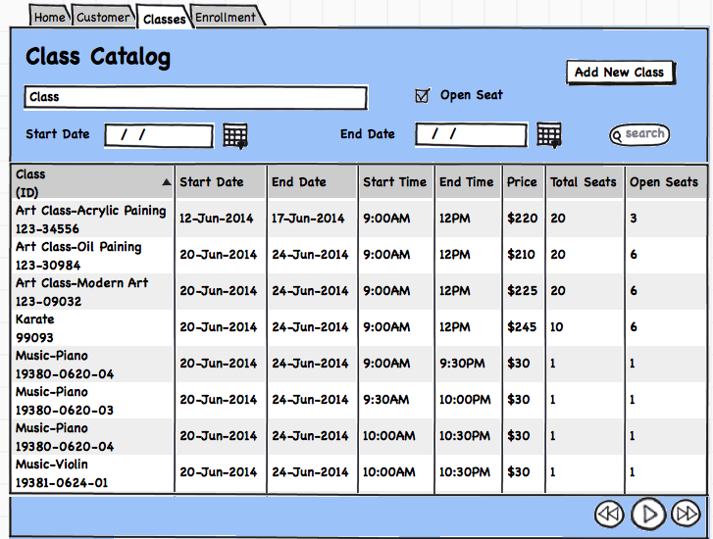

STEP 5: Enrollment

Provider and end use both can use the screen to enroll student. The user can navigate from Offering details screen and offering id will be in the context. The screen primarily lets the use Offering and add student information.

Enrolment represents Offering, Schedule, Student info, Parent info.

Once the enrollment is complete, contact table will be populated with student and parent info.

**Contact**

|  |  |  |
| --- | --- | --- |
| **Column name** | **Type/Length** | **Description** |
| Contact ID | VARCAHR (30) | This is system generated ID |
| First Name * | VARCAHR (30) | System linking based on user logged in or provided in context |
| Last Name * | VARCAHR (200) | System linking based on user logged in or provided in context |
| Role * | VARCAHR (30) | This would be Provider, Admin, Student, Parent |
| Parent Contact ID | VARCAHR (30) | Parent Contact ID in case the record is for Student |
| Home Phone | VARCHAR (10) | Home Phone |
| Work Phone | VARCHAR (10) | Work Phone |
| Cell Phone | VARCHAR (10) | Cell Phone |
| Email Address | VARCAHR (30) |  |
| Address 1 | VARCAHR (30) | Address 1 |
| Address 2 | VARCAHR (30) | Address 2 |
| City | VARCAHR (30) | City |
| State | VARCAHR (30) | State |
| Postal Code | VARCAHR (30) | Postal Code |
| User name | VARCAHR (30) | User name |
| Password | VARCAHR (30) | Password |
| Last Accessed | Datetime | Last accessed |

**Enrollment**

|  |  |  |
| --- | --- | --- |
| **Column name** | **Type/Length** | **Description** |
| Enrollment ID | VARCAHR (30) | This is system generated ID |
| Provider ID | VARCAHR (30) | Provider ID |
| Provider Name | VARCAHR (200) | Provider Name |
| Offering ID | VARCAHR (30) | Offering ID |
| Offering Name | VARCAHR (20) | Offering Name |
| Student Contact ID | VARCAHR (30) |  |
| Student Contact Name | VARCAHR (200) | First name, Last name |
| Parent Contact ID | VARCAHR (30) |  |
| Parent Contact Name | VARCAHR (200) | First name, Last name |
| Start Date | VARCAHR (30) | Start date when the student start the class |
| Offering day | VARCAHR (30) | Offering day, like Sunday, Monday etc. |
| Offering start time | VARCAHR (30) | Offering start time (like 3PM) |
| Offering end time | VARCAHR (30) | Offering end time (like 3.30PM) |
| Payment mode | VARCAHR (30) | Payment mode |