Supporting Information Figure S1
A
B
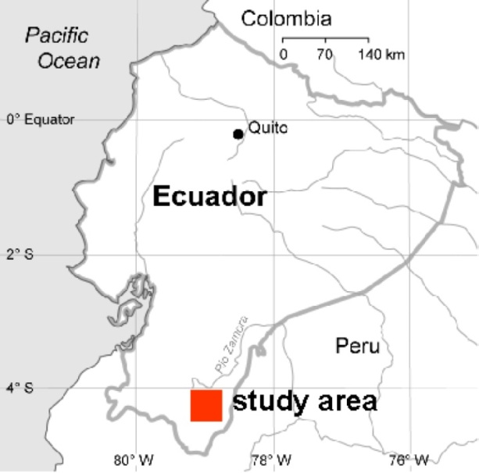
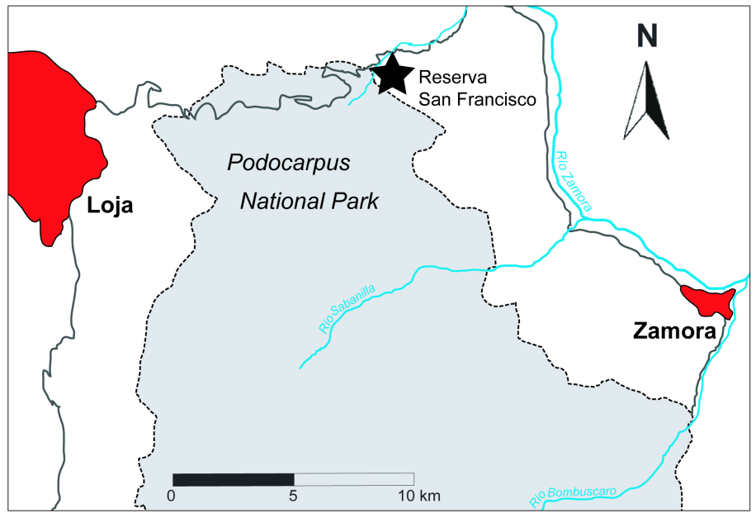

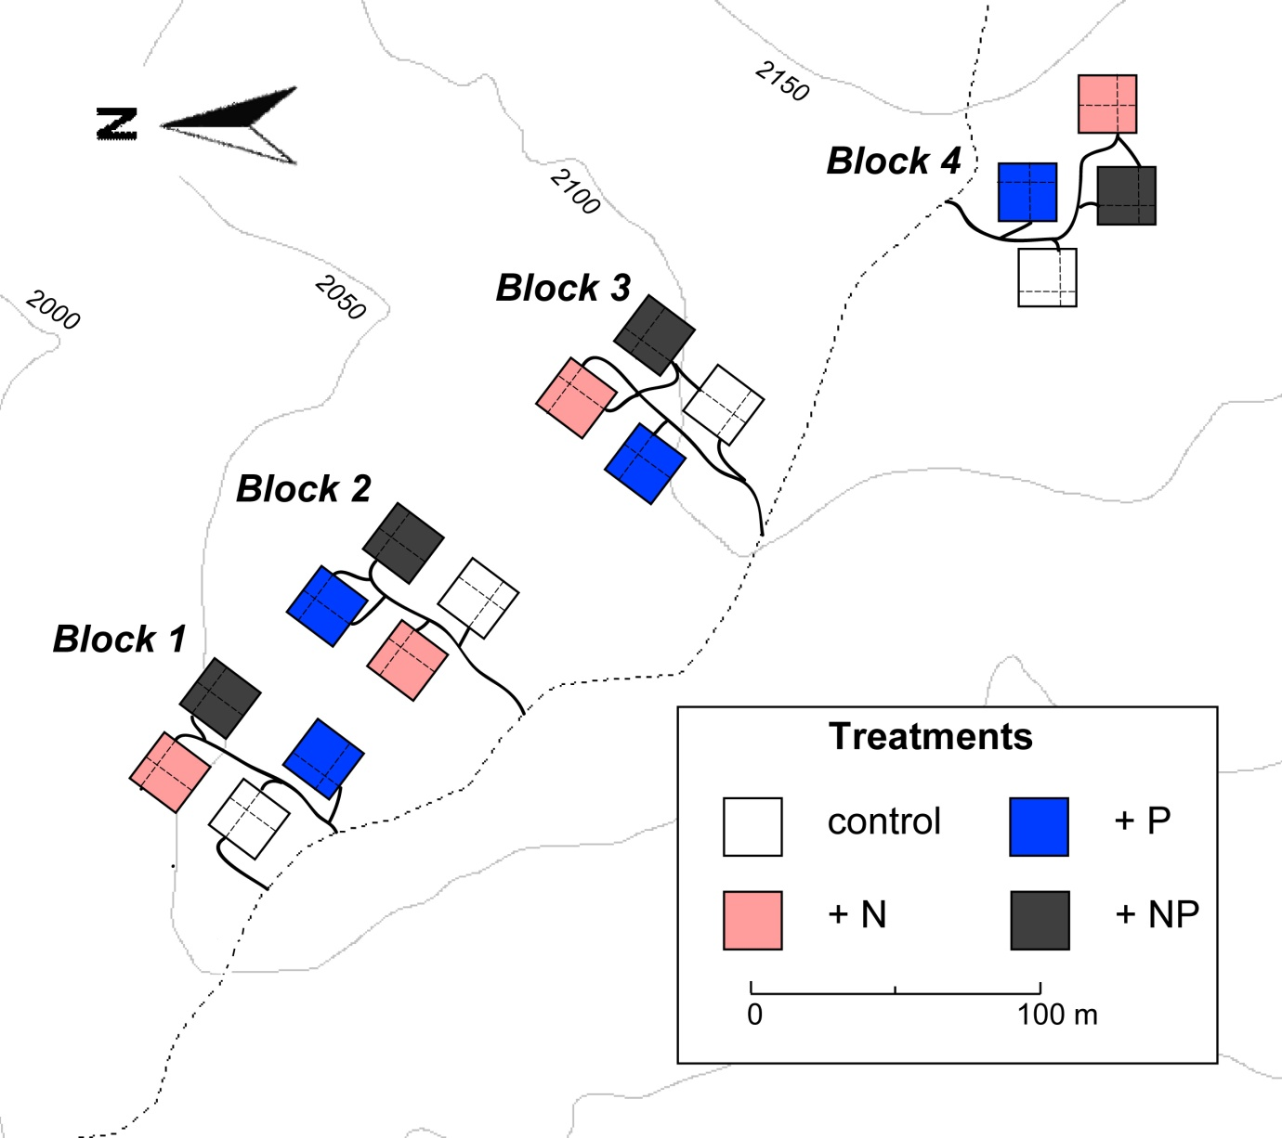
C

Figure S1. Location of the study area in southern Ecuador and outline of the Ecuadorian Nutrient Manipulation EXperiment (NUMEX). A. and B. Location of the study area in southern Ecuador. C. Outline of the Ecuadorian Nutrient Manipulation EXperiment (NUMEX). The study was conducted in 16 plots à 400 m² (20m x 20m) consisting of four treatments (control, N, P, N+P); the replicates were randomly arranged in four blocks at ~ 2100 m a.s.l..

