 | Elevation | Specie | N | P | N x P | Num.Obs. | R2 Marg. | AIC
iWUE | 1000 | Pouteria torta | 14.546* | 3.507 | -20.319+ | 36 |  | 306.6
 |  | Clarisia racemosa | -14.390 | 9.654 | 1.726 | 12 |  | 94.5
 | 2000 | Alchornea lojaensis | -0.703 | -6.601 | 4.128 | 45 |  | 380.1
 |  | Myrcia sp nov | 6.687 | 5.608 | -5.984 | 50 |  | 394.1
 | 3000 | Hedyosmum purpurascens | 5.492 | -5.891 | 24.202 | 21 |  | 191.9
 |  | Weinmannia loxensis | -4.356 | -8.323 | -3.588 | 18 |  | 141.5
δ13C | 1000 | Pouteria torta | 0.282 | 0.285 | -0.750 | 36 | 0.038 | 108.9
 |  | Clarisia racemosa | -1.170 | 0.788 | 0.138 | 12 | 0.352 | 35.4
 | 2000 | Alchornea lojaensis | 0.006 | -0.581 | 0.332 | 45 | 0.039 | 154.2
 |  | Myrcia sp nov | 0.551 | 0.457 | -0.486 | 50 | 0.057 | 149.5
 | 3000 | Hedyosmum purpurascens | 0.453 | -0.483 | 1.986 | 21 | 0.188 | 84.3
 |  | Weinmannia loxensis | -0.346 | -0.613 | -0.253 | 18 | 0.154 | 53.3
Ci/Ca | 1000 | Pouteria torta | -0.055* | -0.013 | 0.077+ | 36 | 0.152 | -68.5
 |  | Clarisia racemosa | 0.055 | -0.037 | -0.007 | 12 | 0.353 | -13.7
 | 2000 | Alchornea lojaensis | 0.000 | 0.027 | -0.015 | 45 | 0.039 | -97.7
 |  | Myrcia sp nov | -0.025 | -0.022 | 0.023 | 50 | 0.057 | -133.3
 | 3000 | Hedyosmum purpurascens | -0.021 | 0.022 | -0.092 | 21 | 0.188 | -20.2
 |  | Weinmannia loxensis | 0.016 | 0.029 | 0.012 | 18 | 0.155 | -32.7
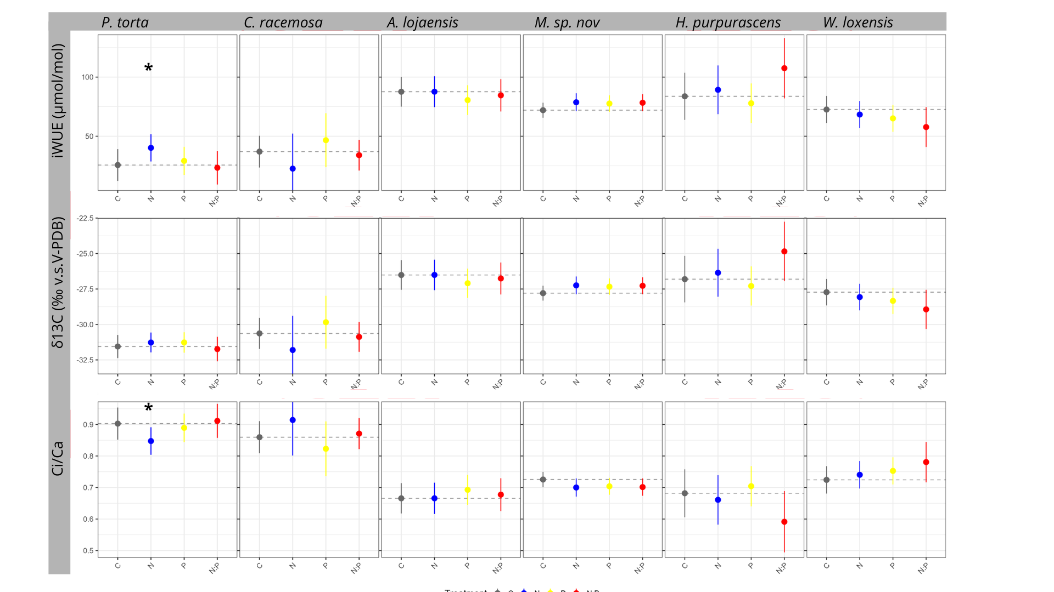

Table 1. Estimates of intrinsic water-use efficiency (iWUE), δ13C (‰ v.s.V-PDB), and Ci/Ca ratio to nitrogen (N) and phosphorus (P) addition. Results are based on linear mixed-effects models (LMMs) using a factorial N × P design. Significant effects are indicated by * (p < 0.05).

Table 2. Estimates of nutrients and leaf ratios to nitrogen (N) and phosphorus (P) addition. Results are based on linear mixed-effects models (LMMs) using a factorial N × P design. Significant effects are indicated by * (p < 0.05).
Modelo | Elevation | Specie | N | P | N × P | Num.  Obs. | R2 Marg. | AIC
logLNC | 1000 | Pouteria torta | 0.021 | 0.082* | -0.054 | 36 | 0.132 | -54.8
 |  | Clarisia racemosa | 0.150 | 0.120 | 0.043 | 12 | 0.520 | 4.9
 | 2000 | Alchornea lojaensis | 0.125* | -0.043 | -0.044 | 45 | 0.182 | -26.6
 |  | Myrcia sp nov | 0.132** | -0.071+ | 0.041 | 49 | 0.350 | -52.1
 | 3000 | Hedyosmum purpurascens | 0.201** | 0.088 | -0.126 | 21 | 0.243 | -5.4
 |  | Weinmannia loxensis | 0.092 | 0.026 | -0.042 | 18 | 0.067 | 3.2
Narea | 1000 | Pouteria torta | 0.127 | 0.250* | -0.222 | 36 | 0.123 | 22.3
 |  | Clarisia racemosa | -0.102 | 0.159 | 0.238 | 12 | 0.342 | 12.3
 | 2000 | Alchornea lojaensis | 0.320 | -0.133 | 0.057 | 45 | 0.106 | 87.9
 |  | Myrcia sp nov | 0.401*** | -0.034 | -0.094 | 49 | 0.324 | 25.5
 | 3000 | Hedyosmum purpurascens | 0.702** | -0.022 | -0.232 | 21 | 0.433 | 33.2
 |  | Weinmannia loxensis | 0.182 | -0.000 | -0.113 | 18 | 0.114 | 16.1
logLPC | 1000 | Pouteria torta | -0.038 | 0.178+ | -0.019 | 36 | 0.153 | 7.5
 |  | Clarisia racemosa | 0.194 | 0.386** | -0.210 | 12 | 0.684 | 4.1
 | 2000 | Alchornea lojaensis | -0.019 | 0.428*** | 0.080 | 44 | 0.491 | 14.9
 |  | Myrcia sp nov | 0.027 | 1.315*** | -0.655** | 50 | 0.707 | 55.8
 | 3000 | Hedyosmum purpurascens | -0.039 | 0.492*** | -0.203 | 20 | 0.622 | 9.4
 |  | Weinmannia loxensis | 0.081 | 1.043*** | -0.869*** | 18 | 0.858 | 11.4
Parea | 1000 | Pouteria torta | -0.000 | 0.018** | -0.006 | 36 | 0.279 | -170.3
 |  | Clarisia racemosa | -0.003 | 0.033* | -0.008 | 12 | 0.437 | -27.6
 | 2000 | Alchornea lojaensis | -0.011 | 0.129*** | 0.048 | 44 | 0.485 | -69.9
 |  | Myrcia sp nov | -0.001 | 0.382*** | -0.258*** | 50 | 0.604 | -38.1
 | 3000 | Hedyosmum purpurascens | 0.008 | 0.063* | -0.034 | 20 | 0.322 | -39.6
 |  | Weinmannia loxensis | 0.009 | 0.145*** | -0.134** | 18 | 0.778 | -35.7
Leaf N:P | 1000 | Pouteria torta | 1.444 | -2.163 | -1.269 | 36 | 0.087 | 211.6
 |  | Clarisia racemosa | -0.995 | -4.953+ | 4.873 | 12 | 0.356 | 55.5
 | 2000 | Alchornea lojaensis | 2.152* | -5.550*** | -1.908 | 44 | 0.670 | 193.3
 |  | Myrcia sp nov | 0.673 | -16.578*** | 5.278* | 49 | 0.771 | 272.6
 | 3000 | Hedyosmum purpurascens | 4.611* | -5.020* | -0.826 | 20 | 0.591 | 100.9
 |  | Weinmannia loxensis | 0.234 | -11.345*** | 8.033** | 18 | 0.823 | 83.1
logLCC | 1000 | Pouteria torta | 0.005 | 0.003 | -0.008 | 33 | 0.036 | -155.4
 |  | Clarisia racemosa | 0.060 | 0.040 | -0.078 | 12 | 0.263 | -16.6
 | 2000 | Alchornea lojaensis | -0.005 | -0.006 | 0.012 | 43 | 0.029 | -183.4
 |  | Myrcia sp nov | -0.003 | -0.006 | -0.007 | 50 | 0.119 | -219.7
 | 3000 | Hedyosmum purpurascens | -0.008 | -0.003 | 0.022 | 21 | 0.104 | -71.4
 |  | Weinmannia loxensis | 0.002 | -0.006 | 0.043 | 18 | 0.215 | -45.7
Carea | 1000 | Pouteria torta | 5.475 | 2.721 | -7.198 | 33 | 0.064 | 225.4
 |  | Clarisia racemosa | -8.463* | -2.305 | 5.705 | 12 | 0.274 | 55.3
 | 2000 | Alchornea lojaensis | -5.913 | 0.059 | 12.199 | 43 | 0.045 | 355.2
 |  | Myrcia sp nov | 1.625 | 6.197 | -9.664 | 50 | 0.046 | 393.7
 | 3000 | Hedyosmum purpurascens | 5.565 | -7.692 | 2.922 | 21 | 0.194 | 148.4
 |  | Weinmannia loxensis | 1.384 | -2.826 | 1.675 | 18 | 0.072 | 108.9

 |  | δ13C (‰ v.s.V-PDB) |  | iWUE  (μmol/mol) |  | LNC (mg/g) |  | LPC (mg/g) |  | N:P
 |  | mean | std | mean | std | mean | std | mean | std | mean | std
Clarisia racemosa | C | -30.63 | 0.42 | 36.98 | 5.19 | 17.39 | 2.56 | 0.79 | 0.05 | 21.87 | 2.18
 | N | -31.8 |  | 22.59 |  | 20.06 |  | 0.96 |  | 20.86
 | NP | -30.88 | 0.36 | 33.97 | 4.43 | 23.65 | 1.5 | 1.15 | 0.14 | 20.83 | 3.48
 | P | -29.84 | 1.24 | 46.63 | 15.2 | 19.62 | 2.69 | 1.17 | 0.17 | 16.87 | 2.64
Pouteria torta | C | -31.55 | 0.76 | 25.62 | 9.34 | 15.29 | 1.26 | 0.65 | 0.12 | 24.45 | 5.16
 | N | -31.27 | 0.87 | 40.17 | 22.44 | 15.69 | 1.16 | 0.64 | 0.2 | 25.95 | 5.44
 | NP | -31.74 | 1.35 | 23.36 | 16.58 | 16.38 | 0.98 | 0.73 | 0.07 | 22.58 | 1.81
 | P | -31.27 | 0.93 | 29.13 | 11.48 | 16.68 | 1.52 | 0.77 | 0.13 | 22.47 | 5.11
Alchornea lojaensis | C | -26.51 | 0.89 | 87.61 | 10.75 | 11.61 | 1.5 | 0.78 | 0.12 | 15.07 | 2.24
 | N | -26.57 | 1.13 | 86.9 | 13.72 | 13.14 | 1.82 | 0.79 | 0.15 | 16.83 | 1.83
 | NP | -26.77 | 1.45 | 84.43 | 17.61 | 12.04 | 1.6 | 1.32 | 0.33 | 9.59 | 2.28
 | P | -27.06 | 1.51 | 81.01 | 18.29 | 11.1 | 1.37 | 1.24 | 0.28 | 9.36 | 2.34
Myrcia sp nov | C | -27.79 | 1.15 | 72.02 | 13.97 | 8.82 | 1.17 | 0.43 | 0.17 | 22.9 | 4.05
 | N | -27.24 | 0.92 | 78.7 | 11.13 | 9.99 | 0.83 | 0.43 | 0.03 | 23.54 | 2.22
 | NP | -27.27 | 1 | 78.33 | 12.19 | 9.79 | 0.81 | 0.88 | 0.36 | 12.42 | 3.68
 | P | -27.34 | 0.66 | 77.63 | 8.05 | 8.19 | 0.95 | 1.7 | 0.66 | 6.34 | 5.05
Hedyosmun purpurascens | C | -26.81 | 1.44 | 83.75 | 17.6 | 14.31 | 1.09 | 0.84 | 0.08 | 17.17 | 1.02
 | N | -26.35 | 2.06 | 89.25 | 25.08 | 17.47 | 3.63 | 0.8 | 0.05 | 21.78 | 4.15
 | NP | -24.85 | 1.27 | 107.56 | 15.36 | 17.08 | 1.68 | 1.07 | 0.08 | 15.94 | 0.42
 | P | -27.29 | 1.59 | 77.86 | 19.36 | 15.65 | 1.54 | 1.42 | 0.44 | 12.15 | 3.82
Weinmania loxensis | C | -27.7 | 0.27 | 72.87 | 3.29 | 10.43 | 1.34 | 0.56 | 0.05 | 18.65 | 1.67
 | N | -28.06 | 0.9 | 68.51 | 10.95 | 11.47 | 1.77 | 0.61 | 0.05 | 18.89 | 1.99
 | NP | -29.03 | 0.79 | 56.6 | 9.7 | 11.17 | 0.14 | 0.72 | 0.07 | 15.57 | 1.25
 | P | -28.38 | 1.13 | 64.54 | 13.8 | 10.73 | 1.7 | 1.64 | 0.44 | 7.31 | 3.43

