GEORG-AUGUST-UNIVERSITÄT GÖTTINGEN

Uploaddatum: 23.08.2021
Uploadzeit: 00:54

Dies ist ein von FlexNow automatisch beim Upload generiertes Deckblatt. Es dient dazu, die Arbeit automatisiert der Prüfungsakte zuordnen zu können.

This is a machine generated frontpage added by FlexNow. Its purpose is to link your upload to your examination file.

Matrikelnummer: 21770315



Influence of tree functional strategy on

the growth response to nutrient addition – results from a long-term nutrient manipulation experiment (NuMEx) along an elevation gradient in the tropical montane forest of southern Ecuador
bachelor thesis
in the field of study Biology (B.Sc.)
at the George-August-Universität Göttingen

submitted by
Thilo Reng (matriculation number: 21770315) born on 27. December 1998, Nabburg
prepared at
Albrecht-von-Haller-Institute for plant science at the faculty of Biology and Psychology

First reviewer: Dr. Jürgen Homeier Second reviewer: Prof. Dr. Christoph Leuschner

22.08.2021

Table of Contents
Abstract 2
Introduction 3
Tropical Montane Forest 3
Nutrient Entry and Limitations 4
NuMEx Project 6
Materials and Methods 9
Study Area 9
Bombuscaro, 1000m asl site 11
San Francisco, 2000m asl site 12
Cajanuma, 3000m asl site 12
Nutrient Addition Experiment and Plot Setup 13
Functional Traits 15
Statistical Analysis 15
Functional Trait Analysis at the Community Scale and within the Experimental Plots 15
Modelling of Tree Growth 19
Estimation of Forest Productivity per Plot 21
Results 22
Trait Composition and Variation along and inside the Elevation Gradient 22
Trait-based Responses to Nutrient Addition 24
Species Responses to Nutrient Addition 29
Response of basal area (BA) as an ecosystem proxy to nutrient addition 32
Discussion 33
Implications of PC Scores between Community and NuMEx 33
Influence of Nutrient Treatment on Growth 34
Role of Nutrient Strategies explained by Functional Traits concerning Growth Response 36
Species-specific Response to Nutrient Addition in the light of Resource Strategies 39
Conclusion 41
Bibliography 42
Declaration of Authorship 49
Supplementary Material 50

Abstract
Changes in nutrient cycles due to anthropogenic nutrient entry are one of the leading causes of ecosystem disruption in the face of global change. Numerous forest populations in ecosystems around the world are nutrient limited, contributing to species coexistence. Especially highly diverse and heterogeneous ecosystems like tropical rainforests are hypothesized to experience major changes in species diversity and composition. In south Ecuador the Andean tropical montane rainforest’s tree composition is highly diverse and nutrient limited while at the same time already being threatened by nutrient entry and land-use changes. To predict future changes through increasing nutrient deposition, a nutrient manipulation experiment (NuMEx) was set up in 2007 to study the effects of moderate amounts of nitrogen and phosphor addition over the long-term. Several different experiments and study designs have been devised in the framework of NuMEx. My research is focused on evaluating the tree growth response of montane tropical forests in Ecuador along an elevation gradient to experimental addition of N and P, using mean species functional trait assessment as well as increases of biomasses across plots. For this purpose, probabilistic principal component analysis and linear mixed modelling were used.
Tree growth differed across elevation sites, but overall N+P addition performed best when looking at trait level growth as well as ecosystem productivity inside plots, suggesting that co-limitation of N and P varies with elevation. N addition showed a slight increase in productivity effects with increased altitude, whereas individual P treatment showed the opposite trend, supporting a gradient from stronger P limitation due to weathered soils at lower elevations and stronger N limitation at higher elevations due to slower turnover. Acquisitive species showed increased growth response to nutrient addition. Species specific response was diverse but no negative responses to nutrient addition were observed. Several species showed distinct positive responses to nutrient addition, with the highest number of such species being observed at the 3000m asl site. In general, individual species also responded most positively to N+P addition. The results stress the importance of research into these highly diverse and still poorly understood ecosystems, highlighting that potential community shifts could occur due to anthropogenic nutrient alterations.

Introduction

Tropical Montane Forest
Tropical montane forests (TMF) can be found in regions with tropical temperatures up to cold altitudinal belts without extended periods of snow or frost. High productivity and rapid organic turnover are attributed to tropical forest in general due to excessive solar radiation, elevated temperatures, and strong precipitation (Keller et al., 2005). TMFs, when compared to lowland tropical forests (LTF) in the same region, are characterised by lower canopy heights, higher stem densities and lower aboveground biomass (AGB) (Homeier & Leuschner, 2021) as well as higher rainfall and no regular dry seasons (Emck, 2007). Their forest structure consists of evergreen and semi-deciduous trees with a high variance in tree height along the altitudinal gradient and an uneven canopy layer. Trees and epiphytes make up most of the plant life in these ecosystems and they harbour a unique species richness, with tropical forest providing a variety of ecosystem products and serving as a pool for genetic diversity (Homeier, Werner, et al., 2013). Distinction between different sub-ecosystems and altitudinal levels are much harder compared to other montane forests, for example in the Alps, as clear-cut distribution belts are not as profound, but some differentiation through floristic, physiognomic, and physiological differences can be made. They range from lower montane forest with tree heights reaching up to 40m and evergreen elfin forest with trees reaching barely 8m to tropical montane cloud forest with extremely high precipitation rate even if surroundings consist of dry woodland (Doumenge et al., 1995).
My thesis, based on Báez and Homeier's (2018) paper “Functional traits determine tree growth and ecosystem productivity of a tropical montane forest: Insights from a long-term nutrient manipulation experiment”, looked at tree growth data collected from 2008 to 2020 in NuMEx plots in the Reserva Biológica San Francisco (RBSF) and Podocarpus National Park (Podocarpus NP) located on the eastern range of the south Ecuadorian Andes, separating the humid Amazonian basin and dryer Inter-Andean region (Beck et al., 2008). The Ecuadorian rainforest is often referred to as part of the “hottest” hotspots of biodiversity (Barthlott et al., 2007; Bendix, Paladines, et al., 2013; Brummitt & Lughadha, 2003) with 6,7% of all plant species being endemic in the Tropical Andes (Myers et al., 2000), 1450 vascular plant species being identified in the RBSF alone, along with an outstanding number of bryophytes (500 species) (Homeier et al., 2008). Richter et al. (2009) for example named as reasons for this unprecedented

biodiversity in vascular plants inter alia a historical long-term species accumulation and geographical dispersion barriers. It can be very locally distributed across and inside altitudinal ranges of the montane forest. A high heterogeneity of species diversity is also observed especially due to a variety of environmental conditions created by the rugged mountainous terrain and disturbance through landslides, enabling a coexistence of a high number of forest species (Richter et al., 2009). The highest abundance of species can be found at intermediate altitudes (~ 2000 m asl) and species diversity as well as overall growth potential decreases with height (Homeier et al., 2010). Its high diversity in traits and species is linked to ecosystem functions like carbon storage, maintenance of air and water quality, and soil formation (Bendix, Beck, et al., 2013; Roy et al., 2018), making conservation of biodiversity not only intrinsically but also economically valuable (Roy et al., 2018). The rainforest in Ecuador with many other ecosystems around the world (Sala et al., 2000) faces risks by human impact. Global warming and most importantly anthropogenic land use (Sala, 2000; Tapia-Aemijos et al., 2015) in the form of land reforms, pasteurization of forest and road construction (Pohle et al., 2013), will seriously damage this ecosystem in the future and forest deforestation, as well as fragmentation, has increased yearly, strongest in the years 1989 to 2008, already destroying 46% of south Ecuador’s original forest cover ( Tapia-Armijos et al., 2015).

Nutrient Entry and Limitations
In addition, natural nutrient entry concerning nitrogen (N) and phosphor (P) cycles have already been disturbed by humans. In 1965, anthropogenic production of reactive nitrogen exceeded natural production (Galloway & Cowling, 2002) leading to oversaturation of ecosystems driven mainly by the agricultural and livestock sector (Bouwman et al., 2013). Through artificial fertilization P is also being deposited into ecosystems in excessive amounts (Filippelli, 2008). Looking at the Andean rainforest, 90% of nutrient deposition today comes from anthropogenic sources such as air pollution, pasteurization of land and forest burns (Boy et al., 2008; Fabian et al., 2005) increasing N deposition by >10kg ha⁻¹ in the decade between 2000 and 2010 (Fabian et al., 2005; Wilcke et al., 2013). The macronutrients I want to examine in detail (i.e., N and P) have been directly linked to forest burns. N deposition originates from mass burning of rainforest in addition to currents passing active volcanos (Fabian et al., 2005, 2009) whereas P has been associated with forest burns (Mahowald et al., 2005) and/or phosphate mining in Africa (Fabian et al., 2009). At the same time, tight P cycling and almost 100% retention and accumulation of P

deposition was shown by Wilcke et al. (2019). While nutrient limitations of various kinds have been shown to influence productivity of forest worldwide (Fernández-Martínez et al., 2014), the Andean rainforest in particular, being located on soil with low mineral fertility (Richter et al., 2013), is believed to be primarily limited by nutrients (Homeier & Leuschner, 2021). Increased fertilization is postulated to have a major impact on individual tree growth (Báez & Homeier, 2018; Fabian et al., 2005; Homeier et al., 2012) as well as composition of trees in the ecosystem (Báez & Homeier, 2018). Therefore, lifting nutrient restrictions potentially leads to domination of a few fast-growing tree species overgrowing competitors (Báez & Homeier, 2018; Huston & Huston, 1994). Changes to the forest structure and diversity would be the result leading to changed net primary productivity (NPP) indirectly impacting the carbon cycling capacity of the ecosystem (Alvarez-Clare et al., 2013) as well as disturb ecosystem functions if a critical mass of key species is lost. Fertilization experiments in the frame of the Ecuadorian NuMEx project with Pouteria torta seedlings (Sapotaceae), a locally abundant species, also found physiological and morphological adaptations to increased N and P availability. These hint to changes in recruitment and impacts on forest composition even though they could not be predicted due to the complex nature of population level changes associated with increased nutrient access in this species (Cárate-Tandalla et al., 2015).
Most likely the highly diverse and structurally heterogenous TMF will not respond equally to nutrient addition at differing elevations. The reason being, N limitation should increase and P limitation should decrease with altitude derived from the leaf N:P gradient observed in the Andes (Fisher et al., 2013) as well as other montane tropical forest (Tanner et al., 1998). In theory, lowland soils, having undergone longer soil genesis, are more weathered (i.e., lower P content), whereas high plant turnover/decomposition and nitrogen fixators over an extended period accumulate N. The montane soils are not as old therefore should provide more P, but less N had time to accumulate and plant turnover is slower (Wilcke et al., 2008) most likely due to the temperature gradient (Salinas et al., 2011). Litter quality and therefore nutrient/mineral content has also been shown to decrease with altitude (Beck & Richter, 2008). This difference is probably weaker in this analysis as all plots are located inside the Andean montane rainforest compared to findings of Fisher’s et al. (2013) leaf nutrient analysis, setting up the lowest plot at 200 m asl. There have also been many findings contradicting the clear gradient of lowland forest being only P

limited while montane forests are solely N limited (Wullaert et al., 2010). Co-limitation of N and P has been postulated to play a key role in limiting production of species especially at lower elevations (up to 1000 m asl) in the rainforest of Ecuador (Fisher et al., 2013).

NuMEx Project
Nutrient manipulation experiments are common practice to test the influence of nutrient addition on seedlings and mature trees. In the framework of NuMEx in south Ecuador the experimental site setup was devised and is entertained by a collaboration of scientists since January 2008. In such an experiment plots are surveyed and a treatment of nutrients is applied to all but control plots. Tree diameter changes, above ground biomass, and root density pre- and post-nutrient addition are only a few variables that can then be measured over the course of the experiment to get insights in how the ecosystem will respond to “natural” nutrient increases. Most of the body of knowledge concerning this topic comes from the abundant amount of data present for ecosystems of the northern hemisphere, but quantitative understanding of processes is still lacking for the southern hemisphere, especially for tropic ecosystems (Phoenix et al., 2006). The heterogenous response to nutrient addition observed, for example, in highly diverse, lowland tropical forest in Costa Rica (Alvarez-Clare et al., 2013) complicates abstraction in and across tropical ecosystems leading to contradictive and inconclusive findings. To get reliable data nutrient manipulation experiments have to be set up as long-term experiments (Alvarez-Clare et al., 2013; Cárate-Tandalla et al., 2015). In addition to NuMEx, other long term nutrient manipulation experiments around the world are looking at tropical forests notably in China, Costa Rica, Indonesia, and Panama (Alvarez-Clare et al., 2013; Mirmantoet al., 1999; Wright et al., 2011; Zhu et al., 2013).
The sites in south Ecuador set themselves apart through usage of more moderate amounts of nutrient addition of 50 kg ha⁻¹ a⁻¹ N and 10 kg ha⁻¹ a⁻¹ P (Báez & Homeier, 2018) compared to more aggressive dosing by Alvarez-Clare et al. (2013) and Gargallo-Garriga et al. (2017) (100/125 kg ha⁻¹ a⁻¹ N and 47/50 kg ha⁻¹ a⁻¹ P respectively), mimicking more closely the anthropogenic entries of either
~20-30 kg ha⁻¹ a⁻¹ N and ~1-3 kg ha⁻¹ a⁻¹ P - a rough estimation derived from findings by Boy et al. (2008) between 1998 and 2003 - or the more recent data from Velescu et al. (2016) recording 46kg ha⁻¹ a⁻¹ N and 2.4 kg ha⁻¹ a⁻¹ P dry bulk deposition, while still being high enough to show significant impacts on tree growth in the timeframe of the study. Plots have been set up at three different

elevations (~ 1000 / 2000 / 3000m asl) to study the differing effects of nutrient increase over this ecological gradient.
Functional Traits
To evaluate the net primary production (NPP) of ecosystems a diversity–productivity relationship (DPR) is often called on. But mixed results have been found if such a relationship exists (Homeier & Leuschner, 2021). Therefore, I will not be assessing productivity in relation to diversity but functional traits. Even though individual level assessment of trees to nutrient addition would have a great expressiveness for the overall response of the forest ecosystem it would be near impossible due to the low density of each species (some tree species are not even represented with at least one species in each plot) as well as the high work/monetary costs associated with a full sampling. Therefore, species mean functional traits have been used by Báez & Homeier (2018) to explain effects of nutrient addition, with functional traits being “morphological, biochemical, physiological, structural, phenological, or behavioural characteristics that are expressed in phenotypes of individual organisms and are considered relevant to the response of such organisms to the environment and/or their effects on ecosystem properties” (Díaz et al., 2013). There exist many more definitions of functional traits and functional effects based on the aspects that are looked at in detail (Weiss & Ray, 2019). My working definition states that functional traits can be adaptive to environmental factors and mediate the survival of individuals in the face of environmental drivers (i.e., response traits) and/or shape environmental processes (i.e., effect traits) that need not to be adaptive (Nock et al., 2016). These functional traits can be used to group and predict responses and strategies of plants in ecosystems. The review of Caruso et al. (2020) presents the main problems usage of functional traits had, including “Difficulty of Measuring Functional Traits”, “A Lack of Emphasis on the Process by Which Functional Traits Evolve”, “The Difficulty of Connecting Variation in Functional Traits to Variation in Fitness” and “A Lack of Researchers Trained in Both Ecophysiology and Evolutionary Biology” and outlines that in the last 17 years major advancements have been made on all of the topics making functional traits established in modern biological research. To assess functional traits in a species rich environment like the montane rainforest in Ecuador a sampling of at least one individual per species per plot (where possible) has the optimal cost-benefit ratio to derive meaningful species trait values for further analysis (Baraloto et al., 2010). But Baraloto et al. (2010)

also state that with increased investment (monetary, time, etc.) the data quality can still be increased, therefore where possible multiple individuals per species should be sampled to calculate meaningful species mean trait values.
Because of the outlined complexity and heterogeneity of the ecosystem in Ecuador as well as the necessity to be observed over long time periods to find significant changes to forest composition and species-/trait-dependent discrepancies, the data gathered in plots of this long-term NuMEx project is worth being periodically analysed to create reliable models and predictions of how this uniquely biodiverse ecosystem will respond to this aspect of global change. Therefore, my thesis explores the in-situ response of trees in the tropical montane forest in the Ecuadorian Andes to the addition of moderate amounts of nitrogen and/or phosphate based on 10 functional traits, tree diameter, tree species and, their total basal area (BA) as a means of estimating biomass. It will also expand the models and protocols of Báez & Homeier (2018) to analyse not only the 2000m asl plots but all three elevations (1000/2000/3000m asl) to get insights into the effects of an altitudinal gradient on nutrient limitation. Looking at an extended timeframe of about 12-years, I hypothesize that:
- The trait composition should change along the elevation gradient; the higher the elevation, the more conservative traits would be expected due to N-limitation and lower temperatures
- The trends in Báez & Homeier (2018) will be confirmed, i.e., nutrient addition plots will show more growth than control plots, with stronger increases in plots receiving both N and P.
- Along the altitudinal gradient the impact of P-addition should decrease, and the impact of N-addition should increase based on the findings outlined in the introduction.
- Acquisitive species, as categorized by mean functional traits, should respond more strongly in terms of growth to nutrient addition than conservative species. Trees with different functional traits should differ in their growth response to nutrient addition whereas similar functional traits should yield similar growth responses and therefore productivity during the study period could be explained by the trait-based response to N and P addition.

Materials and Methods

Study Area
The data for this study was gathered at three sites along a gradient from premontane to upper montane tropical old-growth forests in Ecuador. The plots are spread over the study area: at 990-1200m asl (hereafter called the ‘1000m asl site’ or Bombuscaro) near the city of Zamorra (S 4°06″, W 78°58″), at 1800-2100m asl (hereafter called the ‘2000m asl site’ or San Francisco) in the Reserva San Francisco (3°580S, 79°040W), and at 2800-3000m asl (hereafter called the ‘3000m asl site’ or Cajanuma) south of Loja (S 04°06, W 79°10) (Fig. 1). The 1000m asl site and the 3000m asl site are located inside the Podocarpus National Park. Climate, ecological aspects, as well as soil properties vary across the distinct locations (Tab. 1). Distinct trends are associated with the altitudinal gradient. Temperature decreases by ~ 5 K/km whereas precipitation increases with altitude (Cárate-Tandalla et al., 2018). The climate at all three sites is tropical humid with April to July being wet season and September to December the driest period (Homeier et al., 2021). Nonetheless, rainfall shows only marginal seasonality with no pronounced dry periods (Emck, 2007). All three sites are year-round humid with canopy cover and tree height decreasing along the elevation gradient. The structure, composition, and appearance of the forest varies greatly (Fig. 2) with only five tree species being shared between 2000m asl site and each of the other sites and a complete species turnover between the 1000m asl and 3000m asl site (Homeier, Leuschner, et al., 2013). At the two upper sites, soils are periodically influenced by surface water and show in some parts chemically reducing conditions. The topography at all elevation is rugged with slopes ranging from 20 to 50° (Báez & Homeier, 2018; Soethe et al., 2008). Highest plant diversity is found at medium elevation and following 2000m asl a continuous reduction in absolute species number and tree height is observed with overall ratio of species-groups (i.e., percentage of trees, shrubs, etc. of total species) staying constant (Homeier, Werner, et al., 2013).

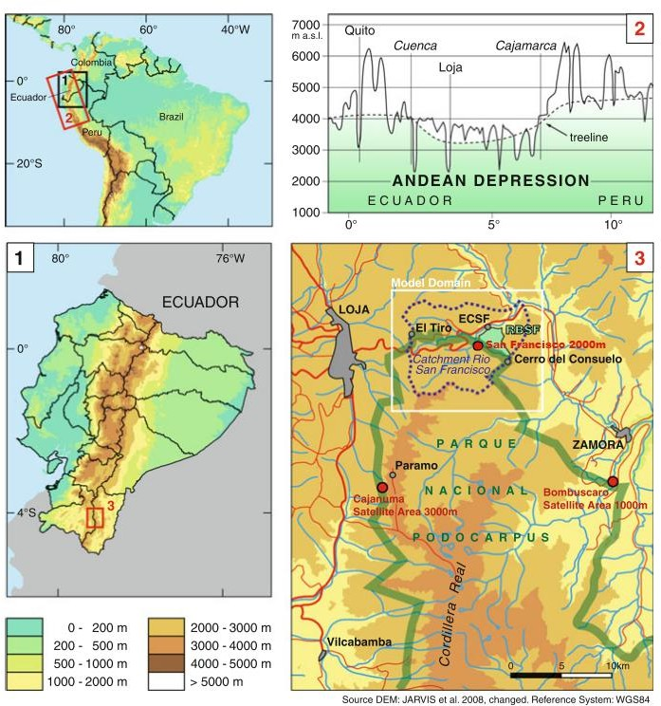

Fig. 1: Location of the research area. The image on the top left shows the general area the sites are situated in in South America. Map 1 shows the location of the study area in Ecuador. Map 2 is a cross-section of the Andean highlighting the Andean depression. Map 3 (modified) shows the small-scale topography of the experimental plots in and around Podocarpus National Park; blocks at each altitude are marked with a red dot. The digital elevation model (DEM) is based on Jarvis et al. (2008). Source: after Richter et al. (2013)

Tab. 1: Physiogeographic and stand structural characteristics of the three study
sites. After Cárate-Tandalla et al., 2018
Site characteristics | Bombuscaro  1000m asl | San Francisco  2000m asl | Cajanuma  3000m asl
Location
Altitudinal range ª | 990-1100m asl | 2020-2100m asl | 2900-3020m asl
Coordinates ª | 4°7’ S, 78°58’ W | 3°58’ S, 79°11’ W | 4°7’ S, 79°11’ W
Temperature ^{b} | 19.4°C | 15.7°C | 9.4°C
Mean  precipitation ^{b} | 2230mm | 1950mm | 4500mm
Forest structure
Canopy height ª | 20-25m | 10-14m | 6-8m
Tree density ª | 748 trees/ha | 1143 trees/ha | 1305 trees/ha
Basal area (BA) ª | 33.4 m²/ha | 22.8 m²/ha | 25.5 m²/ha
Vegetation type ª | Evergreen  premontane forest | Evergreen lower  montane forest | Evergreen upper  montane forest
Soil type ª | Dystric Cambisol | Stagnic Cambisol | Stagnic Histosol
Organic layer depth ª | <1 cm | 10-30 cm | 10-40 cm
Total N organic soil ^{c}  mineral soil ª | 22 g/kg  6.0 g/kg | 19 g/kg  0.7 g/kg | 15 g/kg  0.7 g/kg
Total P ^{d}  organic soil mineral soil | 450 +/- 28 g/kg  220 +/- 36 g/kg | 527 +/- 22 g/kg  53 +/- 5 g/kg | 525+/- 47 g/kg  175 +/- 68 g/kg
ª Homeier, Leuschner, et al., 2013
^{b} Wittich et al., 2015
^{c} Iost, S. et al., 2008
^{d} Dietrich et al., 2016

Bombuscaro, 1000m asl site
Mean temperature at the 1000m asl site is highest with 19.4 ºC while precipitation is only 2000 mm, being the lowest compared to the other sites (Cárate-Tandalla et al., 2018). The soil is dystric cambisols formed by deeply weathered granodioritic rock of the Jurassic Zamora granitoid formation (Wolf et al., 2011) covered only with a thin organic layer (Oi) (Homeier, Leuschner, et al., 2013). The vegetation growing between 800-1300 m asl can be characterised as evergreen premontane rain forest with trees growing to a maximum of 40m. (Homeier et al., 2008). Many tree species at this elevation are from the families Fabaceae, Melastomataceae, Moraceae, Myristicaceae, Rubiaceae, and Sapotaceae (Homeier, Leuschner, et al., 2013)

San Francisco, 2000m asl site
Mean temperature follows the trend outlined above and lies at 15.7ºC. Precipitation at this location shows a trend-expectation, being lower than expected, with 1950mm mean rainfall (Wittich et al., 2015). The soil consists of stagnic cambisols covered by a thick organic layer of up to 30cm (Oi + Oe + Oa) (Homeier, Leuschner, et al., 2013). Its vegetation range between 1300-2100m asl can be characterised as evergreen lower montane forest with trees growing to a maximum of 30m (Homeier et al., 2008). Euphorbiaceae, Lauraceae, Melastomatacea and Rubiaceae are the characterizing tree families at this elevation (Homeier, Leuschner, et al., 2013).
Cajanuma, 3000m asl site
Temperature is lowest with 9.4 ºC whereas precipitation is highest with 4500mm at the 3000m asl site (Wittich et al., 2015). The mineral soil at this elevation consists of stagnic histosols which is covered by a up to 40cm thick organic layer (Oi + Oe + Oa) (Homeier, Leuschner, et al., 2013). From here on up to the timberline (3100 m asl) the vegetation is characterised by Homeier, Leuschner, et al. (2013b) as upper montane forest reaching up to the timberline with overall canopy height being 6-8m and rarely higher than 8-10m. The most tree prominent families are Aquifoliceae, Clusiaceae, Cunoniaceae, Lauraceae, and Melastomataceae.

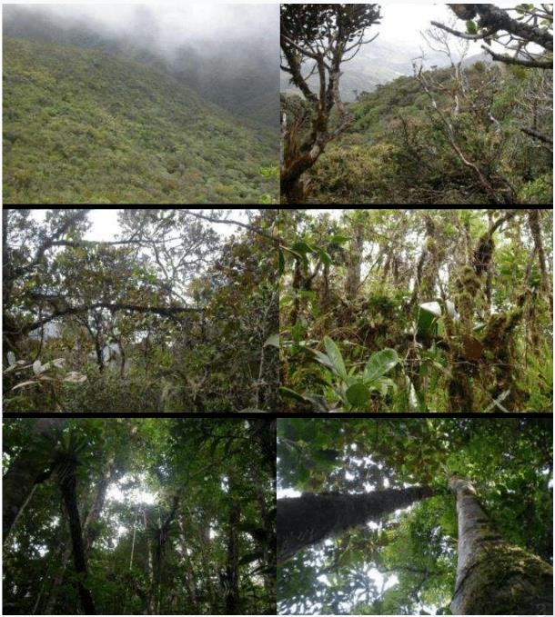
Fig. 2: Pictures of example vegetation and composition at the different altitudes. From top to bottom: Cajanuma, Podocarpus NP with canopy cover reaching 8m, highest tree density and medium basal area (3000m asl site); San Francisco, RSBF, with canopy cover reaching 14m, medium tree density but lowest basal area (3000m asl site) Bombuscaro, Podocarpus NP with canopy cover reaching 25m, lowest tree density but highest basal area (1000m asl site); Source: Jürgen Homeier

Nutrient Addition Experiment and Plot Setup
The experiment was set up as follows at each altitude (Fig. 3): “The full-factorial experiment was set in a stratified random design that includes four blocks and 16 plots of 400m² (20 x 20 m), with a minimum distance of 10m between plots. Thus, each block has four plots randomly assigned to a treatment: N, P, N + P, and control. N and P were added to the experimental plots at a moderate annual rate of 50 kg N/ha as urea, and 10 kg P/ha as monosodium phosphate. Both nutrients were distributed in solid form by hand, homogeneously within the plot area, twice a year “ (Báez & Homeier, 2018). At all sites measurements were first taken in February 2008.

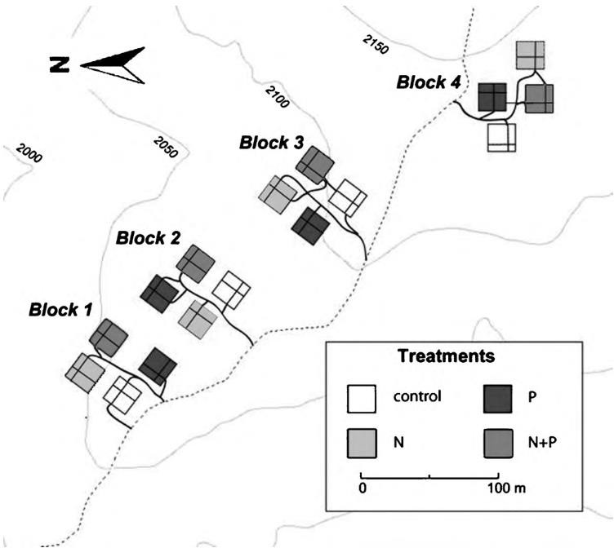
Fig. 3: Map of the plot setup at 2000m asl site. Dotted lines within plots represent transects and continuous lines between the plots represent the access roads. Source: Wullaert et al. (2010)
The tree community and starting conditions of the NuMEx plots highly differed among elevations: Plots at 1000m asl included 82 species with a mean tree diameter of 20.80; plots at 2000m asl included 45 species with a mean tree diameter of 14.; and plots at 3000m asl included 68 species with a mean tree diameter of 14.87 cm all at the start of the study period.
To accurately measure diameter at breast height (dbh) increments permanent dendrometers (D1, UMS, Munich, Germany) were installed on all individual trees inside the experimental plots with dbh of ≥ 10 cm. The dbh was measured at least every 6 months (until 2015) and following that at least once a year “simultaneously” across plots where possible.

Functional Traits
In total 352 species were evaluated for functional traits across all three elevations (118 at 1000m asl; 168 at 2000m asl; 66 at 3000m asl). For all functional trait data non-fertilized trees with dbh ≥ 10 cm in control plots or along trails in the research area (Fig. 1 Map 3) were sampled. Measurements were either conducted on site (e.g., bark thickness) or gathered and analysed at the local research station in the RSFB (e.g., SLA) or send to the Department of Plant Ecology in Göttingen (Germany). Mean trait values were used opposed to the more accurate analysis at the individual level (Liu et al., 2016) because of the high heterogeneity of the tree communities and low species abundance. The measurement methods for each trait can be found in Báez & Homeier (2018) supplementary material. In total 5 leaf traits - namely foliar nitrogen (N) and foliar phosphor (P) concentrations, leaf area (LA), leaf toughness (LT), specific leaf area (SLA) - and 5 stem traits – namely bark thickness (BT), sapwood-specific conductivity (KS), stem vessel density (VDens), stem vessel diameter (VDia), and wood-specific gravity (WSG) - were included in the final PCA analysis.

Statistical Analysis
Functional Trait Analysis at the Community Scale and within the Experimental Plots
Only dicotyledonous trees with secondary thickness growth that survived the whole study period (i.e., only trees with dbh measurements in 2008 and 2020) were included in the analysis. A probabilistic principal component analysis (PPCA) was chosen over a standard principal component analysis (PCA) to fill in missing values as many species lacked trait values in at least one trait and could not have been included in a standard PCA.
The PPCA method is derived from Porta's et al (2005) Mathlab script and Roweis (1998). It uses an expectation-maximum (EM) approach to calculate missing values under the assumption that latent variables as well as noise are normal distributed. The method is not called directly but implemented into a PCA-wrapper function as advised by the methods documentation. As this method uses randomly generated numbers the seed ”2491284” is used to yield stable results through repeated runs. The PPCA was conducted on standardized species mean trait data (the mean was subtracted and then divided by the standard deviation: Z-Score), sticking to the procedure of Báez & Homeier (2018), collapsing variation among species on a maximum of 5 axis.

This was done for each elevation separately (Fig. 4) to avoid unwanted cross-influence of species across elevations.

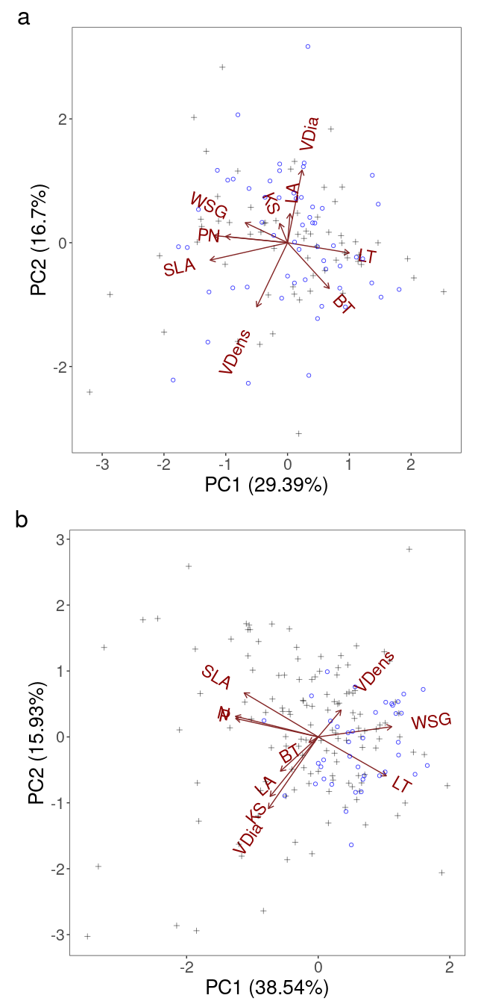
Fig. 4: Probabilistic principal component analysis (PPCA) of (a) 118 tree species traits at the 1000m asl site at Bombuscaro, Ecuador; (b) 168 tree species traits at the 2000m asl site at the Reserva San Francisco, Ecuador; and (c) 66 tree species traits at the 3000m asl site at Cajanuma, Ecuador. Tree species that are represented inside the NuMEx plots are visualized as blue circles. Ten functional traits were included in the PPCAs: foliar nitrogen (N) and foliar phosphor (P) concentrations, leaf area (LA), leaf toughness (LT), specific leaf area (SLA), bark thickness (BT), sapwood-specific conductivity (KS), stem vessel density (VDens), stem vessel diameter (VDia), and wood-specific gravity (WSG). Loadings of functional traits in both PC axes are given in Tab. S1

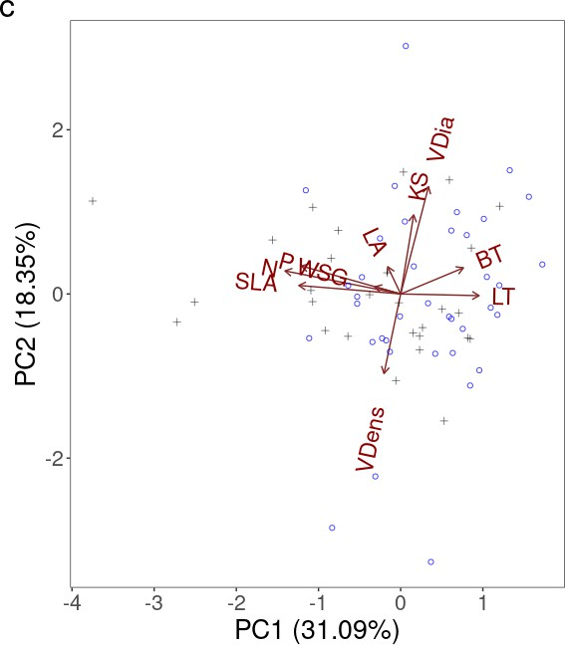

All three elevations show similar trends of trait variation across the three study sites (Fig. 4). The PC1 axis summarized variation related mostly to leaf trats (SLA, N, P) whereas the PC2 axis described variation mostly to stem traits (KS, VDia, VDen). Wood density was mostly associated to PC1, but its direction of response varied among sites. Same was true for BT and to a smaller degree LA. For each elevation these first 2 axes of each PPCA were used as explanatory variables in the following models as they explained at least 45% of the variation in each trait analysis.
The first two axis at the 1000m asl site captured in their sum ~ 45.71% of the trait variation among these species (Fig. 4a, Tab. S1). On the PC1 axis, which explained 29.39% of the variation, negatives scores are associated with high leaf nutrient concentrations and a high SLA, whereas positive scores are associated with high BT and LT, outlining a gradient from species with fast nutrient acquisition and growth (i.e., high nutrient concentration, high SLA) to those with slower nutrient uptake and growth (i.e., higher LT) (Reich, 2014). On the PC2 axis, which explained 16.7% of the variation, positive scores are connected to bigger and fewer vessels (and higher KS), whereas negative scores are connected to smaller but denser vessels. This differing investment in hydraulic conductivity (i.e., high vs. low) also describes a similar gradient from more acquisitive (positive values) to more conservative (negative values) strategies (Báez & Homeier, 2018; Reich, 2014).
The first two axis at the 2000m asl site captured in their sum ~ 54% of the trait variation among these species (Fig. 4b, Tab. S1). Trends at this altitude are alike to the site at 1000m asl, with the plot being mirrored on the x-axis. The PC1 axis explained 38.54% of the variation highlighting the same strategy differences: species with fast nutrient acquisition and growth (i.e., negative PC1 scores) and those with slower nutrient uptake and growth (i.e., positive PC1 scores). The PC2 axis (mirrored in comparison to Fig. 4a) explaining 15.93% of the variation again describes a differing investment in hydraulic conductivity (i.e., high vs. low) therefore also a gradient from more acquisitive (negative PC2 scores) to more conservative strategies (positive PC2 scores). Notable differences are that WSG is associated with negative PC1 values at this elevation, reinforcing the acquisitive-conservative strategy difference as brought forth by Reich (2014) and BT being more strongly associated with VDia on the PC2 axis than with LT on the PC1 axis. LA seems to be associated with the hydraulic investment gradient of the PC2 axis unlike in the other two PPCAs (Fig. 4a and 4c).

The first two axis at the 3000m asl site captured in their sum ~ 50% of the trait variation among these species (Fig. 4c, Tab. S1). Trends at this altitude are again like the site at 1000m and 2000m asl. The directions of the predictors are more focused on the individual axis compared to the other elevations, with only LA and BT varying evenly on the PC1 and PC2 axis. The PC1 axis explained 31.09% of the variation highlighting a difference in species strategies with fast nutrient acquisition and growth (i.e., negative PC1 scores) and those with slower nutrient uptake and growth (i.e., positive PC2 scores) as seen in the other two elevations. Acquisitive and fast-growing species are characterised by high SLA, leaf nutrient content and to a lesser extent by high WSG whereas conservative and slow growing species show a high LT and BT. BT was in the other two elevations not a clear predictor on the PC1 axis. The PC2 axis explained 18.35% of the variation describing the same investment divergence in hydraulic conductivity (i.e., low vs. high) therefore also a gradient from conservative to acquisitive strategies with increasing PC2 scores. This gradient is emphasized, as seen in the other sites, by investment in either big vessel and high KS (high hydraulic investment) or fewer, but denser vessels (low hydraulic investment).
For the trait pattern analysis in and across elevations a PPCA with the trait data from all sites grouped together was used to construct a trait grouping in the same way as outlined above (Fig. S7). To compare if there were significant differences in PC variation and therefore trait variation across the sites a basic one-way ANOVA with PC scores as the dependent variable and the site identity as the independent variable was used. This was done for the whole recorded community at each elevation as well as only with tree species situated inside NuMEx plots. Lastly, I tested, using a two-sample t-test and scores from the individual PPCAs for each elevation, if tree community composition inside NuMEx plots showed significant differences to the whole recorded community composition judged by the PC1 and PC2 values, respectively.
The same PPCA results were then also used to construct a hypervolume to visualize the trait space of each site in relation to the PC1 and PC2 scores. Hypervolumes follow the hypothesis of Hutchinson (1957) and are defined by a set of points inside a n-dimensional (in this case two dimensional) space. The points reflect suitable values for a pre-set group of n variables with biological important (in this case trait axis PC1 and PC2) and can inter alia be used to quantify species niches (Blonder et al., 2014) or in this case the 2-dimensional trait space of communities of trees. I used the package “hypervolume” (Blonder & Harris, 2019) following example code

provided in Blonder et al. (2014) to construct two hypervolumes and overlaps of the resulting set of points again for the whole community and exclusively NuMEx communities.
Modelling of Tree Growth
To deal with grouped data in hierarchical structures due to individual measurements inside the plot structure of the experiment, I used Linear Mixed Models (LMM). These analyses also allow for estimations of the relative importance for fixed and random effects (Bates et al., 2015). Before starting the actual linear mixed modelling, the data was explored to ensure linear modelling can be applied on this dataset. I followed the approach outlined in Zuur et al. (2009). In detail, the criterions of normality, homogeneity, fixed explanatory variables (i.e., explanatory values are known a priori) and independence were assessed to check if a serious violation of any of these aspects complicate modelling or make the dataset unsuitable to begin with. Basal area (BA) increases of trees who showed a recorded negative BA increase were substituted by zeros. Some violation of homogeneity was detected in the residuals (most notably at the 3000m asl site). Therefore, one was added to the response variable (i.e., BA increase) to eliminate zeros from the dataset and enable the following natural logarithmic transformation at each elevation site. A negligible amount of non-normality and heterogeneity as well as a degree of “randomness” concerning certain explanatory variables (in detail tree size and PC scores) was expected and can be tolerated (Zuur et al., 2009). Following the transformation of the response variable, no site showed major violations of the above-mentioned criterions and I proceeded with the linear mixed modelling.
For the model construction the approach used by Báez & Homeier (2018) was utilised. I constructed models from simple (using only fertilized nutrients as additive factors) to complex (including nutrient addition, starting tree size and a principal component all as multiplicative factors) considering additive as well as multiplicative interactions to estimate the most fitting model predicting tree size change. In the end, for each site I ran 16 models including functional trait information (i.e., PC 1 and PC 2 scores) as well as five models excluding functional trait variation. Not all interactions between fixed factors (i.e., nutrient addition and initial tree size) and the functional trait variation were tested as the increasing complexity could compromise interpretability (Báez & Homeier, 2018).

I included species identity and the block each tree is situated in as random factors to account for idiosyncratic responses and allow for possible spatial autocorrelation inherited by the design of the experiment, respectively. I opted for variation in intercept across treatments (Báez & Homeier, 2018). This random factor structure was selected again through the approach outlined by Zuur et al. (2009). Species needed to be represented by at least one individual in every type of treatment plot to be included with their species identity. The remaining trees included in the analysis were grouped under the species code “R” (for “rare species”). I, in accordance with Báez's & Homeier's (2018) approach, chose the Akaike information criterion (AIC) to evaluate the models as it allows for quality assessment of models in relation to one another (Symonds & Moussalli, 2011). The best fitting models were selected based on their ΔAIC values (ΔAIC = AIC model I – minAICc; where minAICc is the smallest AIC value of all the models). Following Symonds & Moussalli (2011), models with ΔAIC < 6 should not be rejected. Models that showed a higher ΔAIC should be evaluated for plausible rejection arguments and if the ΔAIC is above 10 models should be rejected.
In the end, I extracted prediction values from the most accurate model, i.e., with the lowest ΔAIC, including PC1 and PC2 respectively to predict individual BA growth as well as the upper and lower confidence intervals for the fixed effects. These were calculated from 1000 simulations for each model with the recorded observations as a base using the merTools package (Knowles & Frederick, 2020). From the same models, the species-specific response was derived and analysed. Responses in treatment represented by only a single measurement were not evaluated, as the range of error is unknown.
All statistical analyses were done in R version 4.0.3 (R Core Team, 2013) with main packages being “pcaMethods” (Stacklies et al., 2007) for doing the PPCA, “hypervolume” (Blonder & Harris, 2019) to compute the trait space analysis, merTools (Knowles & Frederick, 2020) to run simulations, “ggplot2” (Wickham, 2008) and ggbiplot (Vu, 2011) for plotting and “lme4” (Bates et al., 2015) for linear mixed model construction.

Estimation of Forest Productivity per Plot
For my analysis of biomass changes, the sum of all individual BAs of recorded trees per plot was used. This simplified estimation of productivity was called on in replacement of above ground biomass (AGB) as tree heights, necessary for AGB estimation, were not yet recorded for 2020. The BA for each plot was calculated for the start of the experiment (2008) as well as the last measurement in 2020 to yield the BA growth for each plot. From the last measurement, same as with the individual growth data, only trees whose dbh increase was recorded for the whole study period were included. The overall BA growth per plot over the whole study period was normed on BA growth per year to allow for comparison of not synchronically measured plots. The values for total BA and BA growth were plotted against one another using ggplot2 to compare the different treatments as well as across altitudinal levels.

Results

Trait Composition and Variation along and inside the Elevation Gradient
Trait variation showed mixed differences between elevations as well as at the individual sites, depending on whether the whole community or only species situated inside the NuMEx plots were incorporated. By using the first two PC axes to assess trait variation across the three study sites, I found no statistically significant differences among the three sites (SitesPC1: F2, 349 = 0.008, p = .992; SitesPC2: F2, 349 = 0.068, p = .934). However, PC scores varied significantly among the NuMEx plots located at the different elevations but only for the PC1 axis (SitesPC1: F2, 131 = 10.77, p = 4.68e-05; SitesPC2: F2, 131 = 0.849, p = .43). This finding is also supported by the hypervolume analysis of the first two PPCA axis. When all recorded species were considered, overlap between the sites was considerably higher: 79.98% between 1000m and 2000m asl; 73.25% between 1000m and 3000m asl; and 68.12% between 2000m and 3000m asl (Fig. 5). When only species situated in the NuMEx plots were analysed, overlap in trait space decreased to 54.40% between 1000m and 2000m asl and 50.45% between 2000m and 3000m asl, whereas it increased to 75.44% between 1000m and 3000m asl (Fig. S8).
The NuMEx plots represented the trait spectrum of the community at each elevation well with some trait variation compared to the whole community at the 2000m asl site (65% and 87% at 1000m asl, 45% and 41% at 2000m asl, 100% and 100% at 3000m asl in PC1 and PC2, respectively).
At the 1000m asl site trees in NuMEx were neither more acquisitive nor conservative compared to the community considering PC1 and PC2 (NuMEx mean 1000-PC1 = -0,08 +/- 0.21, community mean 1000-PC1 = -0.01 +/- 0.24, two-sample t1000-PC1(122.05) = 0.32343, p = .7469; NuMEx mean 1000-PC2 = -0.06 +/- 0.19, community mean 1000-PC2 = -0,003 +/- 0.18, two-sample t1000-PC2(104.77) = 0.33854, p = .7356).
At the 2000m elevation, the community inside NuMEx was more conservative compared to the community considering PC1 (NuMEx mean 2000-PC1 = -1.17 +/- 0.13, community mean 2000-PC1 = -0.02 +/- 0.24, two-sample t2000-PC1(106.37) = 5.2106, p = 9.29e-07) but showed no difference in PC2 (NuMEx mean 2000-PC2 = 0.18 +/- 0.09, community mean 2000-PC2 = -0,02 +/- 0.15, two-sample t2000-PC2(99.948) = -1.3355, p = .1847).

At the 3000m elevation, again neither PC1 nor PC2 showed significant differences between NuMEx and the whole community (NuMEx mean 3000-PC1 = -0,51 +/- 0.26, community mean 3000-PC1 = -0.02 +/- 0.35, two-sample t3000-PC1(95.779) = 1.6776, p = .09669; NuMEx mean 3000-
PC2 = -0.08 +/- 0.31, community mean 3000-PC2 = -0.02 +/- 0.27, two-sample t3000-PC2(68.19) = 0.20035, p = .8418)
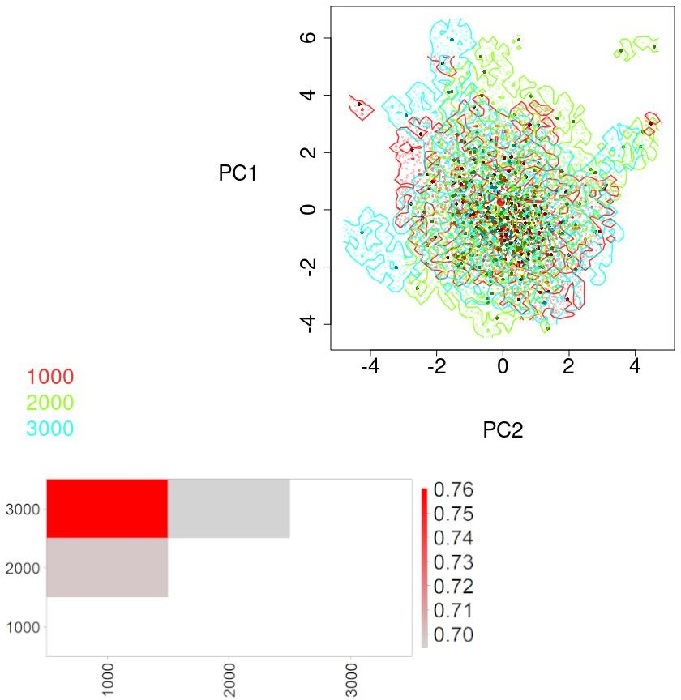
Fig. 5: Estimated two-dimensional hypervolumes for the three elevations inside the study area of the NuMEx project in the tropical montane forest in south Ecuador listed in the bottom left inset shown as pair plots. Variables have not been transformed as they share the same scale. The coloured points for each elevation reflect the stochastic description of each hypervolume, i.e., random points sampled from the inferred hypervolume, rather than original observations. The inset shows all possible pairwise overlaps between site pairs, i.e., the overlap between the trait space (as derived from the PC axis) of each one site to another (calculated as 2 × shared volume/summed volume). The hypervolume consider all sampled tree species in the communities used for the PPCA.

Trait-based Responses to Nutrient Addition
Responses in relation to species mean traits showed mixed results across the different elevations and compared to the results of Báez & Homeier (2018). The order of the best-fitting models judged by AIC varied at each elevation. The best model structures for each type (PC1 axis, PC2 axis, no PC axis) stayed constant (Tab. S2-S4). All best fitting models incorporated only additive effects of the explanatory variables (N + P + PC1 or PC2 + initBA). In addition, the overall best fitting model for each elevation, apart from the 2000m asl site, was without a PC axis (ΔAIC of 0; Tab. S2-S4), but these were omitted as the focus of this study lies in understanding tree response to nutrient addition in relation to their functional traits.
At the 1000m asl site, the model including the PC1 axis was the second-best fitting model. The only significant estimator of predictors was initial BA. None of the 95% confident intervals of the remaining estimators differed from 0 (Fig. S4a). A slight increase in predicted growth was indistinguishable with P and N+P treatments in trees with acquisitive strategies (low PC1, Fig. 6a) characterised by high SLA, nutrient contents, and WSG (Fig. 4a). However, the model predictions do not lie outside the margin of error of control treatments. Individual N treatment showed no deviation from control plots. In general, acquisitive species - judged by the PC1 score – showed increased growth response compared to conservative species across all treatments.
The third best model included the PC2 axis, showing the same estimates in the forest plots of the predictors as the PC1 model (Fig. S4b). The predicted growth of the model showed no clear increase in any nutrient addition plot when compared to control plots (Fig. 6b). N+P treatments were only slightly above all other treatments across the hydraulic conductivity gradient of the PC2 axis concerning predicted growth. Species with high VDia, labelled as acquisitive, exhibited slightly more growth than conservative species with smaller vessels.
Both models yielded equivalent results when plotted as a function of initial BA (Fig. S1). P and N+P treatments showed highest growth response compared to control plots whereas growth in individual N treatments did not differ from control plots. Again, no model predictions lie distinctly outside the margin of error compared to the control plots.

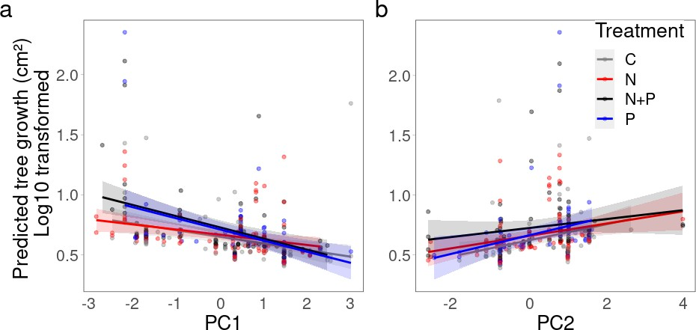

Fig. 6: Predicted tree growth and SE at the 1000m asl site with confidence interval as a function of functional traits. Predictions values were extracted from the two best models for the 1000m asl site that consider growth over at least 12 years as a function of the additive effects of nutrients added (N, P), as well as the additive effects of tree functional traits (PC 1 or PC 2) and the additive effect of initial tree size. (a) Model using PC 1. (b) Model using PC 2. PC 1 describes a gradient of acquisitive functional traits (high leaf nutrient content, high specific leaf area) to conservative traits (leaf toughness). PC 2 describes a gradient from conservative to acquisitive functional traits (low to high vessel diameter and high to low vessel density, respectively)

At the 2000m site, the best fitting model including the PC1 axis was the second-best model judged by the AIC. In this model, estimates of the predictors N treatment as well as BA were highly significant but only N treatment did differ positively from 0 (Fig. S5a). N+P treatment showed overall higher growths (Fig. 7a), especially in species with nutrient conservative strategies (high PC1 scores) that were identified in the matching PPCA (Fig. 4b) to have high leaf nutrient concentrations and SLA. Individual N addition had the second biggest growth impact in acquisitive species but no clear impact on growth in conservative species (low PC1) characterised by tough leaves and high WSG compared to control plots. P treatments on the other hand showed similar growth responses across the fast-slow resource acquisition gradient parallel to control plots.

The incorporation of the PC2 axis yielded the best fitting model at this elevation and growth response was highest in acquisitive species (i.e., high PC2 scores) characterised by small but dense vessels (Fig. 7b). Estimates were increasingly significant in rising order for the trait axis (i.e., PC2 scores), N-treatment, and initial BA. All estimates were different from 0 expect initial BA (treatments were positive, whereas trait values were negative) (Fig. S5b). N+P treatments showed the highest growth response overall, followed by individual N, then P treatments, and lastly the control treatments. The pronounced differences in growth between the treatments at low PC2 scores decrease with increasing PC2 score and were on similar levels as control plots at the highest PC2 scores across treatments.
With predicted growth as a function of initial BA, both models showed matching trends (Fig. S2). Here, N+P treatments again had the highest growth response, with individual N and P treatments being similar. Nevertheless, all treatments show effects compared to control plots apart from individual level P treatment (Fig. S2a).
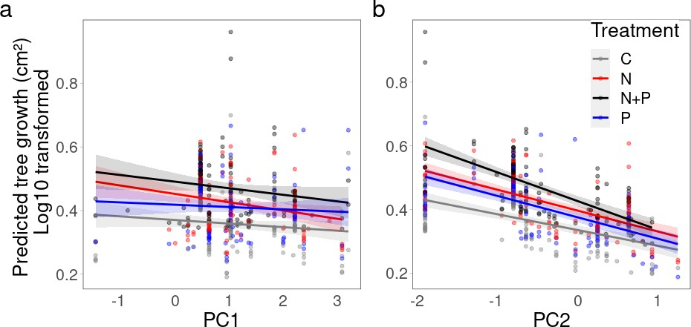
Fig. 7: Predicted tree growth and SE at the 2000m asl site with confidence interval as a function of functional traits. Predictions values were extracted from the two best models for the 2000m asl site that consider growth over at least 12 years as a function of the additive effects of nutrients added (N, P), as well as the additive effects of tree functional traits (PC 1 or PC 2) and the additive effect of initial tree size. (a) Model using PC 1. (b) Model using PC 2. PC 1 describes a gradient of acquisitive functional traits (high leaf nutrient content, high specific leaf area) to conservative traits (wood density and leaf toughness). PC 2 describes a gradient from acquisitive to conservative functional traits (high to low vessel diameter and low to high vessel density, respectively)

At the 3000m asl site, the model incorporating the PC1 axis was the third best fitting model. All treatments showed a growth increase, most profound in the combined N+P treatment. Conservative species (i.e., high PC1 scores) with high LT and BT did respond the strongest to N+P addition whereas acquisitive species (i.e., low PC1 scores) responded strongly to only individual N treatment. Individual P treatments showed overall lowest growth response and were only marginally different from control plots.
In the model incorporating the PC2 axis, which was the fourth best fitting model at this site, N+P addition as well as N addition showed a growth response in hydraulic investing species (i.e., high PC2 score) with few, broad vessels and a high KS, differing from control plots. N+P addition also showed highest growth response of all treatments in trees with low hydraulic investment (i.e., low PC2 score). Individual N treatment showed a slightly lower growth response in trees with low hydraulic investment. P addition was not different from control plots (Fig. 8b). Acquisitive species showed higher growth response than conservative species across all treatments. Measurements in P plots extended into higher PC2 scores, but these cannot be evaluated due to the missing comparable data in other treatments.
The estimates of predictors were identical for both models with treatments showing positive estimates and trait axis (i.e., PC1 and PC2 scores respectively) did not differ from 0. The only difference was that P treatment was a significant predictor in the second model in addition to N treatment and initial BA being a highly significant predictor (Fig. S6).
With predicted growth as a function of initial BA both models showed identical trends. N+P treatments were the only treatment distinctly different from control plots whereas N addition only showed growth response in trees with smaller BA. P treatments were on par with control plots (Fig. S3a).

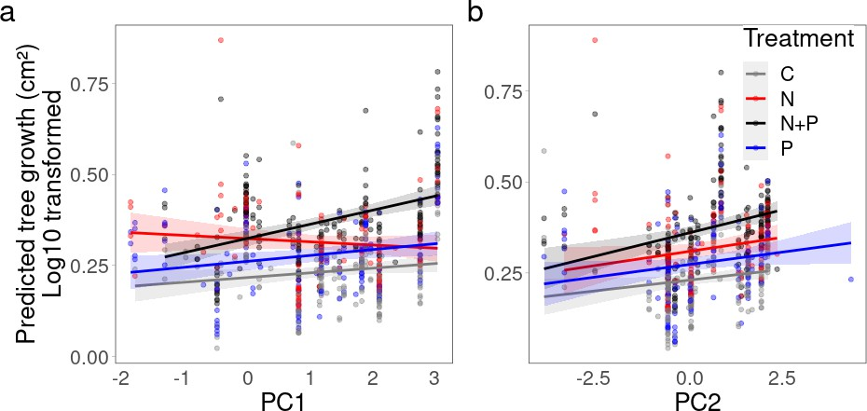
Fig. 8: Predicted tree growth and SE at the 3000m asl site with confidence interval as a function of functional traits. Predictions values were extracted from the two best models for the 3000m asl site that consider growth over at least 12 years as a function of the additive effects of nutrients added (N, P), as well as the additive effects of tree functional traits (PC 1 or PC 2) and the additive effect of initial tree size. (a) Model using PC 1. (b) Model using PC 2. PC 1 describes a gradient of acquisitive functional traits (high leaf nutrient content, high specific leaf area) to conservative traits (bark thickness and leaf toughness). PC 2 describes a gradient from conservative to acquisitive functional traits (low and high vessel diameter and high to low vessel density, respectively)

Species Responses to Nutrient Addition
The identity of species played a role on whether nutrient treatments had positive or negative effects on growth. The responses, which were extracted out of the two best models at each elevation, showed similar trends for all elevations with mostly positive and no negative growth response to nutrient addition (Fig. 9-11).
At 1000m asl, nutrient addition influenced fewer species when compared to the 2000m and 3000m asl sites with treatments showing effects only in two species. All treatments led to growth increase in one species (Virola sebifera) in the PC1 model (Fig. 9a) and all expect N addition in the PC2 model (Fig. 9b). This was not clear for P treatment as there was only a single individual left in the analysis. In addition, Mollia gracilis did respond to P addition in both models. Rare species did not respond to nutrient addition.
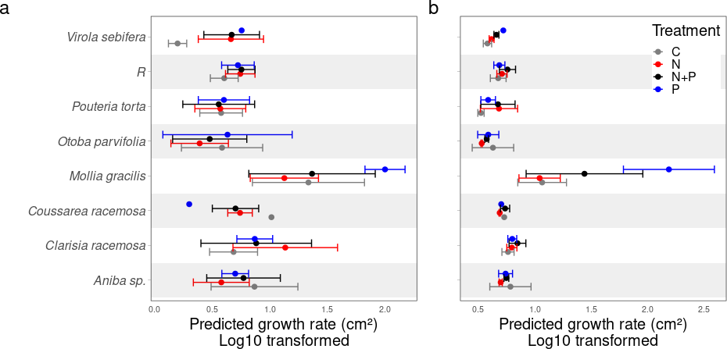
Fig. 9: Predicted mean tree growth and SE per species at 1000m asl. Predictions were extracted from the two best models considering growth over more than 12 years at the 1000m asl site (see Fig. 6) using logarithmic basal area increase as a function of additive effects between nutrients added (N, P), tree functional traits and initial basal area. (a) Model using traits in PC1 axis (i.e., fast/acquisitive species with high specific leaf area and leaf nutrient concentrations versus slow/conservative species with high leaf toughness) and (b) using traits in PC2 axis (i.e., faster nutrient acquisition due to higher vessel diameter vs. slower nutrient acquisition due to smaller but denser vessels)

At 2000m asl, more species showed an increased response to nutrient addition. N+P addition showed growth increases in the highest number of species, leading to a growth increase in 8 out of 14 species (Alzatea verticillata in both models; Prunus opaca, Myrcia sp. nov, Graffenrida emarginata Hieronyma fendleri, Clusia ducuoides, Alchornea lojaensis, and rare species all only in the second model (Fig. 10)). Individual treatment with N increased growth in 6 species albeit only in the PC2 model (Prunus opaca, Myrcia sp. nov, Hieronyma fendleri, Graffenrieda emarginata, Clusia ducuoides, and Alchornea lojaensis). P treatment also increased growth clearly in 5 species (Alzatea verticillata in both models; Prunus opaca, Myrcia sp. nova, Hieronyma fendleri, and Graffenrieda emarginata in the second model). Negative responses to nutrient additions were not observed in any of the two models. Prunus opaca, Myrcia sp. nova, Hieronyma fendleri, and Graffenrieda emarginata showed positive response to all treatments in the second model.
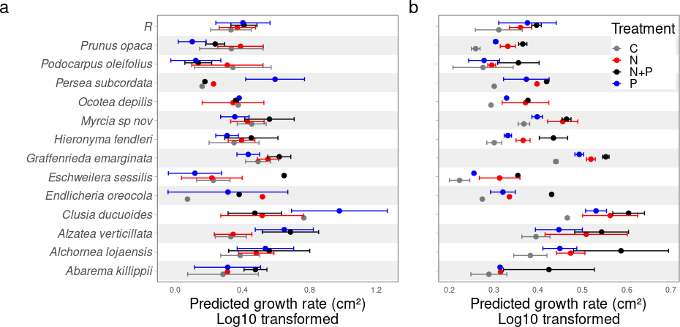

Fig. 10: Predicted mean tree growth and SE per species at 2000m asl. Predictions were extracted from the two best models considering growth over more than 12 years at the 2000m asl site (see Fig. 7) using logarithmic basal area increase as a function of additive effects between nutrients added (N, P), tree functional traits and initial basal area. (a) Model using traits in PC1 axis (i.e., fast/acquisitive species with high specific leaf area and leaf nutrient concentrations versus slow/conservative species with high leaf toughness and specific wood gravity) and (b) using traits in PC2 axis (i.e., fast nutrient acquisition due to higher vessel diameter vs. slower nutrient acquisition due to smaller, but denser vessels)

At 3000m asl, N+P addition exhibited biggest influence on species-specific tree growth with 13 of 16 species showing positive responses (Graffenrieda harlingii and Clusia alata in both models; Weinmannia ovata, Weinmannia loxensis, Weinmannia elliptica, Styrax foveolaria, Persea ferruginea, Miconia jahnii, Ilex weberlingii, Gordonia fruticosa, Geissanthus vanderwerffii, Clusia ducuoides, and rare species in the second model (Fig. 11)). This was followed by N addition yielding growth responses in 6 species (Rare species in both models; Miconia jahnii, Graffenrieda harlingii, Gordonia fructiosa, Clusia ducuoides, and Clusia alata in the second model) and lastly by P addition showing responses in 2 species only in the PC2 model (Fig. 11b) (Styrax foveolaria and Graffenrieda harlingii).
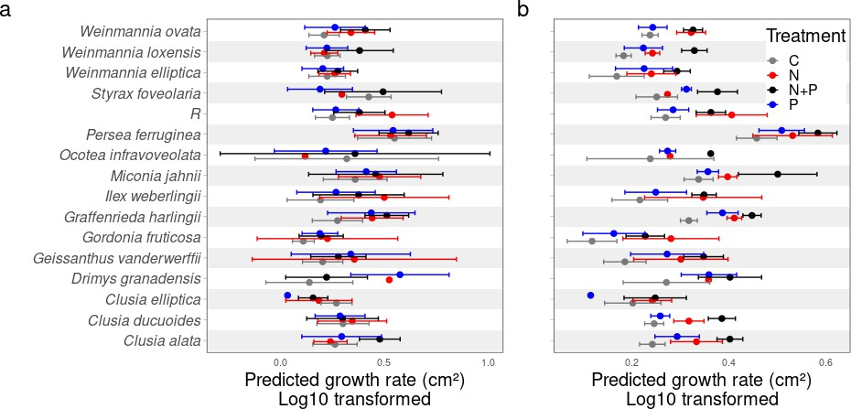
Fig. 11: Predicted mean tree growth and SE per species at 3000m asl. Predictions were extracted from the two best models considering growth over more than 12 years at the 3000m asl site (see Fig. 8) using logarithmic basal area increase as a function of additive effects between nutrients added (N, P), tree functional traits and initial basal area. (a) Model using traits in PC1 axis (i.e., fast/acquisitive species with high specific leaf area and leaf nutrient concentrations versus slow/conservative species with high leaf toughness and specific wood gravity) and (b) using traits in PC2 axis (i.e., fast nutrient acquisition due to higher vessel diameter vs. slower nutrient acquisition due to smaller but denser vessels)

Response of basal area (BA) as an ecosystem proxy to nutrient addition
Increases in BA varied across the elevation gradient, with the mean BA growth per plot per year ranging from 191.64 +/- 30.76 m²/a at the 1000m site, 69.00 +/- 9.40 m²/a at the 2000m site and 65.18 +/- 14.31 m²/a at the 3000m site (Fig. 12). Productivity decreased along the elevation gradient with no significant difference between the 2000m asl and 3000m asl site. In addition, significant differences were not observed between the treatments at any site (Treatment1000m: F3, 12
= 0.725, p = .557; Treatment2000m: F3, 12 = 2.983, p = .0738; Treatment3000m: F3, 12 = 2.515, p = .108).
At the elevation with the highest mean growth - i.e., 1000m - fertilization with N+P yielded highest BA increases per year (229.45 +/- 68.87 m²/a) followed by P treatments (203.65 +/- 134.37 m²/a). N treatments and control plots have similar yearly BA growth, with N addition showing slightly more growth (169.722 +/- 23.21 m²/a) with a narrower confidence interval compared to control plots (163.74 +/- 74.36 m²/a). At the 2000m asl site, plots fertilized with N+P showed highest yearly BA growth (91.75 +/- 28.33 m²/a) followed by plots with P treatment (65.47 +/- 10.72 m²/a) and plots with N treatment (62.62 +/- 16.67 m²/a) with similar growth response. Control plots showed the smallest BA increase per year (56.15 +/- 25.09 m²/a). Lastly, at the 3000m asl site N+P treatments again showed the highest BA increase, albeit also the widest error margin (99.18
+/- 47.59 m²/a) whereas BA growths in P (53.10 +/- 26.44 m²/a), N (54.83 +/- 27.05 m²/a) and control plots (53.62 +/- 28.90 m²/a) per block were indistinguishable.
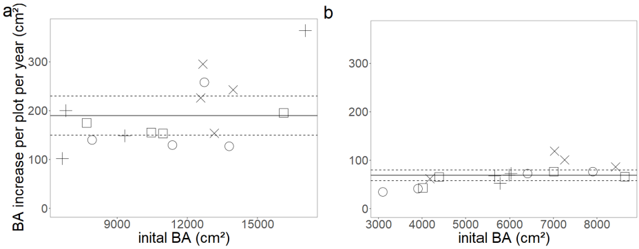
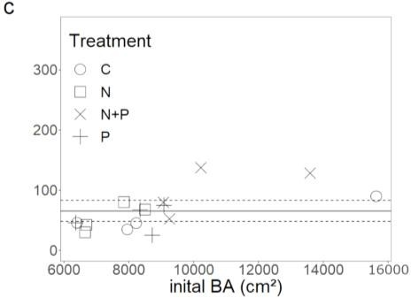
Fig. 12: Relationship between the increment of basal area (BA) per year (measured over 12 years) per plot and mean BA in 16 experimental plots in NuMEx in 2008 from left to right at (a) 1000m asl; (b) 2000m asl; and (c) at 3000m asl. Overall means and standard errors are presented by solid and dashed lines, respectively.

Discussion

Implications of PC Scores between Community and NuMEx
A decrease in SLA, leaf nutrient content and leaf N:P ratio, leaf traits that are associated with acquisitive nutrient strategies (Reich et al., 2014), and increase in leaf thickness and LT, associated with conservative nutrient strategies (Reich et al., 2014), with elevation have been found at the study site (Homeier et al., 2021). Fine-root traits in the TMF in south Ecuador also vary considerably with small scale topography, showing more conservative traits in less fertile soils (Pierick et al., 2021). These findings, in addition to the increase of N limitation (see “Influence of Nutrient Treatment on Growth”) at higher elevations as well as a general decrease in productivity and nutrient cycling due to lower temperatures (Fisher et al., 2013; Homeier & Leuschner, 2021; Tanner et al., 1998) or at flat ridged locations due to water logging (Wolf et al., 2011) support the hypothesis that conservative traits are more prevalent at higher elevations. Consequently, I also expected to see a change in the PC scores with elevation.
Conversely, no significant differences were found between the trait-spaces across elevations, especially when considering the complete recorded community for each elevation. Overlap between the sites was lower when only species situated inside NuMEx were considered. As comparison between NuMEx plots and the whole community also showed some variation, at least at the 2000m elevation, it can be assumed that the NuMEx plot communities, due to their selective sampling size, are intrinsically biased across all elevation sites. However, my study cannot support the hypothesis that conservative species are more prevalent at higher elevation. Alas, my analysis is not the ideal way to test this hypothesis as functional trait variation was collapsed on only 2 axis and not analysed per trait as done by Homeier et al. (2021) for leaf traits and Pierick et al. (2021) for fine-root traits. This led to a convergence of trait variation concealing the differences between sites. This could be assessed in another study constructing n-dimensional hypervolumes of all recorded traits separately. In addition, an inherent shortcoming of my approach needs to be considered: The tree species occurrences used in the PPCA as well as for the hypervolume analysis were not weighed. Consequently, the abundance did not play into the hypervolumes, disregarding this in hyper-diverse TMF very influential factor (Homeier, personal communication, July 28, 2021). An analysis of community-weighted means would be more insightful.

However, it is certain that across sites the traits were all grouped in a similar fashion by the PPCA, with the PC1 axis incorporating mainly leaf traits, whereas the PC2 axis grouped together stem traits. The 4 main traits of the PC1 axis were SLA, N, P, and LT and the 3 main traits of the PC2 axis were VDen, VDia, and KS. The remaining, more variant traits all had only minor loadings and thus not seeming as influential. The 7 most influential traits should be sufficient to describe species performances (Baraloto et al., 2012). A high SLA and high leaf nutrient content is negatively correlated with LT, whereas the leaf traits are generally not correlated with stem traits, i.e., VDen and VDia together with KS, with the second two stem traits being negatively correlated to the first stem trait. The stem trait of BT and WSG and the leaf trait of LA showed the highest variation across sites but with minor loading, and thus do not play a major role in the grouping of species. In the PPCA across all sites (Fig. S7), LA showed higher loading and was strongly correlated with VDia, breaking away from the separation of leaf and stem traits and contrasting Homeier et al. (2021), analysing the same elevation gradient with notably far fewer species and only leaf traits. Here, LA showed smaller loading than the above-mentioned major traits but was clearly associated with nutrient acquisitive traits of SLA and leaf nutrient contents, whereas in my study it is more correlated to hydraulic stem traits than to nutrient acquisitive leaf traits. Association of leaf size with acquisitive hydraulic traits has been recorded in temperate forests in China as well (Song et al., 2018), therefore a correlation of LA and VDia could be plausible for the sites in south Ecuador and more analyses are need to find a definite correlation.

Influence of Nutrient Treatment on Growth
Global ecosystem productivity approximated through BA growth seemed to be enhanced by nutrient addition in all cases, especially in N+P treatments across the gradient, even though none of the differences between treatments per elevation were significant. This aligned with the findings of Báez & Homeier (2018) at the 2000m elevation site. Using BA did not have the problem that acquisitive species with their inherently lower wood density impacted the overall biomass recorded per plot less than conservative species as hypothesized by Báez & Homeier (2018). However, it had the downside of not incorporating tree height and therefore is a cruder proxy for ecosystem productivity. The increasing N limitation with altitude due to lower nutrient turnover and lower temperatures at higher elevations (Dalling et al., 2016; Fisher et al., 2013) and decreasing P limitation due to less eroded more mineral rich soils (Fisher et al., 2013; Tanner et al., 1998) was

supported in parts by the BA analysis as well as the models. Tree BA of N- and P- fertilized plots grew more similar with altitude, but N plots did not overtake P plots even at the highest elevation. P treatment seemed to show a greater response than N treatment at lower elevations, but overall plot BA growth was not significantly different. In addition, the models showed a decrease of P treatments impact with altitude, being equal to control plots at 3000m asl (Fig. S3). This is also supported by the N:P ratio of leaves at the 1000m asl site being above 16, suggesting P limitation, whereas the other two sites fall into an optimal margin of 14-16 (Fisher et al., 2013; Townsend et al., 2007) judged by leaf data of Homeier et al. (2021). Overall, individual P addition treatments had the least impact and therefore exclusive P limitation probably plays a role in only a few species. Contrary to Fisher et al. (2013) findings in the Peruvian Andeans, all elevation sites in south Ecuador are to a varying degree co-limited, as N+P treatments performed best at all elevations (in BA analysis as well as models) and not as expected only in the lower/medium elevation. Long term manipulation experiments in Panama found co-limitation even at low elevations (Wright et al., 2011). In addition, an altitudinal soil analysis in Hawaii (Vitousek et al., 1988) suggests that processes slowing nitrogen cycling might also influence bioavailability of theoretically abundant rock-derived nutrients such as P at higher elevations (Dalling et al., 2016), because P concentrations were even lower at high elevations when compared to lower elevations. Furthermore, the uptake of one nutrient might be limited by the availability of another as it has been concluded in the review of Dalling et al. (2016). For example, N-mineralization was shown to be highly P dependent (Kitayama et al., 2004) whereas P uptake is driven by N-rich enzymes and allocation to such in P limited environments (Treseder & Vitousek, 2001). Co-limitation is also supported in the plots in south Ecuador by a litter analysis for the 2000m asl elevation plots individually (Homeier et al., 2012) as well as across the altitudinal gradient, showing highest litterfall decreasing with elevation under N+P treatment (Ahlers, 2016). In general, the impacts of nutrient addition seem to increase between the 1000m and the other elevations, judging by the models. Treatments at the 1000m site showed only marginal differences from control plots (Fig. 6 and Fig. S1). Therefore, nutrients might not be the main limiting factors at the 1000m elevation. Other factors such as “neighbourhood effects” and competition for light or other resources (Alvarez-Clare et al., 2013; Fortunel et al., 2016) might influence tree growth and forest composition more strongly than nutrient addition at this elevation. The 2000m site is assumed to

be limited by P in other studies, e.g., when looking at leaf traits (Siegel, 2019), or co-limited of N+P in a more holistic picture (Báez & Homeier, 2018). In my study, the trees at this elevation showed strong response to N+P addition, as well as in other treatments to a smaller degree, aligning with Báez & Homeiers (2018) findings for this elevation. The differences in growth response to treatments were even more profound (N+P > N > P > C; Fig. S2) but individual N treatment did only show a non-significantly bigger BA growth than P. Judging from this data, the trend of P limitation decreasing and N limitation increasing with elevation is supported. An increasing but varying degree of co-limitation by N and P seems to be present across elevations.

Role of Nutrient Strategies explained by Functional Traits concerning Growth Response
Now including the fast-slow spectrum brought forth by Reich (2014), the two different kinds of models (for PC1 and PC2) painted similar trends in the light of the idea of discrepancy in growth response between acquisitive and conservative species characterized by mean functional traits. All models showed clear differences between acquisitive and conservative species. Species characterised by more nutrient acquisitive traits (i.e., SLA, nutrient content) in general showed a positive relation to growth with few exceptions, whereas species characterised by nutrient conservative traits (LT and BT) showed less growth when compared to acquisitive strategies, explained by an inherent trade-off between those traits (Cárate-Tandalla et al., 2018). All models were in line with the hypothesis that acquisitive species excel in nutrient rich environments and grow faster than conservative species (Reich, 2014). Even though the 1000m elevation showed no significant variance between treatments, differences in growth of nutrient conservative versus acquisitive species was found (Fig. 6a). At 2000m site, the differences in treatment response were clearer and acquisitive species showed increased growth responses (Fig. 7a). A shift from P limitation to a more N dominant limitation as discussed before is observed at this site as, concerning nutrient strategies, N and N+P also showed a higher increase in growth in acquisitive species compared to P and control plots. Nutrient conservative species did not benefit from nutrient addition at this elevation contrasting Báez & Homeier (2018) who reported a growth response of nutrient conservative species in P treatments. The increased time frame of the fertilization experiment led to the expected outperformance of acquisitive over conservative species. Major differences between acquisitive and conservative species were observed at the 3000m elevation (Fig. 8a). Breaking the trend seen in the other models, conservative species

responded positively to N+P treatment with the highest growth response in the model overall being seen in high PC1 scores under N+P addition. Only in individual N treatments did acquisitive species grow more than conservative species when administered with the same treatment, supporting a strong N limitation but little P limitation of acquisitive species at high elevations. The strong response of conservative species to N+P addition might be due to the highly variable trait-based response as seen for N in comparison to P (Dalling et al., 2016). Whereas Baéz & Homeier (2018) did find responses of nutrient conservative species based on the PC1 score for the 2000m asl site - which was not seen as distinctly in my study (Fig. 6a) – to my knowledge no responses to N+P in conservative species without a response to individual treatments has been recorded prior to this study. This suggests a strong N+P limitation of conservative species with acquisitive species being mainly limited by N alone at the highest elevation. However, the model for this site was one of the worst fitting models with an ΔAIC of 8.55 so the results should be interpreted with care.
The hypothesis that acquisitive species respond more strongly to nutrient addition was supported by all models including the PC2 axis (Fig. 6b, 7b, 8b). The theory behind this finding is that species with higher hydraulic conductivity and more efficient water transportation, achieved through higher investment into VDia as well as KS, can transport water and nutrients more efficiently (Poorter et al., 2010). Albeit, they trade this fast nutrient acquisition for the protection against embolism under low water supply that dense, small vessels offer (Sedio et al., 2012). Poorter et al. (2010) studied rainforest species and showed the first in-field example of the positive relation between VDia and hydraulic conductivity to growth. The species at the 1000m asl and 3000m asl sites that had a 3rd Quarter or higher (0.70 and 0.89, respectively) showed no significantly differing mean PC1 scores in comparison to all recorded species at the same site (two-sample t1000-PC1(55.796) = 0.77895, p = 0.4393; two-sample t3000-PC1(21.416) = -0.12817, p = 0.8992).
Only at the 2000m asl site, species with a PC2 score in the 1st Quarter or lower (- 0.72) showed significantly different mean PC1 scores compared to all species at the 2000m asl site (two-sample t2000-PC1(87.435) = -3.2571, p = 0.001603). However, they were not associated with more acquisitive traits concerning the PC1 axis. They rather showed a higher mean PC1 score, being associated with more conservative nutrient strategies. An interconnected influence of traits on one another has been seen for a variety of tree traits (Reich, 2014) and hydraulic conductance has been observed to

positively correlate with leaf size (Song et al., 2018). Although, high investment into hydraulic traits such as VDia and KS identified in my study do not correlate with nutrient acquisitive leaf traits it fails to further explain the growth response of high hydraulic investing species. Hydraulic traits also showed the strongest response to N+P addition across the elevation. Due to the differing effects of nutrients on acquisitive species, outcompeting of conservative species under nutrient rich conditions is highly likely (Báez & Homeier, 2018; Werner & Homeier, 2015) as they would be no longer restricted to locally distributed fertile soils. This would lead to a decline in tree diversity and shifts in forest composition. Following this, changes in carbon cycles, physiognomy as well as other ecosystem functions are to be expected. In general, both resource and hydraulic strategies derived from functional traits were a good predictor of growth response to nutrient addition and can help understand nutrient limitation across the elevation gradient.
In all models, initial BA was the most significant predictor as judged by the forest plots (Fig. S4-6), most likely as bigger trees tend to show higher growth by nature (Tabata et al., 2015; Homeier, personal communication, July 28, 2021). N treatment appeared more often as a significant predictor than did P treatment, suggesting a bigger effect of N addition compared to P addition. Only in the best fitting model for the well-studied 2000m elevation (Fig. 7b) was PC2 a minor significant, negative predictor in the model. Due to this, the results of the models in light of functional strategy should be interpreted with care, as functional traits do not seem to be as influential on growth under nutrient addition as was expected. If a more holistic picture of traits would be known, for example including root traits into the PCAs, the quality of PC scores as predictors could likely be improved. However, there are very little studies on root traits (Pierick et al., 2021) and the root traits gathered during the study period for these three sites did not provide enough data to construct meaningful PCAs. Competition for resources such as light (Fortunel et al., 2016; Homeier, personal communication, July 28, 2021), soil and productivity differences due to varying slope (Wolf et al., 2011) as well as factors following nutrient addition such as changes in herbivory, which has been shown to be variably with elevation (Bergamnn, 2017; Cárate-Tandalla et al., 2015), also influence the growth response of trees to nutrient addition but are not incorporated into this analysis. Therefore, the extent on how influential these factors are would need to be assessed in another study building upon the models of this bachelor thesis.

Closing the model error discussion, the best fitting model (ΔAIC = 0) for each elevation did not include a PC axis (with one exception at 2000m asl, Tab. S3). All models used for extracting predictions showed a ΔAIC smaller than 10, two even smaller than 6 and should therefore not be per se rejected (Symonds & Moussalli, 2011). For the models between 10 and 6, there stands no plausible reason to reject them, as they incorporate an important and not randomly varying information (as seen by the similarities in PPCA orientation and trait overlap between sites), that is essential for the hypothesis I was testing for. Therefore, they should not be rejected, and conclusions drawn from them are not inherently flawed, but should be interpreted with care Further studies that try to create an across elevation model and include other predictors such as elevation or use data from an even longer timeframe could help improve the models.

Species-specific Response to Nutrient Addition in the light of Resource Strategies
Nutrient response has been shown to be highly species specific (Güsewell et al., 2003) for example, in studies on six common species across the elevation gradient in the TMF in south Ecuador (Cárate-Tandalla et al., 2018). The species-specific responses are driving the diversity in the TMF through different resource utilisation strategies, therefore allowing coexistence (Yáñez-Espinosa et al., 2006). The differing species showed pronounced distinct effects, especially concerning LA promoting increased SLA and LAR in some, but decreased SLA and LAR in other species. Báez & Homeier (2018) also found strong evidence for species-specific responses at the 2000m elevation site. Furthermore, species-specific response has also been found in leaf traits in the NuMEx plots (Siegel, 2019) in addition to the leaves’ N:P ratio being most strongly influenced by species variability in other tropical forest in Brazil and Costa Rica (Townsend et al., 2007). Clearly, species specificity plays a role in the trees’ response to the nutrient addition, which is supported by the NuMEX plots.
My study revealed that most of the species at the different sites would benefit from nutrient addition. 23 out of a total of 38 species groups (including the groups of rare species at the 2000m asl and 3000m asl site) showed an interpretable response to nutrient addition. No negative responses were detected but this does not mean that no negative effects on forest composition are to be expected. Even if nutrient uptake is increased through fertilization, utilisation of such nutrients is still highly dependent on the morphology and physiology of the individual species (Cárate-Tandalla et al., 2018). In addition, the heterogenous nutrient response, also found in the

nutrient addition experiment in Panama (Wright et al., 2011), is shaped by factors such as tree age, therefore it is hard to quantify the influence of single variables. Species identity nonetheless plays an important role, as Alvarez-Clare et al. (2013) found that a lowland tropical forest was heterogeneously limited by nutrients driven by inter alia species identity. Due to variable species-specific responses, the more acquisitive species such as Alzatea verticillate (low PC1), Graffenrieda harlingii (very high PC2 score) or Clusia alata (low PC1 and very high PC2 score) responding positively to nutrient addition in both models could still displace the not responding conservative species due to out-competition (Suding et al., 2005) or cancelling of nutrient trade-offs that enable species coexistence (Fortunel et al., 2016; Harpole et al., 2016). Contrary to Báez & Homeier (2018), grouped rare species did respond positively to nutrient addition at 2000m asl as well as the 3000m asl site. Rare species play a major role in shaping the forest structure and maintaining plant diversity in this TMF (Báez & Homeier, 2018) as they, across all sites, make up 77% of all species (n = 85) but only account for 22% of all individuals (n = 328). If they on average respond positively to nutrient addition, the expected partly negative impact of nutrient addition on rare species - being a mix of conservative and acquisitive species – and on forest diversity (Báez & Homeier, 2018) seem to be milder after this increased study period. Nonetheless, most nutrient manipulation studies, for example in grasslands worldwide, led to a loss of diversity (Harpole et al., 2016). Especially rare species have been shown to be affected by fertilization in large scale N-fertilization experiments (Suding et al., 2005). In addition, reduced seedling richness has been shown after N addition in the NuMEx sites (Cárate-Tandalla et al., 2015). All these findings hint to strong effects on adult trees as well as seedlings, directly impacting forest structure in the TMF due to species-specific differences in growth response and utilisation of resources.

Conclusion
The montane tropical rainforest in southern Ecuador, with its high biodiversity and potential nutrient limitation, showed responses to nutrient addition, as was expected from the prior analysis of Báez & Homeier (2018). Tree growth differed across elevation sites but overall N+P addition performed best, looking at trait level growth as well as ecosystem productivity inside plots, suggesting that co-limitation of N and P varies with elevation. N addition showed a slight increase in productivity effects with increased altitude, whereas individual P treatment showed the opposite trend, supporting a gradient from stronger P limitation due to weathered soils at lower elevations and stronger N limitation at higher elevations due to slower turnover. Acquisitive species showed increased growth and increased growth response to nutrient addition. Species-specific response was diverse but no negative responses to nutrient addition were observed. Several species had clear positive responses to nutrient addition, with the highest number of species showing growth responses at the 3000m asl site. Individual species also responded in general most positively to N+P addition. The results stress the importance of research into these highly diverse and still poorly understood ecosystems, highlighting that potential community shifts could occur due to anthropogenic nutrient alterations.

Bibliography
Ahlers, J.-P. (2016). Variabilität der Feinstreuquantität und -qualität sowie die Auswirkungen einer kontinuierlichen N und P Düngung entlang eines Höhengradienten im tropischen Bergregenwald Südecuadors. Georg-August University.
Alvarez-Clare, S., Mack, M. C., & Brooks, M. (2013). A direct test of nitrogen and phosphorus limitation to net primary productivity in a lowland tropical wet forest. Ecology, 94(7), 1540–1551. https://doi.org/10.1890/12-2128.1
Báez, S., & Homeier, J. (2018). Functional traits determine tree growth and ecosystem productivity of a tropical montane forest: Insights from a long-term nutrient manipulation experiment. Global Change Biology, 24(1), 399–409. https://doi.org/10.1111/gcb.13905
Baraloto, C., Hardy, O. J., Paine, C. E. T., Dexter, K. G., Cruaud, C., Dunning, L. T., … Chave, J. (2012). Using functional traits and phylogenetic trees to examine the assembly of tropical tree communities. Journal of Ecology, 100(3), 690–701. https://doi.org/10.1111/j.1365-2745.2012.01966.x
Baraloto, C., Timothy Paine, C. E., Patiño, S., Bonal, D., Hérault, B., & Chave, J. (2010). Functional trait variation and sampling strategies in species-rich plant communities. Functional Ecology, 24(1), 208–
216. https://doi.org/10.1111/j.1365-2435.2009.01600.x
Barthlott, W., Hostert, A., Kier, G., Küper, W., Kreft, H., Mutke, J., … Sommer, J. H. (2007). Geographic patterns of vascular plant diversity at continental to global scales. Erdkunde, 61(4), 305–315. https://doi.org/10.3112/erdkunde.2007.04.01
Bates, D., Mächler, M., Bolker, B., & Walker, S. (2015). Fitting Linear Mixed-Effects Models Using lme4.
Journal of Statistical Software, 67(1), 1–48. https://doi.org/10.18637/jss.v067.i01
Beck, E., Makeschin, F., Haubrich, F., Richter, M., Bendix, J., & Valerezo, C. (2008). The Ecosystem (Reserva Biológica San Francisco). In Gradients in a Tropical Mountain Ecosystem of Ecuador (pp. 1–13). https://doi.org/10.1007/978-3-540-73526-7_1
Beck, E., & Richter, M. (2008). Ecological aspects of a biodiversity hotspot in the Andes of southern Ecuador. Biodiversity and Ecology Series, 2, 195–217.
Bendix, J., Beck, E., Bräuning, A., Makeschin, F., Mosandl, R., Scheu, S., & Wilcke, W. (2013). Ecosystem Services, Biodiversity and Enviromental Change in a Tropical Mountain Ecosystem of South Ecuador. In Ecosystem Services, Biodiversity and Enviromental Change in a Tropical Mountain Ecosystem of South Ecuador. https://doi.org/10.1007/978-3-642-38137-9_23
Bendix, J., Paladines, B., Ribadeneira-Sarmiento, M., Romero, L. M., Valarezo, C., & Beck, E. (2013). Benefit sharing by research, education and knowledge transfer – a success story of biodiversity research in southern Ecuador. In Tracking key trends in biodiversity science and policy. Retrieved from www.TropicalMountainForest.org
Bergamnn, A. (2017). Der Einfluss von N und/oder P Düngung auf die Herbivorie im tropischen Bergwald Ecuadors. University Göttingen.
Blonder, B., & Harris, D. J. (2019). hypervolume: High Dimensional Geometry and Set Operations Using Kernel Density Estimation, Support Vector Machines, and Convex Hulls. Retrieved from https://cran.r-project.org/package=hypervolume

Blonder, B., Lamanna, C., Violle, C., & Enquist, B. J. (2014). The n -dimensional hypervolume. Global Ecology and Biogeography, 23(5), 595–609. https://doi.org/10.1111/geb.12146
Bouwman, L., Goldewijk, K. K., Van Der Hoek, K. W., Beusen, A. H. W., Van Vuuren, D. P., Willems, J., … Stehfest, E. (2013). Exploring global changes in nitrogen and phosphorus cycles in agriculture induced by livestock production over the 1900-2050 period. Proceedings of the National Academy of Sciences of the United States of America, 110(52), 20882–20887. https://doi.org/10.1073/pnas.1012878108
Boy, J., Rollenbeck, R., Valarezo, C., & Wilcke, W. (2008). Amazonian biomass burning-derived acid and nutrient deposition in the north Andean montane forest of Ecuador. Global Biogeochemical Cycles,
22(4). https://doi.org/10.1029/2007GB003158
Brummitt, N., & Lughadha, E. N. (2003). Biodiversity: Where’s Hot and Where’s Not. Conservation Biology, 17(5), 1442–1448. Retrieved from http://www.jstor.org/stable/3588969
Cárate-Tandalla, D., Camenzind, T., Leuschner, C., & Homeier, J. (2018). Contrasting species responses to continued nitrogen and phosphorus addition in tropical montane forest tree seedlings. Biotropica, 50(2), 234–245. https://doi.org/10.1111/btp.12518
Cárate-Tandalla, D., Leuschner, C., & Homeier, J. (2015). Performance of seedlings of a shade-tolerant tropical tree species after moderate addition of N and P. Frontiers in Earth Sciences, 3(December), 1–
10. https://doi.org/10.3389/feart.2015.00075
Caruso, C. M., Mason, C. M., & Medeiros, J. S. (2020). The evolution of functional traits in plants: Is the giant still sleeping? International Journal of Plant Sciences, 181(1), 1–8. https://doi.org/10.1086/707141
Dalling, J. W., Heineman, K., González, G., & Ostertag, R. (2016). Geographic, environmental and biotic sources of variation in the nutrient relations of tropical montane forests. Journal of Tropical Ecology, 32(5), 368–383. https://doi.org/10.1017/S0266467415000619
Díaz, S., Purvis, A., Cornelissen, J. H. C., Mace, G. M., Donoghue, M. J., Ewers, R. M., … Pearse, W. D. (2013). Functional traits, the phylogeny of function, and ecosystem service vulnerability. Ecology and Evolution, 3(9), 2958–2975. https://doi.org/10.1002/ece3.601
Dietrich, K., Spoeri, E., & Oelmann, Y. (2016). Nutrient addition modifies phosphatase activities along an altitudinal gradient in a tropical montane forest in Southern Ecuador. Frontiers in Earth Science, 4, 12. https://doi.org/10.3389/feart.2016.00012
Doumenge, C., Gilmour, D., Pérez, M. R., & Blockhus, J. (1995). Tropical Montane Cloud Forests: Conservation Status and Management Issues. In Tropical Montane Cloud Forests (Vol. 110, pp. 24–37). https://doi.org/10.1007/978-1-4612-2500-3_2
Emck, P. (2007). A Climatology of South Ecuador With special focus on the Major Andean Ridge as Atlantic-Pacific Climate Divide (Friedrich-Alexander-Universität). Retrieved from https://opus4.kobv.de/opus4-fau/frontdoor/index/index/docId/477
Fabian, P., Kohlpaintner, M., & Rollenbeck, R. (2005). Biomass burning in the Amazon-fertilizer for the mountaineous rain forest in Ecuador. Environmental Science and Pollution Research, 12(5), 290–296. https://doi.org/10.1065/espr2005.07.272
Fabian, P., Rollenbeck, R., Spichtinger, N., Brothers, L., Dominguez, G., & Thiemens, M. (2009). Sahara dust, ocean spray, volcanoes, biomass burning: Pathways of nutrients into Andean rainforests.
Advances in Geosciences, 22, 85–94. https://doi.org/10.5194/adgeo-22-85-2009

Fernández-Martínez, M., Vicca, S., Janssens, I. A., Sardans, J., Luyssaert, S., Campioli, M., … Peñuelas, J. (2014). Nutrient availability as the key regulator of global forest carbon balance. Nature Climate Change, 4(6), 471–476. https://doi.org/10.1038/nclimate2177
Filippelli, G. M. (2008). The global phosphorus cycle: Past, present, and future. Elements, 4(2), 89–95. https://doi.org/10.2113/GSELEMENTS.4.2.89
Fisher, J. B., Malhi, Y., Torres, I. C., Metcalfe, D. B., van de Weg, M. J., Meir, P., … Huasco, W. H. (2013).
Nutrient limitation in rainforests and cloud forests along a 3,000-m elevation gradient in the Peruvian Andes. Oecologia, 172(3), 889–902. https://doi.org/10.1007/s00442-012-2522-6
Fortunel, C., Valencia, R., Wright, S. J., Garwood, N. C., & Kraft, N. J. B. (2016). Functional trait differences influence neighbourhood interactions in a hyperdiverse Amazonian forest. Ecology Letters, 19(9), 1062–1070. https://doi.org/10.1111/ele.12642
Galloway, J. N., & Cowling, E. B. (2002). Reactive nitrogen and the world: 200 Years of change. Ambio, 31(2), 64–71. https://doi.org/10.1579/0044-7447-31.2.64
Gargallo-Garriga, A., Wright, S. J., Sardans, J., Pérez-Trujillo, M., Oravec, M., Večeřová, K., … Penuelas, J. (2017). Long-term fertilization determines different metabolomic profiles and responses in saplings of three rainforest tree species with different adult canopy position. PLoS ONE, 12(5). https://doi.org/10.1371/journal.pone.0177030
Güsewell, S., Bollens, U., Ryser, P., & Klötzli, F. (2003). Contrasting effects of nitrogen, phosphorus and water regime on first- and second-year growth of 16 wetland plant species. Functional Ecology, 17(6), 754–765. https://doi.org/10.1111/j.1365-2435.2003.00784.x
Harpole, W. S., Sullivan, L. L., Lind, E. M., Firn, J., Adler, P. B., Borer, E. T., … Wragg, P. D. (2016). Addition of multiple limiting resources reduces grassland diversity. Nature, 537(7618), 93–96. https://doi.org/10.1038/nature19324
Homeier, J., Breckle, S. W., Günter, S., Rollenbeck, R. T., & Leuschner, C. (2010). Tree diversity, forest structure and productivity along altitudinal and topographical gradients in a species-rich Ecuadorian montane rain forest. Biotropica, 42(2), 140–148. https://doi.org/10.1111/j.1744-7429.2009.00547.x
Homeier, J., Hertel, D., Camenzind, T., Cumbicus, N. L., Maraun, M., Martinson, G. O., … Leuschner, C. (2012). Tropical Andean Forests Are Highly Susceptible to Nutrient Inputs-Rapid Effects of Experimental N and P Addition to an Ecuadorian Montane Forest. PLoS ONE, 7(10). https://doi.org/10.1371/journal.pone.0047128
Homeier, J., & Leuschner, C. (2021). Factors controlling the productivity of tropical Andean forests: climate and soil are more important than tree diversity. Biogeosciences, 18(4), 1525–1541. https://doi.org/10.5194/bg-18-1525-2021
Homeier, J., Leuschner, C., Bräuning, A., Cumbicus, N. L., Hertel, D., Martinson, G. O., … Veldkamp, E. (2013). Effects of Nutrient Addition on the Productivity of Montane Forests and Implications for the Carbon Cycle. In Ecosystem Services, Biodiversity and Enviromental Change in a Tropical Mountain Ecosystem of South Ecuador (pp. 315–329). https://doi.org/10.1007/978-3-642-38137-9_23
Homeier, J., Seeler, T., Pierick, K., & Leuschner, C. (2021). Leaf trait variation in species-rich tropical Andean forests. Scientific Reports, 11(1), 9993. https://doi.org/10.1038/s41598-021-89190-8

Homeier, J., Werner, F. A., Gawlik, J., Peters, T., Diertl, K.-H. J., & Richter, M. (2013). Plant Diversity and Its Relevance for the Provision of Ecosystem Services. In Ecological Studies (Vol. 221, pp. 93–106). https://doi.org/10.1007/978-3-642-38137-9_8
Homeier, J., Werner, F. A., Gradstein, S. R., Breckle, S. W., & Richter, M. (2008). Potential vegetation and floristic composition of Andean forests in South Ecuador, with a focus on the RBSF. Ecological Studies, 198, 87.
Huston, M. A., & Huston, M. A. (1994). Biological diversity: the coexistence of species. Cambridge University Press.
Hutchinson, G. E. (1957). Concluding Remarks. Cold Spring Harbor Symposia on Quantitative Biology, 22(0), 415–427. https://doi.org/10.1101/sqb.1957.022.01.039
Iost, S., Makeschin, F., Abiy, M., and Haubrich, F. (2008). Biotic soil activities. In Gradients in a Tropical Mountain Ecosystem of Ecuador (pp. 217–227). Berlin: Springer.
Jarvis, A., Reuter, H., Nelson, A., & Guevara, E. (2008). Hole-filled seamless SRTM data V4. Retrieved 13 October 2011, from International Centre for Tropical Agriculture (CIAT) website: http://srtm.csi.cgiar.org
Keller, M., Varner, R., Dias, J. D., Silva, H., Crill, P., De Oliveira, R. C., & Asner, G. P. (2005). Soil-atmosphere exchange of nitrous oxide, nitric oxide, methane, and carbon dioxide in logged and undisturbed forest in the Tapajos National Forest, Brazil. In Earth Interactions (Vol. 9). https://doi.org/10.1175/EI125.1
Kitayama, K., Aiba, S.-I., Takyu, M., Majalap, N., & Wagai, R. (2004). Soil Phosphorus Fractionation and Phosphorus-Use Efficiency of a Bornean Tropical Montane Rain Forest During Soil Aging With Podozolization. Ecosystems, 7(3). https://doi.org/10.1007/s10021-003-0229-6
Knowles, J. E., & Frederick, C. (2020). merTools: Tools for Analyzing Mixed Effect Regression Models.
Retrieved from https://cran.r-project.org/package=merTools
Liu, X., Swenson, N. G., Lin, D., Mi, X., Umaña, M. N., Schmid, B., & Ma, K. (2016). Linking individual-level functional traits to tree growth in a subtropical forest. Ecology, 97(9), 2396–2405. https://doi.org/10.1002/ecy.1445
Mahowald, N. M., Baker, A. R., Bergametti, G., Brooks, N., Duce, R. A., Jickells, T. D., … Tegen, I. (2005).
Atmospheric global dust cycle and iron inputs to the ocean. Global Biogeochemical Cycles, 19(4). https://doi.org/10.1029/2004GB002402
Mirmanto, E., Proctor, J., Green, J., Nagy, L., & Suriantata. (1999). Effects of nitrogen and phosphorus fertilization in a lowland evergreen rainforest. Philosophical Transactions of the Royal Society B: Biological Sciences, 354(1391), 1825–1829. https://doi.org/10.1098/rstb.1999.0524
Myers, N., Mittermeler, R. A., Mittermeler, C. G., Da Fonseca, G. A. B., & Kent, J. (2000). Biodiversity hotspots for conservation priorities. Nature, 403(6772), 853–858. https://doi.org/10.1038/35002501
Nock, C. A., Vogt, R. J., & Beisner, B. E. (2016). Functional Traits. In eLS (pp. 1–8). https://doi.org/10.1002/9780470015902.a0026282
Phoenix, G. K., Hicks, W. K., Cinderby, S., Kuylenstierna, J. C. I., Stock, W. D., Dentener, F. J., … Ineson, P. (2006). Atmospheric nitrogen deposition in world biodiversity hotspots: The need for a greater global perspective in assessing N deposition impacts. Global Change Biology, 12(3), 470–476. https://doi.org/10.1111/j.1365-2486.2006.01104.x

Pierick, K., Leuschner, C., & Homeier, J. (2021). Topography as a factor driving small-scale variation in tree fine root traits and root functional diversity in a species-rich tropical montane forest. New Phytologist, 230, 129–138. https://doi.org/10.1111/nph.17136
Pohle, P., Gerique, A., López, M. F., & Spohner, R. (2013). Current Provisioning Ecosystem Services for the Local Population: Landscape Transformation, Land Use, and Plant Use. In Ecosystem Services, Biodiversity and Environmental Change in a Tropical Mountain Ecosystem of South Ecuador (pp. 219–234). https://doi.org/10.1007/978-3-642-38137-9_16
Poorter, L., McDonald, I., Alarcón, A., Fichtler, E., Licona, J. C., Peña-Claros, M., … Sass-Klaassen, U. (2010).
The importance of wood traits and hydraulic conductance for the performance and life history strategies of 42 rainforest tree species. New Phytologist, 185(2), 481–492. https://doi.org/10.1111/j.1469-8137.2009.03092.x
Porta, J. M., Verbeek, J. J., & Kröse, B. J. A. (2005). Active appearance-based robot localization using stereo vision. Autonomous Robots, 18(1), 59–80. https://doi.org/10.1023/B:AURO.0000047287.00119.b6
R Core Team. (2013). R: A Language and enviroment for statistical computing. Retrieved from http://www.r-project.org
Reich, P. B. (2014). The world-wide ‘fast-slow’ plant economics spectrum: A traits manifesto. Journal of Ecology, 102(2), 275–301. https://doi.org/10.1111/1365-2745.12211
Richter, M., Beck, E., Rollenbeck, R., & Bendix, J. (2013). The Study Area. In Ecosystem Services, Biodiversity and Environmental Change in a Tropical Mountain Ecosystem of South Ecuador (pp. 3–17). https://doi.org/10.1007/978-3-642-38137-9_1
Richter, M., Diertl, K. H., Emck, P., Peters, T., & Beck, E. (2009). Reasons for an outstanding plant diversity in the tropical Andes of Southern Ecuador. Landscape Online, 12(1), 1–35. https://doi.org/10.3097/LO.200912
Roweis, S. (1998). EM algorithms for PCA and SPCA. Advances in Neural Information Processing Systems, 626–632.
Roy, B. A., Zorrilla, M., Endara, L., Thomas, D. C., Vandegrift, R., Rubenstein, J. M., … Read, M. (2018). New Mining Concessions Could Severely Decrease Biodiversity and Ecosystem Services in Ecuador.
Tropical Conservation Science, 11, 1–2. https://doi.org/10.1177/1940082918780427
Sala, O. E., Chapin, F. S., Armesto, J. J., Berlow, E., Bloomfield, J., Dirzo, R., … Wall, D. H. (2000). Global biodiversity scenarios for the year 2100. Science (New York, N.Y.), 287(5459), 1770–1774. https://doi.org/10.1126/science.287.5459.1770
Salinas, N., Malhi, Y., Meir, P., Silman, M., Roman Cuesta, R., Huaman, J., … Farfan, F. (2011). The sensitivity of tropical leaf litter decomposition to temperature: Results from a large-scale leaf translocation experiment along an elevation gradient in Peruvian forests. New Phytologist, 189(4), 967–977. https://doi.org/10.1111/j.1469-8137.2010.03521.x
Sedio, B. E., Wright, S. J., & Dick, C. W. (2012). Trait evolution and the coexistence of a species swarm in the tropical forest understorey. Journal of Ecology, 100(5), 1183–1193. https://doi.org/10.1111/j.1365-2745.2012.01993.x
Siegel, J. (2019). Effects of long-term nitrogen and phosphorus addition on leaf morphology and nutrient contents of tropical montane forest trees in southern Ecuador. HLUW Yspertal.

Soethe, N., Lehmann, J., & Engels, C. (2008). Nutrient availability at different altitudes in a tropical montane forest in Ecuador. Journal of Tropical Ecology, 24(4), 397–406. https://doi.org/10.1017/S026646740800504X
Song, J., Yang, D., Niu, C.-Y., Zhang, W.-W., Wang, M., & Hao, G.-Y. (2018). Correlation between leaf size and hydraulic architecture in five compound-leaved tree species of a temperate forest in NE China. Forest Ecology and Management, 418, 63–72. https://doi.org/10.1016/j.foreco.2017.08.005
Stacklies, W., Redestig, H., Scholz, M., Walther, D., & Selbig, J. (2007). pcaMethods - A bioconductor package providing PCA methods for incomplete data. Bioinformatics, 23(9), 1164–1167. https://doi.org/10.1093/bioinformatics/btm069
Suding, K. N., Collins, S. L., Gough, L., Clark, C., Cleland, E. E., Gross, K. L., … Pennings, S. (2005). Functional- and abundance-based mechanisms explain diversity loss due to N fertilization. Proceedings of the National Academy of Sciences, 102(12), 4387–4392. https://doi.org/10.1073/pnas.0408648102
Symonds, M. R. E., & Moussalli, A. (2011). A brief guide to model selection, multimodel inference and model averaging in behavioural ecology using Akaike’s information criterion. Behavioral Ecology and Sociobiology, 65(1), 13–21. https://doi.org/10.1007/s00265-010-1037-6
Tabata, K., Hashimoto, H., & Morimoto, Y. (2015). The effects of initial size and competing trees on the growth of Quercus glauca thunb. and Quercus myrsinaefolia blume. in a large-scale mature urban forest. Journal of the Japanese Society of Revegetation Technology, 41(1), 97–102. https://doi.org/10.7211/jjsrt.41.97
Tanner, E. V. J., Vitousek, P. M., & Cuevas, E. (1998). Experimental Investigation of Nutruient Limitation of Forest Growth on wet tropical Mountains. Ecology, 79(1), 10–22. https://doi.org/10.1890/0012-9658(1998)079[0010:EIONLO]2.0.CO;2
Tapia-Armijos, M. F., Homeier, J., Espinosa, C. I., Leuschner, C., & de la Cruz, M. (2015). Deforestation and Forest Fragmentation in South Ecuador since the 1970s – Losing a Hotspot of Biodiversity. PLOS ONE, 10(9), e0133701. https://doi.org/10.1371/journal.pone.0133701
Townsend, A. R., Cleveland, C. C., Asner, G. P., & Bustamante, M. M. C. (2007). Controls over foliar N:P ratios in tropical rain forests. Ecology, 88(1), 107–118. https://doi.org/10.1890/0012-9658(2007)88[107:COFNRI]2.0.CO;2
Treseder, K. K., & Vitousek, P. M. (2001). Effects of soil nutrient availability on investment in acquisition of N and P in Hawaiian rain forests. Ecology, 82(4), 946–954. https://doi.org/https://doi.org/10.1890/0012-9658(2001)082[0946:EOSNAO]2.0.CO;2
Velescu, A., Valarezo, C., & Wilcke, W. (2016). Response of dissolved carbon and nitrogen concentrations to moderate nutrient additions in a tropical montane forest of south Ecuador. Frontiers in Earth Science, 4. https://doi.org/10.3389/feart.2016.00058
Vitousek, P. M., Matson, P. A., & Turner, D. R. (1988). Elevational and age gradients in hawaiian montane rainforest: foliar and soil nutrients. Oecologia, 77(4), 565–570. https://doi.org/10.1007/BF00377275
Vu, V. Q. (2011). ggbiplot: A ggplot2 based biplot. Retrieved from http://github.com/vqv/ggbiplot Weiss, K. C. B., & Ray, C. A. (2019, December 1). Unifying functional trait approaches to understand the
assemblage of ecological communities: synthesizing taxonomic divides. Ecography, Vol. 42, pp. 2012–2020. https://doi.org/10.1111/ecog.04387

Werner, F. A., & Homeier, J. (2015). Is tropical montane forest heterogeneity promoted by a resource-driven feedback cycle? Evidence from nutrient relations, herbivory and litter decomposition along a topographical gradient. Functional Ecology, 29(3), 430–440. https://doi.org/10.1111/1365-2435.12351
Wickham, H. (2008). Elegant Graphics for Data Analysis: ggplot2. In Applied Spatial Data Analysis with R. Retrieved from https://ggplot2.tidyverse.org
Wilcke, W., Leimer, S., Peters, T., Emck, P., Rollenbeck, R., Trachte, K., … Bendix, J. (2013). The nitrogen cycle of tropical montane forest in Ecuador turns inorganic under environmental change. Global Biogeochemical Cycles, 27(4), 1194–1204. https://doi.org/10.1002/2012GB004471
Wilcke, W., Oelmann, Y., Schmitt, A., Valarezo, C., Zech, W., & Homeier, J. (2008). Soil properties and tree growth along an altitudinal transect in Ecuadorian tropical montane forest. Journal of Plant Nutrition and Soil Science, 171(2), 220–230. https://doi.org/10.1002/jpln.200625210
Wilcke, W., Velescu, A., Leimer, S., Bigalke, M., Boy, J., & Valarezo, C. (2019). Temporal Trends of Phosphorus Cycling in a Tropical Montane Forest in Ecuador During 14 Years. Journal of Geophysical Research: Biogeosciences, 124(5), 1370–1386. https://doi.org/10.1029/2018JG004942
Wittich, B., Homeier, J., & Leuschner, C. (2015). Ammonium, nitrate and glycine uptake of six Ecuadorian tropical montane forest tree species: an in situ pot experiment with saplings. Journal of Tropical Ecology, 31(2), 139–152. https://doi.org/10.1017/S0266467414000650
Wolf, K., Veldkamp, E., Homeier, J., & Martinson, G. O. (2011). Nitrogen availability links forest productivity, soil nitrous oxide and nitric oxide fluxes of a tropical montane forest in southern Ecuador. Global Biogeochemical Cycles, 25(4), n/a-n/a. https://doi.org/10.1029/2010GB003876
Wright, S. J., Yavitt, J. B., Wurzburger, N., Turner, B. L., Tanner, E. V. J., Sayer, E. J., … Corre, M. D. (2011).
Potassium, phosphorus, or nitrogen limit root allocation, tree growth, or litter production in a lowland tropical forest. Ecology, 92(8), 1616–1625. https://doi.org/10.1890/10-1558.1
Wullaert, H., Homeier, J., Valarezo, C., & Wilcke, W. (2010). Response of the N and P cycles of an old-growth montane forest in Ecuador to experimental low-level N and P amendments. Forest Ecology and Management, 260(9), 1434–1445. https://doi.org/10.1016/j.foreco.2010.07.021
Yáñez-Espinosa, L., Terrazas, T., & López-Mata, L. (2006). Integrated Analysis of Tropical Trees Growth: A Multivariate Approach. Annals of Botany, 98(3), 637–645. https://doi.org/10.1093/AOB/MCL142
Zhu, F., Yoh, M., Gilliam, F. S., Lu, X., & Mo, J. (2013). Nutrient limitation in three lowland tropical forests in southern China receiving high nitrogen deposition: Insights from fine root responses to nutrient additions. PLoS ONE, 8(12). https://doi.org/10.1371/journal.pone.0082661
Zuur, A., Ieno, E. N., Walker, N., Saveliev, A. A., & Smith, G. M. (2009). Mixed effects models and extensions in ecology with R. Springer Science & Business Media.

Declaration of Authorship


I hereby certify that this thesis has been composed by me and is based on my own work, unless stated otherwise. No other person’s work has been used without due acknowledgement in this thesis. All references and verbatim extracts have been quoted, and all sources of information, including graphs and data sets, have been specifically acknowledged.

Date: Göttingen, 22.08.2021 Signature:

Supplementary Material
Tab. S1: Loadings and variation explained in Principal Component Analysis (PCA) using functional traits of (first two rows) 118 tree species traits at the 1000m asl site at Bombuscaro, Ecuador; (third and fourth row) 168 tree species traits at the 2000m asl site at the Reserva San Francisco, Ecuador; and (last two rows) 66 tree species traits at the 3000m asl site at Cajanuma, Ecuador.

Functional Trait | PC1  1000m Asl | PC2 1000m ASL | PC1  2000m asl | PC2  2000m asl | PC1  3000m asl | PC2  3000m asl
Bark thickness (BT) | 0.270 | -0.392 | -0.048 | -0.045 | 0.293 | 0.159
Leaf area (LA) | 0.016 | 0.250 | -0.199 | -0.280 | -0.060 | 0.166
Leaf nitrogen (N) | -0.402 | 0.054 | -0.436 | 0.169 | -0.541 | 0.140
Leaf phosphorus (p) | -0.477 | 0.061 | -0.435 | 0.151 | -0.464 | 0.171
Leaf Toughness (LT) | 0.400 | -0.088 | 0.359 | -0.319 | 0.367 | -0.010
Specific leaf area (SLA) | -0.502 | -0.149 | -0.390 | 0.360 | -0.476 | 0.052
Sapwood-specific conductivity  (KS) | -0.051 | 0.165 | -0.253 | -0.487 | 0.061 | 0.481
Vessel density (VD) | 0.094 | -0.550 | 0.121 | 0.220 | -0.078 | -0.484
Vessel diameter (D) | -0.199 | 0.623 | -0.262 | -0.587 | 0.130 | 0.654
Wood specific gravity (WSG) | -0.274 | 0.172 | 0.388 | 0.084 | -0.121 | 0.043
Variation explained | 29.39% | 16.7% | 38.54% | 15.93% | 31.09% | 18.35%

Tab. S2: Comparison of 21 Linear Mixed Models for the 1000m asl site predicting tree basal area change over at least 12 years as a function of nutrient addition treatment (N, P), initial basal area (Tree size), functional traits collapsed in two PCA axes (PC 1 and PC 2), species identity and block are included as random factors. Best model for each grouping is highlighted in bold.
Models | df | AIC | ΔAIC
Models with PC1 axis
N x P x Tree size x PC1 | 19 | 302.71 | 54.10
N x P x Tree size + PC1 | 12 | 273.96 | 25.35
N x P x PC1 + Tree size | 12 | 274.03 | 25.41
N x P + Tree size + PC1 | 9 | 258.67 | 10.05
N + P + Tree size + PC1 | 8 | 254.11 | 5.49
N x P x PC1 | 11 | 360.10 | 111.49
N x P + PC1 | 8 | 342.53 | 93.92
N + P + PC1 | 7 | 337.86 | 89.24
Models with PC2 axis
N x P x Tree size x PC2 | 19 | 299.79 | 51.18
N x P x Tree size + PC2 | 12 | 274.94 | 26.33
N x P x PC2 + Tree size | 12 | 272.98 | 24.37
N x P + Tree size + PC2 | 9 | 256.88 | 8.26
N + P + Tree size + PC2 | 8 | 252.42 | 3.81
N x P x PC2 | 11 | 357.04 | 108.43
N x P + PC2 | 8 | 341.09 | 92.48
N + P + PC2 | 7 | 336.50 | 87.88
Models without a PC axis
N x P x Tree size | 11 | 269.02 | 20.40
N x P + Tree size | 8 | 253.18 | 4.57
N + P + Tree size | 7 | 248.62 | 0.00
N x P | 7 | 336.32 | 87.71
N + P | 6 | 331.65 | 83.04

Tab. S3: Comparison of 21 Linear Mixed Models for the 2000m asl site predicting tree basal area change over at least 12 years as a function of nutrient addition treatment (N, P), initial basal area (Tree size), functional traits collapsed in two PCA axes (PC 1 and PC 2), species identity and block are included as random factors. Best model for each grouping is highlighted in bold.
Models | df | AIC | ΔAIC
Models with PC1 axis
N x P x Tree size x PC1 | 19.00 | 872.62 | 48.66
N x P x Tree size + PC1 | 12.00 | 847.09 | 23.13
N x P x PC1 + Tree size | 12.00 | 846.65 | 22.69
N x P + Tree size + PC1 | 9.00 | 833.61 | 9.65
N + P + Tree size + PC1 | 8.00 | 830.32 | 6.36
N x P x PC1 | 11.00 | 868.81 | 44.85
N x P + PC1 | 8.00 | 857.09 | 33.13
N + P + PC1 | 7.00 | 853.45 | 29.49
Models with PC2 axis
N x P x Tree size x PC2 | 19.00 | 871.34 | 47.38
N x P x Tree size + PC2 | 12.00 | 840.44 | 16.48
N x P x PC2 + Tree size | 12.00 | 840.21 | 16.25
N x P + Tree size + PC2 | 9.00 | 827.54 | 3.58
N + P + Tree size + PC2 | 8.00 | 823.96 | 0.00
N x P x PC2 | 11.00 | 860.88 | 36.92
N x P + PC2 | 8.00 | 849.77 | 25.81
N + P + PC2 | 7.00 | 845.87 | 21.91
Models without a PC axis
N x P x Tree size | 11.00 | 840.45 | 16.48
N x P + Tree size | 8.00 | 827.57 | 3.61
N + P + Tree size | 7.00 | 824.26 | 0.30
N x P | 7.00 | 852.56 | 28.60
N + P | 6.00 | 848.89 | 24.93

Tab. S4: Comparison of 21 Linear Mixed Models for the 3000m asl site predicting tree basal area change over at least 12 years as a function of nutrient addition treatment (N, P), initial basal area (Tree size), functional traits collapsed in two PCA axes (PC 1 and PC 2), species identity and block are included as random factors. Best model for each grouping is highlighted in bold.
Models | df | AIC | ΔAIC
Models with PC1 axis
N x P x Tree size x PC1 | 19 | 161.20 | 145.75
N x P x Tree size + PC1 | 12 | 46.03 | 30.58
N x P x PC1 + Tree size | 12 | 82.46 | 67.00
N x P + Tree size + PC1 | 9 | 30.74 | 15.28
N + P + Tree size + PC1 | 8 | 24.01 | 8.55
N x P x PC1 | 11 | 62.09 | 46.63
N x P + PC1 | 8 | 48.87 | 33.42
N + P + PC1 | 7 | 42.33 | 26.87
Models with PC2 axis
N x P x Tree size x PC2 | 19 | 152.21 | 136.75
N x P x Tree size + PC2 | 12 | 45.80 | 30.35
N x P x PC2 + Tree size | 12 | 82.96 | 67.50
N x P + Tree size + PC2 | 9 | 31.28 | 15.82
N + P + Tree size + PC2 | 8 | 24.54 | 9.08
N x P x PC2 | 11 | 61.44 | 45.98
N x P + PC2 | 8 | 48.55 | 33.09
N + P + PC2 | 7 | 41.99 | 26.53
Models without a PC axis
N x P x Tree size | 11 | 73.93 | 58.47
N x P + Tree size | 8 | 22.20 | 6.74
N + P + Tree size | 7 | 15.46 | 0.00
N x P | 7 | 40.42 | 24.97
N + P | 6 | 33.86 | 18.40

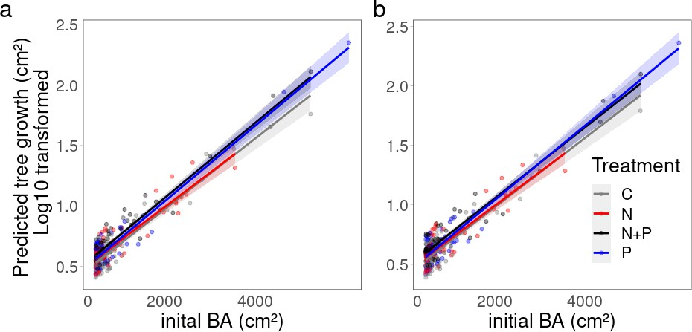
Fig. S1: Predicted tree growth and SE at the 1000m asl site with confidence interval as a function of initial basal area (BA). Predictions values were extracted from the two best models for the 1000m asl site that consider growth over at least 12 years as a function of the additive effects of nutrients added (N, P), as well as the additive effects of tree functional traits (PC 1 or PC 2) and the additive effect of initial tree size. (a) Model using PC 1. (b) Model using PC 2.
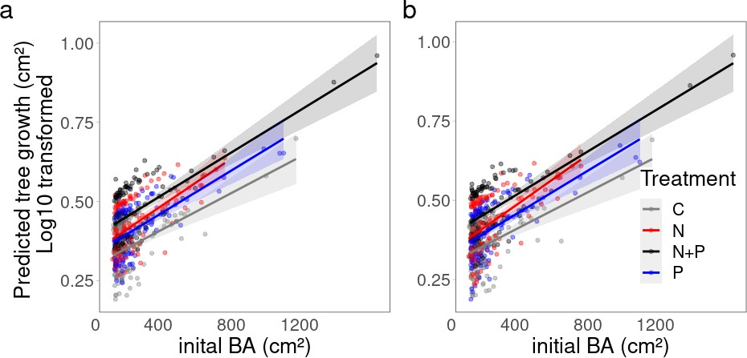
Fig. S2: Predicted tree growth and SE at the 2000m asl site with confidence interval as a function of initial basal area. Predictions values were extracted from the two best models for the 2000m asl site that consider growth over at least 12 years as a function of the additive effects of nutrients added (N, P), as well as the additive effects of tree functional traits (PC 1 or PC 2) and the additive effect of initial tree size. (a) Model using PC 1. (b) Model using PC 2.

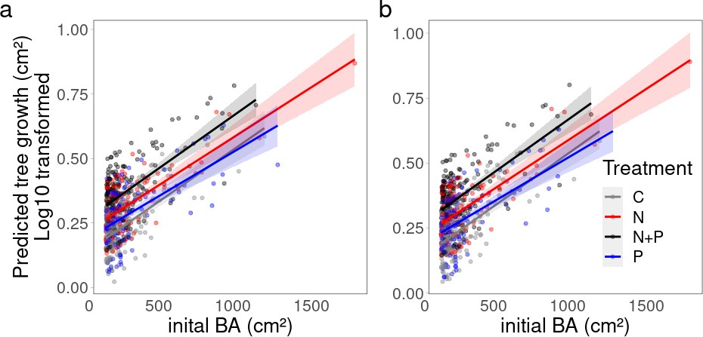
Fig. S3: Predicted tree growth and SE at the 3000m asl site with confidence interval as a function of initial basal area. Predictions values were extracted from the two best models for the 3000m asl site that consider growth over at least 12 years as a function of the additive effects of nutrients added (N, P), as well as the additive effects of tree functional traits (PC 1 or PC 2) and the additive effect of initial tree size. (a) Model using PC 1. (b) Model using PC 2.

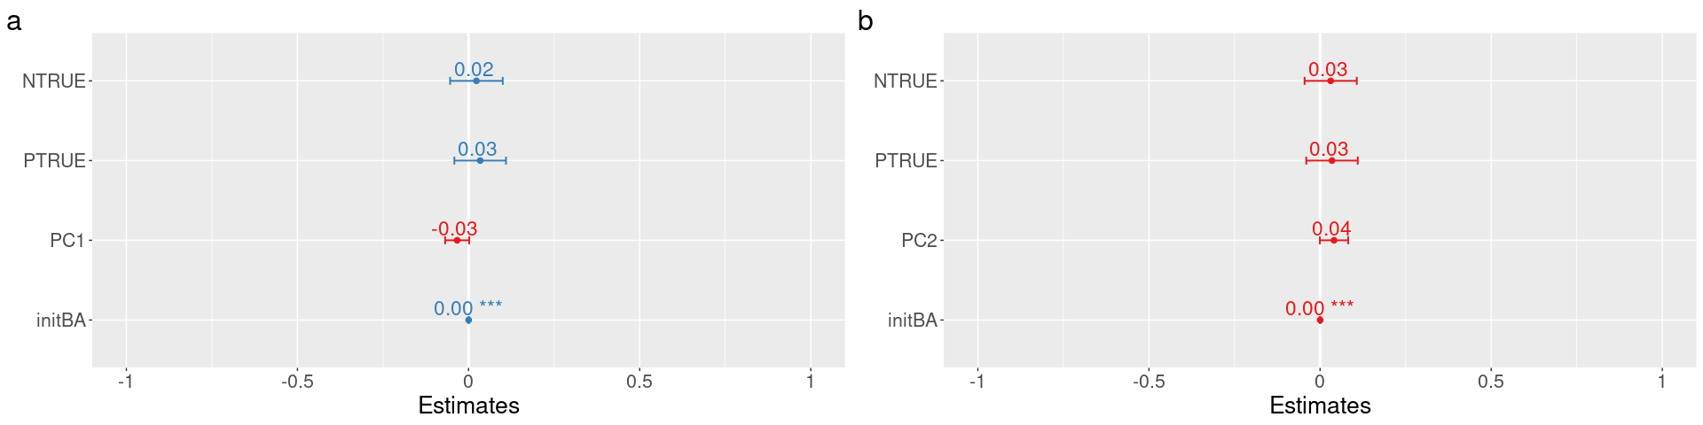
Fig. S4: Forest-plot for the estimates in the fitted model for the 1000m asl site, with means shown by points and whiskers representing the 95% confidence interval. Positive coefficients are in blue and negative are in red. (a) Model using PC 1. (b) Model using PC 2. Signif. codes 0 ‘***’ 0.001 ‘**’ 0.01 ‘*’ 0.05 ‘.’ 0.1 ‘ ’ 1
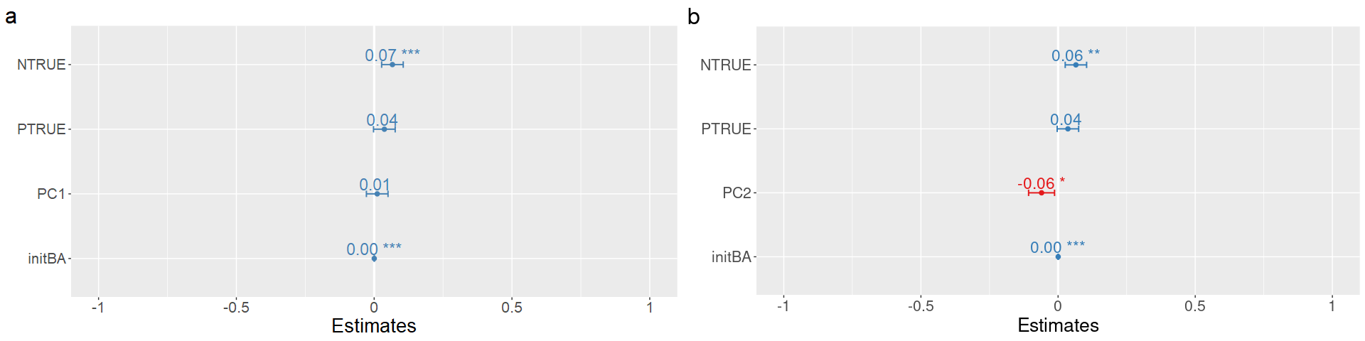
Fig. S5: Forest-plot for the estimates in the fitted model for the 2000m asl site, with means shown by points and whiskers representing the 95% confidence interval. Positive coefficients are in blue and negative are in red. (a) Model using PC 1. (b) Model using PC 2. Signif. codes 0 ‘***’ 0.001 ‘**’ 0.01 ‘*’ 0.05 ‘.’ 0.1 ‘ ’ 1
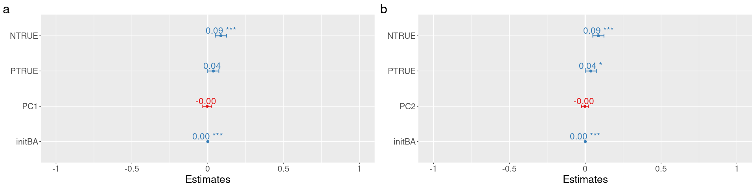
Fig. S6: Forest-plot for the estimates in the fitted model for the 3000m asl site, with means shown by points and whiskers representing the 95% confidence interval. Positive coefficients are in blue and negative are in red. (a) Model using PC 1. (b) Model using PC 2. Signif. codes 0 ‘***’ 0.001 ‘**’ 0.01 ‘*’ 0.05 ‘.’ 0.1 ‘ ’ 1

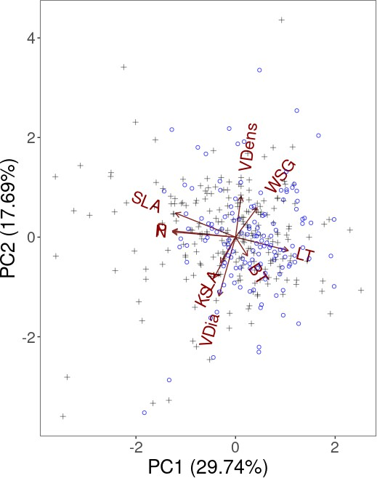

Fig. S7: Probabilistic principal component analysis (PPCA) from left to right of 352 grouped species traits across three elevations: the 1000m asl site at Bombuscaro, Ecuador; the 2000m asl site at the Reserva San Francisco, Ecuador; and the 3000m asl site at Cajanuma, Ecuador. Tree species that are represented inside the NuMEx plots are visualized as blue circles. Ten functional traits were included in the PPCAs: foliar nitrogen (N) and foliar phosphor (P) concentrations, leaf area (LA), leaf toughness (LT), specific leaf area (SLA), bark thickness (BT), sapwood-specific conductivity (KS), stem vessel density (VDens), stem vessel diameter (VDia), and wood-specific gravity (WSG).

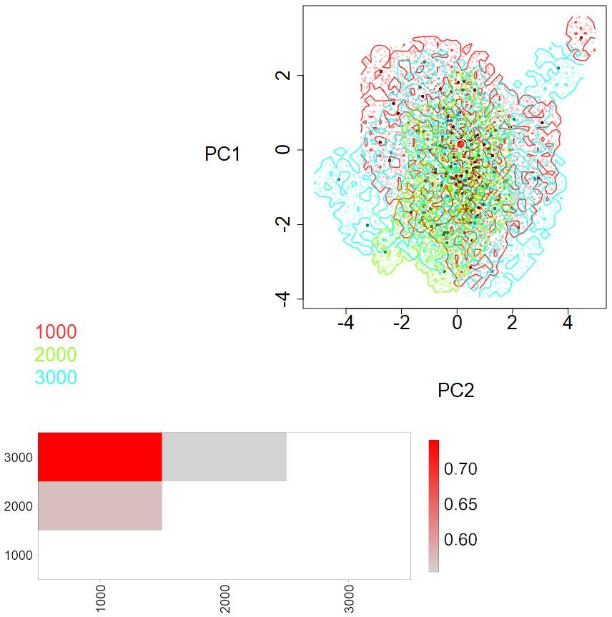
Fig. S8: Estimated two-dimensional hypervolumes for the three elevations inside the study area of the NuMEx project in the tropical montane forest in south Ecuador listed in the bottom left inset shown as pair plots. Variables have not been transformed as they share the same scale. The coloured points for each elevation reflect the stochastic description of each hypervolume, i.e., random points sampled from the inferred hypervolume, rather than original observations. The inset shows all possible pairwise overlaps between site pairs, i.e., the overlap between the trait space (as derived from the PC axis) of each one site to another (calculated as 2 × shared volume/summed volume). The hypervolume considers only species situated inside NuMEx plots.

