Title: Intrinsic water-use efficiency remains unchanged despite nutrient addition across an elevational gradient in tropical montane forests
Authors:
Andrea Chávez-Pacheco^{a,}, Selene Báez^{b}, Jürgen Homeier, Hans Verbeeck ª, Marijn Bauters^{bc}
*Corresponding author: andrea.chavezpacheco@ugent.be, Coupure Links 653, 9000 Gent, Belgium
Affiliations:
ª Q-ForestLab, Department of Environment, Ghent University, Coupure Links 653, 9000, Ghent, Belgium
^{b} Departamento de Biología, Escuela Politécnica Nacional, Av. Ladrón de Guevara y Andalucía, Quito-Ecuador.
^{c} Isotope Bioscience Laboratory – ISOFYS, Department of Green Chemistry and Technology, 9000, Ghent University, Coupure Links 653, Ghent, Belgium
d Conservation Ecology, University of Marburg, Germany
Keywords:
Nutrient experiment, tropical mountain forest, isotopes, water use efficiency, altitudinal gradient, Andes ecosystems

Abstract
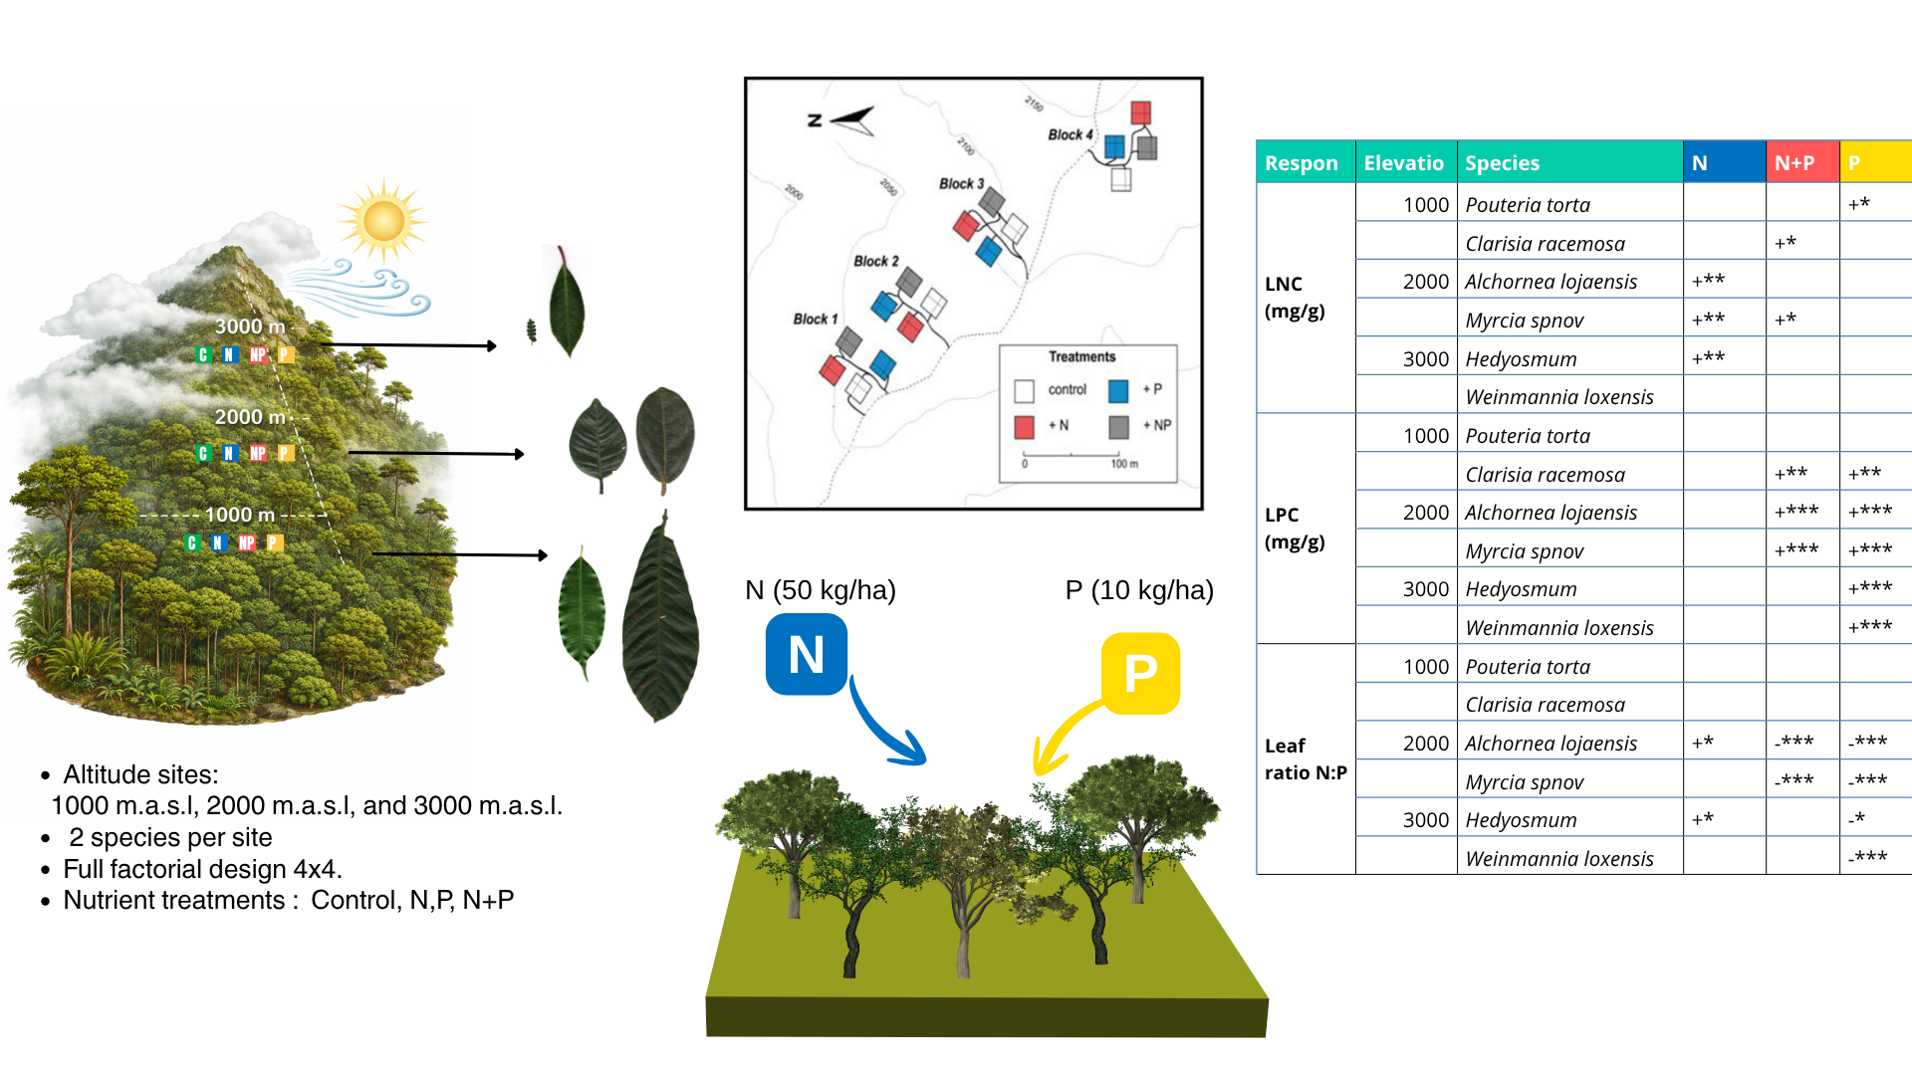

Introduction

- Nutrient deposition in the tropics effects. Literature: (Wright 2019) has an overview of tropical experiments. (Sayer & Banin 2016) Meta-analyzes of tropical mountains.(Dalling et al. 2016) also an overview on nutrients on mountain forests.

- Experimental nutrient manipulations suggest that lower montane forests are highly sensitive to N+P addition. Indeed, N+P addition increase tree growth rate in periods as short as one year (Homeier et al 2011). Moreover, addition of N+P increases the growth rates of species with acquisitive resource use strategies, relative to species with conservative strategies (Báez and Homeier 2018). However, plant responses to nutrient addition remain largely dependent on species identity .

- NUMEX is a long-term nutrient manipulation experiment established in 2009 in a tropical montane forest, designed to evaluate ecosystem responses to sustained, moderate additions of nitrogen (N) and phosphorus (P).Use (Homeier et al. 2012; Cárate-Tandalla et al. 2018a) for references on the experiment. Numex was set along a nutrient limitation gradient, with expected P limitation at 1000 m, N and P limitation at 2000 m, and N limitation at 3000 m.

- Intrinsic water-use efficiency (iWUE) is a key physiological parameter that links the carbon and water cycles. It reflects how plants balance carbon assimilation with stomatal regulation of water loss. Literature on its relevance.

- Studies examining how nutrient availability affects iWUE in tropical montane forests remain scarce. Most experimental evidence on nutrient–water use interactions comes from temperate systems. Previous studies suggest that nutrient deposition can increase the representation of plants with traits associated with higher photosynthetic capacity ,particularly in nitrogen-limited ecosystems (Huang et al., 2016).
Previous studies at this site have shown that some species exhibit higher nitrogen and phosphorus concentrations in the experimental plots (ref). We hypothesize that moderate nutrient addition after 18 years will increase plant iWUE. Assessing leaf-level response of water-use efficiency iWUE nutrient addition experiment allows us to explore the balance between carbon gain and water loss under these conditions. Likewise, we use the elevational gradient of the experiment to evaluate how this response is modulated by changes in elevation.
Specifically, we aim to answer the following questions:
- What is the effect of moderate nutrient addition on leaf nutrient concentrations across treatments along an elevational gradient?
- Does nutrient addition affect iWUE, δ¹³C, and Ci/Ca across the elevational gradient?
- What are the relationships among nutrient traits, iWUE, and elevation?

Materials and methods

Site description
The present study was conducted at the Nutrient Manipulation Experiment (NUMEX) sites, in the Podocarpus National Park and the San Francisco Reserve (SRF) located in southern Andes of Ecuador. The experiment was established across a 2000 m elevation gradient, with research sites at 1000 m, 2000 m, and 3000 m asl. All sites are evergreen old-growth forests located in protected forest areas with noticeable differences (Homeier et al., 2013).
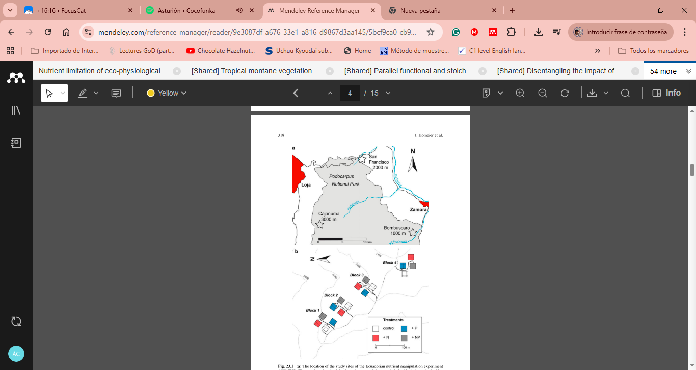
Fig. 1. Experimental Design of the NUMEX plots in the South of Ecuador (Homeier et al., 2013a)
The environmental conditions shared at the three sites are a tropical humid climate with wet season from April to July, and a less-humid period from September to December (Velescu et al., 2026). The temperature changes in the different sites mean annual temperature decreases with elevation, and annual precipitation increases with elevation, see Table 1 with site characteristics.
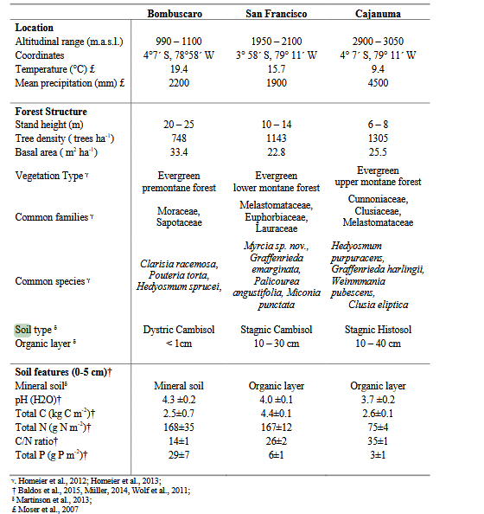
Table 1. Site characteristics of NUMEX data from Cárate-Tandalla et al., (2018)
Experimental design
NUMEX sites were established to explore the effects of moderate nutrient deposition on tropical mountain forests in an elevation gradient. The plots were established inside a protected area, closed canopy stands without visible signs of disturbance and distributed at least 10 m apart from each other (Homeier et al., 2013a). The experiment had full-factorial experimental design with four blocks per site. Each block had four 20 x 20 m with four treatments (N, P, N+P, control). One replicate plot per treatment was assigned to four different blocks. Since 2008, N and P were added to the plots at an annual rate of 50 kgha⁻¹ (as urea ((NH₂)₂CO)) and 10 kg P/ha (as monosodium phosphate (NaH₂PO₄)). The nutrients were dispersed across the plots on two application dates per year (Homeier et al., 2013a).
We collected data on commonly occurring species at each elevation, which have been monitored since the beginning of the experiment. See Table 2. Sampling at 1000 and 3000 m a.s.l. took place in November 2024, while samples at 2000 m a.s.l. were collected in November 2023. All sampled individuals had a diameter at breast height (DBH) greater than 10 cm, except for Hedyosmum purpurascens, which ranged between 5 and 10 cm. Details on the number of replicates for each plot at the corresponding elevation levels are provided in Table 2.
Elevation | Vegetation Type | Familiy | Species | C | N | N+P | P
1000 | Evergreen premontane forest | Moraceae | Clarisia racemosa Ruiz & Pav | 3 | 1 | 4 | 4
 |  | Sapotaceae | Pouteria torta (Mart.) Radlk | 11 | 10 | 7 | 8
2000 | Evergreen lower montane forest | Euphorbiaceae | Alchornea lojaensis Secco | 12 | 9 | 8 | 15
 |  | Myrtaceae | Myrcia sp nov | 15 | 10 | 13 | 11
3000 | Evergreen upper montane forest | Chloranthaceae | Hedyosmun purpurascens Todzia | 5 | 6 | 3 | 7
 |  | Cunoniaceae | Weinmania loxensis  Harling | 5 | 5 | 2 | 6
Table 2. Overview of samples collected.

Leaf morphology
Sun-exposed leaves were collected, and leaf functional traits were measured: leaf area, thickness, force to punch, and specific leaf area (SLA) following guidelines from Pérez-Harguindeguy et al., (2013). For thickness and force to punch, three randomly selected leaves per plant were assessed at two points per leaf, avoiding veins. Plant-level measures were calculated by averaging leaf scale measures, and then averaging among leaves. For each tree, 15-20 fresh leaves were scanned using a flat bed scanner (EPSON V39 II MODEL J371B). The images were analyzed with ImageJ software for calculation of leaf area. Leaves were dried in a stove 72° hours at 70°C. Specific leaf area (SLA) was estimated as the ratio of leaf a leaf dry weight. Dry samples were milled using a centrifugal mill (ZM 200, Retsch, Haan, Germany; 0.25 mm sieve).

Leaf stoichimetry and isotopic composition
Leaf carbon content (LCC), leaf nitrogen content (LNC), and δ13C (‰ v.s.V-PDB) of the bulk were analyzed using an elemental analyzer (Automated Nitrogen Carbon Analyser; ANCA-SL, SerCon, 158 UK), interfaced with an Isotope Ratios Mass Spectrometer (). For this article, we also analyzed Nitrogen and Phosphorus per foliar area, as this parameter might be interesting to assess photosynthesis-nutrient relationships and give complementary insights (Lloyd et al., 2013). In addition, the leaf phosphorus content (LPC) was analyzed using an Inductively Coupled Plasma Analyzer (Optima 5300DV ICP-OES, Perkin Elmer) after digesting the samples with concentrated HNO3. Stoichiometric ratios C: N, N: P, and C: P were calculated at all mass ratios.

Foliar α-cellulose extraction was performed following the method described by Andreu-Hayles et al. (2019): 30 mg of pulverized sample was added to each glass filter, and then the chemical extractions for the analysis of carbon ( δ¹³C ) was performed. The samples were bleached with a sodium chlorite concentration of 1.5%, followed by a NaOH 10% wash at 70°, and a NaOH 17% wash to ensure a-cellulose is extracted. 0.4 mg of α-cellulose was weighed into tin capsules to determine the isotopic composition of (C¹³/¹²C) on an elemental analyzer (EA) coupled with an isotope ratio mass spectrometer described previously.

Calculations and statistical analyses

Data analysis
The classic model of C isotope discrimination during photosynthesis $∆^{13}C$ by Farquhar et al., 1982 was used using the cellulose derived delta13C.
$∆^{13}C_{i}=\frac{δ^{13}C_{air}-δ^{13}C_{i}}{1+δ^{13}C_{i}}$ (1)
If respiration-related fractionation, carbon isotope can be describe as:
$∆^{13}C_{i}=a+\left(b-a\right)\frac{C_{i_{}}}{C_{a}}-\frac{fΓ⋅}{C_{a}}$ (2)
The parameter a represents fractionation during CO₂ diffusion through the stomata (a = 4.4‰), while b corresponds to fractionation associated with carboxylation by Rubisco and PEP carboxylase (b = 27‰). An additional term accounts for fractionation during photorespiration (f = 12‰), where Γ* denotes the CO₂ compensation point in the absence of day respiration (≈ 40 ppmv).
$Ci=\frac{Ca\left(Δ13Ccell-a\right)+fτ^{⋅}}{b-a}$ (3)
Photosynthetic rate (A) and stomatal conductance (gₛ) regulate CO₂ concentration in the stomatal cavity (Cᵢ), while atmospheric CO₂ concentration is represented by Cₐ.
$WUE=\frac{A}{gs}=\frac{C_{a}}{1.6}\left(1-\frac{C_{i}}{C_{a}}\right)$ (4)
We used annual atmospheric CO₂ concentrations of 421.08 ppm for 2023 and 424.61 ppm for 2024, together with mean annual atmospheric δ¹³C values of −8.6475‰ and −8.71916‰, respectively, derived from global observatory records from Scripps CO2 Program (http://scrippsco2.ucsd.edu). Although atmospheric flask samples were collected along the elevational gradient to assess potential local variation in atmospheric CO₂ concentration and isotopic composition, mixed-effects models did not reveal a consistent elevational trend. While a simple linear model suggested lower CO₂ concentrations at higher elevations, this pattern should be interpreted cautiously because some high-elevation samples were collected in more open environments rather than within closed-canopy forest conditions, potentially affecting local atmospheric mixing and CO₂ dynamics. Given the limited local sampling coverage and the substantial spatial and temporal variability expected in tropical montane environments, we considered globally standardized atmospheric records to provide a more robust and consistent baseline for intrinsic water-use efficiency (iWUE) calculations.
Statistical analyses
Treatment effects on iWUE, leaf nutrients, and leaf traits were evaluated using linear mixed-effects models, with N and P included as binary fixed-effect predictors indicating nutrient addition (1) or no addition (0), and Block included as a random effect. Estimated marginal means (EMMs) were subsequently calculated from the fitted models to compare treatment responses.
Response variables of leaf nutrients (LNC and LPC) were log-transformed to fit the statistical assumptions. For all models, normality and homoskedasticity of the residuals were checked visually using, respectively, normal QQ plots and plots of the residuals as a function of the fitted values. Statistical significance was set at α = 0.05. All data and statistical analyses were carried out using RStudio (version 4.5.2 RStudio Team, 2020).
Lastly, with the aim to understand the trends across elevations, scaling relationships between iWUE, Narea and SLA were assessed using standardized major axis (SMA) regression (Wright et al. 2004; Warton et al. 2006; Mantlana et al. 2008). SMA regression is a regression method preferred used when the true slope of a relationship needs to be analyzed, rather than predicting values for a dependent variable from a predictor variable. It is thus commonly used to establish allometric scaling relationships, especially when the two variables are not measured on comparable scales (Warton et al. 2006).

Results
Overview –
The foliar nutrients showed a stronger response to nutrient addition, while the physiological parameters here examined namely intrinsic water use efficiency (iWUE) and δ13C did not show a consistent response across the species. In general, responses from 2000 m and 3000 m were more similar in magnitude than in those from the lower montane site.
 |  | δ13C (‰ v.s.V-PDB) |  | iWUE  (μmol/mol) |  | LNC (mg/g) |  | LPC (mg/g) |  | N:P
 |  | mean | std | mean | std | mean | std | mean | std | mean | std
Clarisia racemosa | C | -30.63 | 0.42 | 36.98 | 5.19 | 17.39 | 2.56 | 0.79 | 0.05 | 21.87 | 2.18
 | N | -31.8 |  | 22.59 |  | 20.06 |  | 0.96 |  | 20.86
 | NP | -30.88 | 0.36 | 33.97 | 4.43 | 23.65 | 1.5 | 1.15 | 0.14 | 20.83 | 3.48
 | P | -29.84 | 1.24 | 46.63 | 15.2 | 19.62 | 2.69 | 1.17 | 0.17 | 16.87 | 2.64
Pouteria torta | C | -31.55 | 0.76 | 25.62 | 9.34 | 15.29 | 1.26 | 0.65 | 0.12 | 24.45 | 5.16
 | N | -31.27 | 0.87 | 40.17 | 22.44 | 15.69 | 1.16 | 0.64 | 0.2 | 25.95 | 5.44
 | NP | -31.74 | 1.35 | 23.36 | 16.58 | 16.38 | 0.98 | 0.73 | 0.07 | 22.58 | 1.81
 | P | -31.27 | 0.93 | 29.13 | 11.48 | 16.68 | 1.52 | 0.77 | 0.13 | 22.47 | 5.11
Alchornea lojaensis | C | -26.51 | 0.89 | 87.61 | 10.75 | 11.61 | 1.5 | 0.78 | 0.12 | 15.07 | 2.24
 | N | -26.57 | 1.13 | 86.9 | 13.72 | 13.14 | 1.82 | 0.79 | 0.15 | 16.83 | 1.83
 | NP | -26.77 | 1.45 | 84.43 | 17.61 | 12.04 | 1.6 | 1.32 | 0.33 | 9.59 | 2.28
 | P | -27.06 | 1.51 | 81.01 | 18.29 | 11.1 | 1.37 | 1.24 | 0.28 | 9.36 | 2.34
Myrcia sp nov | C | -27.79 | 1.15 | 72.02 | 13.97 | 8.82 | 1.17 | 0.43 | 0.17 | 22.9 | 4.05
 | N | -27.24 | 0.92 | 78.7 | 11.13 | 9.99 | 0.83 | 0.43 | 0.03 | 23.54 | 2.22
 | NP | -27.27 | 1 | 78.33 | 12.19 | 9.79 | 0.81 | 0.88 | 0.36 | 12.42 | 3.68
 | P | -27.34 | 0.66 | 77.63 | 8.05 | 8.19 | 0.95 | 1.7 | 0.66 | 6.34 | 5.05
Hedyosmun purpurascens | C | -26.81 | 1.44 | 83.75 | 17.6 | 14.31 | 1.09 | 0.84 | 0.08 | 17.17 | 1.02
 | N | -26.35 | 2.06 | 89.25 | 25.08 | 17.47 | 3.63 | 0.8 | 0.05 | 21.78 | 4.15
 | NP | -24.85 | 1.27 | 107.56 | 15.36 | 17.08 | 1.68 | 1.07 | 0.08 | 15.94 | 0.42
 | P | -27.29 | 1.59 | 77.86 | 19.36 | 15.65 | 1.54 | 1.42 | 0.44 | 12.15 | 3.82
Weinmania loxensis | C | -27.7 | 0.27 | 72.87 | 3.29 | 10.43 | 1.34 | 0.56 | 0.05 | 18.65 | 1.67
 | N | -28.06 | 0.9 | 68.51 | 10.95 | 11.47 | 1.77 | 0.61 | 0.05 | 18.89 | 1.99
 | N+P | -29.03 | 0.79 | 56.6 | 9.7 | 11.17 | 0.14 | 0.72 | 0.07 | 15.57 | 1.25
 | P | -28.38 | 1.13 | 64.54 | 13.8 | 10.73 | 1.7 | 1.64 | 0.44 | 7.31 | 3.43

Table 3. Summary of leaf nutrient concentrations and physiological traits under nutrient addition treatments, presented as means ± standard deviations (SD).
In the control groups, LNC was higher at 1000 m sites in the species: C. racemosa (mean = 17.29 mg g⁻¹ ) and P. torta (mean= 15.20 mg g⁻¹). The values for LNC for 2000m sites: Myrcia sp. Nov (mean = 8.82 mg g⁻¹) and A. lojaensis (mean = 11.61 mg g⁻¹); and 3000 m sites: H. purpurascens (mean = 14.31 mg g⁻¹), W. loxensis (mean = 10.43 mg g⁻¹) are in similar ranges. All species had an increase in foliar LNC in the N treatments with a significant response when comparted to the control for A. lojaensis, M. spnov and H. purpurascens. Interestingly, under P addition, P. torta showed an increase in N acquisition. Lastly, under the combination of nutrients (N+P) all species had increase the LNC, in this case significant responses were obtained for C. racemosa, A. lojaensis, Myrcia sp nov and H. purpurascens.
Higher nitrogen per unit leaf area (N_{area}) was found in the species occurring at 2000 m, Myrcia sp. nov. (mean = 2.43 g m⁻²) and A. lojaensis (mean = 3.27 g m⁻²). Across species, N_{area} generally increased in response to N addition, with the strongest response observed in H. purpurascens. Similar to the pattern found for LNC, P. torta showed an increase in N_{area} relative to the control plots. In contrast, for the other species at 2000 and 3000 m, P addition did not result in higher Narea values compared to the controls.
No clear patterns were found with the leaf phosphorus content (LPC). Similar leaf phosphorus concentrations (LPC) were found among control plants at different elevatios, with C. racemosa (mean = 0.79 mg g⁻¹), A. lojaensis (mean = 0.78 mg g⁻¹), and H. purpurascens (mean = 0.84 mg g⁻¹) showing comparable values. In the N addition plots, LPC tended to increase in some species, with a significant response for C. racemosa. In contrast, P addition consistently increased LPC across all species. A similar pattern was observed for phosphorus per unit leaf area (P_{area}), which increased under P addition in every species. Under N+P addition, C. racemosa, Myrcia sp. nov., and H. purpurascens exhibited higher LPC values than those in the control treatment. Myrcia sp. nov. and A. lojaensis showed particularly strong increases in P_{area} whit the combination of nutrients. suggesting enhanced phosphorus accumulation when both nutrients were supplied simultaneously.
In the control plots, N:P ratios were similar among P. torta (24) and C. racemosa (23), both occurring at 1000 m, and Myrcia sp. nov. (21) at 2000 m. In contrast, lower N:P ratios were observed in A. lojaensis (14), H. purpurascens, and W. loxensis (17). Nitrogen addition alone generally increased N:P ratios across species, with the strongest response observed in A. lojaensis. However, as described above, species receiving P addition exhibited higher LPC values, resulting in lower N:P ratios under both the N+P and P addition treatments. The enhanced phosphorus acquisition observed in most species under these treatments led to a relative increase in foliar P concentrations and consequently to reduced N:P ratios.
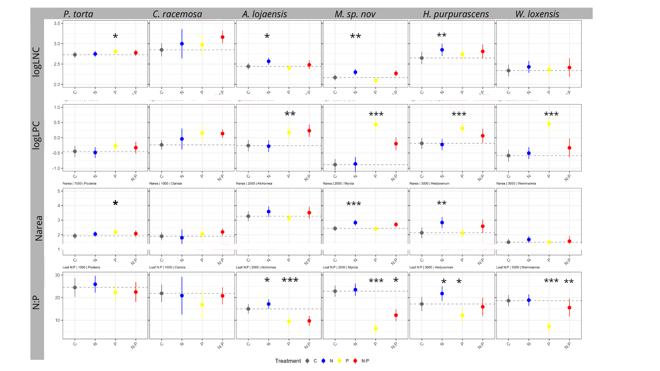
Figure 2. Estimated marginal means (± 95% confidence intervals) for leaf nutrients content log-transformed, Nitrogen per area foliar and ratio N:P across nutrient addition treatments (Control, N, P, and N + P), obtained from linear mixed-effects models with block as a random effect. Dashed lines indicate the estimated mean of the control treatment. Asterisks denote significant treatment effects (P < 0.05).
Intrinsic Water-Use Efficiency (iWUE) - δ¹³C – No significant differences in iWUE or δ¹³C were observed among treatment groups relative to the control within species.
A one-way ANOVA revealed a strong effect of elevation on iWUE (F2,48 =73.22). Post-hoc Tukey tests indicated significantly higher iWUE values at 2000 m and 3000 m compared to 1000 m, whereas no significant differences were detected between 2000 m and 3000 m. Specifically, in the control groups, the mean iWUE increased by approximately 50 µmol mol−1 between lower and higher elevations. Residuals met the assumption of normality according to the Shapiro–Wilk test (W=0.973, p=0.295). Across species, the Ci/Ca ratio decreased with elevation, indicating lower intercellular CO₂ concentrations relative to atmospheric CO₂ at higher elevations.
No statistically significant treatment effects were detected, except for a positive response of P. torta to N addition. In addition, iWUE showed slight increases in P. torta, Myrcia sp. nov., and H. purpurascens, whereas decreases were observed in C. racemosa, A. lojaensis, and W. loxensis, indicating contrasting species-specific responses within the same elevation. Similarly, the result of P. torta is largely driven by a few outlying observations; therefore, there is a need for caution about the interpretation. A similar species-specific pattern was reflected in δ¹³C variability. In contrast, the P treatment led to increases in iWUE for P. torta, C. racemosa, and Myrcia sp. nov., while decreases were observed in A. lojaensis, H. purpurascens, and W. loxensis. These results suggest that nutrient addition may modify physiological regulation, but such changes do not consistently translate into a coherent long-term isotopic signal. When evaluating the N x P interaction, positive effects were observed for C. racemosa, A. lojaensis, and H. purpurascens, whereas negative interaction effects were found for P. torta, Myrcia sp. nov., and W. loxensis.
.
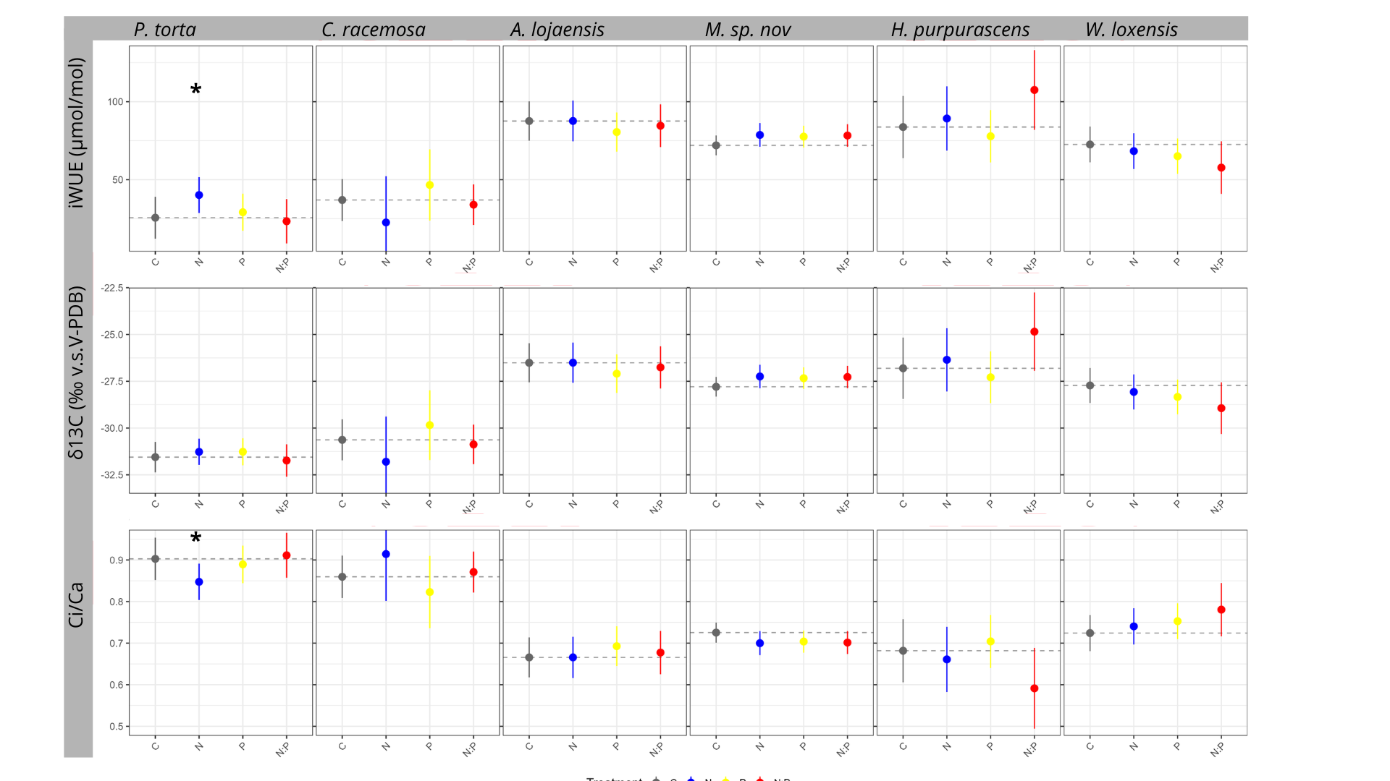Figure 3. Estimated marginal means (± 95% confidence intervals) for physiological and isotopic traits across nutrient addition treatments (Control, N, P, and N + P), obtained from linear mixed-effects models with block as a random effect. Dashed lines indicate the estimated mean of the control treatment. Asterisks denote significant treatment effects (P < 0.05).
Leaf nutrients and iWUE relationships
Exploratory SMA analyses revealed a consistent negative association between SLA and iWUE across all six species, with slopes ranging from −1.05 to −3.64. Species with lower SLA tended to exhibit higher intrinsic water-use efficiency, suggesting a coordination between conservative leaf construction and water-use strategies. This relationship was particularly strong in Myrcia and Alchornea, which showed the steepest negative slopes (−3.55 and −3.64, respectively) and the highest explanatory power (R² = 0.52 and 0.26). Supplementary material.
In contrast, SMA analyses showed a positive association between Narea and iWUE across all species, with slopes ranging from 27.3 to 64.8. The strongest relationships were observed in Pouteria torta, Hedyosmum purpurascens, and Weinmannia loxensis. However, these patterns should be interpreted as exploratory because the SMA analyses do not account for the experimental treatment structure but aims to understand the trends across elevations.

DISCUSSION

General overview
Our results show that after 18 years of moderate addition of nitrogen and phosphorus int the NUMEX experimental setting, the studied species did not exhibit a significant response in intrinsic water-use efficiency (iWUE) compared to control plots, despite detectable increases in leaf nutrient parameters.

Leaf nutrient responses -
- Previous studies.
- P uptake is higher than N.
- Coregulation of nutrients.
Leaf N and P are key elements analyzed in several articles as a consistent indicator of a response of nutrient inputs (Báez & Homeier, 2018; Baldos et al., 2015; Dietrich et al., 2016; Firn et al., 2019; Homeier et al., 2012, 2013b, 2017). As previously reported by Homeier et al., (2012), there are significant increases of leaf nutrient content in various of the most common species at different altitudes in this study site. Leaf tissue N:P ratios in mature trees were consistently high, but decreased following P addition across all species. This pattern has also been reported in the same region for seedlings (Cárate-Tandalla et al., 2018) and for mature trees at 2000 m a.s.l. (Homeier et al., 2012b).

Our results indicate that species at 2000 and 3000 m responded strongly to the nitrogen addition with higher LNC, LPC and Nareas. Elaborate why.

IWUE is not sensitive to nutrient inputs -
- Check other articles. I found Perkowski, indicates trade-offs between N and water use.
To our knowledge, studies explicitly examining iWUE responses to long-term nutrient addition in mature trees from tropical montane forests remain scarce. Intrinsic water-use efficiency (iWUE), Ci/Ca and δ¹³C did not show significant responses to fertilization treatments, despite observed increases in leaf nutrient parameters (LNC, LPC and Narea). Previous studies (e.g., Dusenge et al. 2015; Ziegler et al. 2020) have shown that, in tropical montane forest species, total nitrogen content—whether expressed on a mass or area basis—is not always a good predictor of photosynthetic capacity. This is largely because nitrogen allocation within leaves varies depending on species ecological strategies. Conservative species may allocate a greater proportion of nitrogen to structural components, defense, or light-harvesting complexes rather than to carboxylation machinery (e.g., Rubisco). As a result, increases in LNC or Narea do not necessarily lead to proportional increases in photosynthetic capacity because they are being allocated for different purposes (i.e. defense , and therefore do not directly translate into higher iWUE.

IWUE trends in the altitudinal gradient and association with traits-
Intrinsic water-use efficiency was higher at mid and high elevations, indicating that environmental constraints associated with elevation exert a stronger influence on plant water-use strategies than nutrient availability.
Previous studies have pointed out to an increase of iWUE with increasing elevation (Jiang et al., 2024; Midolo et al., 2019). Higher iWUE at upper elevations may be linked to more conservative trait syndromes (i.e., low SLA, low LNC), consistent with the plant economic spectrum, where water limitation and environmental stress favor resource-use efficiency (Jiang et al., 2024; Reich, 2014). Likewise,o ptimality theory predictions (Wang et al., 2016). explains this trend, as a response to atmospheric pressure declines with altitude, plants adjust their photosynthetic capacity and stomatal behaviour to maintain carbon assimilation under lower CO₂ partial pressures. These coordinated adjustments reduce Ci/Ca and increase carbon gain per unit stomatal conductance, resulting in higher intrinsic water-use efficiency at higher elevations.
Our results indicate that the two species selected at 2000 m exhibited the highest iWUE. This suggests that mid-elevation conditions may favor a combination of relatively high carbon assimilation and conservative water use, resulting in greater iWUE than at either lower or higher elevations. This pattern is consistent with the elevational trend in photosynthetic capacity reported by Wittich et al. (2012). In their study of 40 tree species in the same area, photosynthetic capacity reached a maximum around 2000 m, despite showing relatively small differences across the broader elevational gradient. The authors attributed this peak to higher foliar nutrient concentrations at mid-elevation. Although we did not directly assess photosynthetic capacity, the higher photosynthetic capacity observed in other species at the same elevation may help explain the elevated iWUE found in our study, as greater photosynthetic performance could increase carbon gain relative to water loss.
Lastly, our exploratory analyses indicate that, although nutrient addition increased leaf nutrient concentrations in some species, these changes did not necessarily translate into higher leaf nitrogen per unit area (Narea) or increased intrinsic water-use efficiency (iWUE). While Narea was positively associated with iWUE across species, we found no consistent evidence that nutrient addition increased Narea, nor that changes in Narea resulted in higher iWUE. These findings suggest that the relationship between nutrient availability and plant water-use strategies is complex and may be mediated by species-specific physiological responses. Therefore, further studies are needed in these highly biodiverse tropical montane forests to better understand the mechanisms underlying ecophysiological responses to nutrient enrichment and environmental change.

Conclusion
The results from the NUMEX experiment are consistent with research done in the area in previous years showing that nutrient additions, particularly phosphorus, significantly increased leaf phosphorus concentration (LPC) across species and elevations, indicating a clear physiological uptake response.
However, these changes in foliar nutrient status did not translate into consistent shifts in intrinsic water-use efficiency (iWUE) and delta13C under nutrient addition, which remained largely unresponsive across elevations. This suggests that nutrient availability was not a primary driver of iWUE in the studied species over the duration of the experiment. Nevertheless, the observed variation in leaf nutrient concentrations and iWUE along the elevational gradient provides insights into how these traits are associated with elevation, even though nutrient addition itself did not directly influence iWUE.
The observed decoupling between foliar nutrient enrichment and iWUE highlights that increased nitrogen availability does not necessarily enhance carbon–water coupling at the leaf level. Or that nitrogen content could be allocated for other purposes beyond photosynthesis.
These findings emphasize the importance of considering multiple leaf nutrient metrics and environmental gradients to better understand physiological responses under changing nutrient and climatic conditions.

Acknowledgments
Special thanks go to Karina Gonzalez, the field coordinator and local people who helped with the sample collection and scientific follow-up. Additionally, we would like to thank Elise and Katja for their help with the isotopic analyses of the leaf material.

CRediT authorship contribution statement
Andrea Chávez-Pacheco: Writing – original draft, Data analysis, Lab work, Sampling, Investigation, Conceptualization, Data curation Marijn Bauters: Writing – review & editing, Investigation, Conceptualization, Resources, Funding acquisition, Data curation.

Declaration of Competing Interest
The authors declare not to have any known conflict of interest.

Data availability
Data will be made available on request.

Funding sources
This study was made possible by the VLIRUOS-TEAM Project: Restoration and Recovery of Tropical Mountain Forest.

Declaration of generative AI and AI-assisted technologies in the writing process
During the preparation of this work, the first author used ChatGPT in order to improve the grammar and language of the manuscript and kept 95% of the original ideas and text.
References
Andreu-Hayles, L., Levesque, M., Martin-Benito, D., Huang, W., Harris, R., Oelkers, R., Leland, C., Martin-Fernández, J., Anchukaitis, K. J., & Helle, G. (2019). A high yield cellulose extraction system for small whole wood samples and dual measurement of carbon and oxygen stable isotopes. Chemical Geology, 504, 53–65. https://doi.org/10.1016/J.CHEMGEO.2018.09.007
Báez, S., & Homeier, J. (2018). Functional traits determine tree growth and ecosystem productivity of a tropical montane forest: Insights from a long-term nutrient manipulation experiment. Global Change Biology, 24(1), 399–409. https://doi.org/10.1111/gcb.13905
Baldos, A. P., Corre, M. D., & Veldkamp, E. (2015). Response of N cycling to nutrient inputs in forest soils across a 1000-3000 m elevation gradient in the Ecuadorian Andes. Ecology, 96(3), 749–761. https://doi.org/10.1890/14-0295.1
Cárate-Tandalla, D., Camenzind, T., Leuschner, C., & Homeier, J. (2018). Contrasting species responses to continued nitrogen and phosphorus addition in tropical montane forest tree seedlings. Biotropica, 50(2), 234–245. https://doi.org/10.1111/btp.12518
Dietrich, K., Spoeri, E., & Oelmann, Y. (2016). Nutrient addition modifies phosphatase activities along an altitudinal gradient in a tropical montane forest in Southern Ecuador. Frontiers in Earth Science, 4, 163776. https://doi.org/10.3389/feart.2016.00012
Firn, J., McGree, J. M., Harvey, E., Flores-Moreno, H., Schütz, M., Buckley, Y. M., Borer, E. T., Seabloom, E. W., La Pierre, K. J., MacDougall, A. M., Prober, S. M., Stevens, C. J., Sullivan, L. L., Porter, E., Ladouceur, E., Allen, C., Moromizato, K. H., Morgan, J. W., Harpole, W. S., … Risch, A. C. (2019). Leaf nutrients, not specific leaf area, are consistent indicators of elevated nutrient inputs. Nature Ecology & Evolution, 3(3), 400–406. https://doi.org/10.1038/S41559-018-0790-1
Homeier, J., Báez, S., Hertel, D., & Leuschner, C. (2017). Editorial: Tropical forest ecosystem responses to increasing nutrient availability. Frontiers in Earth Science, 5, 255840. https://doi.org/10.3389/feart.2017.00027
Homeier, J., Hertel, D., Camenzind, T., Cumbicus, N. L., Maraun, M., Martinson, G. O., Poma, L. N., Rillig, M. C., Sandmann, D., Scheu, S., Veldkamp, E., Wilcke, W., Wullaert, H., & Leuschner, C. (2012). Tropical Andean Forests Are Highly Susceptible to Nutrient Inputs—Rapid Effects of Experimental N and P Addition to an Ecuadorian Montane Forest. PLOS ONE, 7(10), e47128. https://doi.org/10.1371/JOURNAL.PONE.0047128
Homeier, J., Leuschner, C., Bräuning, A., Cumbicus, N. L., Hertel, D., Martinson, G. O., Spannl, S., & Veldkamp, E. (2013a). Effects of Nutrient Addition on the Productivity of Montane Forests and Implications for the Carbon Cycle. 315–329. https://doi.org/10.1007/978-3-642-38137-9_23
Homeier, J., Leuschner, C., Bräuning, A., Cumbicus, N. L., Hertel, D., Martinson, G. O., Spannl, S., & Veldkamp, E. (2013b). Effects of Nutrient Addition on the Productivity of Montane Forests and Implications for the Carbon Cycle. 315–329. https://doi.org/10.1007/978-3-642-38137-9_23
Jiang, F., Pu, T., Xue, Z. J., Ma, Y. W., Shi, X. Y., & Shi, F. X. (2024). Stable carbon isotope composition and intrinsic water use efficiency in plants along an altitudinal gradient on the eastern slope of Yulong Snow Mountain, China. Ecological Processes, 13(1), 1–13. https://doi.org/10.1186/S13717-024-00518-4/FIGURES/6
Lloyd, J., Bloomfield, K., Domingues, T. F., & Farquhar, G. D. (2013). Photosynthetically relevant foliar traits correlating better on a mass vs an area basis: Of ecophysiological relevance or just a case of mathematical imperatives and statistical quicksand? New Phytologist, 199(2), 311–321. https://doi.org/10.1111/NPH.12281;PAGE:STRING:ARTICLE/CHAPTER
Midolo, G., De Frenne, P., Hölzel, N., & Wellstein, C. (2019). Global patterns of intraspecific leaf trait responses to elevation. Global Change Biology, 25(7), 2485–2498. https://doi.org/10.1111/GCB.14646;WEBSITE:WEBSITE:PERICLES;REQUESTEDJOURNAL:JOURNAL:13652486;JOURNAL:JOURNAL:13652486;WGROUP:STRING:PUBLICATION
Pérez-Harguindeguy, N. A., Díaz, S. A., Garnier, E. B., Lavorel, S. C., Poorter, H. D., Jaureguiberry, P. A., Bret-Harte E, M. S., Cornwell F, W. K., Craine G, J. M., Gurvich A, D. E., Urcelay, C. A., Veneklaas H, E. J., Reich I, P. B., Poorter, L. J., Wright K, I. J., Ray, P. L., Enrico, L. A., Pausas M, J. G., de Vos F, A. C., … C Cornelissen F, J. H. (2013). New handbook for standardised measurement of plant functional traits worldwide. Australian Journal of Botany. https://doi.org/10.1071/BT12225
Velescu, A., Homeier, J., Espinosa, C. I., & Wilcke, W. (2026). Response of element cycling and budgets to nutrient additions in a tropical montane forest of Ecuador. Geoderma, 466(11), 117698. https://doi.org/10.1016/j.geoderma.2026.117698

