Supporting Information
Article title: Above- and belowground strategies of tropical montane tree species are coordinated and driven by small-scale nitrogen availability

Authors: Kerstin Pierick, Christoph Leuschner, Roman M. Link, Selene Baez, Andre Velescu, Wolfgang Wilcke & Jürgen Homeier

The following Supporting Information is available for this article:
Fig. S1 Map of the study area
Fig. S2 Soil C/N ratios and plant available P at the three elevational levels
Fig. S3 Relationship between soil C/N ratios and plant available P
Fig. S4 Relationship between PCA axis scores and nutrient availability
Table S1 List of permanent plots, their coordinates, and elevations
Table S2 List of tree species
Table S3 Inference and diagnostics from models with soil C/N ratio
Table S4 Marginal and conditional R² values of models
Table S5 Inference and diagnostics from models with soil P
Methods S1 Within-species centering models

Fig. S1 Map of the study area showing the locations of the three sites in southern Ecuador.
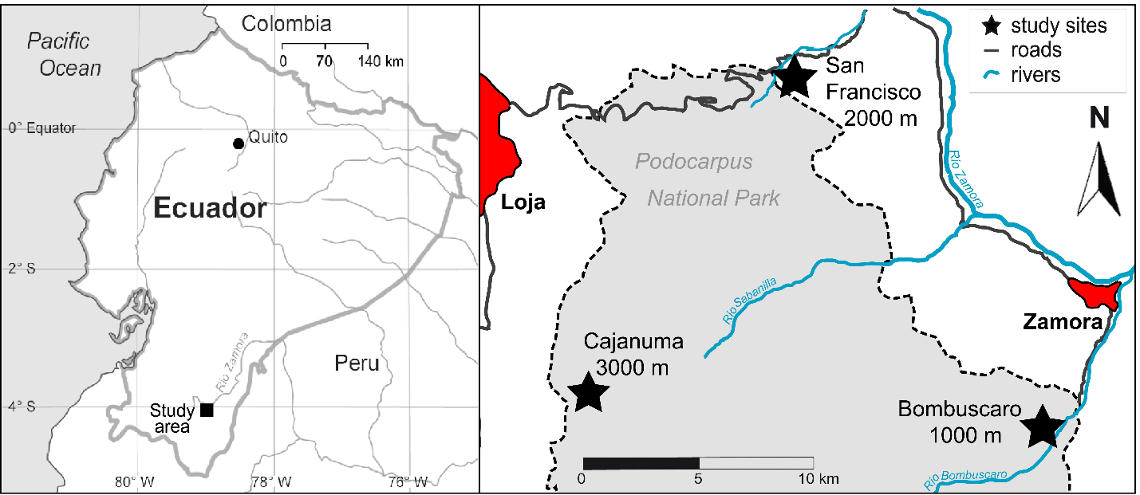

Fig. S2 Soil C/N ratios and plant-available P concentrations in the vicinity of the sampled trees at the three elevations.
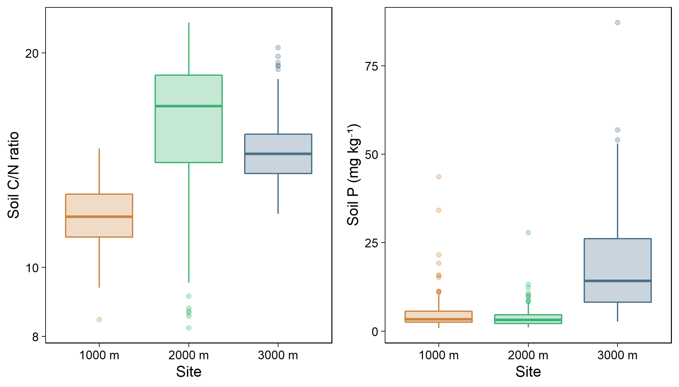
Fig. S3 Relationship between soil C/N ratios and plant-available P concentrations measured in the vicinity of the sampled trees at three elevations.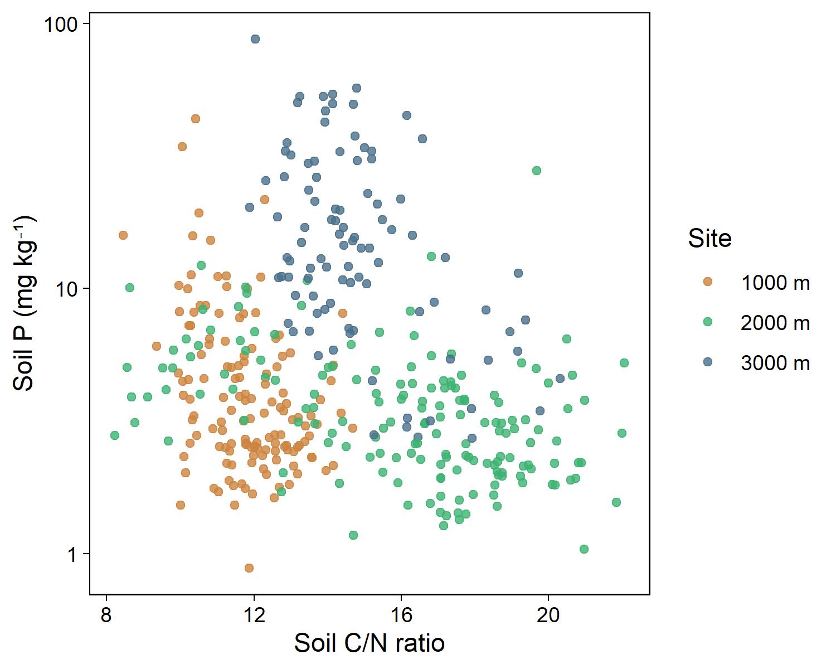

Fig. S4 Species-level relationships between the first and second axes of PCA_{all} with mean soil C/N ratio and mean log-transformed soil P concentration. Only the relationship between PCA_{all} PC1 and soil C/N ratio was significant in linear models (shown in detail in Fig. 5)
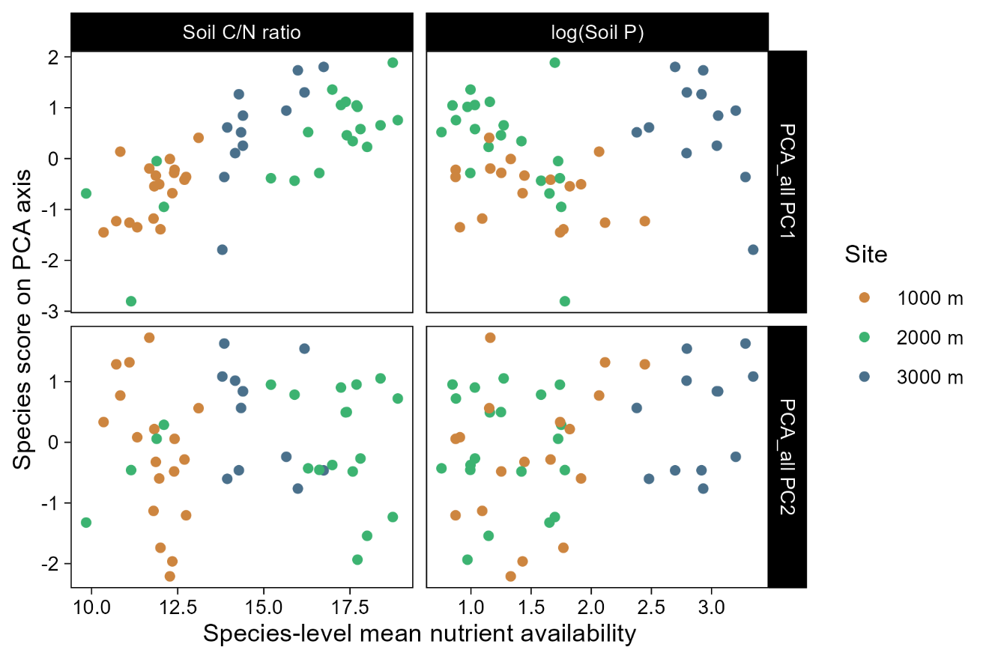

Table S1 List of permanent plots, their coordinates, and elevations.

Site | Plot ID | Latitude (°) | Longitude (°) | Elevation (m) center | Elevation (m) min | Elevation (m) max
Bombuscaro, Podocarpus NP | Bo1 | -4.11526 | -78.9673 | 1070 | 1035 | 1085
Bombuscaro, Podocarpus NP | Bo2 | -4.11847 | -78.9719 | 1100 | 1065 | 1150
Bombuscaro, Podocarpus NP | Bo3 | -4.12151 | -78.9762 | 1150 | 1120 | 1210
Reserva San Francisco | SF1 | -3.97460 | -79.0748 | 2050 | 2025 | 2080
Reserva San Francisco | SF2 | -3.97488 | -79.0725 | 2065 | 2020 | 2100
Reserva San Francisco | SF3 | -3.97420 | -79.0701 | 1960 | 1910 | 2010
Cajanuma, Podocarpus NP | Ca1 | -4.11445 | -79.1784 | 2915 | 2890 | 2940
Cajanuma, Podocarpus NP | Ca2 | -4.10870 | -79.1784 | 2900 | 2870 | 2930
Cajanuma, Podocarpus NP | Ca3 | -4.11445 | -79.1722 | 2960 | 2890 | 3010

Table S2 List of tree species with the number of replicates for leaf, root, and wood functional traits (N obs. Leaf, root, wood respectively), the number of tree individuals for which not all organs (leaf, root, wood) were sampled (N incomplete sampling), and the total number of trees from which at least one organ was sampled (Total N).
Family | Species | Site | N obs. leaf | N obs. root | N obs. wood | N incomplete sampling | Total N
Actinidiaceae | Saurauia JH5994 | 1000 | 8 | 8 | 8 | 0 | 8
Annonaceae | Guatteria pastazae | 1000 | 6 | 6 | 6 | 0 | 6
Apocynaceae | Aspidosperma rigidum | 1000 | 8 | 8 | 8 | 0 | 8
Clusiaceae | Chrysochlamys membranacea | 1000 | 8 | 8 | 8 | 0 | 8
Euphorbiaceae | Alchornea glandulosa | 1000 | 9 | 8 | 8 | 1 | 9
Fabaceae | Pseudopiptadenia suaveolens | 1000 | 8 | 8 | 8 | 0 | 8
Lauraceae | Ocotea JH6030 | 1000 | 8 | 8 | 8 | 0 | 8
Lecythidaceae | Grias peruviana | 1000 | 8 | 8 | 8 | 0 | 8
Malvaceae | Mollia gracilis | 1000 | 7 | 8 | 7 | 1 | 8
Melastomataceae | Miconia aff. punctata | 1000 | 8 | 8 | 8 | 0 | 8
Meliaceae | Guarea macrophylla | 1000 | 8 | 8 | 8 | 0 | 8
Moraceae | Clarisia racemosa | 1000 | 8 | 8 | 8 | 0 | 8
Moraceae | Pseudolmedia laevis | 1000 | 8 | 7 | 8 | 1 | 8
Myristicaceae | Otoba parvifolia | 1000 | 8 | 8 | 8 | 0 | 8
Phyllanthaceae | Hieronyma oblonga | 1000 | 8 | 7 | 8 | 1 | 8
Rubiaceae | Ladenbergia oblongifolia | 1000 | 8 | 8 | 8 | 0 | 8
Rubiaceae | Warszewiczia coccinea | 1000 | 8 | 8 | 8 | 0 | 8
Sapotaceae | Pouteria torta | 1000 | 8 | 7 | 8 | 1 | 8
Urticaceae | Pourouma cecropiifolia | 1000 | 6 | 4 | 4 | 2 | 6
Violaceae | Leonia crassa | 1000 | 8 | 8 | 8 | 2 | 10
Alzateaceae | Alzatea verticillata | 2000 | 9 | 8 | 9 | 1 | 9
Anacardiaceae | Tapirira guianensis | 2000 | 9 | 9 | 9 | 2 | 11
Chloranthaceae | Hedyosmum cf goudotianum | 2000 | 8 | 8 | 8 | 0 | 8
Clusiaceae | Clusia ducuoides | 2000 | 8 | 8 | 8 | 0 | 8
Cunoniaceae | Weinmannia microphylla | 2000 | 8 | 8 | 8 | 2 | 10
Euphorbiaceae | Alchornea lojaensis | 2000 | 9 | 8 | 9 | 1 | 9
Lauraceae | Ocotea andina | 2000 | 9 | 8 | 9 | 1 | 9
Malvaceae | Heliocarpus americanus | 2000 | 8 | 8 | 7 | 2 | 9
Melastomataceae | Graffenrieda emarginata | 2000 | 8 | 8 | 8 | 0 | 8
Melastomataceae | Meriania franciscana | 2000 | 5 | 8 | 5 | 3 | 8
Melastomataceae | Miconia calophylla | 2000 | 8 | 8 | 8 | 2 | 10
Meliaceae | Ruagea glabra | 2000 | 8 | 8 | 8 | 0 | 8
Moraceae | Naucleopsis francisci | 2000 | 9 | 8 | 9 | 1 | 9
Myrtaceae | Myrcia spnov | 2000 | 8 | 8 | 8 | 2 | 10
Phyllanthaceae | Hieronyma fendleri | 2000 | 9 | 8 | 9 | 3 | 10
Podocarpaceae | Podocarpus oleifolius | 2000 | 9 | 8 | 8 | 2 | 9
Primulaceae | Myrsine coriacea | 2000 | 8 | 8 | 8 | 0 | 8
Rubiaceae | Bathysa mollis | 2000 | 8 | 8 | 8 | 0 | 8
Sapindaceae | Matayba inelegans | 2000 | 10 | 8 | 10 | 2 | 10
Urticaceae | Cecropia angustifolia | 2000 | 10 | 10 | 10 | 2 | 11
Aquifoliaceae | Ilex laurina | 3000 | 8 | 8 | 8 | 0 | 8
Araliaceae | Oreopanax sessiliflorus | 3000 | 8 | 8 | 8 | 0 | 8
Asteraceae | Critoniopsis pycnantha | 3000 | 8 | 8 | 8 | 0 | 8
Chloranthaceae | Hedyosmum purpurascens | 3000 | 8 | 8 | 8 | 0 | 8
Clethraceae | Clethra revoluta | 3000 | 8 | 7 | 8 | 1 | 8
Clusiaceae | Clusia elliptica | 3000 | 8 | 7 | 8 | 1 | 8
Cunoniaceae | Weinmannia elliptica | 3000 | 8 | 7 | 8 | 1 | 8
Lauraceae | Aiouea dubia | 3000 | 8 | 7 | 8 | 1 | 8
Lauraceae | Ocotea rotundata | 3000 | 8 | 7 | 8 | 1 | 8
Melastomataceae | Miconia cf jahnii | 3000 | 8 | 7 | 8 | 1 | 8
Siparunaceae | Siparuna muricata | 3000 | 8 | 8 | 8 | 0 | 8
Theaceae | Gordonia fruticosa | 3000 | 9 | 7 | 9 | 2 | 9

Table S3 Inference and diagnostics from mixed models describing the dependency of functional traits on soil C/N ratio. α0: Intercept. βW: Within-species slope. βB: Between-species slope. τ : Standard deviation parameters of random effects. ρ: Correlation between random slopes and intercepts. σ: residual variance. For more information on the model structure, see Method S1. Shown are the posterior mean (Estimate) and the 95% highest density intervals (HDI low and high) of each parameter. Slope parameters are considered credibly different from zero when the 95% HDI does not include zero, in which case they are highlighted in bold case. As indicators of model convergence, ˆR, and bulk and tail effective sample sizes (ESS) are given.

Parameter | Estimate | HDI low | HDI high | $$\hat{R}$$ | ESS bulk | ESS tail
d_{root} ~ soil C/N ratio
α₀ | -0.010 | -0.246 | 0.225 | 1.002 | 1862 | 3743
β_{W} | 0.042 | -0.042 | 0.128 | 1.000 | 15878 | 13745
β_{B} | 0.016 | -0.257 | 0.284 | 1.002 | 2575 | 5160
τ_{species[intercept]} | 0.997 | 0.839 | 1.182 | 1.001 | 3812 | 7136
τ_{species[slope]} | 0.212 | 0.108 | 0.310 | 1.001 | 4855 | 4596
τ_{plot} | 0.082 | 0.019 | 0.154 | 1.000 | 7483 | 5912
ρ | -0.171 | -0.528 | 0.195 | 1.000 | 18423 | 12099
σ | 0.334 | 0.311 | 0.359 | 1.000 | 12885 | 13881
SRL ~ soil C/N ratio
α₀ | -0.014 | -0.243 | 0.213 | 1.005 | 1394 | 3437
β_{W} | -0.170 | -0.293 | -0.053 | 1.001 | 7504 | 11684
β_{B} | -0.151 | -0.410 | 0.114 | 1.001 | 1909 | 3855
τ_{species[intercept]} | 0.913 | 0.768 | 1.085 | 1.001 | 2890 | 6057
τ_{species[slope]} | 0.290 | 0.117 | 0.443 | 1.000 | 3475 | 3403
τ_{plot} | 0.117 | 0.032 | 0.208 | 1.001 | 4627 | 3472
ρ | 0.134 | -0.285 | 0.501 | 1.000 | 10921 | 8216
σ | 0.458 | 0.425 | 0.493 | 1.000 | 8075 | 11710
RTD ~ soil C/N ratio
α₀ | 0.051 | -0.161 | 0.263 | 1.000 | 4752 | 8338
β_{W} | 0.133 | 0.014 | 0.254 | 1.000 | 16048 | 16110
β_{B} | 0.313 | 0.096 | 0.530 | 1.001 | 4248 | 8099
τ_{species[intercept]} | 0.655 | 0.543 | 0.788 | 1.001 | 5307 | 9524
τ_{species[slope]} | 0.148 | 0.020 | 0.287 | 1.000 | 6006 | 6148
τ_{plot} | 0.250 | 0.172 | 0.338 | 1.001 | 11098 | 12697
ρ | 0.348 | -0.269 | 0.816 | 1.000 | 16149 | 10471
σ | 0.575 | 0.538 | 0.614 | 1.000 | 19265 | 14637
N_{root} ~ soil C/N ratio
α₀ | -0.026 | -0.200 | 0.148 | 1.001 | 2272 | 5082
β_{W} | -0.154 | -0.251 | -0.050 | 1.000 | 11518 | 12524
β_{B} | -0.656 | -0.861 | -0.449 | 1.001 | 2177 | 4232
τ_{species[intercept]} | 0.690 | 0.575 | 0.827 | 1.001 | 3567 | 7145
τ_{species[slope]} | 0.173 | 0.026 | 0.319 | 1.002 | 3479 | 4670
τ_{plot} | 0.087 | 0.010 | 0.186 | 1.001 | 4474 | 6568
ρ | 0.223 | -0.309 | 0.677 | 1.000 | 10210 | 9005
σ | 0.448 | 0.418 | 0.479 | 1.000 | 11269 | 14534
P_{root} ~ soil C/N ratio
α₀ | -0.034 | -0.237 | 0.167 | 1.001 | 4550 | 7882
β_{W} | -0.167 | -0.267 | -0.068 | 1.000 | 19851 | 14995
β_{B} | -0.576 | -0.774 | -0.375 | 1.001 | 4202 | 7456
τ_{species[intercept]} | 0.562 | 0.464 | 0.680 | 1.001 | 4689 | 9164
τ_{species[slope]} | 0.067 | 0.005 | 0.168 | 1.000 | 9135 | 9420
τ_{plot} | 0.271 | 0.198 | 0.356 | 1.000 | 11556 | 13002
ρ | 0.107 | -0.627 | 0.761 | 1.000 | 22034 | 12972
σ | 0.504 | 0.473 | 0.538 | 1.000 | 20194 | 15010
LDMC ~ soil C/N ratio
α₀ | 0.027 | -0.162 | 0.220 | 1.002 | 2413 | 4615
β_{W} | 0.017 | -0.080 | 0.112 | 1.000 | 27587 | 15364
β_{B} | 0.306 | 0.086 | 0.528 | 1.002 | 2316 | 4765
τ_{species[intercept]} | 0.788 | 0.658 | 0.940 | 1.001 | 3798 | 7601
τ_{species[slope]} | 0.103 | 0.009 | 0.229 | 1.001 | 6811 | 7743
τ_{plot} | 0.044 | 0.003 | 0.112 | 1.000 | 10193 | 9396
ρ | 0.184 | -0.494 | 0.749 | 1.000 | 20790 | 13008
σ | 0.530 | 0.497 | 0.565 | 1.000 | 19103 | 14063
Tough_{leaf} ~ soil C/N ratio
α₀ | -0.018 | -0.230 | 0.199 | 1.002 | 1561 | 3758
β_{W} | 0.039 | -0.020 | 0.099 | 1.000 | 16414 | 14975
β_{B} | 0.523 | 0.279 | 0.769 | 1.003 | 2039 | 4003
τ_{species[intercept]} | 0.888 | 0.747 | 1.053 | 1.003 | 3556 | 6326
τ_{species[slope]} | 0.089 | 0.015 | 0.161 | 1.001 | 5112 | 5396
τ_{plot} | 0.094 | 0.028 | 0.170 | 1.000 | 6385 | 5932
ρ | -0.156 | -0.667 | 0.410 | 1.000 | 21037 | 12818
σ | 0.265 | 0.247 | 0.283 | 1.000 | 18717 | 14893
Thick_{leaf} ~ soil C/N ratio
α₀ | 0.048 | -0.220 | 0.333 | 1.001 | 5445 | 7598
β_{W} | 0.059 | -0.011 | 0.127 | 1.000 | 20235 | 13582
β_{B} | 0.505 | 0.265 | 0.737 | 1.001 | 3613 | 6597
τ_{species[intercept]} | 0.638 | 0.521 | 0.781 | 1.001 | 3077 | 7006
τ_{species[slope]} | 0.103 | 0.012 | 0.204 | 1.000 | 4433 | 8275
τ_{plot} | 0.394 | 0.130 | 0.765 | 1.001 | 1889 | 5290
ρ | 0.005 | -0.543 | 0.553 | 1.000 | 20512 | 12580
σ | 0.300 | 0.280 | 0.321 | 1.000 | 14714 | 15414
LA ~ soil C/N ratio
α₀ | 0.008 | -0.201 | 0.223 | 1.002 | 1311 | 2781
β_{W} | -0.036 | -0.089 | 0.019 | 1.000 | 13708 | 13230
β_{B} | -0.627 | -0.878 | -0.375 | 1.003 | 1792 | 3748
τ_{species[intercept]} | 0.849 | 0.708 | 1.017 | 1.001 | 2979 | 5871
τ_{species[slope]} | 0.112 | 0.040 | 0.178 | 1.001 | 4669 | 3834
τ_{plot} | 0.026 | 0.002 | 0.072 | 1.000 | 9606 | 10877
ρ | 0.161 | -0.257 | 0.555 | 1.000 | 10711 | 10675
σ | 0.228 | 0.212 | 0.245 | 1.000 | 12026 | 14053
SLA ~ soil C/N ratio
α₀ | -0.047 | -0.236 | 0.142 | 1.000 | 2691 | 5307
β_{W} | -0.077 | -0.159 | 0.008 | 1.000 | 11994 | 14072
β_{B} | -0.595 | -0.802 | -0.381 | 1.002 | 2674 | 5225
τ_{species[intercept]} | 0.680 | 0.555 | 0.825 | 1.001 | 2673 | 5593
τ_{species[slope]} | 0.141 | 0.032 | 0.242 | 1.001 | 4705 | 5405
τ_{plot} | 0.164 | 0.068 | 0.281 | 1.000 | 2972 | 5390
ρ | 0.282 | -0.221 | 0.718 | 1.000 | 12393 | 10954
σ | 0.372 | 0.348 | 0.398 | 1.000 | 13305 | 13079
N_{leaf} ~ soil C/N ratio
α₀ | -0.010 | -0.195 | 0.170 | 1.003 | 2112 | 4068
β_{W} | -0.020 | -0.087 | 0.047 | 1.000 | 15654 | 15247
β_{B} | -0.674 | -0.885 | -0.458 | 1.003 | 2086 | 3881
τ_{species[intercept]} | 0.753 | 0.631 | 0.897 | 1.002 | 3132 | 5430
τ_{species[slope]} | 0.074 | 0.007 | 0.162 | 1.001 | 5857 | 7347
τ_{plot} | 0.089 | 0.029 | 0.162 | 1.001 | 5852 | 4733
ρ | 0.240 | -0.436 | 0.774 | 1.000 | 17399 | 12324
σ | 0.333 | 0.311 | 0.355 | 1.000 | 16312 | 15048
P_{leaf} ~ soil C/N ratio
α₀ | -0.023 | -0.237 | 0.195 | 1.001 | 2913 | 5845
β_{W} | -0.062 | -0.153 | 0.030 | 1.000 | 16261 | 13472
β_{B} | -0.568 | -0.800 | -0.338 | 1.001 | 3044 | 5579
τ_{species[intercept]} | 0.727 | 0.602 | 0.875 | 1.001 | 3210 | 6679
τ_{species[slope]} | 0.101 | 0.009 | 0.225 | 1.001 | 5084 | 8075
τ_{plot} | 0.224 | 0.151 | 0.311 | 1.000 | 7680 | 12556
ρ | 0.136 | -0.534 | 0.699 | 1.000 | 18516 | 10728
σ | 0.423 | 0.396 | 0.451 | 1.001 | 15987 | 15818
WSG ~ soil C/N ratio
α₀ | -0.006 | -0.225 | 0.215 | 1.001 | 2367 | 5162
β_{W} | 0.015 | -0.057 | 0.088 | 1.000 | 22613 | 15567
β_{B} | 0.331 | 0.079 | 0.586 | 1.001 | 3123 | 5230
τ_{species[intercept]} | 0.920 | 0.772 | 1.093 | 1.001 | 4036 | 7263
τ_{species[slope]} | 0.069 | 0.005 | 0.159 | 1.000 | 7614 | 7989
τ_{plot} | 0.087 | 0.018 | 0.169 | 1.000 | 6707 | 6806
ρ | 0.188 | -0.518 | 0.765 | 1.000 | 23679 | 11849
σ | 0.369 | 0.345 | 0.394 | 1.000 | 20154 | 14523

Table S4 Marginal and conditional R2 values for all models of functional traits in dependency of soil C/N ratio and soil P.
Model | R² marginal | R² conditional
d_{root} ~ soil C/N ratio | 0.01 | 0.89
SRL ~ soil C/N ratio | 0.03 | 0.79
RTD ~ soil C/N ratio | 0.08 | 0.66
N_{root} ~ soil C/N ratio | 0.34 | 0.80
P_{root} ~ soil C/N ratio | 0.28 | 0.75
LDMC ~ soil C/N ratio | 0.08 | 0.70
Tough_{leaf} ~ soil C/N ratio | 0.20 | 0.93
Thick_{leaf} ~ soil C/N ratio | 0.24 | 0.90
LA ~ soil C/N ratio | 0.29 | 0.95
SLA ~ soil C/N ratio | 0.30 | 0.86
N_{leaf} ~ soil C/N ratio | 0.34 | 0.89
P_{leaf} ~ soil C/N ratio | 0.23 | 0.82
WSG ~ soil C/N ratio | 0.08 | 0.87
d_{root} ~ soil P | 0.02 | 0.89
SRL ~ soil P | 0.01 | 0.77
RTD ~ soil P | 0.05 | 0.66
N_{root} ~ soil P | 0.01 | 0.80
P_{root} ~ soil P | 0.05 | 0.75
LDMC ~ soil P | 0.01 | 0.70
Tough_{leaf} ~ soil P | 0.01 | 0.93
Thick_{leaf} ~ soil P | 0.11 | 0.90
LA ~ soil P | 0.11 | 0.95
SLA ~ soil P | 0.06 | 0.86
N_{leaf} ~ soil P | 0.01 | 0.89
P_{leaf} ~ soil P | 0.02 | 0.83
WSG ~ soil P | 0.01 | 0.87

Table S5 Inference and diagnostics from mixed models describing the dependency of functional traits on soil Olsen P. α0: Intercept. βW: Within-species slope. βB: Between-species slope. τ : Standard deviation parameters of random effects. ρ: Correlation between random slopes and intercepts. σ: residual variance. For more information on the model structure, see Method S1. Shown are the posterior mean (Estimate) and the 95% highest density intervals (HDI low and high) of each parameter. Slope parameters are considered credibly different from zero when the 95% HDI does not include zero, in which case they are highlighted in bold case. As indicators of model convergence, ˆR, and bulk and tail effective sample sizes (ESS) are given.
Parameter | Estimate | HDI low | HDI high | $$\hat{R}$$ | ESS bulk | ESS tail
d_{root} ~ soil P
α₀ | -0.008 | -0.247 | 0.221 | 1.002 | 1904 | 3887
β_{W} | -0.035 | -0.095 | 0.026 | 1.000 | 21232 | 15706
β_{B} | 0.144 | -0.158 | 0.450 | 1.001 | 2201 | 4819
τ_{species[intercept]} | 0.987 | 0.832 | 1.167 | 1.001 | 3231 | 6458
τ_{species[slope]} | 0.109 | 0.012 | 0.207 | 1.002 | 3332 | 6517
τ_{plot} | 0.097 | 0.033 | 0.172 | 1.000 | 7594 | 6481
ρ | -0.060 | -0.561 | 0.456 | 1.001 | 16961 | 11107
σ | 0.343 | 0.320 | 0.368 | 1.000 | 11186 | 13514
SRL ~ soil P
α₀ | -0.025 | -0.254 | 0.201 | 1.001 | 1656 | 3990
β_{W} | 0.095 | 0.018 | 0.171 | 1.000 | 12551 | 14470
β_{B} | 0.025 | -0.271 | 0.321 | 1.003 | 2233 | 4673
τ_{species[intercept]} | 0.919 | 0.773 | 1.095 | 1.002 | 3153 | 6318
τ_{species[slope]} | 0.070 | 0.006 | 0.167 | 1.000 | 6035 | 7223
τ_{plot} | 0.133 | 0.036 | 0.231 | 1.000 | 4387 | 2979
ρ | -0.065 | -0.702 | 0.633 | 1.000 | 18172 | 11667
σ | 0.479 | 0.449 | 0.512 | 1.000 | 14632 | 14382
RTD ~ soil P
α₀ | 0.077 | -0.144 | 0.301 | 1.000 | 3817 | 7712
β_{W} | -0.102 | -0.197 | -0.006 | 1.000 | 20293 | 14783
β_{B} | -0.256 | -0.506 | -0.002 | 1.000 | 4079 | 7888
τ_{species[intercept]} | 0.681 | 0.561 | 0.820 | 1.001 | 4774 | 8790
τ_{species[slope]} | 0.114 | 0.014 | 0.229 | 1.000 | 6088 | 6642
τ_{plot} | 0.251 | 0.170 | 0.341 | 1.000 | 11622 | 12345
ρ | -0.276 | -0.784 | 0.341 | 1.000 | 15436 | 10661
σ | 0.576 | 0.539 | 0.614 | 1.000 | 19177 | 13929
N_{root} ~ soil P
α₀ | -0.051 | -0.279 | 0.180 | 1.000 | 3216 | 6402
β_{W} | 0.054 | -0.025 | 0.132 | 1.000 | 12819 | 14300
β_{B} | 0.025 | -0.258 | 0.307 | 1.001 | 3095 | 6131
τ_{species[intercept]} | 0.860 | 0.706 | 1.037 | 1.001 | 3783 | 6188
τ_{species[slope]} | 0.110 | 0.015 | 0.206 | 1.000 | 5467 | 7207
τ_{plot} | 0.177 | 0.061 | 0.294 | 1.001 | 3386 | 3488
ρ | -0.200 | -0.708 | 0.363 | 1.000 | 16347 | 13124
σ | 0.453 | 0.424 | 0.484 | 1.000 | 14109 | 13923
P_{root} ~ soil P
α₀ | -0.071 | -0.303 | 0.160 | 1.001 | 3956 | 7448
β_{W} | 0.061 | -0.027 | 0.150 | 1.000 | 16820 | 14883
β_{B} | 0.280 | 0.018 | 0.538 | 1.003 | 3162 | 6713
τ_{species[intercept]} | 0.637 | 0.522 | 0.775 | 1.001 | 3880 | 7781
τ_{species[slope]} | 0.145 | 0.032 | 0.245 | 1.000 | 4026 | 2884
τ_{plot} | 0.313 | 0.231 | 0.404 | 1.000 | 8694 | 11755
ρ | 0.188 | -0.296 | 0.639 | 1.000 | 11519 | 10612
σ | 0.497 | 0.465 | 0.532 | 1.000 | 13914 | 14274
LDMC ~ soil P
α₀ | 0.031 | -0.172 | 0.234 | 1.002 | 2011 | 3879
β_{W} | 0.064 | -0.017 | 0.147 | 1.000 | 15687 | 15271
β_{B} | -0.046 | -0.303 | 0.213 | 1.001 | 1985 | 3903
τ_{species[intercept]} | 0.832 | 0.696 | 0.993 | 1.001 | 3203 | 5829
τ_{species[slope]} | 0.109 | 0.010 | 0.234 | 1.000 | 4182 | 6383
τ_{plot} | 0.058 | 0.004 | 0.146 | 1.001 | 5968 | 8226
ρ | -0.073 | -0.631 | 0.542 | 1.000 | 13344 | 10998
σ | 0.526 | 0.492 | 0.562 | 1.000 | 15278 | 13857
Tough_{leaf} ~ soil P
α₀ | -0.013 | -0.249 | 0.223 | 1.003 | 1352 | 2669
β_{W} | -0.042 | -0.091 | 0.009 | 1.000 | 11079 | 13789
β_{B} | 0.124 | -0.166 | 0.418 | 1.004 | 1685 | 3645
τ_{species[intercept]} | 0.996 | 0.840 | 1.183 | 1.003 | 2148 | 4297
τ_{species[slope]} | 0.104 | 0.057 | 0.154 | 1.000 | 8134 | 7173
τ_{plot} | 0.065 | 0.008 | 0.140 | 1.000 | 5109 | 6534
ρ | -0.251 | -0.630 | 0.157 | 1.000 | 16685 | 14420
σ | 0.260 | 0.243 | 0.278 | 1.000 | 16483 | 14428
Thick_{leaf} ~ soil P
α₀ | 0.013 | -0.197 | 0.216 | 1.002 | 2822 | 5111
β_{W} | -0.002 | -0.057 | 0.052 | 1.000 | 19369 | 15669
β_{B} | 0.397 | 0.140 | 0.653 | 1.001 | 2818 | 5133
τ_{species[intercept]} | 0.774 | 0.632 | 0.940 | 1.002 | 2677 | 4751
τ_{species[slope]} | 0.068 | 0.007 | 0.143 | 1.000 | 5012 | 7891
τ_{plot} | 0.182 | 0.096 | 0.288 | 1.002 | 4208 | 7802
ρ | -0.065 | -0.662 | 0.534 | 1.001 | 23140 | 12030
σ | 0.302 | 0.282 | 0.322 | 1.000 | 18073 | 14704
LA ~ soil P
α₀ | 0.015 | -0.222 | 0.252 | 1.002 | 1007 | 2592
β_{W} | 0.037 | 0.001 | 0.074 | 1.000 | 18883 | 14710
β_{B} | -0.412 | -0.696 | -0.128 | 1.002 | 1803 | 3578
τ_{species[intercept]} | 0.957 | 0.802 | 1.143 | 1.001 | 2342 | 4954
τ_{species[slope]} | 0.035 | 0.003 | 0.085 | 1.000 | 6839 | 7380
τ_{plot} | 0.028 | 0.002 | 0.074 | 1.000 | 9775 | 8352
ρ | -0.241 | -0.807 | 0.486 | 1.000 | 19079 | 12908
σ | 0.235 | 0.220 | 0.251 | 1.000 | 19972 | 14701
SLA ~ soil P
α₀ | -0.053 | -0.274 | 0.172 | 1.001 | 3502 | 6412
β_{W} | 0.028 | -0.040 | 0.098 | 1.000 | 13974 | 13184
β_{B} | -0.304 | -0.572 | -0.040 | 1.001 | 3500 | 6569
τ_{species[intercept]} | 0.781 | 0.628 | 0.958 | 1.001 | 3527 | 7555
τ_{species[slope]} | 0.085 | 0.012 | 0.165 | 1.000 | 6007 | 8303
τ_{plot} | 0.210 | 0.102 | 0.331 | 1.001 | 3382 | 6804
ρ | -0.309 | -0.810 | 0.309 | 1.000 | 21774 | 12775
σ | 0.375 | 0.351 | 0.400 | 1.000 | 20918 | 15196
N_{leaf} ~ soil P
α₀ | -0.018 | -0.245 | 0.211 | 1.002 | 1753 | 3887
β_{W} | 0.037 | -0.018 | 0.090 | 1.000 | 20935 | 15356
β_{B} | -0.066 | -0.347 | 0.223 | 1.000 | 2411 | 4763
τ_{species[intercept]} | 0.956 | 0.802 | 1.136 | 1.002 | 3355 | 6763
τ_{species[slope]} | 0.061 | 0.007 | 0.126 | 1.000 | 7736 | 7539
τ_{plot} | 0.084 | 0.020 | 0.162 | 1.000 | 6689 | 6505
ρ | -0.293 | -0.804 | 0.364 | 1.000 | 25946 | 13895
σ | 0.332 | 0.311 | 0.355 | 1.000 | 24181 | 14152
P_{leaf} ~ soil P
α₀ | -0.035 | -0.268 | 0.198 | 1.002 | 2861 | 5577
β_{W} | 0.039 | -0.044 | 0.119 | 1.000 | 13959 | 14367
β_{B} | 0.125 | -0.160 | 0.409 | 1.003 | 2806 | 5217
τ_{species[intercept]} | 0.855 | 0.712 | 1.025 | 1.001 | 3528 | 6260
τ_{species[slope]} | 0.144 | 0.048 | 0.233 | 1.001 | 4639 | 4709
τ_{plot} | 0.215 | 0.139 | 0.306 | 1.001 | 9505 | 13023
ρ | -0.200 | -0.626 | 0.244 | 1.000 | 15730 | 12469
σ | 0.416 | 0.388 | 0.445 | 1.000 | 11353 | 13369
WSG ~ soil P
α₀ | 0.002 | -0.232 | 0.236 | 1.002 | 2195 | 4468
β_{W} | -0.014 | -0.077 | 0.049 | 1.000 | 20359 | 15139
β_{B} | 0.080 | -0.222 | 0.385 | 1.001 | 2798 | 5301
τ_{species[intercept]} | 0.972 | 0.818 | 1.154 | 1.001 | 4359 | 7733
τ_{species[slope]} | 0.100 | 0.018 | 0.181 | 1.001 | 5598 | 7114
τ_{plot} | 0.077 | 0.013 | 0.153 | 1.000 | 7085 | 7897
ρ | -0.163 | -0.692 | 0.427 | 1.000 | 14987 | 13005
σ | 0.365 | 0.341 | 0.390 | 1.000 | 17264 | 14251

Methods S1 Detailed description of the Bayesian hierarchical within-species centering models

We assumed the observed trait values $y_{ijk}$ for observation $i$, species $j$ and plot $k$ to be normally distributed across their conditional mean $μ_{ijk}$ with residual standard deviation $σ$:
$$y_{ijk}∼Normal(μ_{ijk},σ)$$
Here, the conditional mean $μ_{ijk}$ is expressed as a linear function of both the group-centered predictors $x_{ij}-{\overline{x}}_{j}$ and the species level averages ${\overline{x}}_{j}$.
$$μ_{ijk}=α_{0}+α_{species[j]}+α_{plot[k]}+(β_{W}+β_{W[species][j]})(x_{ij}-{\overline{x}}_{j})+β_{B}{\overline{x}}_{j}$$
where $α_{0}$ is the overall intercept, $α_{species[j]}$ and $α_{plot[k]}$ are random intercepts for species and plot, respectively, $β_{W}$ and $β_{B}$ are the average within- and between-species slopes and $β_{W[species][j]}$ is a species-specific random within-species slope.
On the parameter level, we assumed plot-specific random intercepts to be normally distributed with a mean of zero and a standard deviation $τ_{plot}$, while the species-specific random intercept and slope were assumed to be distributed according to a multivariate normal distribution with mean 0 and covariance matrix $Σ$ containing the random effects standard deviations $τ_{species[slope]}$ and $τ_{species[intercept]}$ and their correlation $ρ$.
$$α_{plot}∼Normal\left(0,τ_{plot}\right)$$
$$\left[\begin{matrix}α_{species} \\ β_{W[species]}\end{matrix}\right]∼MVNormal\left(\left[\begin{matrix}0 \\ 0\end{matrix}\right],Σ\right)$$
We assigned moderately informative priors to all model parameters that were intended to constrain the parameters to reasonable ranges and assuring convergence without overpowering the posterior:
α₀ ∼ normal (μ = 0, σ = 1)
β ∼ normal (μ = 0, σ = 1)

τspecies[intercept] ∼ normal (μ = 0, σ = 1)

τspecies[slope] ∼ normal (μ = 0, σ = 0.2)

τplot ∼ normal (μ = 0, σ = 0.1)

ρ ∼ LKJ (η = 2)
The models were fit with the R package brms (Bürkner 2017), which performs Hamiltonian Monte Carlo (HMC) sampling (Betancourt & Girolami 2015) based on the probabilistic programming language Stan (Carpenter et al. 2017). For each model, we fitted four parallel chains with 10000 iterations each, of which the first 5000 were discarded as warm-up. We set the target acceptance rate adapt_delta to 0.95 and the maximum tree depth to 15. Convergence was assessed by the inspection of the $\hat{R}$ criterion (Vehtari et al. 2021) and visual inspection of trace plots for the main model parameters. Further, we used approximate leave-one-out cross validation (LOO CV) based on Pareto-smoothed importance sampling (Vehtari et al. 2017) to assess model fit and identify highly influential observations. The samples for the main parameters in all models reached $\hat{R}$ below 1.004 (indicating full convergence) and achieved an effective sample size of > 3000 (Table S3, Table S4). In LOO CV, no model had any observations with a Pareto tail shape parameter $k>0.7$ (indicating problematic model fits). We assumed parameters to be credibly different from zero when their 95% highest posterior density interval (Kruschke 2011) excluded zero.

References:
Bürkner P-C. 2017. brms: An R Package for Bayesian Multilevel Models Using Stan. Journal of Statistical Software 80: 1–28.
Betancourt M, Girolami M. 2015. Hamiltonian Monte Carlo for Hierarchical Models. In: Dipak US, Dey K, Loganathan A, eds. Current Trends in Bayesian Methodology with Applications. Boca Raton (FL, USA), London (GB), New York (NY, USA): Chapman & Hall/CRC Press.
Carpenter B, Gelman A, Hoffman MD, Lee D, Goodrich B, Betancourt M et al. 2017. Stan: A Probabilistic Programming Language. Journal of Statistical Software 76:1.
Kruschke JK. 2011. Doing Bayesian data analysis: A tutorial with R and BUGS. Amsterdam, Netherlands: Elsevier.
Vehtari A, Gelman A, Gabry J. 2017. Practical Bayesian model evaluation using leave-one-out cross-validation and WAIC. Statistics and Computing 27: 1413–1432.
Vehtari A, Gelman A, Simpson D, Carpenter B, Bürkner P-C. 2021. Rank-normalization, folding, and localization: An improved $\hat{R}$for assessing convergence of MCMC. Bayesian Analysis 16: 667-718.

